Task in mapReduce : Find average stars grouped by city and category and also sorted categories in ascending and stars in descending order.

1. Cluster with anaconda and Jupiter, Bucket creation already done in gcp setup
2. SSH the cluster

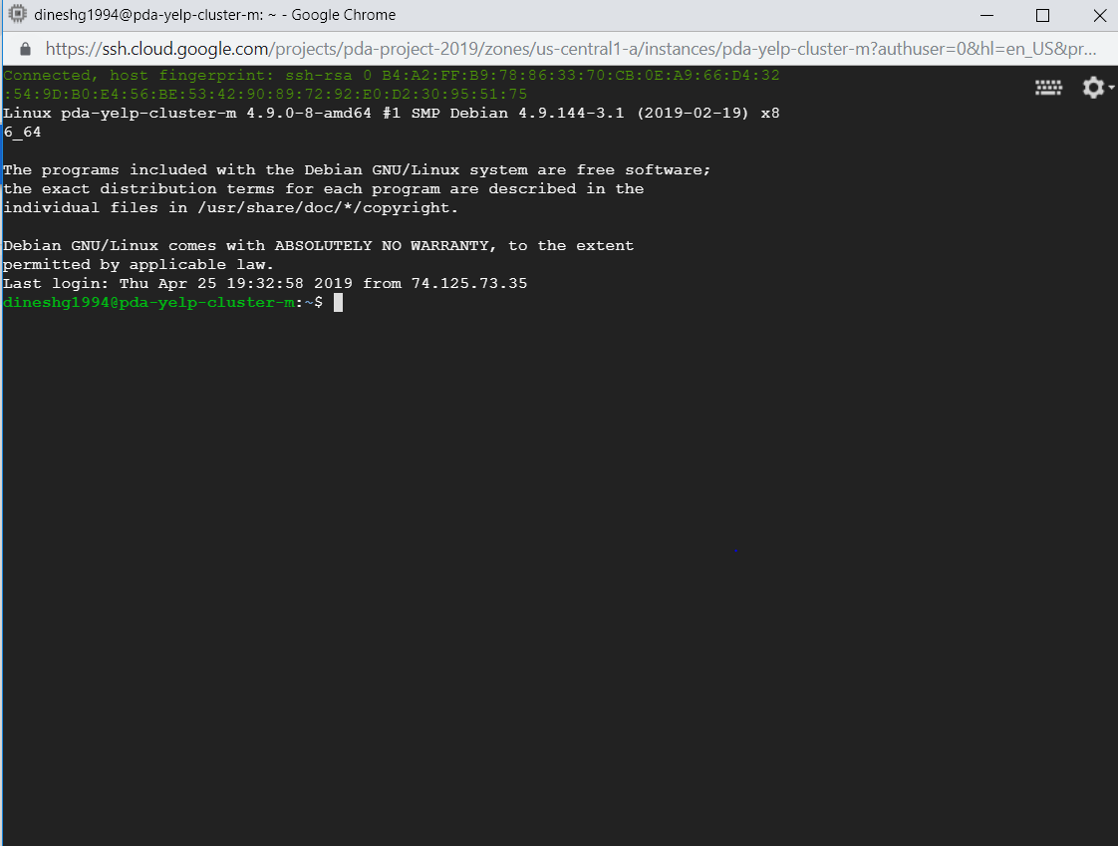

1. Write code in eclipse

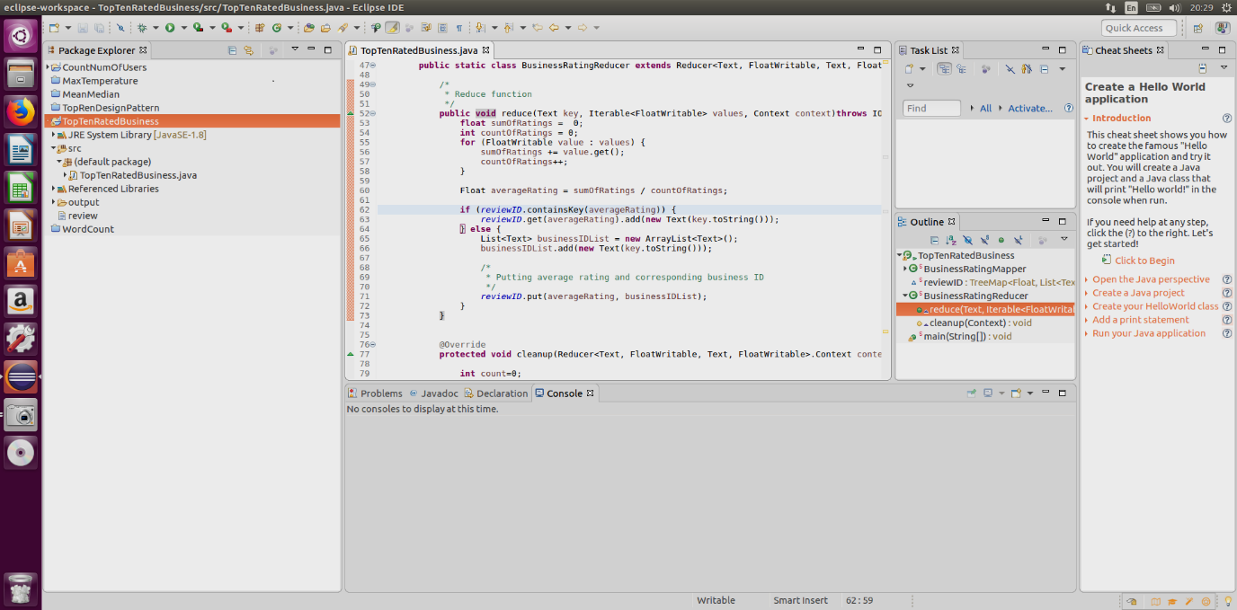

1. Create a java jar and Upload the jar to Google storage

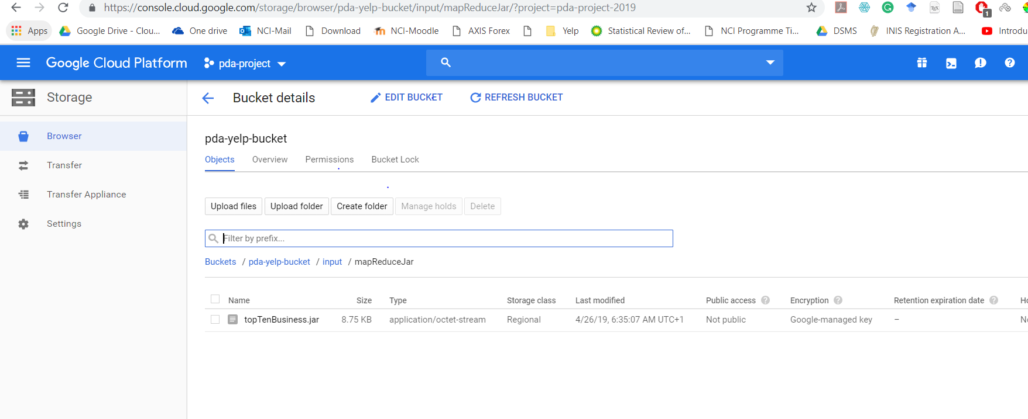

1. Copy jar from google storage to local

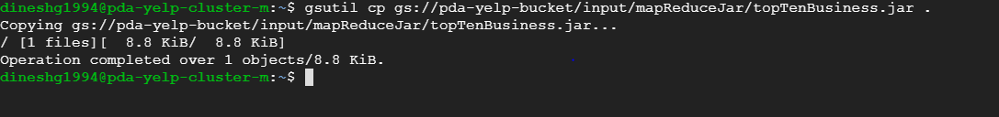

1. Run the jar and save output to google file system

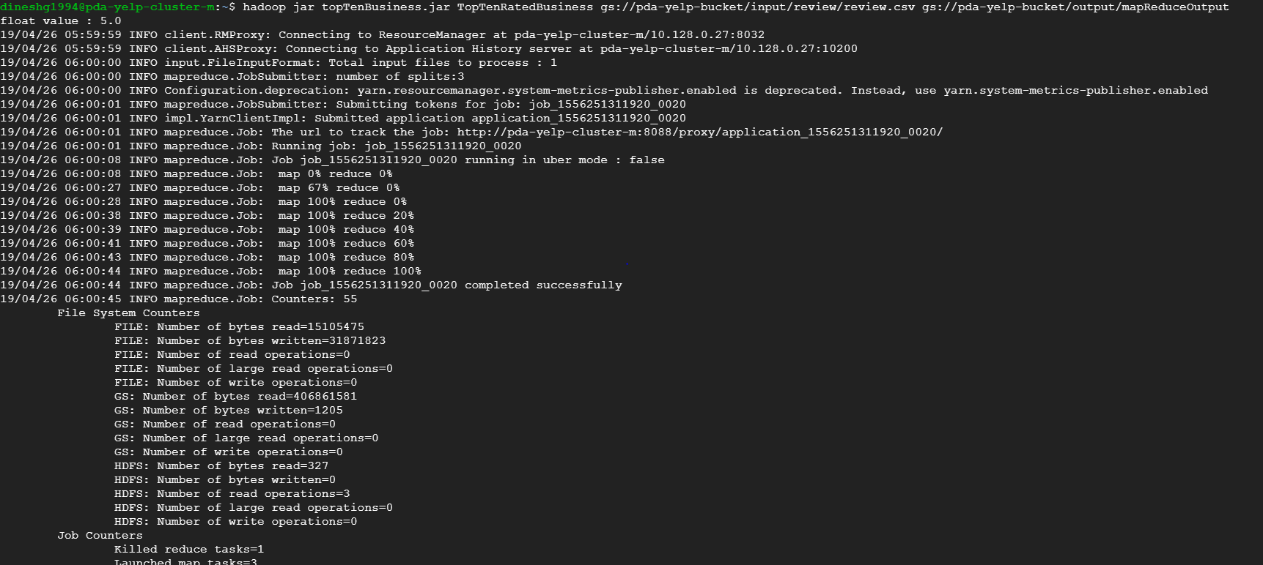

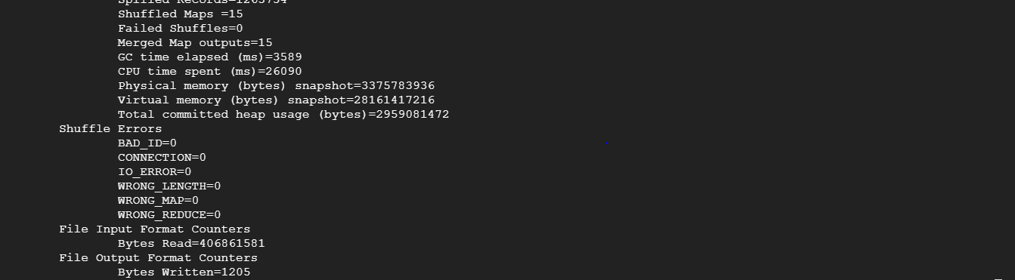

1. Output generated on google file system

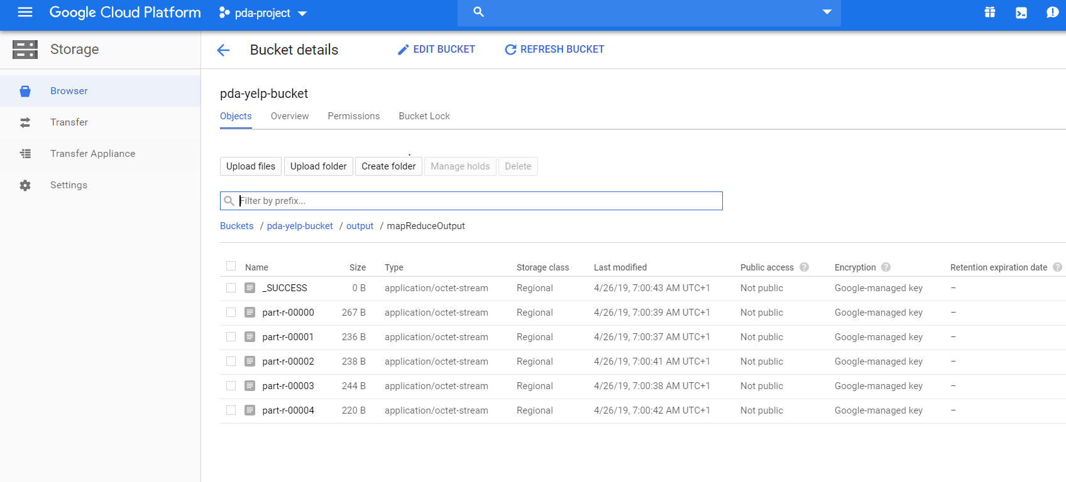

Copy multiple files to single file

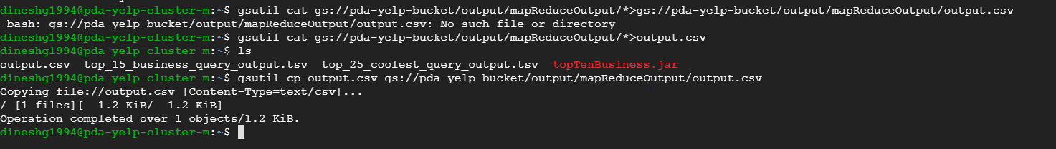

1. Steps to create big query table and connect big tableau with big query is followed same as in pyspark document task 1 steps 9-11.
2. Final Visualisation

