**Steps To Run the Application**

**Step : 1**

Clone the project from GITHUB using the url : https://github.com/DineshKarthickRajendran/Calculator_App.git

Step: 2

Add the project as Maven project

Step: 3

Run the CalculatorApplication.java ,

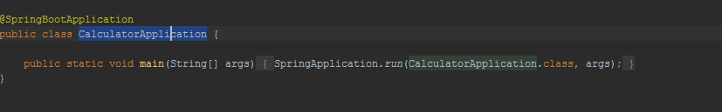

Application started as below:

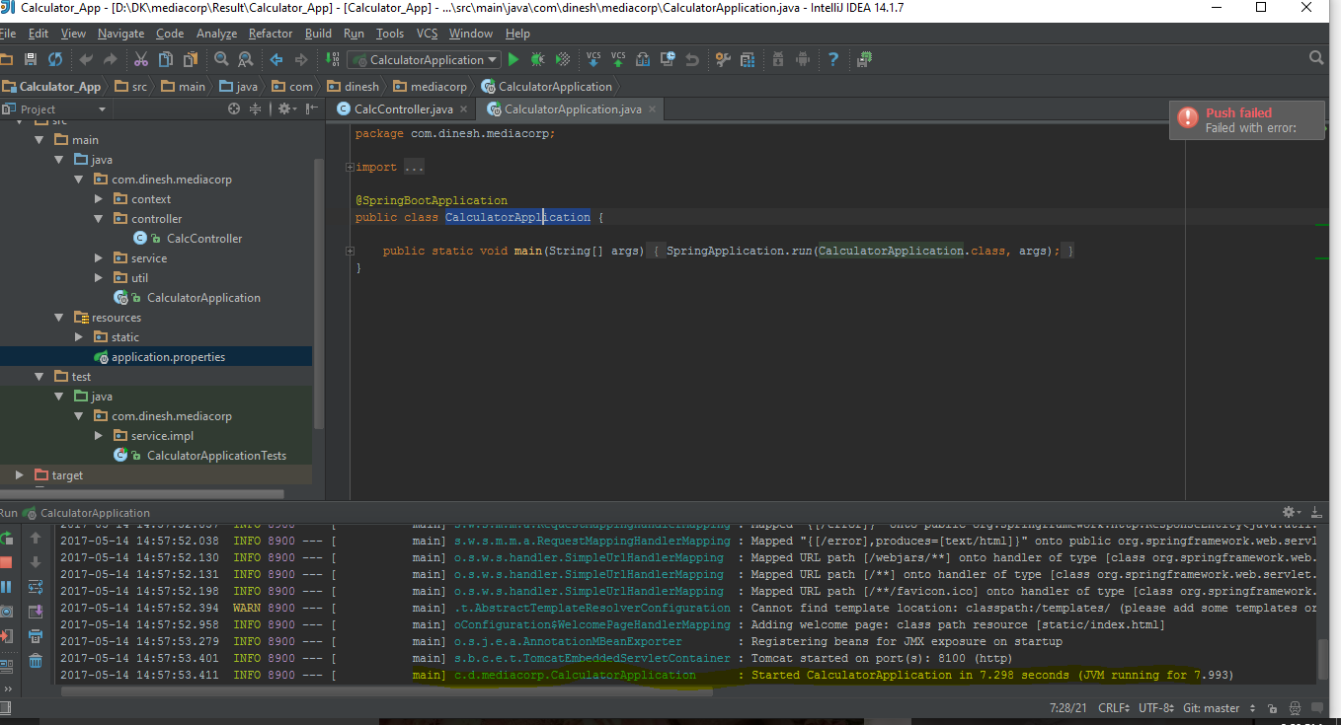

Step :5

Run the service from localhost in the browser as below :

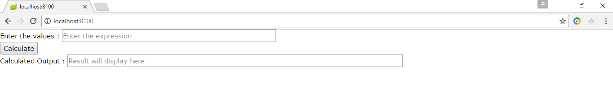

Step : 6

Enter the expression and click Calculate button , the result will be displayed in the ‘Calculated Output’ as below :

