Engineering Orientation Program-Problem Statement
The Engineering Orientation Program is a student run organization through the college of Engineering. This is a one day program in the beginning of the school year to help the transition into college for incoming freshman. It helps the freshman stay updated on network events and helps them stay involved with the College of Engineering the whole year. The incoming freshman students are placed in groups with an upperclassman mentor who will be leading the orientation with them. This will allow the rating system between students and mentors . This system will also make scheduling events for the organization easier for the directors. The director can keep track of which students attend and the mentors that helped to run the event For questions that students have, the system will allow for a simpler and quicker way for their mentors to get answers back. Our goal is to create a successful database system to satisfy the needs that current “information system” needs. Our database would keep track of the mentors’ ratings, events that the directors set up, questions that need to be answered, and students, mentors, and directors’ information. Our database would provide a much easier service for the students, directors, and mentors to use.
Students Can:
- Rate mentors based on various categories
- Ask questions to their corresponding mentor.
- Register to attend events

Mentors Can:
- Answer questions asked by students
- View ratings of themselves

Directors Can:
- Create events

DATA REQUIREMENTS

Students
Each Student is uniquely identified by his/her college email, and further described by his/her student name, cell number, and team color.

Mentor
A mentor is uniquely identified by his/her college e-mail , and further described by his/her name, major, team color, and cell number.
Director
Each director is uniquely identified by his/her email and is further described by his/her name, team color and cell number.
Rating
Each rating is uniquely identified by a submission number, and further described by availability and comments.
Questions
Questions are uniquely identified by question number, and further identified by subject and answer
Event
Each event is uniquely identified by event name, and further described by location, and date.

INSTANCES
Student “Assigned_to” Mentor
Each student is assigned to no more than one mentor.
Each mentor may be assigned many students.
Each student must be assigned to a mentor,
A mentor does not need to have students assigned to them.

Students “Create” Rating
Each rating must be created by a student.
A student does not need to create a rating.
A rating can be created by many students.
Each student can only create one rating.

Mentor “Reports to” Director
Each mentor must report to a director.
A director does not have to have mentors assigned to them.
A mentor can only report to one director.
A director can have many mentors assigned to them.

Mentor “receives” by Rating
A mentor can receive a rating.
A rating must be given to a mentor.
A mentor can receive many ratings.
Each rating can go to only one mentor.

Students “ask” Questions
A student can ask a question.
A question must be asked by a student.
A student can ask many questions.
A question can be asked by a group of students.

Mentor “answers” Questions
Mentors are required to answer questions.
A question must be answered by a mentor.
A mentor can answer many questions.
Each question can be answered by only one mentor.

Students “attend” Events
A student sign in is recorded.
The sign in is described by a Sign_In_ID.
A student can but does not have attend events.
An event has to have students attend it.
An event can have many students.
A student can attend many events.

Director “sets up” Event
A director could set up events.
An event must be set up by a director.
A director can set up multiple events.
An event can be set up by multiple directors.

Mentors “runs” Events
A mentor is required to run an event.
An event has to be ran by a mentor.
A mentor can run multiple events.
An event can be ran by many mentors.

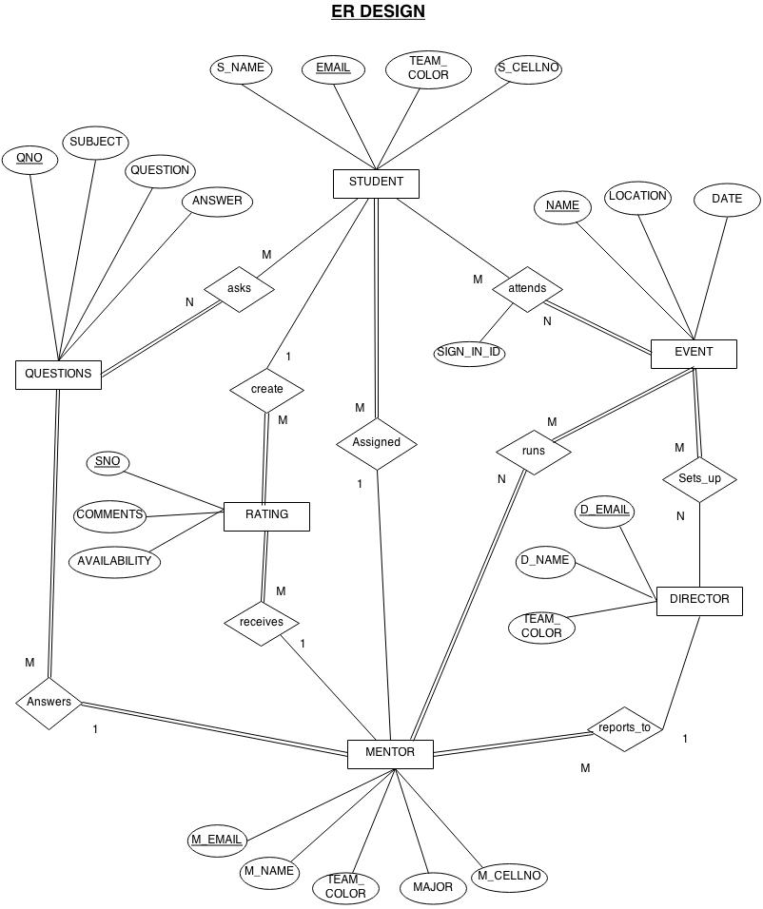

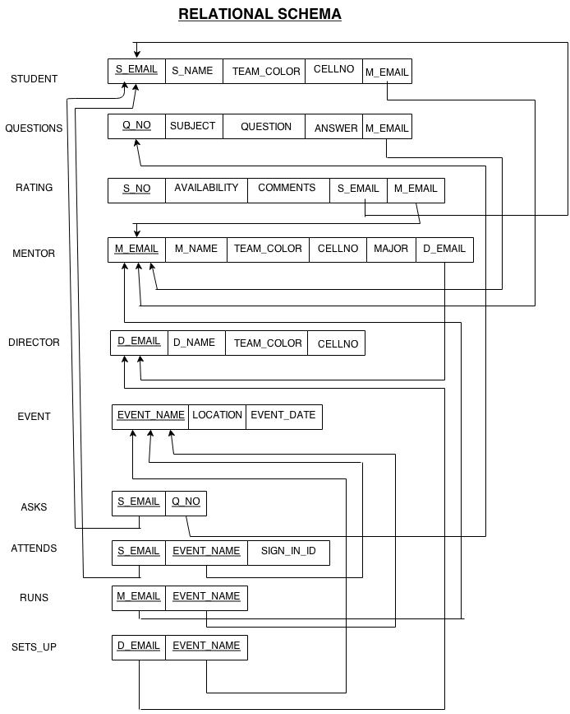

Logical Design - Create Table Statements
CREATE TABLE Director
(
d_email CHAR(13) NOT NULL,
d_name CHAR(30),
team_color CHAR(12),
cellno CHAR(10),
PRIMARY KEY (d_email)
)

CREATE TABLE EVENT
(
event_name CHAR(50) NOT NULL,
location CHAR(50),
event_date DATE,
PRIMARY KEY (event_name)
)

CREATE TABLE Mentor
(
m_email CHAR(13) NOT NULL,
m_name CHAR(40),
team_color CHAR(15),
major CHAR(30),
cellno CHAR(10),
d_email CHAR(13),
PRIMARY KEY (m_email),
FOREIGN KEY(d_email) REFERENCES director(d_email)
)

CREATE TABLE Students
(
s_email CHAR(13)NOT NULL,
cellno CHAR(10),
s_name CHAR(40),
team_color CHAR(15),
m_email CHAR(13),
PRIMARY KEY (s_email),
FOREIGN KEY(m_email) REFERENCES mentor(m_email)
)

CREATE TABLE Attends
(
event_name CHAR(50),
s_email CHAR(13),
sign_in_id INTEGER,
PRIMARY KEY (event_name,s_email),
FOREIGN KEY(s_email) REFERENCES Students,
FOREIGN KEY(event_name) REFERENCES Event
)

CREATE TABLE rating
(
sno INTEGER NOT NULL,
comments CHAR(100),
availability INTEGER,
s_email CHAR(13),
m_email CHAR(13),
PRIMARY KEY (sno),
FOREIGN KEY(s_email) REFERENCES students,
FOREIGN KEY(m_email) REFERENCES mentor
);

CREATE TABLE Questions
(
q_no CHAR(10) NOT NULL,
subject VARCHAR(20),
question VARCHAR(100),
answer VARCHAR(250),
m_email CHAR(13),
PRIMARY KEY (q_no),
FOREIGN KEY(m_email) REFERENCES mentor
)

CREATE TABLE Asks
(
q_no CHAR(10),
s_email CHAR(13),
PRIMARY KEY (q_no,s_email),
FOREIGN KEY(s_email) REFERENCES Students,
FOREIGN KEY(q_no) REFERENCES Questions
)

CREATE TABLE Runs
(
m_email CHAR(13),
event_name CHAR(50),
PRIMARY KEY (event_name,m_email),
FOREIGN KEY(m_email) REFERENCES Mentor,
FOREIGN KEY(event_name) REFERENCES Event
)

CREATE TABLE Sets_up
(
d_email CHAR(13),
event_name CHAR(50),
PRIMARY KEY (event_name,d_email),
FOREIGN KEY(d_email) REFERENCES Director,
FOREIGN KEY(event_name) REFERENCES Event
)

Populating the Database
DIRECTOR:
INSERT INTO DIRECTOR VALUES ( 'PM1@WSU.EDU', 'PANEESH,MURTHY', 'BROWN', '9432864324' );
INSERT INTO DIRECTOR VALUES ( 'JM1@WSU.EDU', 'JOHN,MATRIX', 'BLUE', '9177221314' );
INSERT INTO DIRECTOR VALUES ( 'MX1@WSU.EDU', 'MANYA,XESER', 'GREEN', '9666864321' );
INSERT INTO DIRECTOR VALUES ( 'KR1@WSU.EDU', 'KAMAL,RANGAN', 'RED', '4236864321' );
INSERT INTO DIRECTOR VALUES ( 'SN1@WSU.EDU', 'SUDHA,NARAYAN', 'YELLOW', '9977221314' );

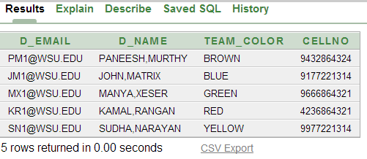
EVENT:
INSERT INTO EVENT VALUES ( 'ADSHOPHOS', 'ALLYN HALL','01-AUG-14');
INSERT INTO EVENT VALUES ( 'INTFEST', 'POLY HALL' ,'15-SEP-14');
INSERT INTO EVENT VALUES ( 'RANGAM', 'APOLLO HALL' ,'15-JAN-14');
INSERT INTO EVENT VALUES ( 'SAJANA', 'MARATHON AUDITORIUM' ,'06-MAY-14');
INSERT INTO EVENT VALUES ( 'THANKSDAY', 'GAJAL STADIUM' ,'28-NOV-14');
INSERT INTO EVENT VALUES ( 'FOODMELA', 'MILLET HALL' ,'14-OCT-14');

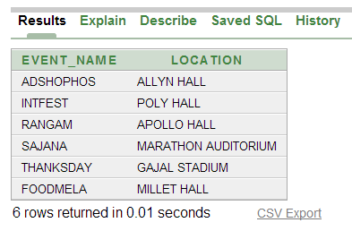

MENTOR:

INSERT INTO MENTOR VALUES ('PT1@WSU.EDU', 'PRUDHVI,TEJA', 'BROWN','CS', '9977221314','PM1@WSU.EDU');

INSERT INTO MENTOR VALUES ('BN1@WSU.EDU', 'BHUVAN,NALLA', 'BLUE','EE', '9907221314','JM1@WSU.EDU');

INSERT INTO MENTOR VALUES ('AC1@WSU.EDU', 'AKSHIHA,CHANDRAN', 'BLUE','CS', '8907221314','JM1@WSU.EDU');

INSERT INTO MENTOR VALUES ('SP8@WSU.EDU', 'SANGRAS,PRANEETH', 'RED','CS', '4907221314','KR1@WSU.EDU');

INSERT INTO MENTOR VALUES ('GR1@WSU.EDU', 'GIRE,RAVI', 'RED','CS', '2907221314','KR1@WSU.EDU');

INSERT INTO MENTOR VALUES ('SH1@WSU.EDU', 'SHIVANNA,HARISH', 'YELLOW','EC', '9997221314','SN1@WSU.EDU');

INSERT INTO MENTOR VALUES ('JH3@WSU.EDU', 'JAKIR,HUSSAIN', 'YELLOW','CS', '9997211314','SN1@WSU.EDU');

INSERT INTO MENTOR VALUES ('PR3@WSU.EDU', 'PRIYANKA,REDDY', 'YELLOW','ME', '8997211314','SN1@WSU.EDU');
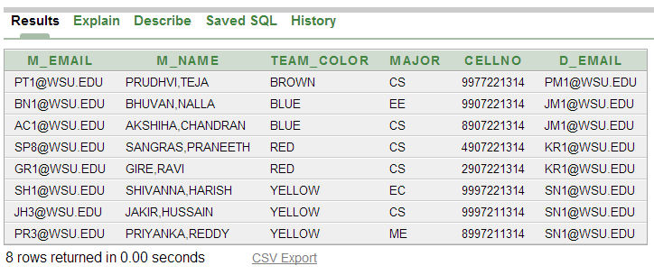

STUDENTS:
INSERT INTO STUDENTS VALUES ('JN1@WSU.EDU','9984657812', 'JALAYA,NARA', 'YELLOW','PR3@WSU.EDU');

INSERT INTO STUDENTS VALUES ('MU1@WSU.EDU','7784657812', 'MOYIN,USMAN', 'YELLOW','JH3@WSU.EDU');

INSERT INTO STUDENTS VALUES ('KA1@WSU.EDU','7184657812', 'AFZAL,KHAN', 'YELLOW','JH3@WSU.EDU');

INSERT INTO STUDENTS VALUES ('SK1@WSU.EDU','8184657812', 'SYAMALA,KUMAR', 'YELLOW','PR3@WSU.EDU');

INSERT INTO STUDENTS VALUES ('RM1@WSU.EDU','9184657812', 'RADHA,MANOHAR', 'YELLOW','PR3@WSU.EDU');

INSERT INTO STUDENTS VALUES ('UY3@WSU.EDU','7014157812', 'UDAY,YENIREDDY', 'BLUE','BN1@WSU.EDU');

INSERT INTO STUDENTS VALUES ('GB1@WSU.EDU','6684657812', 'GURU,BHARATH', 'YELLOW','SH1@WSU.EDU');

INSERT INTO STUDENTS VALUES ('KS1@WSU.EDU','9684657812', 'KATTI,SHRAVYA', 'RED','GR1@WSU.EDU');

INSERT INTO STUDENTS VALUES ('GB4@WSU.EDU','8684657812', 'GANTA,BARANI', 'RED','GR1@WSU.EDU');

INSERT INTO STUDENTS VALUES ('SS4@WSU.EDU','9984657812', 'SUSMITHA,SEIKH', 'RED','SP8@WSU.EDU');

INSERT INTO STUDENTS VALUES ('MC1@WSU.EDU','9984157812', 'MOKSHA,CHAWLA', 'BLUE','AC1@WSU.EDU');

INSERT INTO STUDENTS VALUES ('PR2@WSU.EDU','9084157812', 'PITTA,RAAJA', 'BLUE','AC1@WSU.EDU');

INSERT INTO STUDENTS VALUES ('KK2@WSU.EDU','9014157812', 'KAVYA,KASU', 'BLUE','BN1@WSU.EDU');

INSERT INTO STUDENTS VALUES ('HM2@WSU.EDU','7014157812', 'HEMA,MULPURI', 'BLUE','BN1@WSU.EDU');

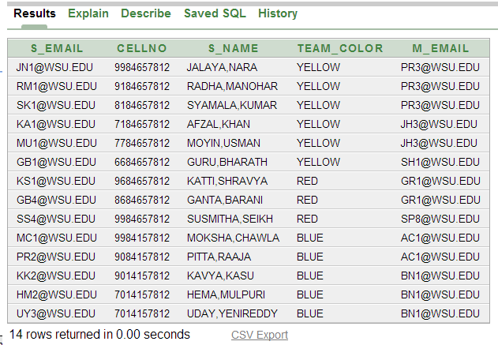

ATTENDS:
INSERT INTO ATTENDS VALUES('ADSHOPHOS','JN1@WSU.EDU',1);
INSERT INTO ATTENDS VALUES('ADSHOPHOS','GB4@WSU.EDU',2);
INSERT INTO ATTENDS VALUES('ADSHOPHOS','KK2@WSU.EDU',3);
INSERT INTO ATTENDS VALUES('ADSHOPHOS','UY3@WSU.EDU',4);
INSERT INTO ATTENDS VALUES('ADSHOPHOS','HM2@WSU.EDU',5);
INSERT INTO ATTENDS VALUES('ADSHOPHOS','PR2@WSU.EDU',6);
INSERT INTO ATTENDS VALUES('FOODMELA','JN1@WSU.EDU',1);
INSERT INTO ATTENDS VALUES('FOODMELA','RM1@WSU.EDU',2);
INSERT INTO ATTENDS VALUES('FOODMELA','SK1@WSU.EDU',3);
INSERT INTO ATTENDS VALUES('FOODMELA','KA1@WSU.EDU',4);
INSERT INTO ATTENDS VALUES('FOODMELA','MU1@WSU.EDU',5);
INSERT INTO ATTENDS VALUES('FOODMELA','GB1@WSU.EDU',6);
INSERT INTO ATTENDS VALUES('FOODMELA','KS1@WSU.EDU',7);
INSERT INTO ATTENDS VALUES('FOODMELA','GB4@WSU.EDU',8);
INSERT INTO ATTENDS VALUES('FOODMELA','SS4@WSU.EDU',9);
INSERT INTO ATTENDS VALUES('FOODMELA','MC1@WSU.EDU',10);
INSERT INTO ATTENDS VALUES('FOODMELA','PR2@WSU.EDU',11);
INSERT INTO ATTENDS VALUES('FOODMELA','KK2@WSU.EDU',12);
INSERT INTO ATTENDS VALUES('FOODMELA','HM2@WSU.EDU',13);
INSERT INTO ATTENDS VALUES('FOODMELA','UY3@WSU.EDU',14);
INSERT INTO ATTENDS VALUES('RANGAM','JN1@WSU.EDU',1);
INSERT INTO ATTENDS VALUES('RANGAM','SK1@WSU.EDU',1);
INSERT INTO ATTENDS VALUES('RANGAM','MU1@WSU.EDU',3);
INSERT INTO ATTENDS VALUES('RANGAM','KS1@WSU.EDU',4);
INSERT INTO ATTENDS VALUES('RANGAM','UY3@WSU.EDU',5);
INSERT INTO ATTENDS VALUES('SAJANA','UY3@WSU.EDU',1);
INSERT INTO ATTENDS VALUES('SAJANA','GB1@WSU.EDU',3);
INSERT INTO ATTENDS VALUES('SAJANA','SS4@WSU.EDU',2);
INSERT INTO ATTENDS VALUES('INTFEST','SS4@WSU.EDU',2);
INSERT INTO ATTENDS VALUES('INTFEST','UY3@WSU.EDU',2);
INSERT INTO ATTENDS VALUES('THANKSDAY','KS1@WSU.EDU',3);
INSERT INTO ATTENDS VALUES('THANKSDAY','MC1@WSU.EDU',2);
INSERT INTO ATTENDS VALUES('THANKSDAY','UY3@WSU.EDU',1);

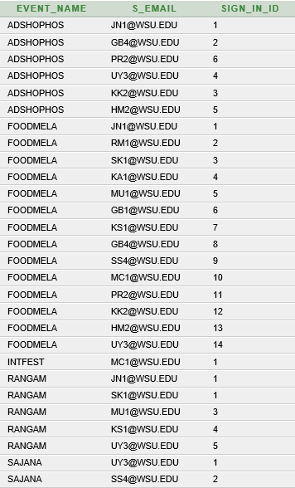

RATING:
INSERT INTO RATING VALUES(2,'VERY HELPFUL',1,'UY3@WSU.EDU','BN1@WSU.EDU');

INSERT INTO RATING VALUES(1,'GOOD WORK',1,'HM2@WSU.EDU','BN1@WSU.EDU');

INSERT INTO RATING VALUES(3,'VERY COOPERATIVE',1,'PR2@WSU.EDU','AC1@WSU.EDU');

INSERT INTO RATING VALUES(4,'VERY NICE MAN',1,'GB4@WSU.EDU','GR1@WSU.EDU');

INSERT INTO RATING VALUES(5,'NICE WORK IN THE EVENT',1,'GB1@WSU.EDU','SH1@WSU.EDU');

INSERT INTO RATING VALUES(6,'EXCELLENT PROGRAM WAS DONE',1,'MU1@WSU.EDU','JH3@WSU.EDU');

INSERT INTO RATING VALUES(7,'NICE SENIOR',1,'SK1@WSU.EDU','PR3@WSU.EDU');

INSERT INTO RATING VALUES(8,'NICE MENTOR CUM CAPT',1,'JN1@WSU.EDU','PR3@WSU.EDU');

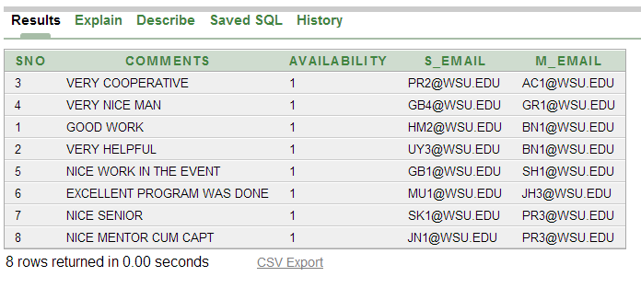

QUESTIONS:

INSERT INTO QUESTIONS VALUES('1','EVENT PARTICIPATION','HOWMANY MEMBERS SHOULD JOIN THE FOOD MELA TEAM','MAX 5 MEMBERS ARE ALLOWED PER TEAM','BN1@WSU.EDU');

INSERT INTO QUESTIONS VALUES('2','EVENT PARTICIPATION','CAN SINGLE PERSON PARTICIPATE IN THE SAJANA POSTER WORK','YES.. TEAM SIZE SHOULD NOT EXCEED 2','SH1@WSU.EDU');

INSERT INTO QUESTIONS VALUES('3','DEPOSIT','HOWMUCH AMOUNT SHOULD I PAY TO GET INTO THE ADSHOPHOS EVENT','ITS FREE OF COST','GR1@WSU.EDU');

INSERT INTO QUESTIONS VALUES('4','DEPOSIT','HOWMUCH AMOUNT NEEDS TO BE PAID IF FOOD MELA EVENT HAS 4 TEAMS','IT IS 5 $ COST','SP8@WSU.EDU');

INSERT INTO QUESTIONS VALUES('5','WITHDRAW','HOWMANY DAYS IT TAKE TO GET THE REFUND FROM ITTEC',' 5 BUSNIESS DAYS','PR3@WSU.EDU');

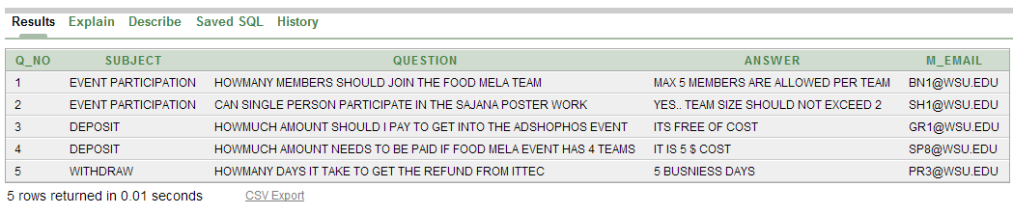

ASKS:

INSERT INTO ASKS VALUES('1','UY3@WSU.EDU');
INSERT INTO ASKS VALUES('2','GB1@WSU.EDU');
INSERT INTO ASKS VALUES('3','KS1@WSU.EDU');
INSERT INTO ASKS VALUES('4','SS4@WSU.EDU');
INSERT INTO ASKS VALUES('5','RM1@WSU.EDU');

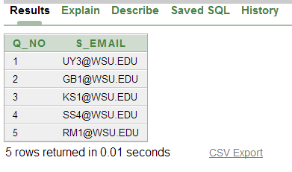

RUNS:
INSERT INTO RUNS VALUES('PR3@WSU.EDU','ADSHOPHOS');
INSERT INTO RUNS VALUES('JH3@WSU.EDU','ADSHOPHOS');
INSERT INTO RUNS VALUES('GR1@WSU.EDU','ADSHOPHOS');
INSERT INTO RUNS VALUES('AC1@WSU.EDU','ADSHOPHOS');
INSERT INTO RUNS VALUES('BN1@WSU.EDU','ADSHOPHOS');
INSERT INTO RUNS VALUES('SH1@WSU.EDU','ADSHOPHOS');
INSERT INTO RUNS VALUES('SP8@WSU.EDU','ADSHOPHOS');
INSERT INTO RUNS VALUES('PT1@WSU.EDU','ADSHOPHOS');
INSERT INTO RUNS VALUES('GR1@WSU.EDU','INTFEST');
INSERT INTO RUNS VALUES('AC1@WSU.EDU','INTFEST');
INSERT INTO RUNS VALUES('BN1@WSU.EDU','RANGAM');
INSERT INTO RUNS VALUES('SH1@WSU.EDU','RANGAM');
INSERT INTO RUNS VALUES('SP8@WSU.EDU','SAJANA');
INSERT INTO RUNS VALUES('PT1@WSU.EDU','SAJANA');
INSERT INTO RUNS VALUES('PT1@WSU.EDU','THANKSDAY');
INSERT INTO RUNS VALUES('AC1@WSU.EDU','THANKSDAY');
INSERT INTO RUNS VALUES('AC1@WSU.EDU','FOODMELA');
INSERT INTO RUNS VALUES('BN1@WSU.EDU','FOODMELA');

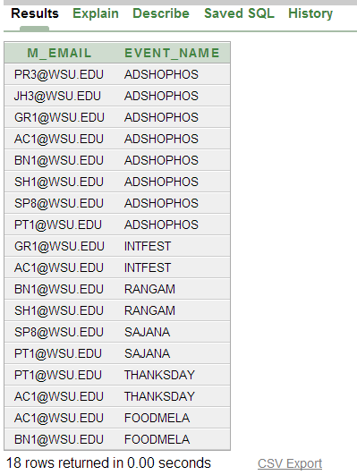

SETS_UP:
INSERT INTO SETS_UP VALUES('JM1@WSU.EDU','ADSHOPHOS');
INSERT INTO SETS_UP VALUES('JM1@WSU.EDU','INTFEST');
INSERT INTO SETS_UP VALUES('JM1@WSU.EDU','THANKSDAY');
INSERT INTO SETS_UP VALUES('JM1@WSU.EDU','FOODMELA');
INSERT INTO SETS_UP VALUES('PM1@WSU.EDU','THANKSDAY');
INSERT INTO SETS_UP VALUES('PM1@WSU.EDU','SAJANA');
INSERT INTO SETS_UP VALUES('PM1@WSU.EDU','ADSHOPHOS');
INSERT INTO SETS_UP VALUES('KR1@WSU.EDU','ADSHOPHOS');
INSERT INTO SETS_UP VALUES('KR1@WSU.EDU','THANKSDAY');
INSERT INTO SETS_UP VALUES('KR1@WSU.EDU','SAJANA');
INSERT INTO SETS_UP VALUES('SN1@WSU.EDU','RANGAM');
INSERT INTO SETS_UP VALUES('SN1@WSU.EDU','ADSHOPHOS');

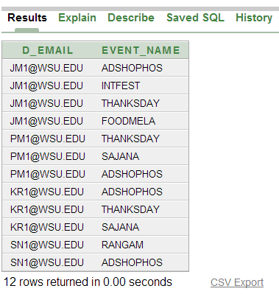

SQL Queries and Results
1) Retrieve the mentors names, majors and their team_colors who have run the maximum number of events. There is a chance that more than one mentor can run the maximum number of events.
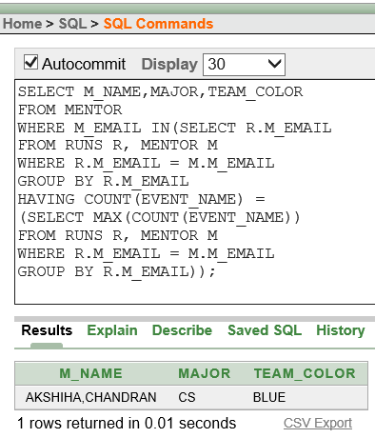

2) For each event on which more than one director sets up, retrieve the event name and no of directors who sets up the event.
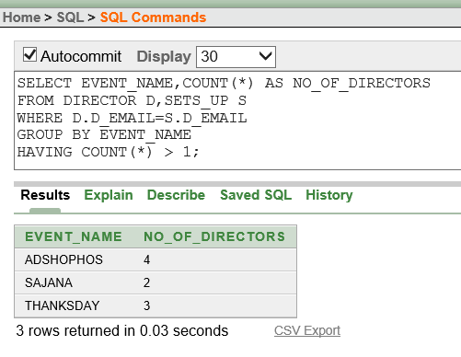
3) Retrieve the names of all mentors who have 2 or more students assigned to them.
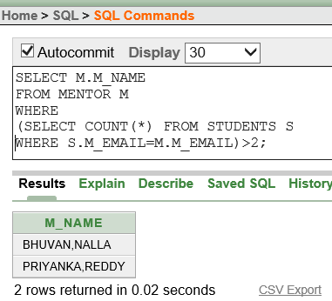

4) Retrieve the number of questions asked by each student who has attended the events in October and November months.(include the student email ids)
.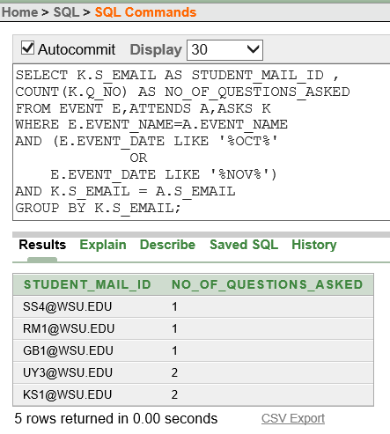

5) Retrieve the team-color of students with their names who asked the maximum number of questions regarding the events.
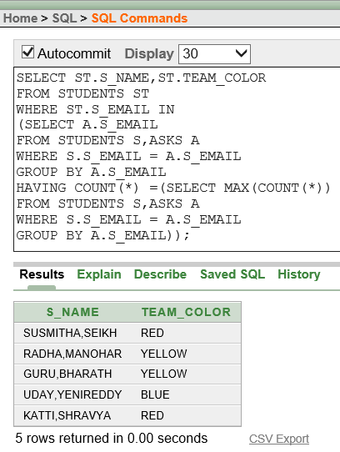

6) Retrieve the number of students (team-color) in the descending order , who gave the rating to the mentors to whom they are assigned.
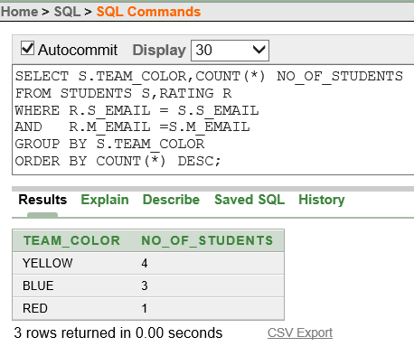

7) Retrieve the event name that was ran by the mentor, which doesn't have the students assigned to the same mentor.
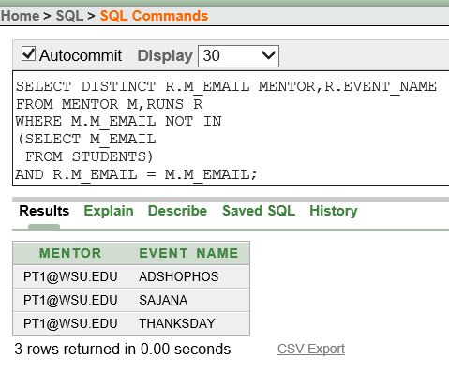

8) Retrieve the name of each mentor who runs the events controlled by directors in the 'CS' major.
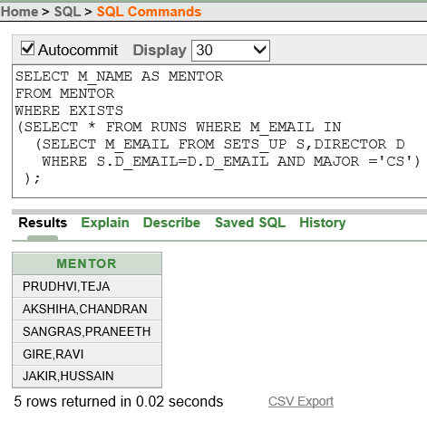

9)Retrieve the number of mentors present in the each major (order of major)
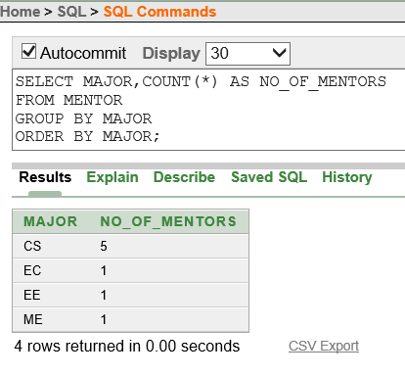

10) Retrieve the names of mentors who answered the questions raised by the students within their team.
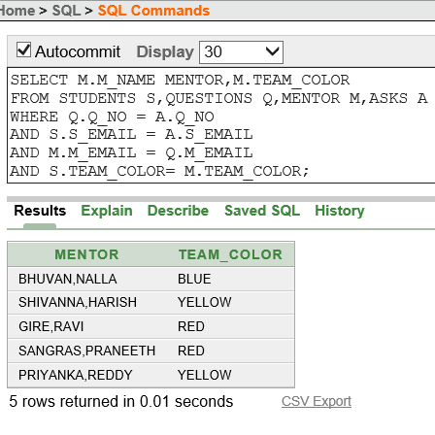

11) Retrieve the mentors names who has got the rating from students along with the students comments and students names.
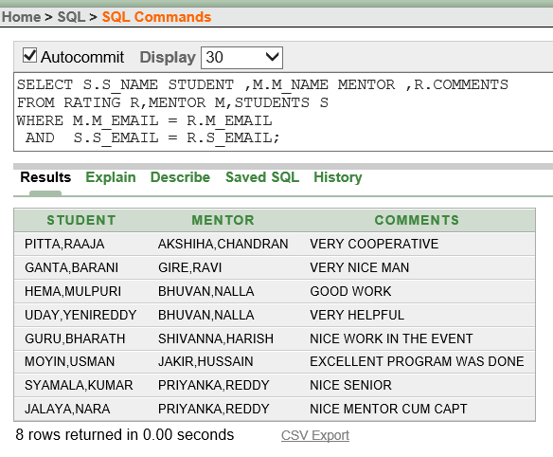

12) Retrieve the names of mentors who did not answer the student questions.
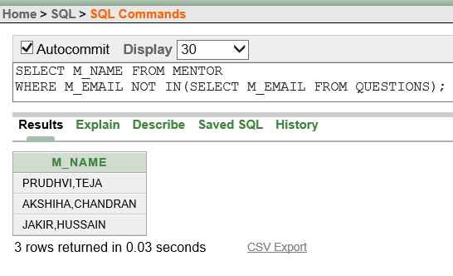

DISCUSSIONS
Current Information System:
The current database does not do an adequate job of showing the relationships between the mentors and the men-tees. Currently an Excel spreadsheet is being used to keep track of the information for the organization. The rating system was done through a Google document which would later have to be transferred to a spreadsheet. With over 800 students and 300 mentors, it is a very tedious process of inserting information. Each student is supposed to submit a rating for each mentor that grades how well the mentor did with the group. This information is also stored in the spread sheets.
Need for a new system/Benefits:
The new database system does a much better job at showing the relationships between the students and the mentors than the old database system did. There will be much less time spent creating new spreadsheets and transferring data between them. The database system will be much more organized for everyone in the group as well as easy to use when inserting new data. This will allow the rating system between students and mentors to be completely online. The new system will also make scheduling events for the organization easier for the directors. A database will allow the director to keep track of which students attend and the mentors that helped to run the event. Directors can assign students to mentors with less effort and make sure the best mentors get the most students. For questions that students have, the system will allow for a simpler and quicker way for their mentors to get answers back.
Cardinalities' in the implemented ER design: We can see the binary relationships in the ER Design.
a)Mentor-Runs-Event
There exists M:N relation between Mentor and Event. So, the primary key of Mentor i.e. M_EMAIL and the primary key of Event i.e. EVENT_NAME becomes the foreign key in the relation-ship Runs. But, their combination becomes the Primary key for relation-ship Runs.
b)Student-Create-Rating
There exists 1:M relation between Student and Rating. So, the primary key of Student i.e. S_EMAIL becomes the foreign key in the Rating . If any attribute exists for relation-ship Create, then the same attributes become the attributes for Rating.

c)Director-Sets-up-Event
There exists M:N relation between Director and Event. So, the primary key of Director i.e. D_EMAIL and the primary key of Event i.e. EVENT_NAME becomes the foreign key in the relation-ship Sets-up. But, their combination becomes the Primary key for relation-ship Sets-up.
d)Mentor-Answers-Questions
There exists 1:M relation between Mentor and Questions. So, the primary key of Mentor i.e. M_EMAIL becomes the foreign key in the Questions . If any attribute exists for relation-ship Answers, then the same attributes become the attributes for Questions.
e)Mentor-Receives-Rating
There exists 1:M relation between Mentor and Rating. So, the primary key of Mentor i.e. M_EMAIL becomes the foreign key in the Rating . If any attribute exists for relation-ship Receives, then the same attributes become the attributes for Rating.
f)Student-Assigned-Mentor
There exists 1:M relation between Mentor and Student. So, the primary key of Mentor i.e. M_EMAIL becomes the foreign key in the Student . If any attribute exists for relation-ship Assigned, then the same attributes become the attributes for Student.
g)Student-Attends-Event
There exists M:N relation between Student and Event. So, the primary key of Student i.e. S_EMAIL and the primary key of Event i.e. EVENT_NAME becomes the foreign key in the relation-ship Attends. But, their combination becomes the Primary key for relation-ship Attends.
h)Mentor-Reports-Director
There exists 1:M relation between Director and Mentor. So, the primary key of Director i.e. D_EMAIL becomes the foreign key in the Mentor . If any attribute exists for relation-ship Reports, then the same attributes become the attributes for Mentor.
i)Student-Asks-Questions
There exists M:N relation between Student and Questions. So, the primary key of Student i.e. S_EMAIL and the primary key of Questions i.e. Q_NO becomes the foreign key in the relation-ship Asks. But, their combination becomes the Primary key for relation-ship Asks.

Future Work:
This db system facility can be made online. Such that user needs account details to log into it. Thus everyone will get access to the data which is relevant to them. In addition to these, the advertisements can be included in the application using yellow pages.

