1. **INTRODUCTION**
   1. **Purpose**

Policy Bazaar system has provides automatic insurance policy to the Indian people. Policy Bazaar includes customer, agent and employee from verification and legal contract department. Policy Bazaar provides system interface to ease some of the processes to the customer, agent and employee . Policy Bazaar is web based application implemented for sending customer details through agents to the verification department further verification department will enter all the details of the customer in to the system and sends the report to the legal contract department. Legal contract department prepare policy contract and sends to customer after payment has received from the customer.

* 1. **Intended Audience and Reading Suggestions**

This project is the university level project and is implementing under the guidance of university professors.

* 1. **Project Scope**

Policy Bazaar provides automatic insurance policy to the Indian policy to the Indian people . Policy Bazaar provides system interface to ease some of the processes to the customer, agent and employee. Policy Bazaar is web based application implemented for sending customer details through agents to the verification department further verification department will enter all the details of the customer in to the system and sends the report to the legal contract department. Legal contract department prepare policy contract and sends to customer after payment has received from the customer.

* 1. **Overview**

The remainder of this document is organized as follow : There will be some definitions of important terms Section2 contains a general description of Policy Bazaar. Section 3 identifies the specific functional requirements the external interfaces and performance requirements of the Policy Bazaar.

Policy Bazaar has provides automatic insurance policy to the Indian people. Policy Bazaar includes customer, agent and employee from verification and legal contract department. Policy Bazaar provides system interface to ease some of the processes to customer, agent and employee. Policy Bazaar is web based application implemented for sending customer details through agents to the verification department .Legal contract department prepare policy contract and sends to customer after payment has received from the customer.

* 1. **Definitions**

Search/View policy- This online insurance management system provides easy access of information regarding the policy to customer , employee and agent. It also helps to verify and validate customer details and generate report with legal contract.

Premium Calculator - A term insurance premium calculator is a specially designed tool that helps you calculate the required monthly cover in order to get a sum insured desired by you. This calculator is simple and extremely helpful when you are planning to buy a term insurance plan. Term insurance calculator allows you to adjust the sum you would want your family to receive post your unfortunate demise.

Payment - To confirm the insurance policy customer has to pay the total charges of the policy and after the payment confirmation related receipt will be generated.

Register- It includes customer name, address and phone number, emailed, user name, password. This information may be used for keeping the records of the customer for any emergency or for any other kind of information and other process.

* 1. **Reference**

Policy Bazaar(www.PolicyBazaar.com)

www.learnerswindow.com

1. **Overall Description**
   1. **Product Perspective**

The Policy Bazaar System is a web based application and maintains a centralized repository of all related information.

* 1. **Product Functions**

The system allows you to easily access the relevant information and choose relevant policy or loan for himself . Users can decide about policy, loan and they can choose policy online and pay the premium of that policy accordingly.

* 1. **User Characteristics**

Customer

The customer interacts with Policy Bazaar via the Internet. It must be very easy for them to access and use the management system. They should be able to do operations like registering, viewing of policy, premium calculation , rating of policy.

Maintainer

It should be easy to maintain the whole system .The maintainer should be the only person that is allowed to give privileges to add new information

* 1. **Abbreviations**

Throughout this document the following abbreviations are used :

SRS: Software Requirement Specification

GUI: Graphical User Interface

PC: Premium Calculation

V: View of the policy

BPO: Buy Policy Online

PP: Premium Payment

1. **Specific Requirements:**
   1. **functional requirements:**

The requirements for the Policy Bazaar are organized in the following way.

General:

Functional Requirement:

* Description:

Initialize parameters V,PC,BPO,and H.

* Input:

V,PC,BPO is entered

* Processing:

Processing the result based on the parameters entered

* Output:

Displaying the result based on the parameters

Functional Requirement 2:

* Description:

If no result is available for the entered parameters the system displays an error message.

* Input:

TYR,S,D is entered

* Output:

Display an error message

**Authentication:**

The Authentication starts when customers enters his login id and password.

* Description:

The system has to check if the entered information is valid

* Input:

Customer enters the login ID and Password.

* Processing:

Check if it is Valid

* Output:

Display error message.

-user id/wrong password if the login id is wrong.

Functional Requirment3

* Description:

Perform Payment operation.

* Input:

Initial payment successful

* Processing:

Online Payment

* Output:

Wait for payment completion

Functional Requiremant4

* Description:

Perform Payment cancellation operation

* Input:

Cancellation successful.

* Processing:

Payment Return.

* Output:

Wait for Payment Return Confirmation.

**3.2 Non Functional Requirements:**

**Reliability:** The system provides storage of all databases on redundant computers with automatic switchover. The reliability of the overall program depends on the reliability of the separate components. The main pillar of reliability of the system is the backup of the database which is continuously maintained and updated to reflect the most recent changes. Thus the overall stability of the system depends on the stability of container and its underlying operating system.

**Availability:** The system should be available at all times, meaning the user can access it using a web browser, only restricted by the down time of the server on which the system runs. In case of a hardware failure or database corruption, a replacement page will be shown. Also in case of a hardware failure or database corruption, backups of the database should be retrieved from the server and saved by the administrator. Then the service will be started. It means 24x7 availability .

**Security:** The business logic is hidden from the users and is much safer and thus avoids unauthorized or illegal access or database corruption. Security of the users information is also as safe as there is a login facility.

**Maintainability:** Maintenance is typically done after the software development has been completed. As the time evolves, so do the requirements and needs. It revolves around the understanding of the existing software and the effects of the change.

**Portability:** The application is HTML and scripting language based. So the end-user part is fully portable and any system using any web browser should be able to use the feature of the system, including any hardware platform that is available or will be available in the future. An end-user is used this system on any OS; either is it windows or Linux. The system shall run on PC, Laptops and PDA etc.

* 1. **External Interface Requirements**

**3.3.1 Hardware Interface Requirements**

**Server Side:**

Processor 2.0GHZ

RAM 2GB

Hard Disk 30 GB free Space

**Client Side:**

Processor 1.0GHZ

RAM 512MB

Hard Disk 2 GB free space

**3.3.2 Software Interface Requirements**

**Server Side:**

Operating System Window Server 2008 or any compatible

operating system.

Runtime Environment .Net Framework 4.0

Web Server IIS 7.0

Front End Microsoft Asp.Net 2010

Back End SQL server 2008

Other Tools Adobe Photoshop, MS office

**Server Side:**

Operating System Windows XP

Web Browser Internet Explorer 6.0

* 1. **Performance Requirements**

**Performance requirement 1**

* **Description**

Error message should be displayed at least 20 sec.

**Performance requirement2**

* **Description**

Online Payment confirmation premium should be confirmed

**Performance requirement 3**

* **Description**

Only after Payment confirmation premium should be confirmed.

* 1. **Other Requirements**
     1. **Database**

The Policy Bazaar must be able to use several data formats according to the data formats that are provided by the data bases of different policy , loans transaction should have all the properties of a database transaction(Atomicity , Consistency , Isolation , Durability)

* + 1. **User Interface**

UI-1: The Policy Bazaar shall provide registration form for customer, agent and employee

UI-2: Agents sends the request all the details of medical report of customer to verification department.

UI-3: Verification department gets requirement from the agent , the employee to send the status report to finance and legal contract department

UI-4: The Policy Bazaar will provide a help link that will download a user manual and project it onto the screen in case the user hs difficulty in using the program

UI5: The customer will be notified by the system that their insurance policy.

* + 1. Communication Interfaces

CI-1: The security of a user must be consistent through the use of passwords.

CI-2: The Policy Bazaar will signal the mail message generator when it needs to send an email to the Customer as well as agents.

CI-3: The Policy Bazaar will communicate to the database through wireless Ethernet system.

* + 1. Performance requirements

There is no performance requirement in this system because the server request and response is depended on the end user internet connection.

1. **Software desire description**

**Level 0 DFD**

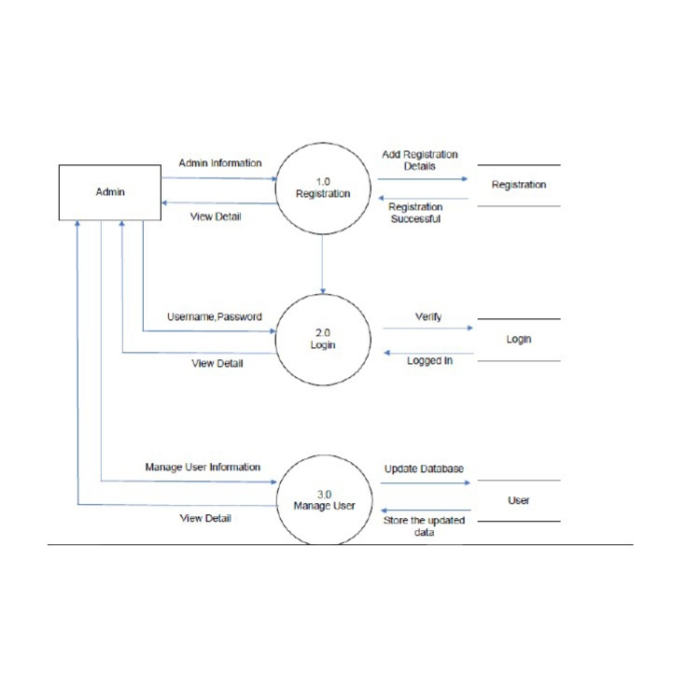

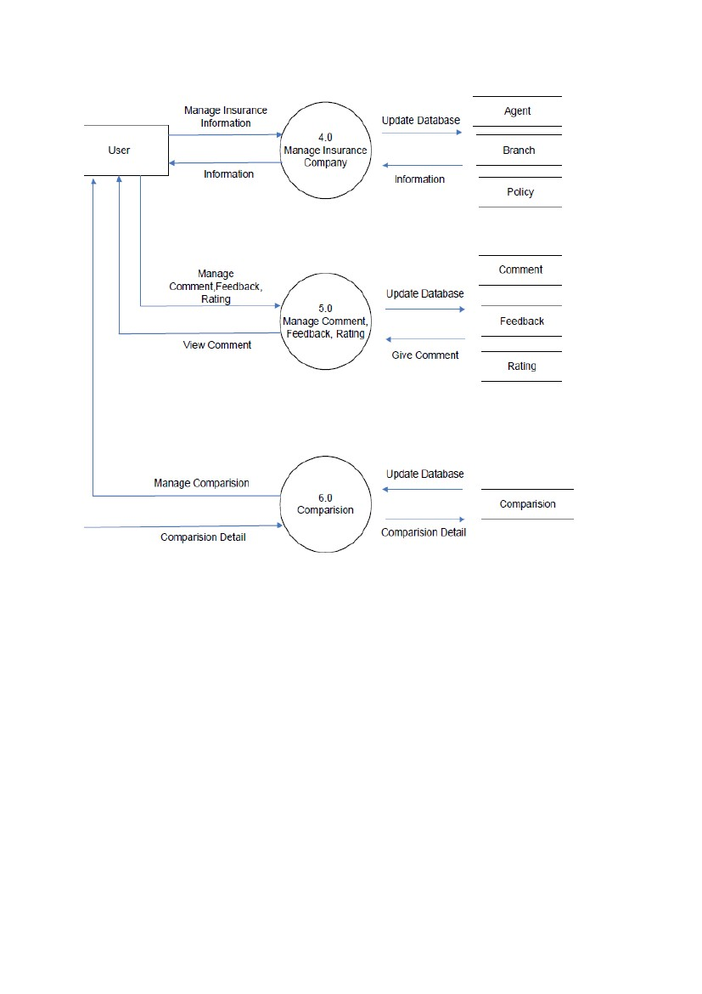

**LEVEL 1**

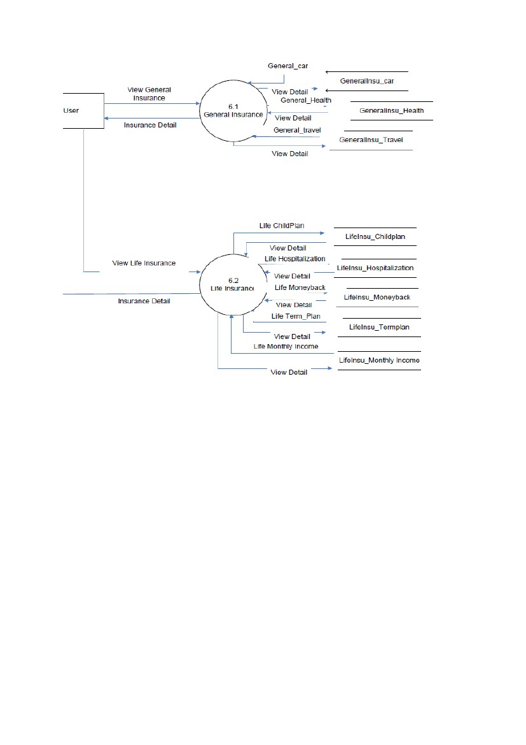

1. **Use case diagrams**

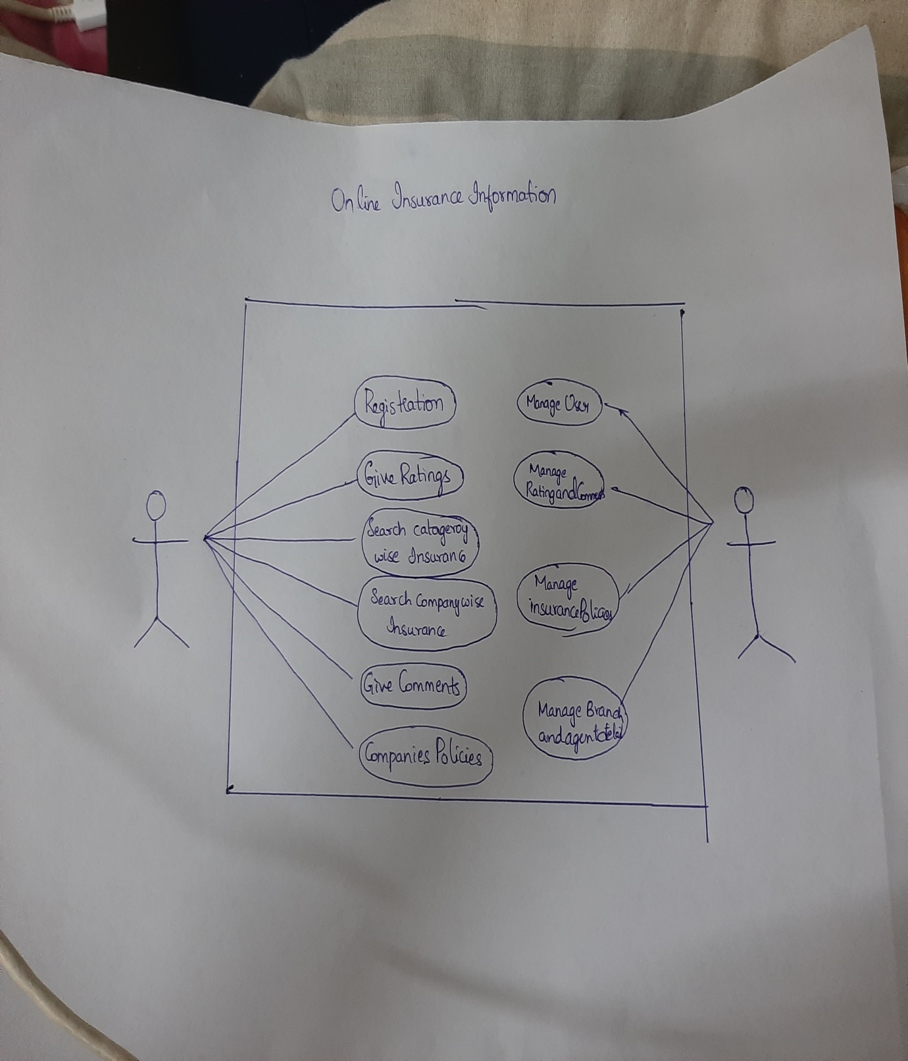

**TEST CASES:**

**Pre-condition: The user can also create or register an account through google or facebook.**

|  |  |  |  |
| --- | --- | --- | --- |
| **step** | **Action** | **Expected system response** | **Pass/**  **Fail** |
| **1.** | **Open login page** | **The systems asks user-id** | **pass** |
| **2.** | **Click on google** | **The systems asks G-mail** | **pass** |
| **3.** | **Enter the G-mail** | **The systems asks password** | **pass** |
| **4.** | **Enter the password** | **The system displays main menu** | **pass** |

**Pre-condition:**

**The user has to register an account in Policy Bazaar to make**

**Insurance in it. The system will display main menu after creating an account.**

|  |  |  |  |
| --- | --- | --- | --- |
| **Step** | **Action** | **Expected response** | **Pass/**  **Fail** |
| **1.** | **Click on application** | **The system displays login page** | **pass** |
| **2.** | **To create an account**  **Click/register** | **The system asks details of**  **user** | **pass** |
| **3.** | **Enter mobile number/G-mail** | **The system asks the OTP** | **pass** |
| **4.** | **Enter OTP** | **The system displays Home page** | **pass** |

**Pre-condition:**

**The user has to reset the password of his/her account in Policy Bazaar**

|  |  |  |  |
| --- | --- | --- | --- |
| **Step** | **Action** | **Expected response** | **Pass/**  **Fail** |
| **1.** | **Open Policy Bazaar** | **The system displays main menu** | **Pass** |
| **2.** | **Select the “my” button at bottom** | **The system displays main menu** | **Pass** |
| **3.** | **Select Profile and go click and reset pin** | **The system asks the OTP to phone** | **Pass** |
| **4.** | **Select OTP** | **The system asks new password.** | **Pass** |
| **5.** | **Enter new password** | **System displays main menu** | **Pass** |

**Pre-condition:**

**Making the insurance by the policy bazaar**

|  |  |  |  |
| --- | --- | --- | --- |
| **Step** | **Action** | **Expected response** | **Pass/**  **Fail** |
| **1.** | **Open Policy Bazaar** | **The system displays main menu** | **pass** |
| **2.** | **Enter the policy to be insured** | **Show list of available policies** | **pass** |
| **3.** | **Select the policy** | **Select the policy** | **pass** |
| **4.** | **Click on apply for the policy** | **Show the policy form** | **pass** |

**Pre-condition:**

**Investing through the policies**

|  |  |  |  |
| --- | --- | --- | --- |
| **Step** | **Action** | **Expected response** | **Pass/**  **Fail** |
| **1.** | **Click on Policy Bazaar** | **The system will show the main menu** | **pass** |
| **2.** | **Select invest option** | **It will shows a list of options and knowledge about that** | **pass** |
| **3.** | **Select mutual funds** | **Gives the brief description about the mutual funds.** | **pass** |
| **4.** | **Select invest now** | **It will shows the investment form** | **pass** |

***SRS documentation for:***

***POLICY BAZAAR***



**Submitted By: K D S HARSHA**

**Regno: 11803788,K18QW**

**Submitted to: Manpreet Dhindsa..**