**AI Lab Report**



***Submitted by***

**DINESH KUMAR G (1BM20CS043)**

**Batch: B3**

**Course: Artificial Intelligence**

**Course Code: 20CS5PCAIP**

**Sem & Section: 5A**

**BACHELOR OF ENGINEERING**

***in***

**COMPUTER SCIENCE AND ENGINEERING**



**B. M. S. COLLEGE OF ENGINEERING**

**(Autonomous Institution under VTU)**

**BENGALURU-560019**

**2022-2023**

**Lab-Program-1**

**Objective: Implement Tic –Tac –Toe Game.**

**Code:**

def printBoard(board):

print(board[1] + '|' + board[2] + '|' + board[3])

print('-+-+-')

print(board[4] + '|' + board[5] + '|' + board[6])

print('-+-+-')

print(board[7] + '|' + board[8] + '|' + board[9])

print("\n")

def spaceIsFree(position):

if board[position] == ' ':

return True

else:

return False

def insertLetter(letter, position):

if spaceIsFree(position):

board[position] = letter

printBoard(board)

if (checkDraw()):

print("Draw!")

exit()

if checkForWin():

if letter == 'X':

print("Bot wins!")

exit()

else:

print("Player wins!")

exit()

return

else:

print("Can't insert there!")

position = int(input("Please enter new position: "))

insertLetter(letter, position)

return

def checkForWin():

if (board[1] == board[2] and board[1] == board[3] and board[1] != ' '):

return True

elif (board[4] == board[5] and board[4] == board[6] and board[4] != ' '):

return True

elif (board[7] == board[8] and board[7] == board[9] and board[7] != ' '):

return True

elif (board[1] == board[4] and board[1] == board[7] and board[1] != ' '):

return True

elif (board[2] == board[5] and board[2] == board[8] and board[2] != ' '):

return True

elif (board[3] == board[6] and board[3] == board[9] and board[3] != ' '):

return True

elif (board[1] == board[5] and board[1] == board[9] and board[1] != ' '):

return True

elif (board[7] == board[5] and board[7] == board[3] and board[7] != ' '):

return True

else:

return False

def checkWhichMarkWon(mark):

if board[1] == board[2] and board[1] == board[3] and board[1] == mark:

return True

elif (board[4] == board[5] and board[4] == board[6] and board[4] == mark):

return True

elif (board[7] == board[8] and board[7] == board[9] and board[7] == mark):

return True

elif (board[1] == board[4] and board[1] == board[7] and board[1] == mark):

return True

elif (board[2] == board[5] and board[2] == board[8] and board[2] == mark):

return True

elif (board[3] == board[6] and board[3] == board[9] and board[3] == mark):

return True

elif (board[1] == board[5] and board[1] == board[9] and board[1] == mark):

return True

elif (board[7] == board[5] and board[7] == board[3] and board[7] == mark):

return True

else:

return False

def checkDraw():

for key in board.keys():

if (board[key] == ' '):

return False

return True

def playerMove():

position = int(input("Enter the position for 'O': "))

insertLetter(player, position)

return

def compMove():

bestScore = -800

bestMove = 0

for key in board.keys():

if (board[key] == ' '):

board[key] = bot

score = minimax(board, 0, False)

board[key] = ' '

if (score > bestScore):

bestScore = score

bestMove = key

insertLetter(bot, bestMove)

return

def minimax(board, depth, isMaximizing):

if (checkWhichMarkWon(bot)):

return 1

elif (checkWhichMarkWon(player)):

return -1

elif (checkDraw()):

return 0

if (isMaximizing):

bestScore = -800

for key in board.keys():

if (board[key] == ' '):

board[key] = bot

score = minimax(board, depth + 1, False)

board[key] = ' '

if (score > bestScore):

bestScore = score

return bestScore

else:

bestScore = 800

for key in board.keys():

if (board[key] == ' '):

board[key] = player

score = minimax(board, depth + 1, True)

board[key] = ' '

if (score < bestScore):

bestScore = score

return bestScore

board = {1: ' ', 2: ' ', 3: ' ',

4: ' ', 5: ' ', 6: ' ',

7: ' ', 8: ' ', 9: ' '}

printBoard(board)

print("Computer goes first! Good luck.")

print("Positions are as follow:")

print("1, 2, 3 ")

print("4, 5, 6 ")

print("7, 8, 9 ")

print("\n")

player = 'O'

bot = 'X'

global firstComputerMove

firstComputerMove = True

while not checkForWin():

compMove()

playerMove()

**State Space Diagram:**

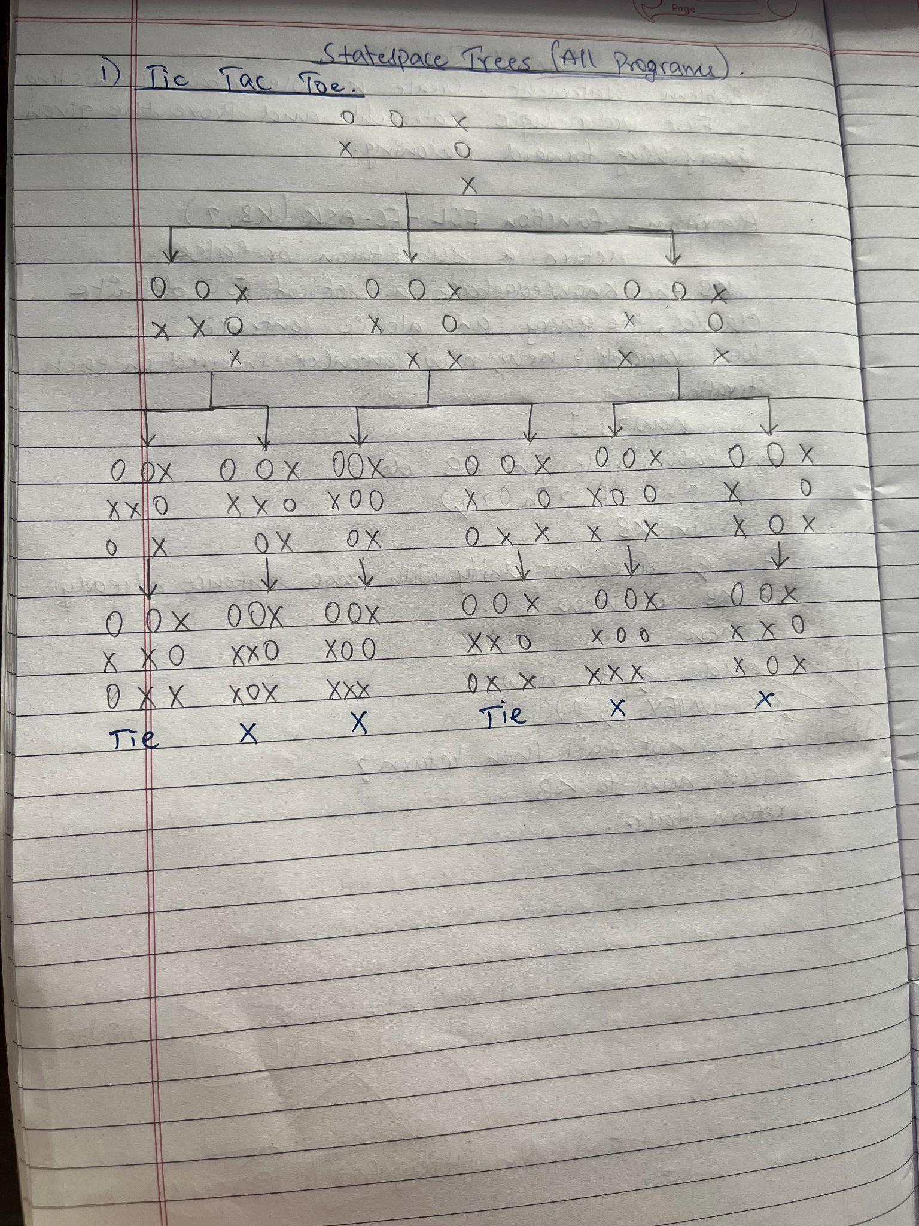

**Output :**

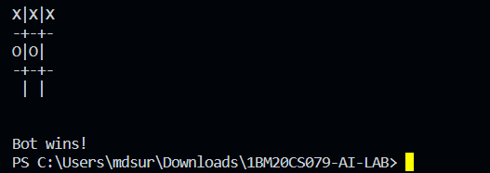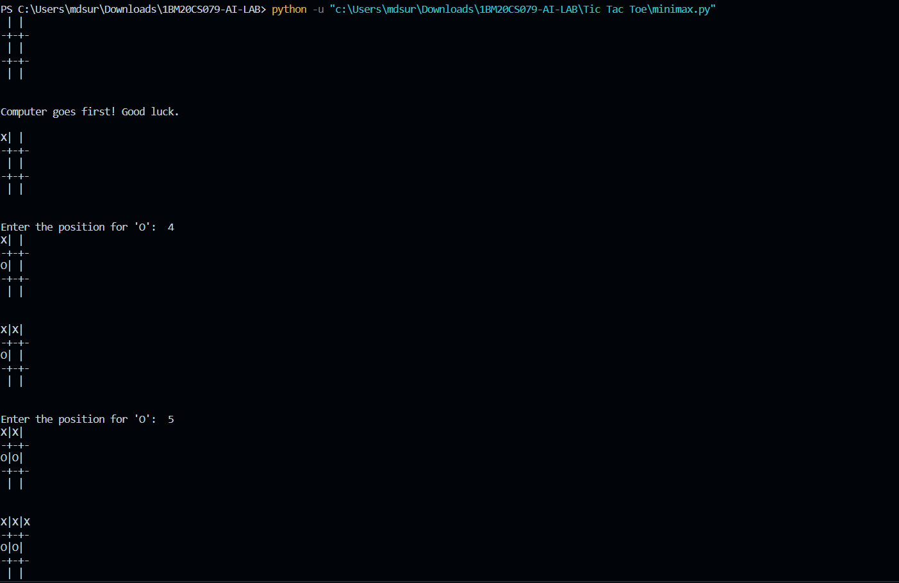

**Lab-Program-2**

**Objective: Solve 8 puzzle problem.**

**Code:**

from queue import Queue

class Puzzle:

goal_state=[1,2,3,5,8,6,0,7,4]

heuristic=None

evaluation_function=None

num_of_instances=0

def __init__(self,state,parent,action,path_cost):

self.parent=parent

self.state=state

self.action=action

if parent:

self.path_cost = parent.path_cost + path_cost

else:

self.path_cost = path_cost

Puzzle.num_of_instances+=1

def __str__(self):

return str(self.state[0:3])+'\n'+str(self.state[3:6])+'\n'+str(self.state[6:9])

def goal_test(self):

if self.state == self.goal_state:

return True

return False

@staticmethod

def find_legal_actions(i,j):

legal_action = ['U', 'D', 'L', 'R']

if i == 0: # up is disable

legal_action.remove('U')

elif i == 2: # down is disable

legal_action.remove('D')

if j == 0:

legal_action.remove('L')

elif j == 2:

legal_action.remove('R')

return legal_action

def generate_child(self):

children=[]

x = self.state.index(0)

i = int(x / 3)

j = int(x % 3)

legal_actions=self.find_legal_actions(i,j)

for action in legal_actions:

new_state = self.state.copy()

if action == 'U':

new_state[x], new_state[x-3] = new_state[x-3], new_state[x]

elif action == 'D':

new_state[x], new_state[x+3] = new_state[x+3], new_state[x]

elif action == 'L':

new_state[x], new_state[x-1] = new_state[x-1], new_state[x]

elif action == 'R':

new_state[x], new_state[x+1] = new_state[x+1], new_state[x]

children.append(Puzzle(new_state,self,action,1))

return children

def find_solution(self):

solution = []

solution.append(self.action)

path = self

while path.parent != None:

path = path.parent

solution.append(path.action)

solution = solution[:-1]

solution.reverse()

return solution

def breadth_first_search(initial_state):

start_node = Puzzle(initial_state, None, None, 0)

if start_node.goal_test():

return start_node.find_solution()

q = Queue()

q.put(start_node)

explored=[]

while not(q.empty()):

node=q.get()

explored.append(node.state)

children=node.generate_child()

for child in children:

if child.state not in explored:

node.__str__()

if child.goal_test():

return child.find_solution()

q.put(child)

return

state = [1, 2, 3,

5, 6, 0,

7, 8, 4]

Puzzle.num_of_instances=0

bfs=breadth_first_search(state)

print('BFS:', bfs)

print('space:',Puzzle.num_of_instances)

print()

**State Space Tree:**

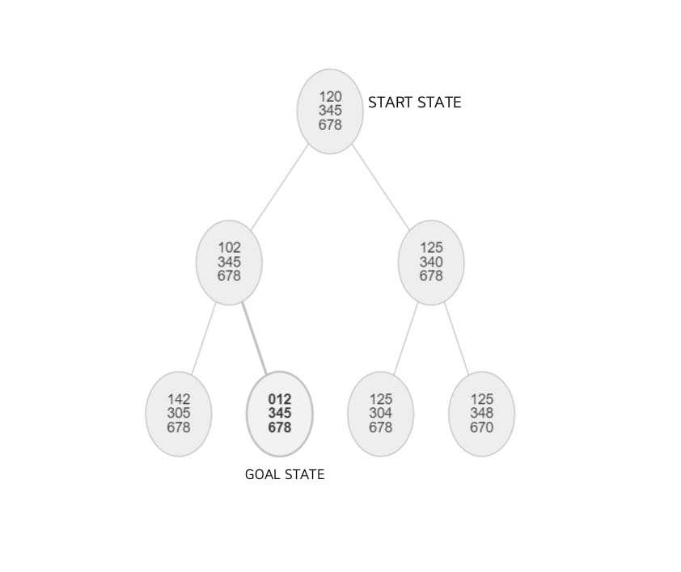

**Output :**



**Lab-Program-3**

**Objective: Implement Iterative deepening search algorithm.**

**Code:**

import itertools

import random

import time

def id_dfs(puzzle, goal, get_moves):

def idfs(path, depth):

if depth == 0:

return

if path[-1] == goal:

return path

for move in get_moves(path[-1]):

if move not in path:

next_path = idfs(path + [move], depth - 1)

if next_path:

#print(next_path, end="")

return next_path

for depth in itertools.count():

path = idfs([puzzle], depth)

if path:

#print(path)

return path

def num_matrix(rows, cols, steps=25):

nums = list(range(1, rows * cols)) + [0]

goal = [ nums[i:i+rows] for i in range(0, len(nums), rows) ]

get_moves = num_moves(rows, cols)

puzzle = goal

for steps in range(steps):

puzzle = random.choice(get_moves(puzzle))

return puzzle, goal

def num_moves(rows, cols):

def get_moves(subject):

moves = []

zrow, zcol = next((r, c)

for r, l in enumerate(subject)

for c, v in enumerate(l) if v == 0)

def swap(row, col):

import copy

s = copy.deepcopy(subject)

s[zrow][zcol], s[row][col] = s[row][col], s[zrow][zcol]

return s

if zrow > 0:

moves.append(swap(zrow - 1, zcol))

if zcol < cols - 1:

moves.append(swap(zrow, zcol + 1))

if zrow < rows - 1:

moves.append(swap(zrow + 1, zcol))

if zcol > 0:

moves.append(swap(zrow, zcol - 1))

return moves

return get_moves

if __name__ == '__main__':

reps = 25

total_time = 0

for i in range(reps):

puzzle = [[1,2,3],[4,0,6],[7,5,8]]

goal = [[1,2,3],[4,5,6],[7,8,0]]

puzzle,goal = num_matrix(3,3)

t0 = time.time()

solution = id_dfs(puzzle, goal, num_moves(3, 3))

t1 = time.time()

total_time += t1 - t0

total_time /= reps

print("Goal State: ")

for i in goal:

print(i, end="\n")

print("Starting State: ")

for i in puzzle:

print(i, end="\n")

print("Solution: ")

for i in solution:

print("")

print(" | ")

print(" | ")

print(" \\\'/ \n")

for j in i:

print(j)

print('Puzzle solved using iterative depth first search in', total_time, 'seconds.') # 0.20 seconds

**State Space Tree:**

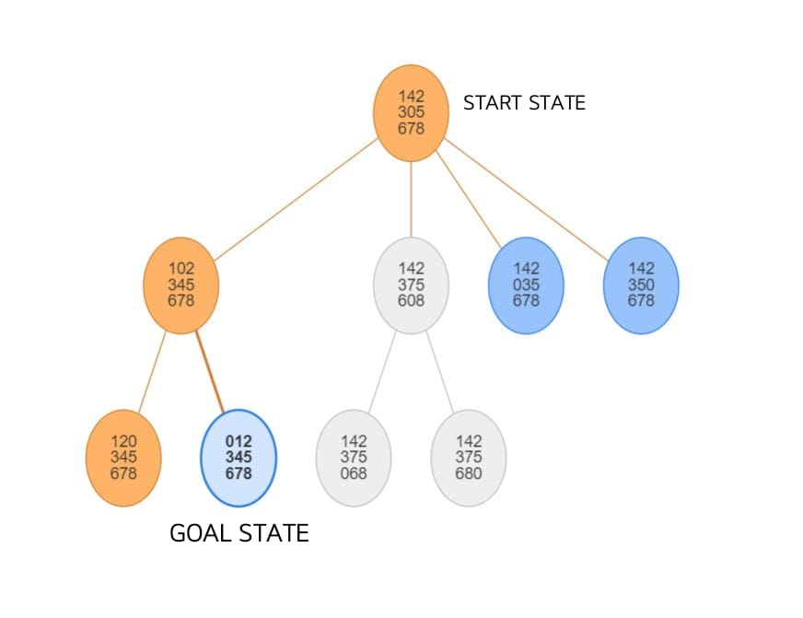

**Output :**

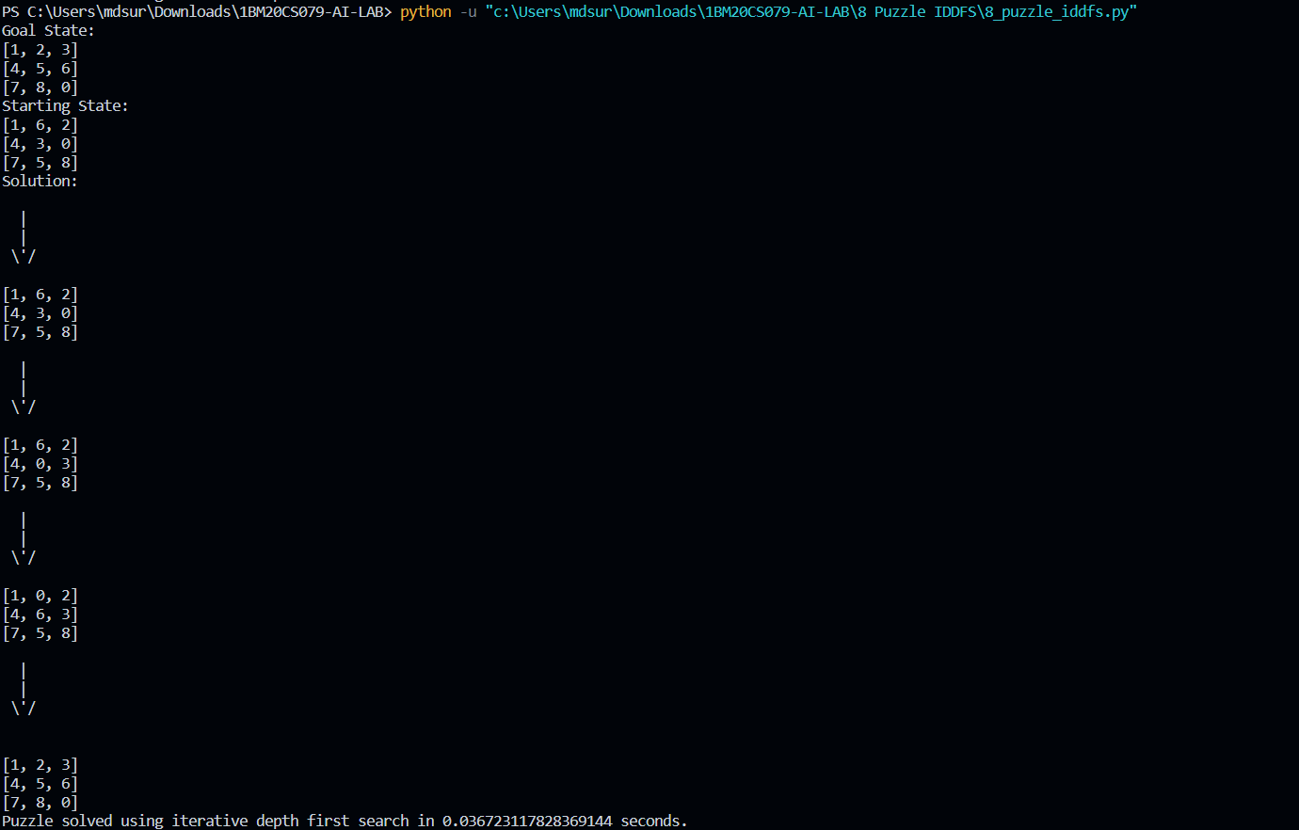

**Lab-Program-4**

**Objective: Implement A* search algorithm.**

**Code:**

class Node:

def __init__(self,data,level,fval):

self.data = data

self.level = level

self.fval = fval

def generate_child(self):

x,y = self.find(self.data,'_')

val_list = [[x,y-1],[x,y+1],[x-1,y],[x+1,y]]

children = []

for i in val_list:

child = self.shuffle(self.data,x,y,i[0],i[1])

if child is not None:

child_node = Node(child,self.level+1,0)

children.append(child_node)

return children

def shuffle(self,puz,x1,y1,x2,y2):

if x2 >= 0 and x2 < len(self.data) and y2 >= 0 and y2 < len(self.data):

temp_puz = []

temp_puz = self.copy(puz)

temp = temp_puz[x2][y2]

temp_puz[x2][y2] = temp_puz[x1][y1]

temp_puz[x1][y1] = temp

return temp_puz

else:

return None

def copy(self,root):

temp = []

for i in root:

t = []

for j in i:

t.append(j)

temp.append(t)

return temp

def find(self,puz,x):

for i in range(0,len(self.data)):

for j in range(0,len(self.data)):

if puz[i][j] == x:

return i,j

class Puzzle:

def __init__(self,size):

self.n = size

self.open = []

self.closed = []

def accept(self):

puz = []

for i in range(0,self.n):

temp = input().split(" ")

puz.append(temp)

return puz

def f(self,start,goal):

return self.h(start.data,goal)+start.level

def h(self,start,goal):

temp = 0

for i in range(0,self.n):

for j in range(0,self.n):

if start[i][j] != goal[i][j] and start[i][j] != '_':

temp += 1

return temp

def process(self):

print("Enter the start state matrix \n")

start = self.accept()

print("Enter the goal state matrix \n")

goal = self.accept()

start = Node(start,0,0)

start.fval = self.f(start,goal)

self.open.append(start)

while True:

cur = self.open[0]

print("")

print(" | ")

print(" | ")

print(" \\\'/ \n")

for i in cur.data:

for j in i:

print(j,end=" ")

print("")

if(self.h(cur.data,goal) == 0):

break

for i in cur.generate_child():

i.fval = self.f(i,goal)

self.open.append(i)

self.closed.append(cur)

del self.open[0]

""" sort the opne list based on f value """

self.open.sort(key = lambda x:x.fval,reverse=False)

puz = Puzzle(3)

puz.process()

**State Space Tree:**

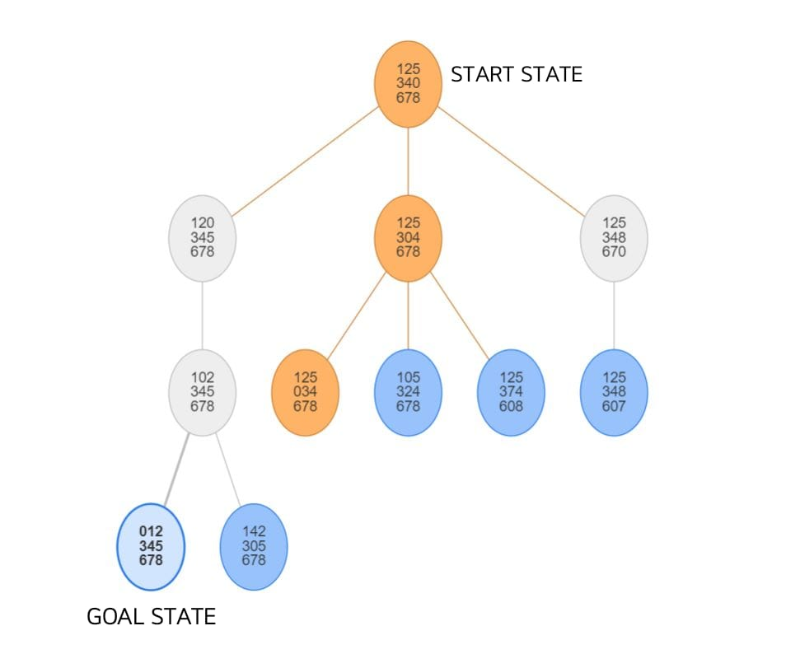

**Output :**

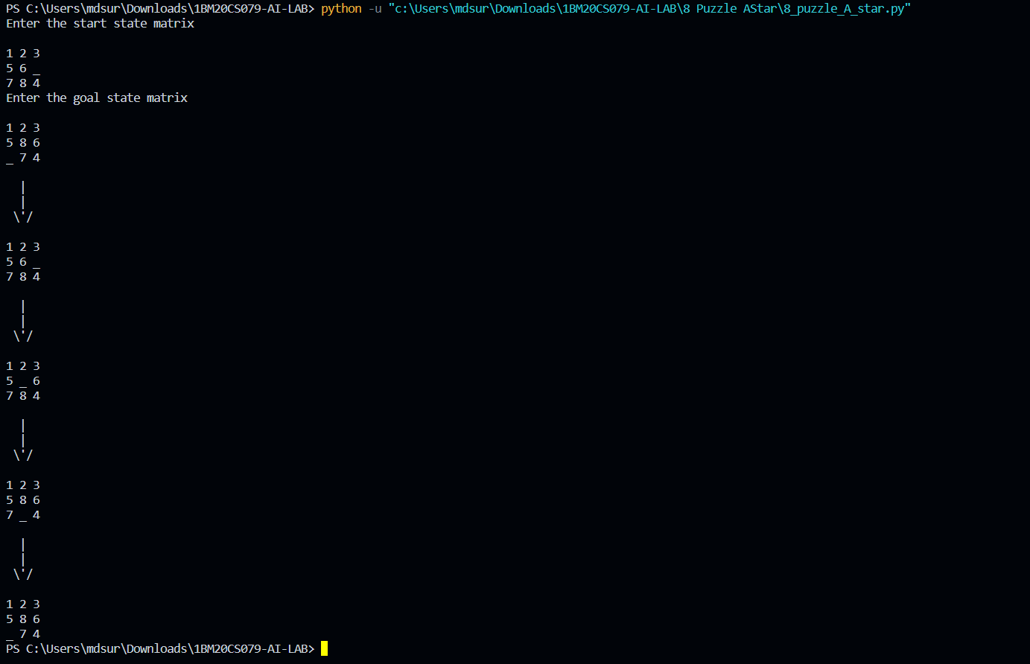

**Lab-Program-5**

**Objective: Implement vacuum cleaner agent.**

**Code**

def vacuum_world():

goal_state = {'A': '0', 'B': '0'}

cost = 0

actions = []

location_input = input("Enter Location of Vacuum: ")

status_input = input("Enter status of " + location_input + ": ")

status_input_complement = input("Enter status of other room: ")

print("Initial Location Condition" + str(goal_state))

if location_input == 'A':

location_complement = 'B'

else:

location_complement = 'A'

if status_input == '1':

actions.append("Suck at Location "+location_input)

goal_state[location_input] = '0'

cost += 1

actions.append("Move to Location "+location_complement)

if status_input_complement == '1':

cost += 1

actions.append("Suck at Location "+location_complement)

goal_state[location_complement] = '0'

cost += 1

if status_input == '0':

actions.append("Move to Location "+location_complement)

if status_input_complement == '1':

actions.append("Suck at Location "+location_complement)

cost += 1

goal_state[location_complement] = '0'

cost += 1

print("GOAL STATE: ")

print(goal_state)

print("Actions Taken are: ")

for var in actions:

print(var)

print("Performance Measurement: " + str(cost))

vacuum_world()

**State Space Tree:**

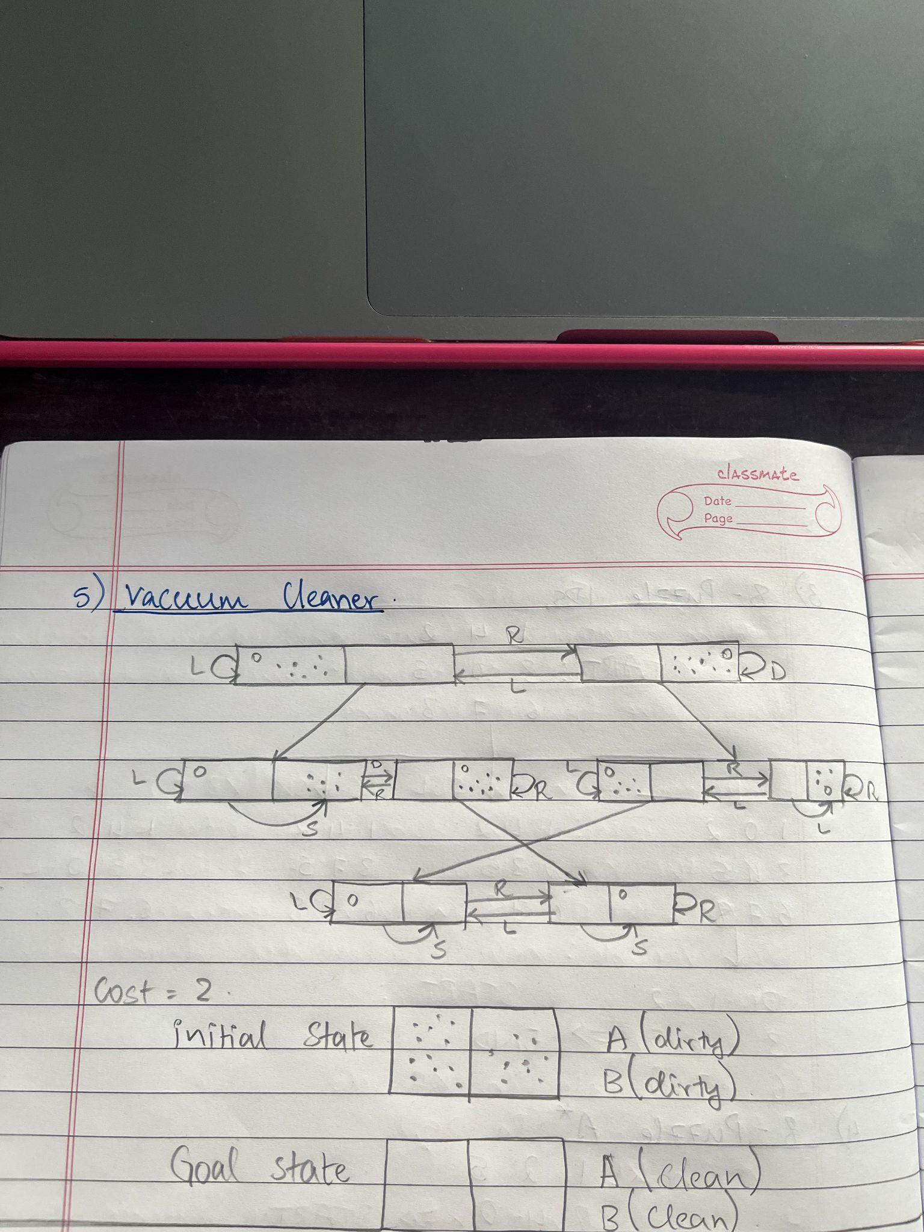

**Output :**

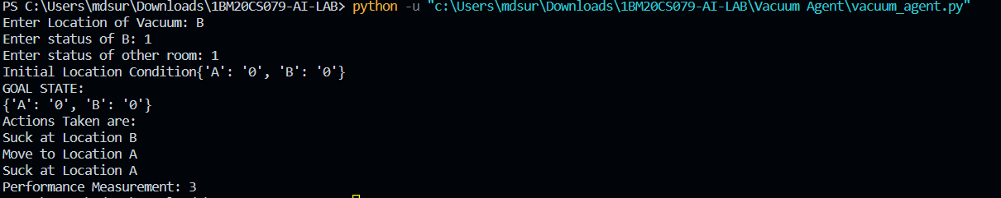

**Lab-Program-6**

**Objective: Create a knowledgebase using prepositional logic and show that the given query entails the knowledge base or not.**

**Code:**

combinations=[(True,True, True),(True,True,False),(True,False,True),(True,False, False),(False,True, True),(False,True, False),(False, False,True),(False,False, False)]

variable={'p':0,'q':1, 'r':2}

kb=''

q=''

priority={'~':3,'v':1,'^':2}

def input_rules():

global kb, q

kb = (input("Enter rule: "))

q = input("Enter the Query: ")

def entailment():

global kb, q

print('*'*10+"Truth Table Reference"+'*'*10)

print('kb','alpha')

print('*'*10)

for comb in combinations:

s = evaluatePostfix(toPostfix(kb), comb)

f = evaluatePostfix(toPostfix(q), comb)

print(s, f)

print('-'*10)

if s and not f:

return False

return True

def isOperand(c):

return c.isalpha() and c!='v'

def isLeftParanthesis(c):

return c == '('

def isRightParanthesis(c):

return c == ')'

def isEmpty(stack):

return len(stack) == 0

def peek(stack):

return stack[-1]

def hasLessOrEqualPriority(c1, c2):

try:

return priority[c1]<=priority[c2]

except KeyError:

return False

def toPostfix(infix):

stack = []

postfix = ''

for c in infix:

if isOperand(c):

postfix += c

else:

if isLeftParanthesis(c):

stack.append(c)

elif isRightParanthesis(c):

operator = stack.pop()

while not isLeftParanthesis(operator):

postfix += operator

operator = stack.pop()

else:

while (not isEmpty(stack)) and hasLessOrEqualPriority(c, peek(stack)):

postfix += stack.pop()

stack.append(c)

while (not isEmpty(stack)):

postfix += stack.pop()

return postfix

def evaluatePostfix(exp, comb):

stack = []

for i in exp:

if isOperand(i):

stack.append(comb[variable[i]])

elif i == '~':

val1 = stack.pop()

stack.append(not val1)

else:

val1 = stack.pop()

val2 = stack.pop()

stack.append(_eval(i,val2,val1))

return stack.pop()

def _eval(i, val1, val2):

if i == '^':

return val2 and val1

return val2 or val1

input_rules()

ans = entailment()

if ans:

print("The Knowledge Base entails query")

else:

print("The Knowledge Base does not entail query")

**Output :**

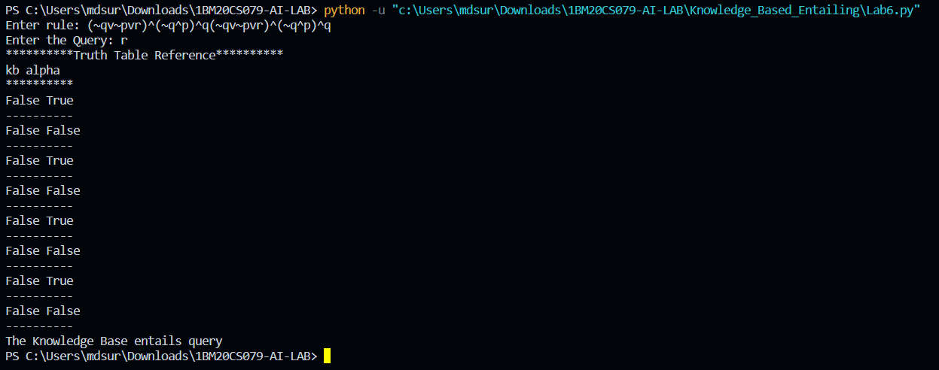

**Lab-Program-7**

**Objective: Create a knowledgebase using prepositional logic and prove the**

**given query using resolution**

**Code:**

kb = []

# Reset kb to an empty list

def CLEAR():

global kb

kb = []

# Insert sentence to the kb

def TELL(sentence):

global kb

# If the sentence is a clause, insert directly.

if isClause(sentence):

kb.append(sentence)

# If not, convert to CNF, and then insert clauses one by one.

else:

sentenceCNF = convertCNF(sentence)

if not sentenceCNF:

print("Illegal input")

return

# Insert clauses one by one when there are multiple clauses

if isAndList(sentenceCNF):

for s in sentenceCNF[1:]:

kb.append(s)

else:

kb.append(sentenceCNF)

# 'ASK' the kb whether a sentence is True or not

def ASK(sentence):

global kb

# Negate the sentence, and convert it to CNF accordingly.

if isClause(sentence):

neg = negation(sentence)

else:

sentenceCNF = convertCNF(sentence)

if not sentenceCNF:

print("Illegal input")

return

neg = convertCNF(negation(sentenceCNF))

# Insert individual clauses that we need to ask to ask_list.

ask_list = []

if isAndList(neg):

for n in neg[1:]:

nCNF = makeCNF(n)

if type(nCNF).__name__ == 'list':

ask_list.insert(0, nCNF)

else:

ask_list.insert(0, nCNF)

else:

ask_list = [neg]

# Create a new list combining the asked sentence and kb.

# Resolution will happen between the items in the list.

clauses = ask_list + kb[:]

# Recursivly conduct resoltion between items in the clauses list

# until it produces an empty list or there's no more pregress.

while True:

new_clauses = []

for c1 in clauses:

for c2 in clauses:

if c1 is not c2:

resolved = resolve(c1, c2)

if resolved == False:

continue

if resolved == []:

return True

new_clauses.append(resolved)

if len(new_clauses) == 0:

return False

new_in_clauses = True

for n in new_clauses:

if n not in clauses:

new_in_clauses = False

clauses.append(n)

if new_in_clauses:

return False

return False

# Conduct resolution on two CNF clauses.

def resolve(arg_one, arg_two):

resolved = False

s1 = make_sentence(arg_one)

s2 = make_sentence(arg_two)

resolve_s1 = None

resolve_s2 = None

# Two for loops that iterate through the two clauses.

for i in s1:

if isNotList(i):

a1 = i[1]

a1_not = True

else:

a1 = i

a1_not = False

for j in s2:

if isNotList(j):

a2 = j[1]

a2_not = True

else:

a2 = j

a2_not = False

# cancel out two literals such as 'a' $ ['not', 'a']

if a1 == a2:

if a1_not != a2_not:

# Return False if resolution already happend

# but contradiction still exists.

if resolved:

return False

else:

resolved = True

resolve_s1 = i

resolve_s2 = j

break

# Return False if not resolution happened

if not resolved:

return False

# Remove the literals that are canceled

s1.remove(resolve_s1)

s2.remove(resolve_s2)

# # Remove duplicates

result = clear_duplicate(s1 + s2)

# Format the result.

if len(result) == 1:

return result[0]

elif len(result) > 1:

result.insert(0, 'or')

return result

# Prepare sentences for resolution.

def make_sentence(arg):

if isLiteral(arg) or isNotList(arg):

return [arg]

if isOrList(arg):

return clear_duplicate(arg[1:])

return

# Clear out duplicates in a sentence.

def clear_duplicate(arg):

result = []

for i in range(0, len(arg)):

if arg[i] not in arg[i+1:]:

result.append(arg[i])

return result

# Check whether a sentence is a legal CNF clause.

def isClause(sentence):

if isLiteral(sentence):

return True

if isNotList(sentence):

if isLiteral(sentence[1]):

return True

else:

return False

if isOrList(sentence):

for i in range(1, len(sentence)):

if len(sentence[i]) > 2:

return False

elif not isClause(sentence[i]):

return False

return True

return False

# Check if a sentence is a legal CNF.

def isCNF(sentence):

if isClause(sentence):

return True

elif isAndList(sentence):

for s in sentence[1:]:

if not isClause(s):

return False

return True

return False

# Negate a sentence.

def negation(sentence):

if isLiteral(sentence):

return ['not', sentence]

if isNotList(sentence):

return sentence[1]

# DeMorgan:

if isAndList(sentence):

result = ['or']

for i in sentence[1:]:

if isNotList(sentence):

result.append(i[1])

else:

result.append(['not', sentence])

return result

if isOrList(sentence):

result = ['and']

for i in sentence[:]:

if isNotList(sentence):

result.append(i[1])

else:

result.append(['not', i])

return result

return None

# Convert a sentence into CNF.

def convertCNF(sentence):

while not isCNF(sentence):

if sentence is None:

return None

sentence = makeCNF(sentence)

return sentence

# Help make a sentence into CNF.

def makeCNF(sentence):

if isLiteral(sentence):

return sentence

if (type(sentence).__name__ == 'list'):

operand = sentence[0]

if isNotList(sentence):

if isLiteral(sentence[1]):

return sentence

cnf = makeCNF(sentence[1])

if cnf[0] == 'not':

return makeCNF(cnf[1])

if cnf[0] == 'or':

result = ['and']

for i in range(1, len(cnf)):

result.append(makeCNF(['not', cnf[i]]))

return result

if cnf[0] == 'and':

result = ['or']

for i in range(1, len(cnf)):

result.append(makeCNF(['not', cnf[i]]))

return result

return "False: not"

# Implication Elimination:

if operand == 'implies' and len(sentence) == 3:

return makeCNF(['or', ['not', makeCNF(sentence[1])], makeCNF(sentence[2])])

# Biconditional Elimination:

if operand == 'biconditional' and len(sentence) == 3:

s1 = makeCNF(['implies', sentence[1], sentence[2]])

s2 = makeCNF(['implies', sentence[2], sentence[1]])

return makeCNF(['and', s1, s2])

if isAndList(sentence):

result = ['and']

for i in range(1, len(sentence)):

cnf = makeCNF(sentence[i])

# Distributivity:

if isAndList(cnf):

for i in range(1, len(cnf)):

result.append(makeCNF(cnf[i]))

continue

result.append(makeCNF(cnf))

return result

if isOrList(sentence):

result1 = ['or']

for i in range(1, len(sentence)):

cnf = makeCNF(sentence[i])

# Distributivity:

if isOrList(cnf):

for i in range(1, len(cnf)):

result1.append(makeCNF(cnf[i]))

continue

result1.append(makeCNF(cnf))

# Associativity:

while True:

result2 = ['and']

and_clause = None

for r in result1:

if isAndList(r):

and_clause = r

break

# Finish when there's no more 'and' lists

# inside of 'or' lists

if not and_clause:

return result1

result1.remove(and_clause)

for i in range(1, len(and_clause)):

temp = ['or', and_clause[i]]

for o in result1[1:]:

temp.append(makeCNF(o))

result2.append(makeCNF(temp))

result1 = makeCNF(result2)

return None

return None

# Below are 4 functions that check the type of a variable

def isLiteral(item):

if type(item).__name__ == 'str':

return True

return False

def isNotList(item):

if type(item).__name__ == 'list':

if len(item) == 2:

if item[0] == 'not':

return True

return False

def isAndList(item):

if type(item).__name__ == 'list':

if len(item) > 2:

if item[0] == 'and':

return True

return False

def isOrList(item):

if type(item).__name__ == 'list':

if len(item) > 2:

if item[0] == 'or':

return True

return False

if __name__ == "__main__":

CLEAR()

print("Test 1")

TELL(['implies', 'p', 'q'])

TELL(['implies', 'r', 's'])

ASK(['implies',['or','p','r'], ['or', 'q', 's']])

CLEAR()

print("Test 2")

TELL('p')

TELL(['implies',['and','p','q'],'r'])

TELL(['implies',['or','s','t'],'q'])

TELL('t')

ASK('r')

CLEAR()

print("Test 3")

TELL('a')

TELL('b')

TELL('c')

TELL('d')

ASK(['or', 'a', 'b', 'c', 'd'])

CLEAR()

print("Test 4")

TELL('a')

TELL('b')

TELL(['or', ['not', 'a'], 'b'])

TELL(['or', 'c', 'd'])

TELL('d')

ASK('c')

**Output :**

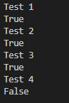

**Lab-Program-8**

**Objective: Implement unification in first order logic**

**Code:**

import re

def getAttributes(expression):

expression = expression.split("(")[1:]

expression = "(".join(expression)

expression = expression.split(")")[:-1]

expression = ")".join(expression)

attributes = expression.split(',')

return attributes

def getInitialPredicate(expression):

return expression.split("(")[0]

def isConstant(char):

return char.isupper() and len(char) == 1

def isVariable(char):

return char.islower() and len(char) == 1

def replaceAttributes(exp, old, new):

attributes = getAttributes(exp)

predicate = getInitialPredicate(exp)

for index, val in enumerate(attributes):

if val == old:

attributes[index] = new

return predicate + "(" + ",".join(attributes) + ")"

def apply(exp, substitutions):

for substitution in substitutions:

new, old = substitution

exp = replaceAttributes(exp, old, new)

return exp

def checkOccurs(var, exp):

if exp.find(var) == -1:

return False

return True

def getFirstPart(expression):

attributes = getAttributes(expression)

return attributes[0]

def getRemainingPart(expression):

predicate = getInitialPredicate(expression)

attributes = getAttributes(expression)

newExpression = predicate + "(" + ",".join(attributes[1:]) + ")"

return newExpression

def unify(exp1, exp2):

if exp1 == exp2:

return []

if isConstant(exp1) and isConstant(exp2):

if exp1 != exp2:

print(f"{exp1} and {exp2} are constants. Cannot be unified")

return []

if isConstant(exp1):

return [(exp1, exp2)]

if isConstant(exp2):

return [(exp2, exp1)]

if isVariable(exp1):

return [(exp2, exp1)] if not checkOccurs(exp1, exp2) else []

if isVariable(exp2):

return [(exp1, exp2)] if not checkOccurs(exp2, exp1) else []

if getInitialPredicate(exp1) != getInitialPredicate(exp2):

print("Cannot be unified as the predicates do not match!")

return []

attributeCount1 = len(getAttributes(exp1))

attributeCount2 = len(getAttributes(exp2))

if attributeCount1 != attributeCount2:

print(f"Length of attributes {attributeCount1} and {attributeCount2} do not match. Cannot be unified")

return []

head1 = getFirstPart(exp1)

head2 = getFirstPart(exp2)

initialSubstitution = unify(head1, head2)

if not initialSubstitution:

return []

if attributeCount1 == 1:

return initialSubstitution

tail1 = getRemainingPart(exp1)

tail2 = getRemainingPart(exp2)

if initialSubstitution != []:

tail1 = apply(tail1, initialSubstitution)

tail2 = apply(tail2, initialSubstitution)

remainingSubstitution = unify(tail1, tail2)

if not remainingSubstitution:

return []

return initialSubstitution + remainingSubstitution

def main():

print("Enter the first expression")

e1 = input()

print("Enter the second expression")

e2 = input()

substitutions = unify(e1, e2)

print("The substitutions are:")

print([' / '.join(substitution) for substitution in substitutions])

main()

**Output :**

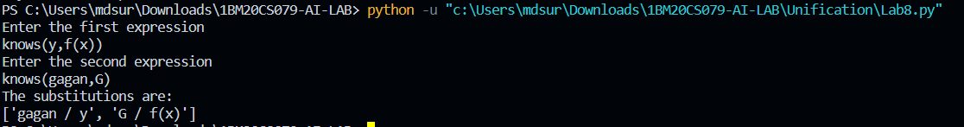

**Lab-Program-9**

**Objective: Create a knowledgebase consisting of first order logic statements**

**and prove the given query using forward reasoning.**

**Code:**

import re

def getAttributes(string):

expr = '\([^)]+\)'

matches = re.findall(expr, string)

return [m for m in str(matches) if m.isalpha()]

def getPredicates(string):

expr = '[a-z~]+\([A-Za-z,]+\)'

return re.findall(expr, string)

def DeMorgan(sentence):

string = ''.join(list(sentence).copy())

string = string.replace('~~','')

flag = '[' in string

string = string.replace('~[','')

string = string.strip(']')

for predicate in getPredicates(string):

string = string.replace(predicate, f'~{predicate}')

s = list(string)

for i, c in enumerate(string):

if c == 'V':

s[i] = '^'

elif c == '^':

s[i] = 'V'

string = ''.join(s)

string = string.replace('~~','')

return f'[{string}]' if flag else string

def Skolemization(sentence):

SKOLEM_CONSTANTS = [f'{chr(c)}' for c in range(ord('A'), ord('Z')+1)]

statement = ''.join(list(sentence).copy())

matches = re.findall('[∀∃].', statement)

for match in matches[::-1]:

statement = statement.replace(match, '')

statements = re.findall('\[\[[^]]+\]]', statement)

for s in statements:

statement = statement.replace(s, s[1:-1])

for predicate in getPredicates(statement):

attributes = getAttributes(predicate)

if ''.join(attributes).islower():

statement = statement.replace(match[1],SKOLEM_CONSTANTS.pop(0))

else:

aL = [a for a in attributes if a.islower()]

aU = [a for a in attributes if not a.islower()][0]

statement = statement.replace(aU, f'{SKOLEM_CONSTANTS.pop(0)}({aL[0] if len(aL) else match[1]})')

return statement

def fol_to_cnf(fol):

statement = fol.replace("<=>", "_")

while '_' in statement:

i = statement.index('_')

new_statement = '[' + statement[:i] + '=>' + statement[i+1:] + ']^['+ statement[i+1:] + '=>' + statement[:i] + ']'

statement = new_statement

statement = statement.replace("=>", "-")

expr = '\[([^]]+)\]'

statements = re.findall(expr, statement)

for i, s in enumerate(statements):

if '[' in s and ']' not in s:

statements[i] += ']'

for s in statements:

statement = statement.replace(s, fol_to_cnf(s))

while '-' in statement:

i = statement.index('-')

br = statement.index('[') if '[' in statement else 0

new_statement = '~' + statement[br:i] + 'V' + statement[i+1:]

statement = statement[:br] + new_statement if br > 0 else new_statement

while '~∀' in statement:

i = statement.index('~∀')

statement = list(statement)

statement[i], statement[i+1], statement[i+2] = '∃', statement[i+2], '~'

statement = ''.join(statement)

while '~∃' in statement:

i = statement.index('~∃')

s = list(statement)

s[i], s[i+1], s[i+2] = '∀', s[i+2], '~'

statement = ''.join(s)

statement = statement.replace('~[∀','[~∀')

statement = statement.replace('~[∃','[~∃')

expr = '(~[∀V∃].)'

statements = re.findall(expr, statement)

for s in statements:

statement = statement.replace(s, fol_to_cnf(s))

expr = '~\[[^]]+\]'

statements = re.findall(expr, statement)

for s in statements:

statement = statement.replace(s, DeMorgan(s))

return statement

def main():

print("Enter FOL:")

fol = input()

print("The CNF form of the given FOL is: ")

print(Skolemization(fol_to_cnf(fol)))

main()

**Output :**

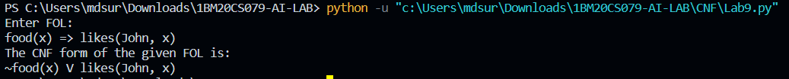

**Lab-Program-10**

**Objective: Create a knowledgebase consisting of first order logic statements**

**and prove the given query using forward reasoning.**

**Code:**

import re

def isVariable(x):

return len(x) == 1 and x.islower() and x.isalpha()

def getAttributes(string):

expr = '\([^)]+\)'

matches = re.findall(expr, string)

return matches

def getPredicates(string):

expr = '([a-z~]+)\([^&|]+\)'

return re.findall(expr, string)

class Fact:

def __init__(self, expression):

self.expression = expression

predicate, params = self.splitExpression(expression)

self.predicate = predicate

self.params = params

self.result = any(self.getConstants())

def splitExpression(self, expression):

predicate = getPredicates(expression)[0]

params = getAttributes(expression)[0].strip('()').split(',')

return [predicate, params]

def getResult(self):

return self.result

def getConstants(self):

return [None if isVariable(c) else c for c in self.params]

def getVariables(self):

return [v if isVariable(v) else None for v in self.params]

def substitute(self, constants):

c = constants.copy()

f = f"{self.predicate}({','.join([constants.pop(0) if isVariable(p) else p for p in self.params])})"

return Fact(f)

class Implication:

def __init__(self, expression):

self.expression = expression

l = expression.split('=>')

self.lhs = [Fact(f) for f in l[0].split('&')]

self.rhs = Fact(l[1])

def evaluate(self, facts):

constants = {}

new_lhs = []

for fact in facts:

for val in self.lhs:

if val.predicate == fact.predicate:

for i, v in enumerate(val.getVariables()):

if v:

constants[v] = fact.getConstants()[i]

new_lhs.append(fact)

predicate, attributes = getPredicates(self.rhs.expression)[0], str(getAttributes(self.rhs.expression)[0])

for key in constants:

if constants[key]:

attributes = attributes.replace(key, constants[key])

expr = f'{predicate}{attributes}'

return Fact(expr) if len(new_lhs) and all([f.getResult() for f in new_lhs]) else None

class KB:

def __init__(self):

self.facts = set()

self.implications = set()

def tell(self, e):

if '=>' in e:

self.implications.add(Implication(e))

else:

self.facts.add(Fact(e))

for i in self.implications:

res = i.evaluate(self.facts)

if res:

self.facts.add(res)

def query(self, e):

facts = set([f.expression for f in self.facts])

i = 1

print(f'Querying {e}:')

for f in facts:

if Fact(f).predicate == Fact(e).predicate:

print(f'\t{i}. {f}')

i += 1

def display(self):

print("All facts: ")

for i, f in enumerate(set([f.expression for f in self.facts])):

print(f'\t{i+1}. {f}')

def main():

kb = KB()

print("Enter KB: (enter e to exit)")

while True:

t = input()

if(t == 'e'):

break

kb.tell(t)

print("Enter Query:")

q = input()

kb.query(q)

kb.display()

main()

**Output :**

