ExNo:1 //TO PRINT MY NAME

PROGRAM:

<html>

<body>

<?php

echo"WELCOME MR.DINESH KUMAR..M";

?>

</body>

</html>

OUTPUT:

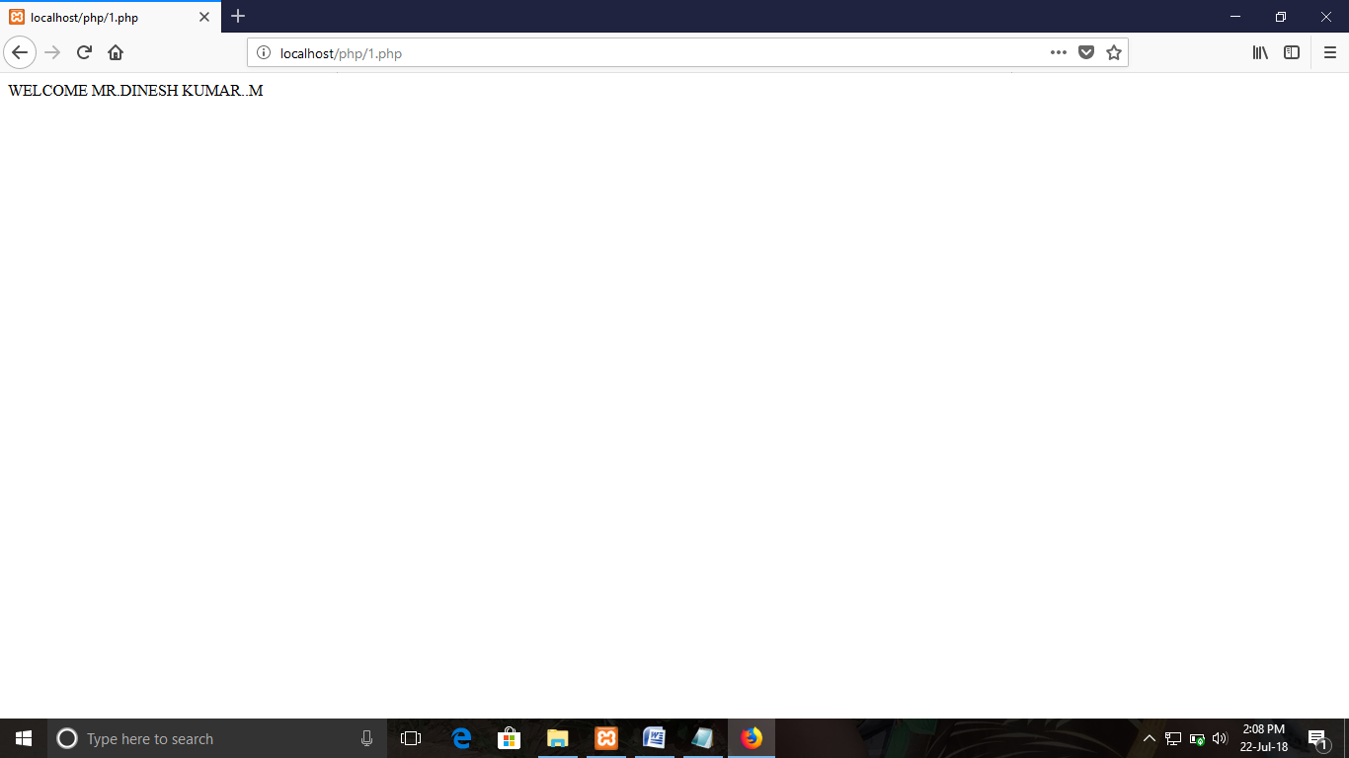

ExNo:2 //ADDITION PROGRAM

PROGRAM:

<html>

<body>

<?php

$txt1 = "Welcome To Php Addition Program";

$x = 5;

$y = 4;

echo "<h2>$txt1</h2>";

echo"The x value is:";

echo $x;

echo "<br>";

echo "The y value is:";

echo $y ;

echo "<br>";

echo "The added output is";

echo $x + $y ;

?>

</body>

</html>

OUTPUT:

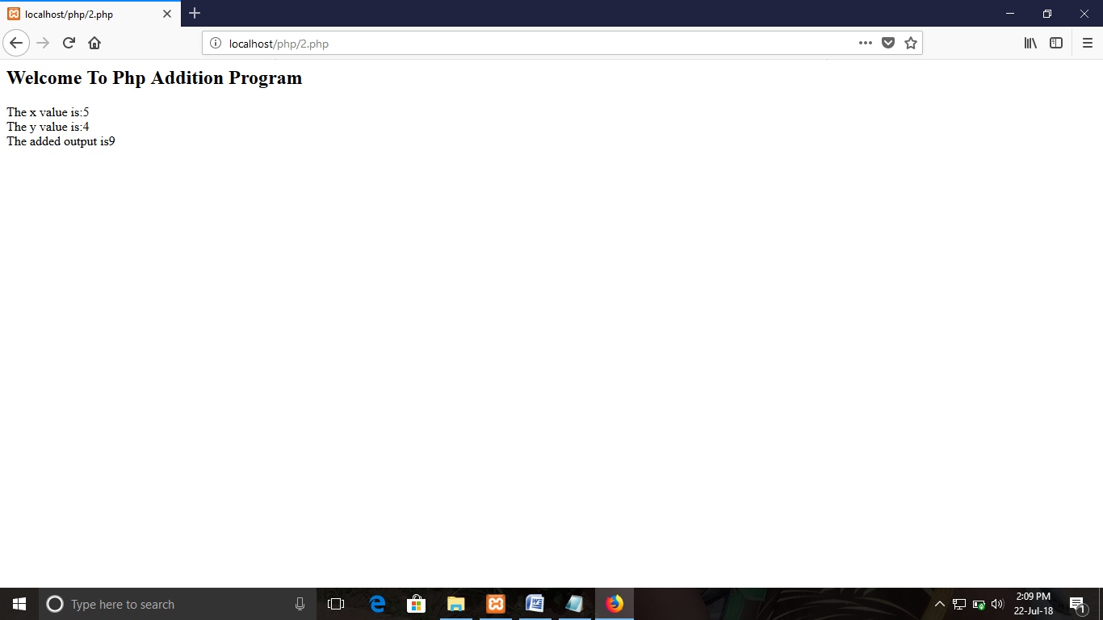

ExNo:3 //TO FIND THE DATATYPE

PROGRAM:

<html>

<head>

<body>

<?php

$x = "Hello Dinesh";

$y = "Hello Guys";

echo $x;

echo "<br>";

echo $y;

echo "<br>";

var_dump($x);?>

</body>

</html>

OUTPUT:

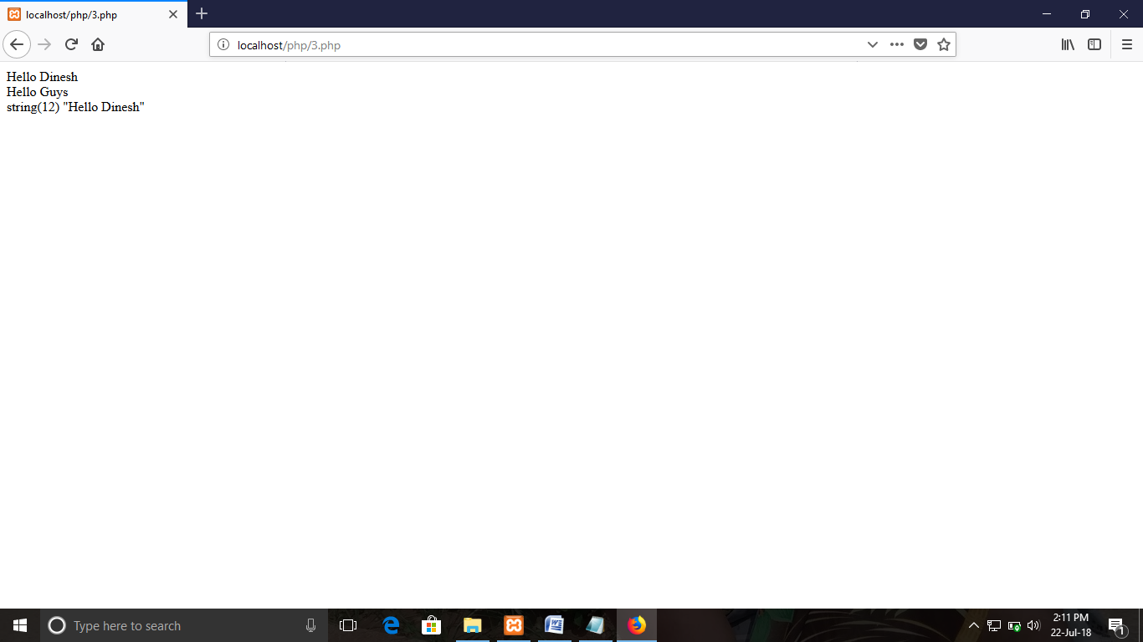

ExNo:4 //CONDITION PROGRAM

PROGRAM:

<html>

<body>

<?php

// put your code here

$t = date("H");

if ($t < "10")

{

echo "Have a good day!";

echo "<br>";

}

$favcolor = "green";

switch ($favcolor) {

case "red":

echo "Your favorite color is red!";

break;

case "blue":

echo "Your favorite color is blue!";

break;

case "green":

echo "Your favorite color is green!";

break;

default:

echo "Your favorite color is neither red, blue, nor green!";

}

?>

</body>

</html>

OUTPUT:

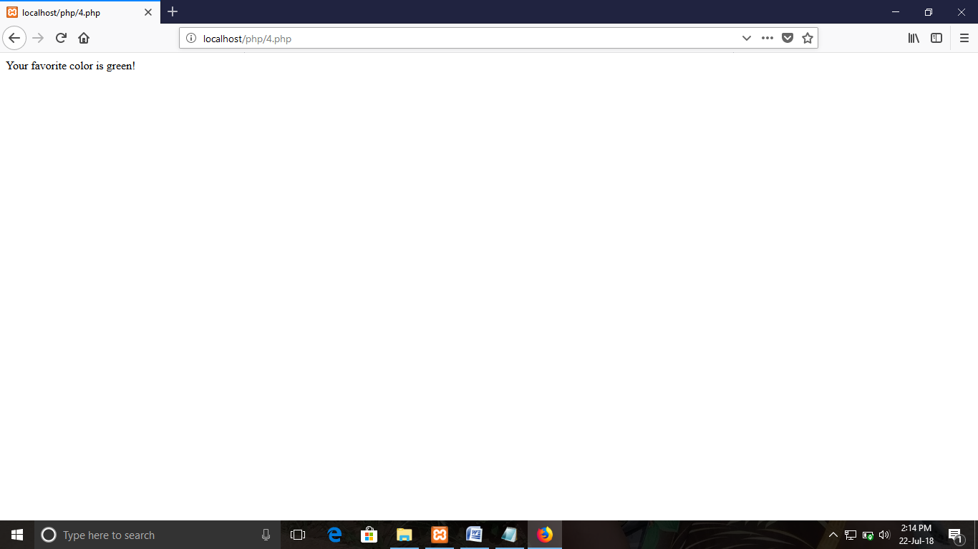

ExNo:5 //ARRAY PROGRAM

PROGRAM:

<html>

<body>

<?php

// put your code here

$people = array("Dinesh","Murugan","Santhosh");

var_dump($people);

$people = array("Dinesh","Murugan","Santhosh");

$arrlength = count($people);

echo "<br>";

for($x = 0; $x < $arrlength; $x++)

{

echo $people[$x];

echo "<br>";

}

$x = 1;

while($x <= 4) {

echo "The number is: $x <br>";

$x++;

}

for ($x = 0; $x <= 5; $x++) {

echo "The number is: $x <br>";

}

echo "Operation are finished!";

?>

</body>

</html>

OUTPUT:

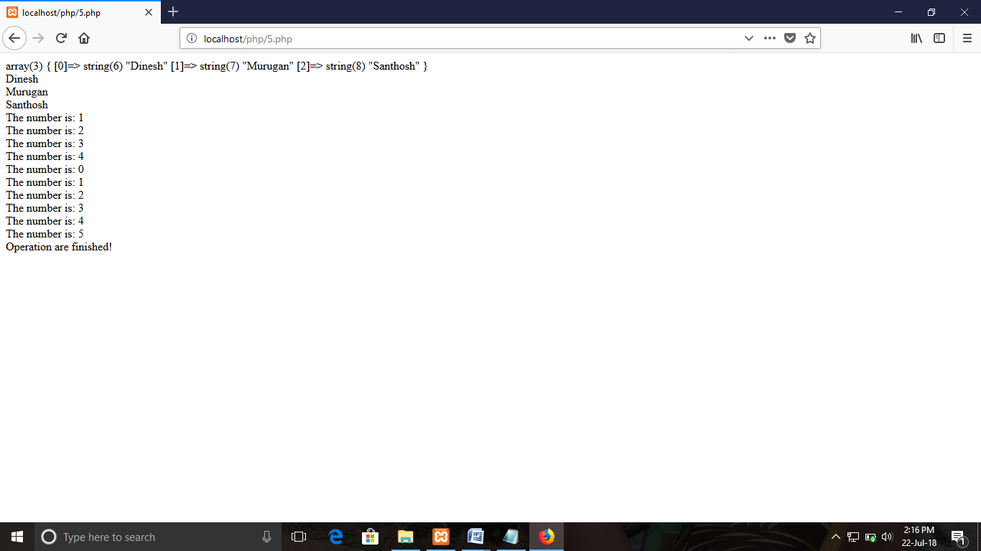

ExNo:6 //OBJECT PROGRAM

PROGRAM:

<html>

<body>

<?php

class php {

function php() {

$this->model = "object was called sucessfully"; }

}

// create an object

$dinesh = new php();

// show object properties

echo $dinesh->model; ?>

</body>

</html>

OUTPUT:

