* **Dependencies to develop an UI using python**

1. Pip install tkinter package should be installed in respective machine.
2. VS code to IDE to develop code.

* **Code**

import tkinter

from tkinter import ttk

#Window is called overall window which contains all elements inside it

Window=tkinter.Tk()

#Window Name like Overal UI name in header

Window.title("Game Data UI")

#Frame is a sub window under the window which keeps all the elements

#in an order

Frame=tkinter.Frame(Window)

#Inside a frame there are many sections like Div in HTML under HTML body

Frame.pack()

#Saving Game information like game name and FGame exe name

Game_info_frame=tkinter.LabelFrame(Frame,text="Game Information")

Game_info_frame.grid(row=0,column=0,padx=30,pady=30)

Game_Name_label=tkinter.Label(Game_info_frame,text="Game name")

Game_Name_label.grid(row=0,column=1)

Game_Exe_label=tkinter.Label(Game_info_frame,text="Game application path")

Game_Exe_label.grid(row=0,column=0)

Game_Name_entry=tkinter.Entry(Game_info_frame)

Game_Exe_entry=tkinter.Entry(Game_info_frame)

Game_Name_entry.grid(row=1,column=0)

Game_Exe_entry.grid(row=1,column=1)

#Saving Game Launchers information like Epic launcher

#Stream launcher and EA launcher etc,

Game_Launchers_frame=tkinter.LabelFrame(Frame,text="Game launchers")

Game_Launchers_frame.grid(row=1,column=0,padx=30,pady=30)

#Steam launcher values

Steam_Launcher=tkinter.Label(Game_Launchers_frame,text="Steam")

Steam_Dropdown=ttk.Combobox(Game_Launchers_frame,values=["True","False"])

Steam_Launcher.grid(row=0,column=0)

Steam_Dropdown.grid(row=1,column=0)

#Epic launcher values

#Padding and spacing for all Child elements of Game_Launchers_frame Frames

for widget in Game_Launchers_frame.winfo_children():

    widget.grid_configure(padx=5,pady=10)

#

#Save conformation frame

Conformation_frame=tkinter.LabelFrame(Frame,text="Powered by AMD")

Conformation_frame.grid(row=2,column=0,padx=10,pady=10)

# Like terms and condition checkbox

Save_Check=tkinter.Checkbutton(Conformation_frame,text="Save the game data.")

Save_Check.grid(row=0,column=0)

#Adding save and conformation button

Button=tkinter.Button(Frame,text="Save the Data")

Button.grid(row=3,column=0,sticky="news",padx=20,pady=20)

#which creates a close button for UI like window close option

Window.mainloop()

**Out put for above code**

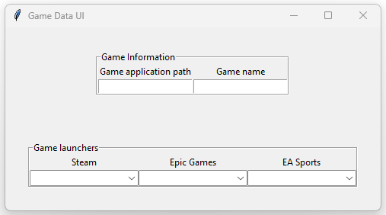

* **Data retrieving**