**[Project #2: ChipARoonie!](https://blackboard.andrew.cmu.edu/webapps/assignment/uploadAssignment?content_id=_1279496_1&course_id=_8912816_1&assign_group_id=&mode=view)**

**Activity 2**

UML Diagram

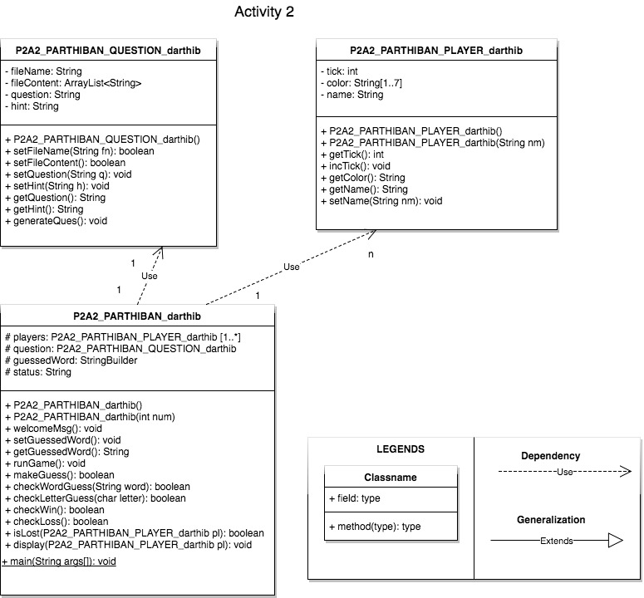

**Activity 3**

UML Diagram

