HireConnect- A Centralized Hiring
Management System for Employers
and Applicants

Dinesh Ram A,
Dept. of Computer Science and Engineering National Engineering College,
Kovilpatti, Tamil Nadu, India
2212046@nec.edu.in
Navedha Evanjalin R,
Dept. of Computer Science and Engineering
National Engineering College,
Kovilpatti, Tamil Nadu, India
navedhae@gmail.com

Petchivaradhan L,
Dept. of Computer Science and Engineering National Engineering College,
Kovilpatti, Tamil Nadu, India
lpetchi2005@gmail.com

Sri Nattar V,
Dept. of Computer Science and Engineering
National Engineering College,
Kovilpatti, Tamil Nadu, India
srinattar37@gmail.com

Abstract- In today’s competitive job market, many existing portals fail to provide effective filtering, resume evaluation and timely communication. Employers struggle to handle large volumes of applications, identify the most relevant candidates and maintain timely communication, while applicants often use platforms that lack personalization, multilingual support and interactive tools. To overcome these challenges, a smart recruitment platform is being developed using the MERN stack (MongoDB, Express.js, React.js and Node.js) with integrated AI components. It includes secure authentication, streamlined job posting and application management, resume parsing with scoring, automated decision-making and advanced dashboards for real-time insights. Recruiters can manage applications efficiently through reporting tools, bulk operations and flexible filtering, while candidates benefit from one-click applications, status tracking, personalized dashboards and instant notifications. The platform also provides scheduled reporting, a responsive design for all devices and an integrated chatbot to guide users through the process. With its modular design, strong error handling and scalable data management, the system ensures a transparent, efficient and user-friendly hiring experience.

Keywords - Job Portal, MERN Stack, Resume Parsing, Candidate Dashboard, Recruiter Dashboard, Reporting System, Automated Communication, Bulk Operations, Chatbot Assistant, Responsive Design, Application Management, Data Analytics

I . INTRODUCTION
In the modern era, recruitment plays a critical role in connecting skilled individuals with organizations that seek talent. However, the rapid pace of the job market has exposed significant inefficiencies in traditional job portals such as Indeed. Many existing platforms provide only limited filtering options, lack effective candidate-to-job matching and offer minimal personalization. Employers are often burdened with large volumes of applications, making it challenging to identify suitable candidates in a timely way. For applicants, delayed communication, poor application tracking and a lack of interactive guidance, creating additional hurdles during the hiring journey. To overcome these challenges, the system has been developed as a centralized hiring management platform using the MERN stack (MongoDB, Express.js, React.js, Node.js). It introduces a structured approach to recruitment by integrating secure authentication, a job posting and application management system, and resume parsing with scoring and filtering to assist recruiters in shortlisting candidates more effectively. The platform also provides role-based dashboards for both recruiters and candidates, enabling real-time insights into applications, job performance and hiring trends. Additional features include automated notifications, bulk operations for handling large datasets, and advanced filtering and sorting for efficient review. The reporting module allows recruiters to generate professional reports in multiple formats, with options for scheduling and white-label customization. An integrated chatbot acts as a virtual assistant, providing responses to frequently asked questions and guiding users through the key functionalities of the system. Furthermore, a responsive design ensures accessibility across both desktop and mobile devices, while robust error-handling mechanisms maintain reliability under load. By combining automation, data-driven insights and user-focused design, the system delivers a transparent, efficient and scalable recruitment experience for both employers and applicants.
.

II. RELATED WORKS
Malewade and Ekbote [1] analyzed performance optimization in web-based applications using the MERN stack, emphasizing scalability, responsive user interfaces, and efficient backend communication, which are essential for modern job portal systems handling dynamic user data. Baez et al. [6] discussed chatbot integration patterns, presenting architectural approaches for embedding conversational agents into existing web platforms. Their work highlights how chatbots can enhance user interaction and system usability without significant changes to the underlying architecture. Shan [3] examined retrieval-augmented generation (RAG) chatbots in high-stakes environments, stressing the importance of grounding chatbot responses in reliable data sources to improve accuracy and trust, which is relevant for job portals providing career and recruitment-related information. Kwieciński et al. [2] compared real-time and batch recommendation systems, demonstrating that real-time recommendations are more suitable for dynamic platforms such as job portals where job listings and user preferences frequently change. Skill extraction from job postings has been widely studied, with Khaouja et al. highlighting NLP-based techniques for identifying structured skill information from unstructured job advertisements [9]. Resume content extraction methods, such as block classification techniques discussed by Zhao et al., address challenges related to diverse resume formats in online recruitment systems [10]. Dhanalakshmi et al. proposed an AI-powered resume screening system using NLP and machine learning to automate candidate evaluation and improve recruitment efficiency [11]. Mahbub et al. examined contextual features for detecting recruitment fraud in online job platforms, emphasizing trust and data reliability in digital hiring environments [8]. Together, these studies support the integration of intelligent analysis, conversational interfaces, and scalable web architectures in modern job portal systems.

III. METHODOLOGY
The development of the system followed a structured Software Development Life Cycle (SDLC) methodology. This approach allows the system to effectively address modern recruitment challenges by integrating candidate management, recruiter operations, resume analysis, analytics, reporting and real-time communication, offering a unified solution that enhances efficiency, transparency and user engagement.

1. Requirement Analysis
The initial phase involved comprehensive requirement gathering through stakeholder interviews, surveys and systematic domain research. Multiple recruitment scenarios were analyzed to identify critical pain points in existing systems, with a particular focus on workflow bottlenecks and user experience gaps. Key recruiter challenges include inefficient candidate shortlisting processes, lack of automated application tracking and difficulty in managing high-volume applications. Simultaneously, candidate expectations centered on streamlined application processes, transparent communication channels and real-time status updates. The functional requirements were categorized into four key domains. Candidate features encompass job browsing with advanced filtering, one-click applications, and real-time tracking dashboards; recruiter features include job posting management, application processing, bulk operations and performance analytics; administrative features cover structured resume parsing, automated scoring algorithms and comprehensive analytics dashboards; and system features involve custom reporting modules, scheduled notification systems and secure multi-factor authentication protocols. Non-functional requirements prioritize system scalability to handle fluctuating application volumes, robust security measures for sensitive data protection, and responsive design to ensure optimal performance across all devices and platforms. This thorough requirement analysis established clear system boundaries, defined precise user role specifications and ensured strategic alignment with contemporary recruitment objectives. Fig.1 illustrates the comprehensive system architecture based on these requirements.
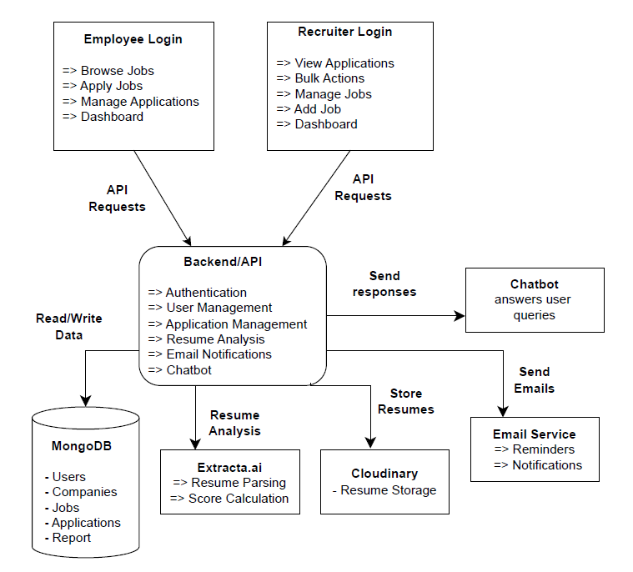
Fig. 1: System Architecture

2. System Design
The system is based on a modular client-server architecture that emphasizes scalability, security and maintainability. The frontend uses React.js with functional components and hooks, Tailwind CSS for responsive design and Lucide React icons for visualization, with the Context API managing the state efficiently. The backend was implemented using Node.js and Express.js and MongoDB with Mongoose. JWT-based authentication and role-based access control secure sensitive data. External services, such as authentication management, cloud storage for resumes, email delivery and resume parsing are seamlessly integrated.

3. Implementation
The implementation phase involved the development of a full-stack application using the MERN architecture. The frontend was constructed using React.js with functional components and hooks, managed by the Context API for the state and styled with Tailwind CSS to ensure a responsive design. On the backend, a secure RESTful API was built using Node.js, Express.js and connected to a MongoDB database using Mongoose for robust data modelling. Security was integrated using JSON Web Token (JWT) -based authentication and role-based access control (RBAC). Core features were implemented as independent services: a Resume Parser to extract structured information from documents, a Scoring Engine that applies a weighted algorithm to evaluate candidates, a Notification Service for automated emails with retry logic and a dynamic Reporting Module for generating and exporting custom reports.

4. Testing

Testing was conducted across several layers to ensure system robustness. Unit testing validated individual modules, such as resume parsing, scoring and reporting. Integration testing ensured seamless interaction between the candidate portal, recruiter dashboard, parsing modules and reporting system. System testing verified the end-to-end workflows, including application submission, scoring, notifications and analytics. Performance testing evaluated the stability under high volume applications and concurrent users, ensuring scalability and responsiveness.

5. Deployment and Maintenance
Deployment prioritizes scalability, reliability and continuous availability. The frontend, which was developed using React.js, was deployed on Vercel. Backend services hosted in a secure cloud environment with MongoDB Atlas provide highly available and scalable data storage. External services such as cloud storage, email delivery and resume parsing are securely integrated. Continuous monitoring, logging, automated error handling and retry mechanisms support ongoing maintenance and system reliability. Candidates apply, the application is created, the resume is stored and parsed, scores are calculated and decisions on acceptance, review, or rejection are made. Recruiters receive real-time updates on the application status. Reporting and scheduling workflows operate in parallel, aggregating metrics and automatically generating insights. Cron jobs and execution logging ensure reliability, traceability and auditability. This integrated workflow ensures efficiency, transparency and a consistent user experience, addressing the limitations of traditional recruitment systems while enhancing recruiter and candidate engagement.

IV. RESULTS AND DISCUSSION
The deployment of the system resulted in a fully functional and user-centric recruitment system. The following figures and analyses demonstrate the effectiveness of the proposed system in meeting its objectives. The candidate portal provides an intuitive interface for job seekers to browse available positions with filters for category and location, as shown in Fig.2.

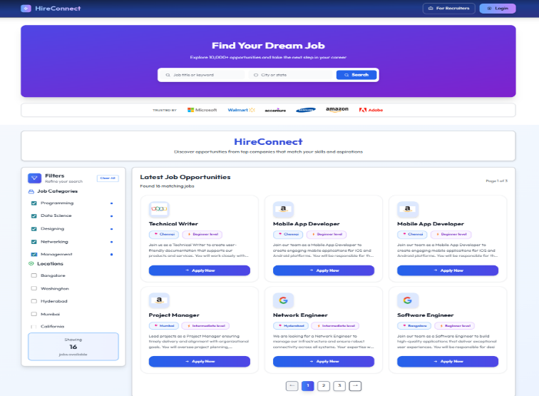

Fig. 2: Home Page

Candidates can submit applications with a single click and resumes are securely stored in the cloud as shown in Fig.3.

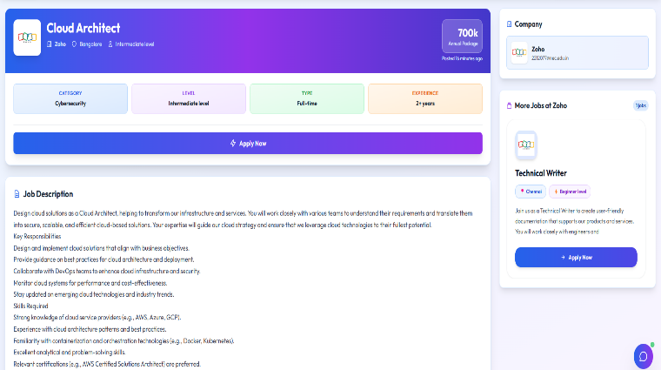

Fig. 3: Apply Job

Real-time application tracking ensures that candidates are always updated on the status of their applications, while immediate email confirmations maintain transparency and engagement as shown in Fig.4.

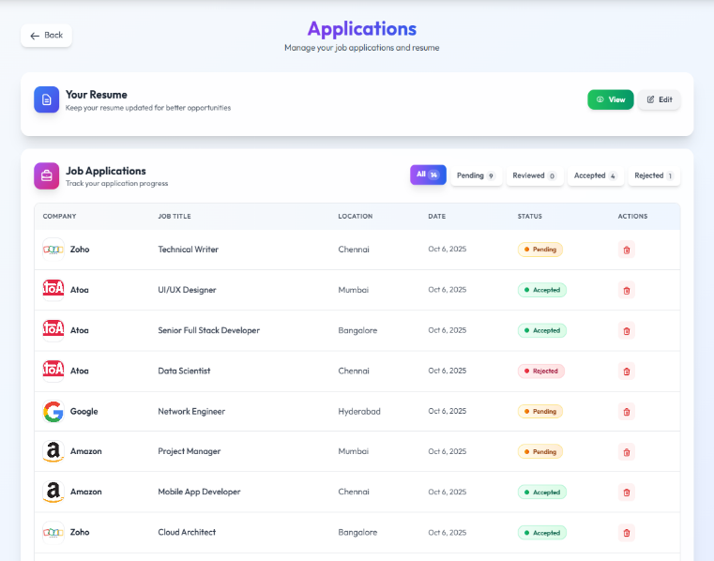
Fig. 4: View Job Applications

The recruiter dashboard allows companies to manage job postings efficiently, including creation, editing and categorization by skills, experience, location and visibility as shown in Figs. 5,6.

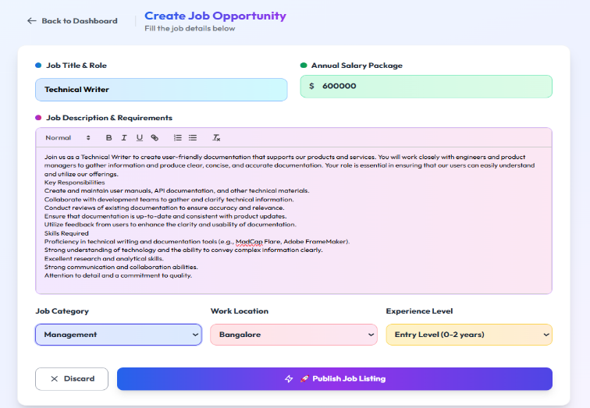
Fig. 5: Add Job
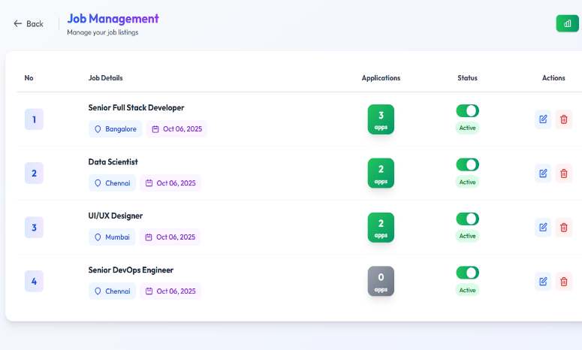
Fig. 6: Manage Jobs

Recruiters can filter, sort and review applications individually or perform bulk operations such as mass acceptance or rejection. Structured resume evaluation supports informed shortlisting, reducing manual effort and improving accuracy as shown in Fig.7.

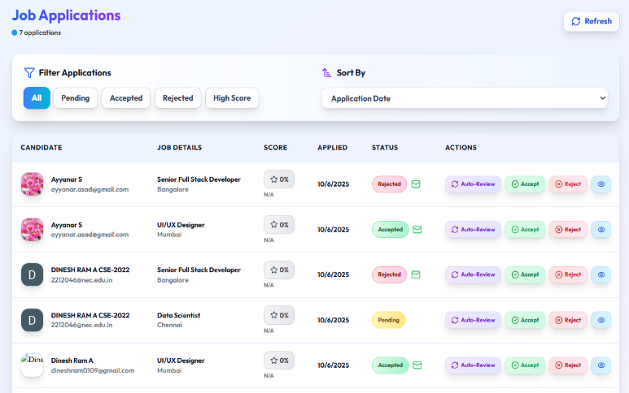
Fig. 7: Manage Applications

The system includes a resume analysis module that parses candidate resumes to extract the structured information. Resumes are evaluated using a weighted scoring system ranging from 0 to 100%, considering skills, experience, education, certifications, projects, achievements and internships. Automated decisions were made based on these scores. Candidates exceeding a threshold are accepted, mid-range scores are flagged for manual review and low scores result in rejection. Personalized emails communicate these outcomes to candidates, providing clarity and constructive feedback (Fig.8).

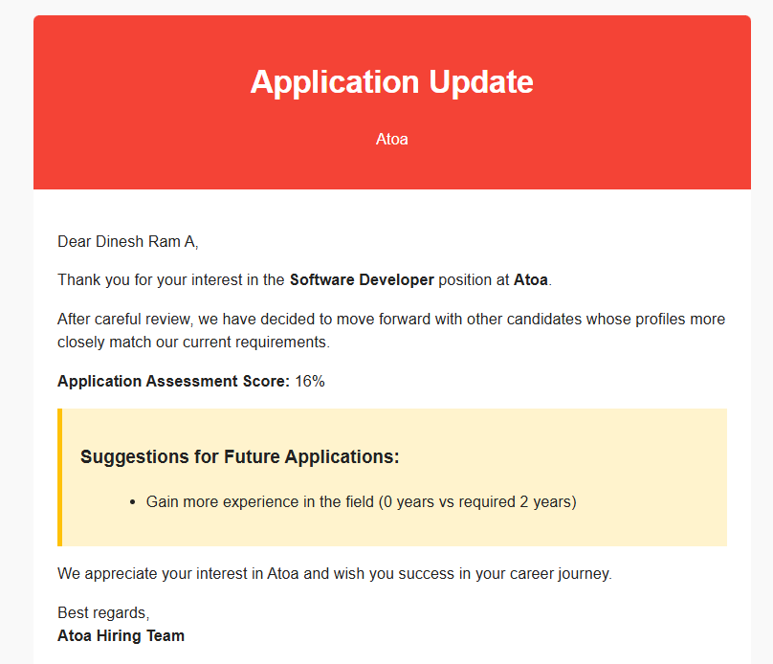

Fig. 8: Rejection Feedback
Advanced analytics and reporting functionalities provide both candidates and recruiters with actionable insights. Dashboards incorporate pie charts, bar graphs, line charts, and geographic visualizations to depict application trends, candidate quality and job performance as shown in Figs.9,10.

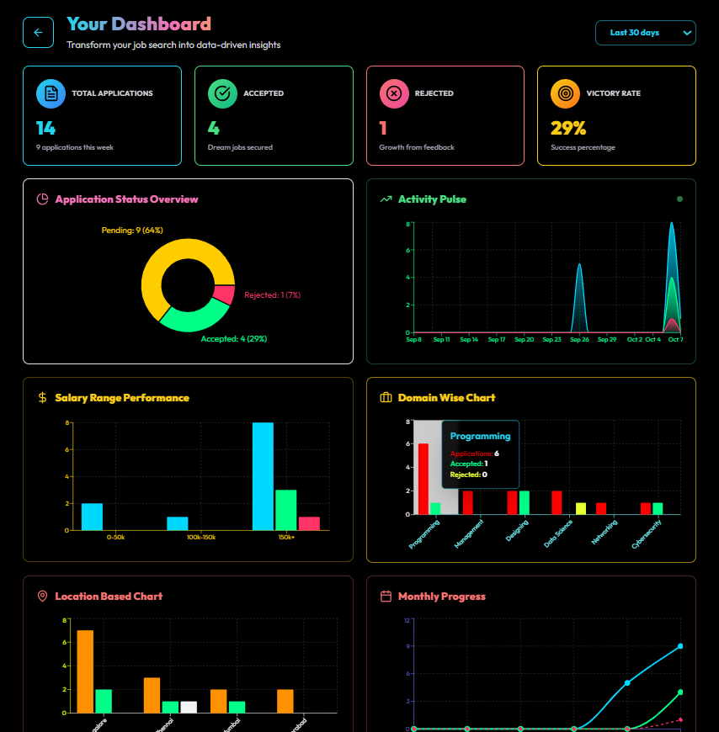

Fig. 9: Employee Dashboard

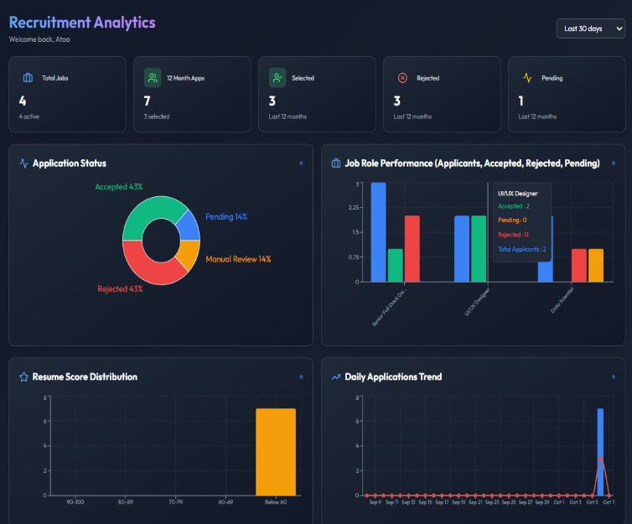

Fig. 10: Employer Dashboard

A custom report builder allows dynamic metric selection, export in multiple formats, white-label branding and automated scheduling, enabling users to generate professional, tailored reports as shown in fig.11. The email and notification system ensures timely communication at every stage of the application process, including application confirmation, acceptance, rejection, company reminders to review pending applications as shown in Figs.12-15. Personalized content and retry logic guarantee delivery even in the event of temporary failures.

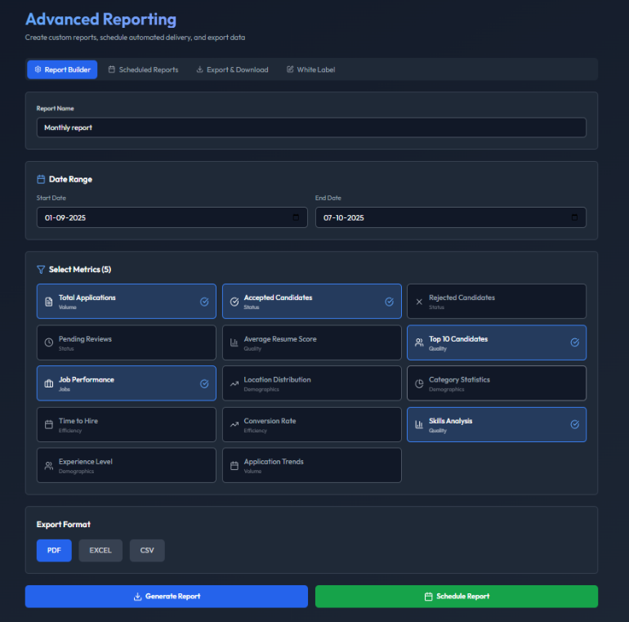

Fig. 11: Custom Generated Reports

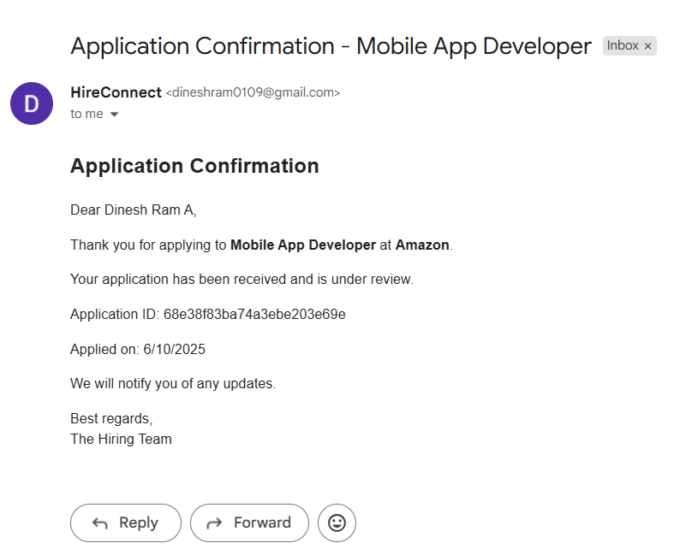
Fig. 12: Application Confirmation Mail

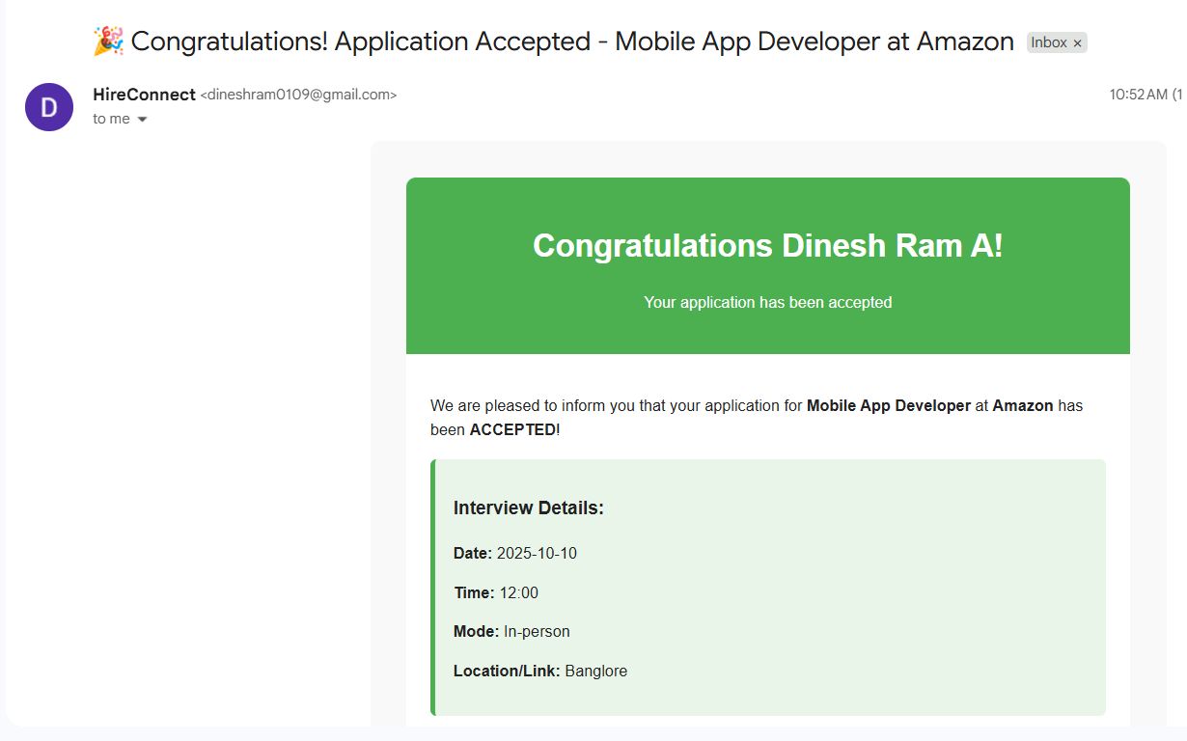
Fig. 13: Acceptance Mail sent to Candidate

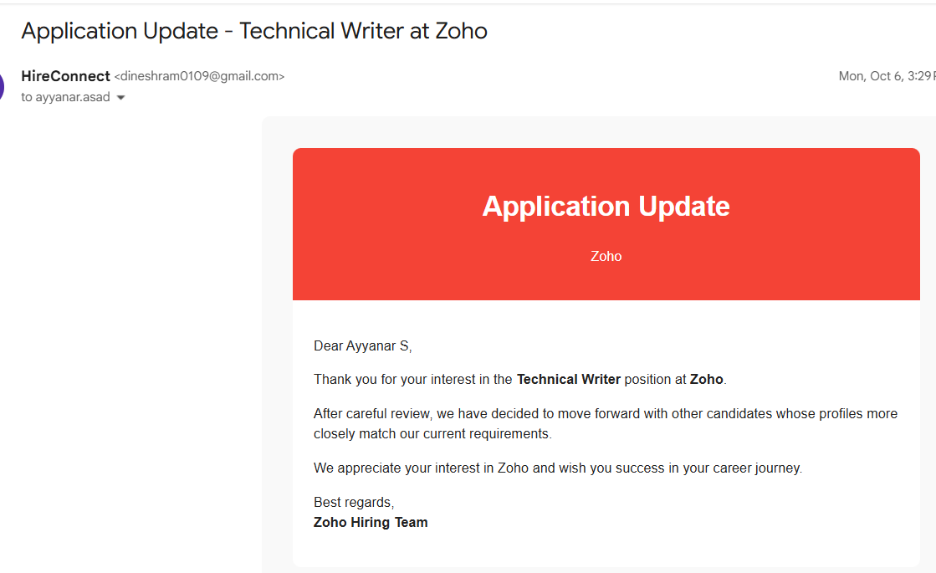

Fig. 14: Rejection Mail Sent to Candidate

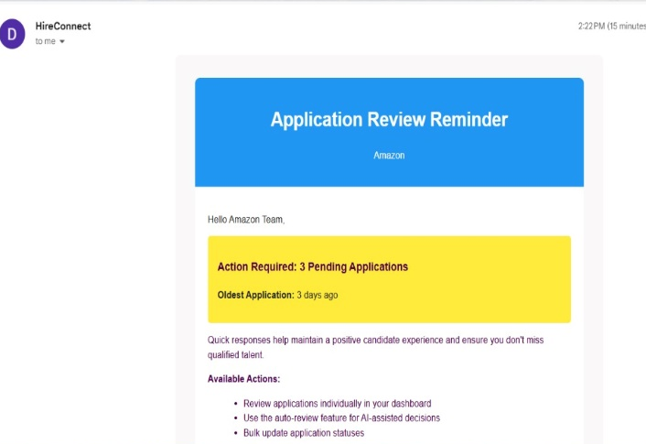

Fig. 15: Company Reminder Mail

Bulk operations and advanced filtering support high-volume recruitment scenarios, allowing recruiters to update multiple application statuses simultaneously, send bulk emails and track progress efficiently. Filters include application status, resume score, job category, location and experience level, while sorting options allow the quick prioritization of candidates. Security and resilience are embedded throughout the systems. JWT authentication and role-based access (Figs.16-17) control prevent unauthorized access, input validation, and secure file handling protect sensitive data and rate limiting and CORS configuration secure API endpoints.

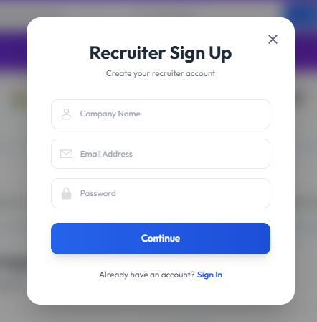
Fig. 16: Company Sign Up Page

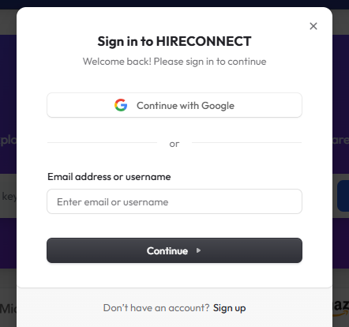

Fig. 17: Job Seeker Login Page

Graceful error handling and user-friendly feedback, ensures a seamless experience even under high load or unexpected errors. Together, these implementation strategies create a robust, scalable and user-centric platform that addresses the core challenges of contemporary recruitment.

Thus, the system integrates a seamless end-to-end workflow. When a candidate applies, the application is created, the resume is stored and parsed, scores are calculated and decisions regarding acceptance, review or rejection are made. Personalized emails are sent to candidates, while recruiters receive real-time updates on the application status. Reporting and scheduling workflows operate in parallel, aggregating metrics and generating insights automatically. Cron jobs and execution logging ensure reliability, traceability and auditability. The system was evaluated in terms of functionality, usability, performance and effectiveness in supporting the recruitment process. This integrated workflow ensures efficiency, transparency and a consistent user experience, addressing the limitations of traditional recruitment systems while enhancing recruiter and candidate engagement.

V. CONCLUSION
The developed system demonstrates that a cohesive and operational efficiency and user satisfaction. By consolidating candidate applications, recruiter management, reporting and notification workflows into a single system, it reduces the fragmentation commonly found in traditional recruitment tools. The system’s emphasis on structured processes, secure data handling and interactive dashboards not only improves transparency but also enables more informed decision-making for recruiters.
Furthermore, the system highlights the importance of real-time communication and automated workflows in modern recruitment, ensuring that both candidates and recruiters are consistently updated and minimizing delays and errors. Its scalable architecture and modular design make it adaptable to evolving recruitment needs, supporting future expansion, such as mobile integration, advanced analytics and intelligent recommendations. In essence, the system provides a foundation for streamlined, reliable and user-centric recruitment practices, demonstrating that well-integrated digital solutions can transform conventional hiring processes into more efficient, transparent and actionable workflows.

REFERENCES

- Sourabh Mahadev Malewade and Archana Ekbote, "Performance optimization using MERN Stack on Web-Based Applications," IJERT, ISSN: 2278-0181 Vol. 10 Issue 06, June-2021. DOI:10.17577/IJERTV10IS060239
- R. Kwieciński, G. Melniczak, and T. Górecki, “Comparison of Real-Time and Batch Job Recommendations,” IEEE Access, vol. 11, 2023, DOI:10.1109/ACCESS.2023.3249356
- Richard Shan, “Certifying Generative AI Retrieval-Augmented Generation Chatbots in High-Stakes Environments,” IEEE,Vol:57, Issue:9,September 2024 DOI: 10.1109/MC.2024.3401085
- William Villegas-Ch, Jaime Govea, And Rommel Gutierrez, “Optimizing Language Model-Based Educational Assistants Using Knowledge Graphs Integration with Moodle LMS,” IEEE Access vol. 12, DOI:10.1109/ACCESS.2024.3518952
- J. Hu, W. Wu, T. Chuan, and Q. Peng, “Enterprise Internal Threat Authentication Traceability Technology Based on Key Authentication System,” Journal of Cyber Security and Mobility, vol. 14, no. 3, pp. 623–652, 2025. https://doi.org/10.13052/jcsm2245-1439.1435
- Marcos Baez, Florian Daniel, Boualem Benatallah and Fabio Casati “Chatbot Integration in Few Patterns,” IEEE Internet Computing Vol: 25, Issue: 3, 01 May-June 2021, DOI: 10.1109/MIC.2020.3024605.
- Paula Maddigan And Teo Susnjak “Chat2VIS: Generating Data Visualizations via Natural Language Using ChatGPT, Codex, and GPT-3 LLMs,” IEEE Access, DOI: 10.1109/ACCESS.2023.3274199
- Syed Mahbub , Eric Pardede and A. S. M. Kayes, “Online Recruitment Fraud Detection: A Study on Contextual Features in Australian Job Industries,” IEEE Access, vol. 10, 2022, DOI: 10.1109/ACCESS.2022.3197225
- Imane Khaouja, Ismail Kassou and Mounir Ghogho, “A Survey on Skill Identification from Online Job Ads,” IEEE Access, vol. 9, 2021, DOI: 10.1109/ACCESS.2021.3106120.
- Li-Hui Zhao, Ji Zhang, Qiqiang Xu, Linlin Hou and Xin Wang, "On Block Classification for Automatic Content Extraction From Chinese Resumes," IEEE Access, vol. 12 2024. DOI: 10.1109/ACCESS.2024.3510581
- Dhanalakshmi R V, Shivashish Gour, Shashank M, Sushmitha K, K J Nithin, Keerthana S N,”AI-Powered Resume Screening System Using NLP and ML”, DOI: 10.1109/ICICI65870.2025.11069785

