**DBMS**

**Vinoth Kumar C**

**CB.EN.U4CYS21085**

**-Create:**

It is used to create a new table 

**-Insert:**

Enters values into the database

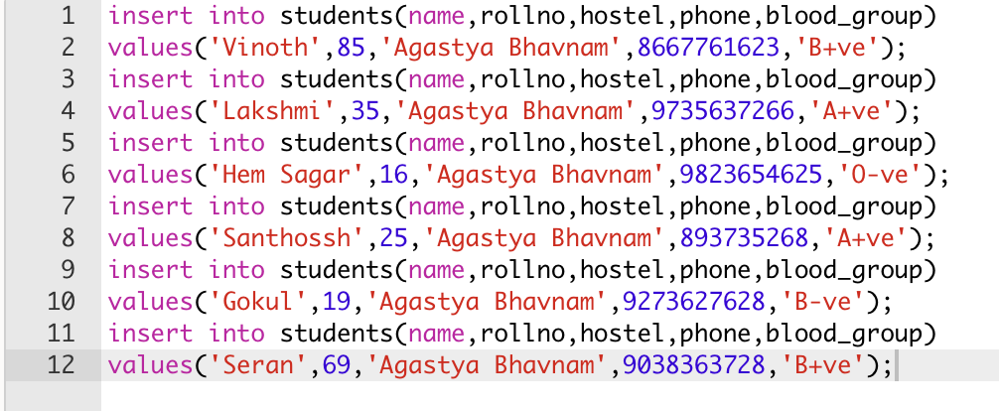

**-Select:**

Selects and displays the date from the database



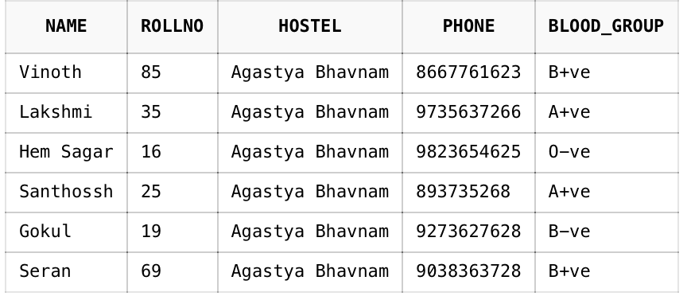

**-Alter:**

Used to add,delete,modify the existing table

**\*Add:**

To add a column in an existing table

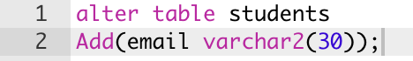

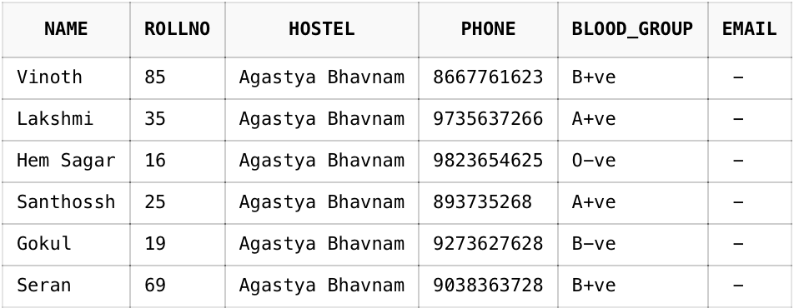

**\*Modify:**

To make changes in the table

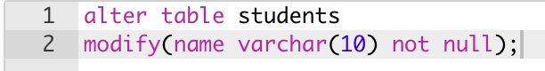

**\*Delete:**

To delete data from the existing table

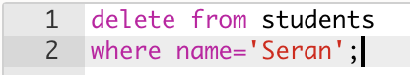

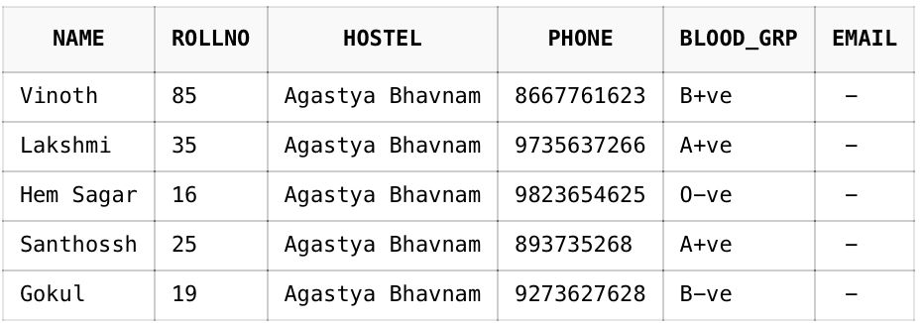

**\*Drop:**

To delete and existing database

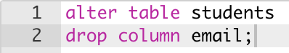

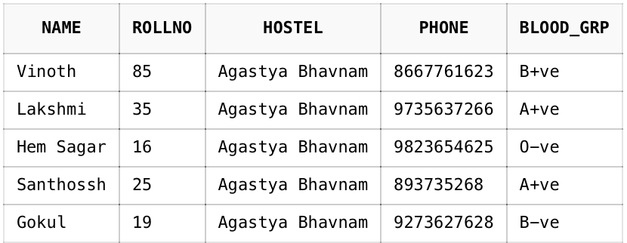

**\*Rename**

To change table name or column name



