# Problem1:

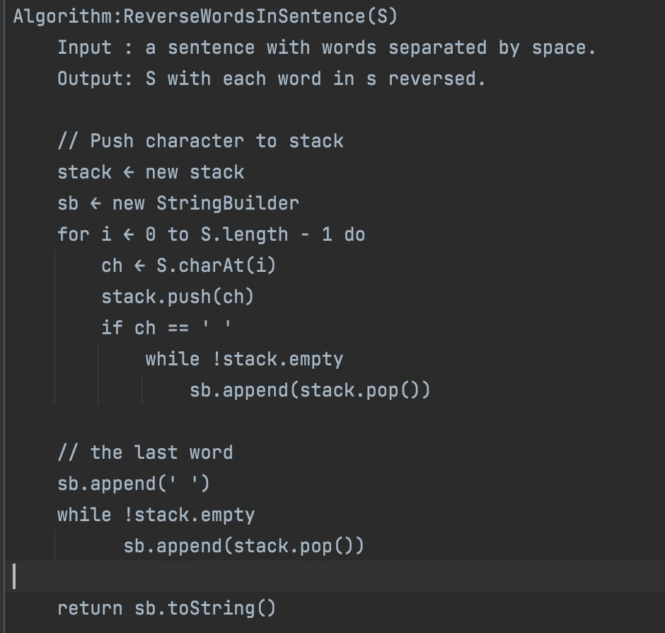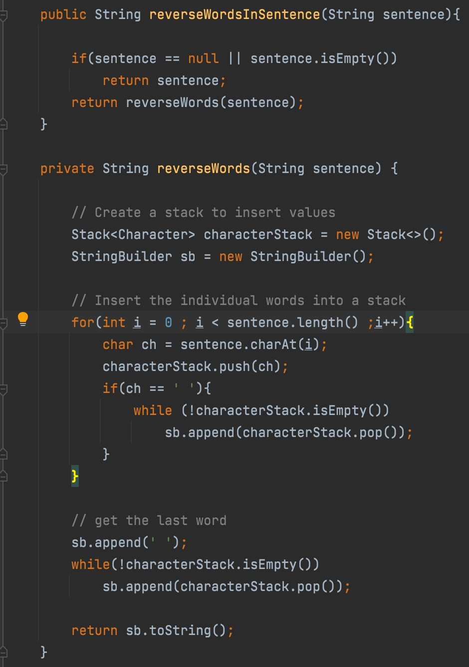

a) Pseudo-code B) Implementation

**Problem2:**

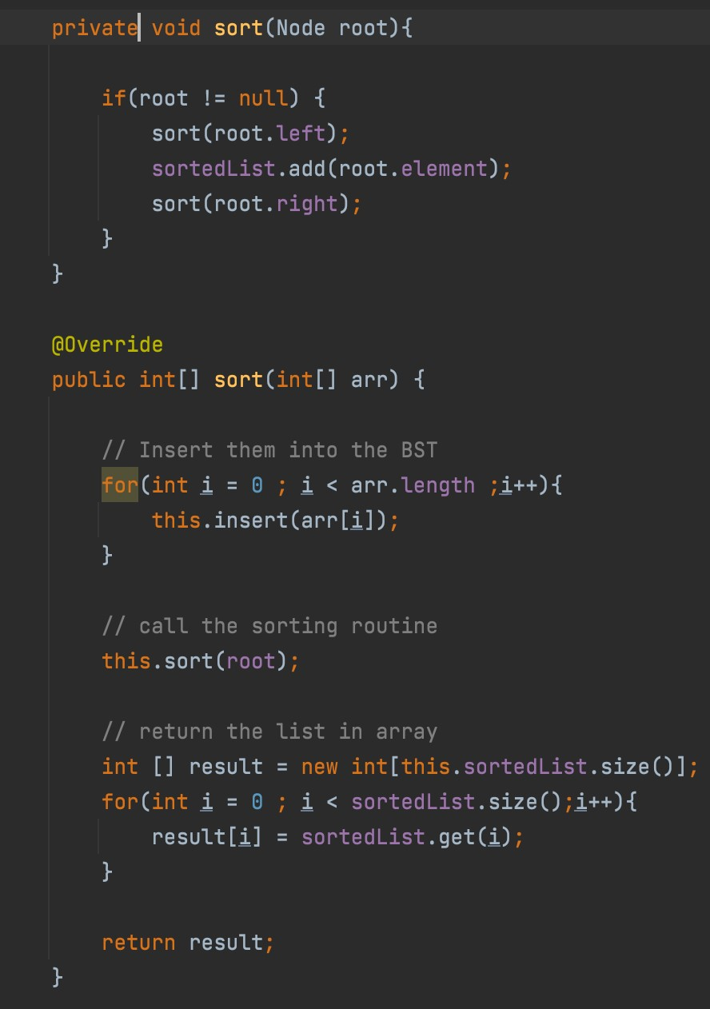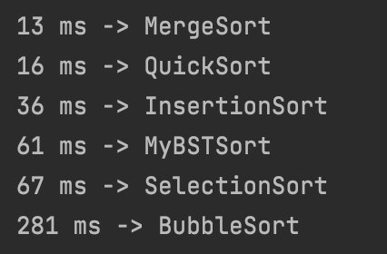

As

shown

below the

BST

sorting

lies between

insertion and

selection sort.

However,

it’s

clear

that it performs worse than

Merge

and Quick sort.

This can be

because

we

must

populate the

tree and

traverse it and copying that to

array.

Running Time of BST

Sort:

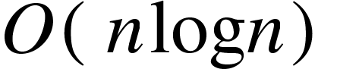

# Problem 3:

|  |  |
| --- | --- |
| **Num nodes n** | **Does there exist a red-black tree with n nodes, all of which are black?** |
| 1 | Yes |
| 2 | No |
| 3 | Yes |
| 4 | No |
| 5 | No |
| 6 | No |
| 7 | Yes |

# Problem 4:

|  |  |
| --- | --- |
| **Num nodes n** | **Does there exist a red-black tree with *n*** *nodes***, which exactly *one* of the nodes is red** |
| 1 | No |
| 2 | Yes |
| 3 | No |
| 4 | Yes |
| 5 | Yes |
| 6 | No |
| 7 | No |