**Problem1:**

**Problem2:**

**Problem3:**

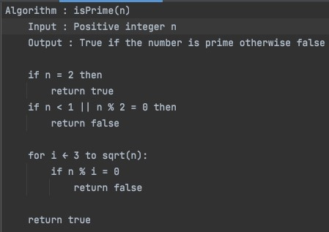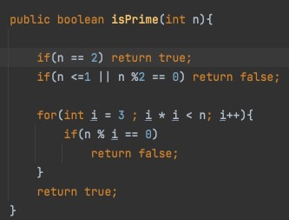

**a) Pseudo-code b) Implementation**

# Running Time: 𝑶(√𝒏)