Git Version Control System: An Introduction
Dinesh Varma Bhetalam,
Computer science and engineering,
Manipal Institute of Technology,
Formula Manipal.

Abstract—Git is a distributed version control system that allows individuals and teams to track changes to source code, coordinate collaborative development, and maintain a complete history of a project over time. This report introduces the fundamental concepts underlying Git, including repositories, the staging area, commits, branches, and remotes, and explains why a distributed model offers advantages over older centralized systems. The report also documents a hands-on exercise in which a local repository was initialised, tracked, committed, cloned from a remote host, and branched, with terminal output captured at each stage. The exercise illustrates the practical application of the theoretical concepts discussed and demonstrates a typical beginner workflow used in academic and engineering project settings.
Index Terms—Git, version control, distributed systems, repository, GitHub, branching, software engineering.

I. INTRODUCTION
Software projects, whether developed by a single student or a large distributed engineering team, accumulate change over time: files are added, edited, reorganised, and occasionally broken. Keeping track of who changed what, when, and why becomes difficult once more than one contributor is involved, or once a project needs to be rolled back to an earlier working state. Version control systems (VCS) were created to solve exactly this problem.
Git is, by a wide margin, the most widely used version control system in both industry and academia today. It was created in 2005 by Linus Torvalds for the development of the Linux kernel, after the kernel community lost access to the proprietary tool it had previously relied upon. Git was designed from the outset to be fast, to handle very large numbers of contributors, and to allow branching and merging with minimal overhead.
This report has two objectives. First, it introduces the core conceptual model of Git — repositories, the working directory, the staging area, commits, branches, and remotes — for a reader who is new to version control. Second, it documents a short practical exercise, performed in a Git Bash terminal on Windows, that walks through repository initialisation, staging, committing, cloning a remote repository, and creating a branch, with terminal screenshots included as supporting evidence.
II. BACKGROUND: CENTRALISED VS. DISTRIBUTED VCS
Early version control systems such as CVS and Subversion (SVN) used a centralised model: a single server held the authoritative history of the project, and every contributor's machine held only a working copy of the current version. Committing a change, browsing history, and even seeing who last modified a line all required contacting the central server. If that server was unreachable, most operations were blocked.
Git instead uses a distributed model. Every clone of a repository is a complete, self-contained copy of the entire project history, not just its latest snapshot. This means a contributor can commit, branch, inspect history, and experiment offline, and only needs network access when explicitly pushing changes to, or pulling changes from, another copy of the repository — typically one hosted on a service such as GitHub, GitLab, or Bitbucket. This design is what makes Git fast for local operations and resilient to the unavailability of any single server.
III. CORE CONCEPTS
A. Repository
A repository (or "repo") is a directory that Git is tracking. Running git init inside a folder creates a hidden .git subdirectory that stores the entire history, configuration, and metadata of the project. The folder's ordinary files are referred to as the working directory.
B. The Three-Stage Model
Git organises a change through three conceptual areas: the working directory, where files are edited; the staging area (or "index"), where changes are collected before being recorded; and the repository history, where committed snapshots are permanently stored. git add moves a change from the working directory into the staging area, and git commit records everything in the staging area as a new, permanent point in the project's history.
C. Commits
A commit is an immutable snapshot of the project at a point in time, together with an author, a timestamp, a message describing the change, and a pointer to the commits that came before it. Because each commit references its parent, the full sequence of commits forms a history graph that can be inspected, compared, or reverted.
D. Branches
A branch is simply a movable pointer to a commit. The default branch is conventionally named main. Creating a new branch (git branch <name>) and switching to it (git checkout <name>) allows a contributor to develop a feature or experiment in isolation without affecting the main line of development; the branch can later be merged back once the work is ready.

E. Remotes
A remote is a reference to another copy of the repository, usually hosted on a service such as GitHub. git clone copies a remote repository, including its full history, onto the local machine; git push and git pull subsequently synchronise commits between the local repository and the remote.

IV. PRACTICAL DEMONSTRATION
To reinforce the concepts above, a short exercise was carried out in a Git Bash terminal on Windows, inside a project folder named driverless_formulamanipal_taskphase1. The sequence below mirrors a typical first use of Git for a coursework or team-project repository, moving from local initialisation through to cloning and branching.
A. Repository Initialisation
The exercise began by running git init inside the project folder. Git reported that a new, empty repository had been created at the path shown, with its metadata stored in a hidden .git directory (Fig. 1). At this point the folder was a Git repository but contained no commits.
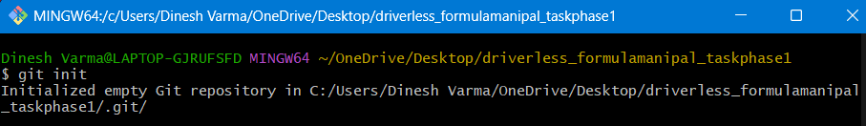
Fig. 1. Output of git init, creating an empty local repository.
B. Checking Repository Status
Running git status confirmed that the repository was on the main branch, had no commits yet, and listed seven untracked Python files (p1q1.py through p1q7.py) that Git had detected in the working directory but was not yet tracking (Fig. 2). git status is typically the first command run before any add or commit, as it shows exactly what has changed.
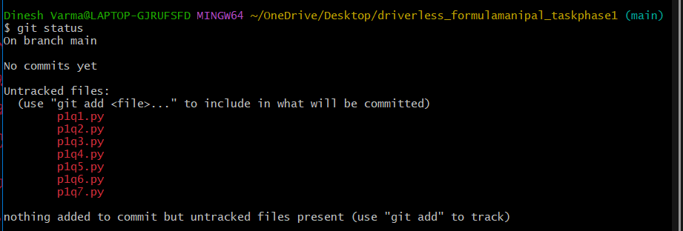
Fig. 2. git status listing seven untracked files prior to the first commit.
C. Staging and Committing
The command git add . staged all seven files at once, moving them from the working directory into the staging area. git commit -m "Initial commit" then recorded them as the repository's first commit (root-commit 76cbd52), reporting that seven files had changed with 208 total insertions (Fig. 3). This pair of commands — stage, then commit — is the basic unit of saving work in Git.
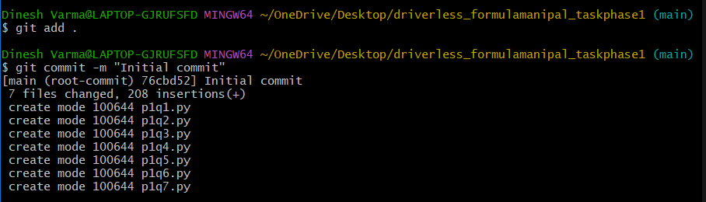
Fig. 3. git add . followed by git commit -m "Initial commit", creating the repository's first commit.
D. Cloning a Remote Repository
To demonstrate the distributed nature of Git, an existing remote repository hosted on GitHub was cloned using git clone https://github.com/DineshVarmaBhetalam/DineshVarma_Driverless_Taskphase.git. Git reported enumerating, counting, and compressing the remote objects before receiving all twenty objects and resolving deltas, producing a complete local copy of the remote project's history (Fig. 4).
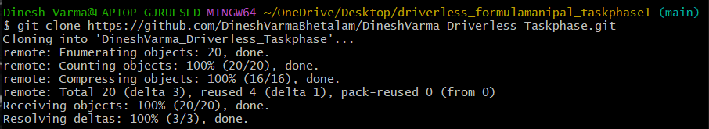
Fig. 4. git clone downloading a complete copy of a remote repository from GitHub.
E. Adding a Further Commit
A new file, one.txt, was created and committed on a branch named new with the message "this is my first commit", producing a second commit (5b9a5bd) with one file changed and one insertion (Fig. 5). Before this commit was made, git add one.txt was run to stage the file; Git additionally warned that the line-ending style of the file would be normalised from LF to CRLF on a Windows checkout, a routine cross-platform notice rather than an error (Fig. 6).
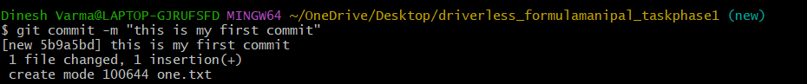
Fig. 5. A second commit adding one.txt on the branch new.
Fig. 6. git add one.txt, with Git's LF-to-CRLF line-ending notice on Windows.
F. Branch Creation and Switching
Finally, branching was demonstrated directly: after returning to main with git checkout main, a new branch named new was created with git branch new. An empty file named new was added on main, and git checkout new then switched the working directory to the new branch, where a second empty file, one.txt, was created (Fig. 7). This sequence shows how git branch creates a pointer without switching to it, while git checkout performs the switch, and how the working directory's contents differ from one branch to another.
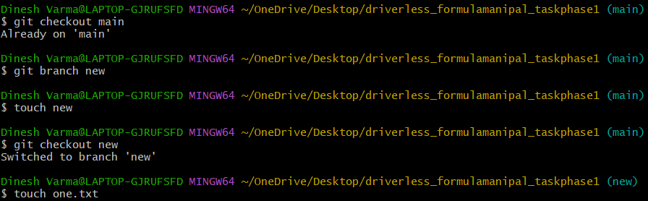
Fig. 7. git checkout, git branch, and file creation demonstrating branch isolation.

V. ADVANTAGES OBSERVED
The exercise highlighted several practical advantages of Git that follow directly from its distributed design. Local commits are instantaneous and require no network access, which makes it practical to save work frequently in small, well-described steps. Cloning a remote repository transfers the entire project history in a single operation, so a new contributor immediately has access to every past commit rather than only the latest snapshot. Branching is lightweight — creating a branch is effectively free — which encourages isolating experimental or feature-specific work from the stable main line until it is ready to be merged.
These properties are especially relevant to student and campus engineering teams, where multiple contributors work on shared codebases such as robotics or software subsystems under time pressure, and where the ability to recover a previous working state or work offline is frequently more valuable than any single feature of the tool.
VI. CONCLUSION
Git's distributed model — every clone has a complete copy of history, combined with a lightweight staging-and-commit workflow and branching — explains its dominance as the version control system of choice across both open-source and commercial software development. The practical exercise documented in this report, covering initialisation, status inspection, staging, committing, cloning, and branching, corresponds to the minimal command set needed to begin using Git productively on a real project, and forms a foundation on which more advanced workflows, such as merging, rebasing, and pull-request-based collaboration, can subsequently be built.
REFERENCES
[1] Git Documentation, git-scm.com., https://git-scm.com/docs
[2] L. Torvalds and J. Hamano, "Git: A distributed version control system," Linux Kernel Organization, 2005.
[3] GitHub, Inc., "GitHub Docs," docs.github.com. https://docs.github.com

