**MEDICAL REPORT MANAGEMENT & DISTRIBUTION SYSTEM ON BLOCK CHAIN**

**ABSTRACT:**

Generally, the Hospital operations involve a lot of medical reports which are an integral part of operations. Hospitals these days have increased their business by integrating pathology and other test labs within the hospital for efficient and fast reports along with increased business. Hospital operations include a variety of processes from patient admission, management, to hospital expense management. This coupled with added services like pathology and pharmacy management increases operational complexity and also makes it difficult to track. So, to overcome this problem, we use a block chain technology to keep track of every single transaction with a 100% authenticity through the hyper ledger concept. All transactions are secured by an encryption and stored as blocks to authenticate within a network of computers rather than a centralized server. Moreover we use hyper ledger concept to associate and store all the associated medical documents associated with each transaction with date stamp. This allows verifying the authenticity of each report which will be detected if modified by any individual.

**KEYWORDS**: PHRs, access control, CP-ABE, policy update, proxy re-encryption, policy versioning, performance evaluation.

**STATEMENT ABOUT THE PROBLEM**

Hospital operations, including patient admission, management, and integrated pathology services, generate numerous critical medical reports. The complexity arises from the involvement of multiple processes and added services, making it challenging to efficiently track and manage transactions. Current systems lack transparency and security, leading to potential data manipulation risks. To address these issues, there is a need for a robust solution. Leveraging blockchain technology, specifically the Hyperledger concept, offers a decentralized, secure, and transparent system. This solution aims to ensure 100% authenticity of transactions, safeguarding medical reports by associating them with a timestamped blockchain, enabling easy verification and detection of any unauthorized modifications.

**SCOPE:**

The proposed blockchain solution aims to streamline and secure hospital operations, particularly in managing medical reports and associated processes. By leveraging Hyperledger technology, it ensures 100% authenticity through decentralized transaction tracking. Integration of pathology and pharmacy management is made efficient, reducing operational complexity. Hyperledger's cryptographic encryption guarantees secure, tamper-proof records stored as blocks, enhancing data integrity. The scope extends to encompass patient admission, management, and hospital expense tracking, providing a comprehensive solution for healthcare operations. Furthermore, the incorporation of date-stamped medical documents in the blockchain ensures transparency, allowing easy verification of report authenticity and detection of any unauthorized modifications for robust healthcare data management.

**OBJECTIVE OF THE PROJECT:**

The objective of the project is to enhance the efficiency and integrity of hospital operations by implementing blockchain technology, specifically leveraging the Hyperledger concept. The system aims to streamline processes, including patient admission, management, pathology, and pharmacy services, while ensuring authenticity and security of medical reports. Through decentralized blockchain networks, all transactions are recorded, encrypted, and stored as blocks, offering a tamper-proof audit trail. The use of Hyperledger ensures the association and secure storage of medical documents with timestamped transactions, enabling real-time verification of report authenticity and detection of any unauthorized modifications, ultimately improving transparency and reliability in hospital operations.

**EXISTING METHOD**

Compared to existing cloud-based electronic medical record system, it relies on a trusted third party and it may have latency or lag time accessing information from across the web. Patient data can be compromised if mixed with other clients and the cloud based electronic medical record system cannot enable patients to have complete control. Attribute-based encryption (ABE) and key-aggregate cryptosystem (KAC) are typical cryptographic for data sharing in cloud storage. Compared with the ABE and KAC, the medical block chain system is tamper-proof and has privacy protection and secure storage.

**DISADVANTAGES**

**1. Complex Implementation:**

Integrating blockchain technology into existing hospital systems can be complex and require significant time and resources. It might involve substantial changes to the current workflow, requiring staff training and potential system downtime during the transition.

**2. Scalability Issues:**

Blockchain networks can face scalability challenges, particularly as the volume of transactions increases. In a hospital setting with a high volume of medical reports and transactions, ensuring efficient and fast processing might be a challenge.

**3. Energy Consumption:**

Blockchain networks, especially those using proof-of-work consensus mechanisms (like Bitcoin), can be energy-intensive. This might be a concern from both an environmental and cost perspective, especially if the hospital is committed to sustainability practices.

**4. Regulatory Compliance:**

The healthcare industry is highly regulated, and implementing blockchain technology might raise issues related to compliance with existing healthcare laws and regulations. Ensuring that the blockchain system complies with data protection laws, such as HIPAA, is crucial.

**5. Interoperability Challenges:**

Achieving seamless integration between different hospital systems and external entities (such as labs and pharmacies) can be challenging. Ensuring interoperability is essential for the success of a blockchain-based solution.

**PROPOSED SYSTEM:**

We have used block chain technology to keep track of every single transaction with a 100% authenticity through the hyper ledger concept and manage the medical reports of all patients along with transaction details to demonstrate how this leads to safe, efficient and secure management of the entire system. When a blockchain system is set up successfully, the system will automatically run record medical data continuously and back up the entire network without the need for disaster recovery costs. Medical data sharing can create more value and reduce the cost of medical information transmissions

**PROJECT FLOW:**

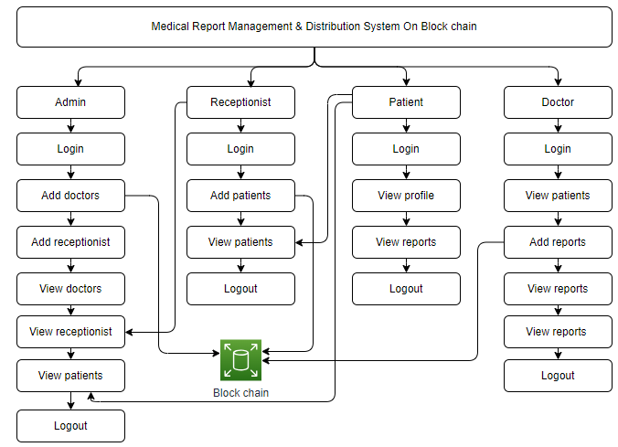

**ADVANTAGES:**

**1. Data Integrity and Authenticity:**

Blockchain ensures the integrity of medical reports and associated documents. Once a block is added to the chain, it is extremely difficult to alter the information within it.

Each transaction is recorded with a timestamp, creating an immutable and transparent ledger. This provides a clear audit trail for all medical reports and associated activities.

**2. Enhanced Security:**

Transactions are secured through encryption, making it challenging for unauthorized parties to access or manipulate sensitive medical information.

With decentralized storage across a network of computers, there is no single point of failure, reducing the risk of data breaches.

**3. Streamlined Operations:**

Integration of pathology and test labs within the hospital becomes more efficient as all transactions, from patient admission to test reports, are recorded on the blockchain. This eliminates the need for redundant record-keeping systems and improves overall operational efficiency.

**4. Transparent and Accessible Information:**

All relevant stakeholders, including patients, doctors, and administrative staff, can access the blockchain to verify the authenticity of medical reports and associated documents.

This transparency fosters trust among stakeholders, as everyone can independently validate the accuracy of the information.

**SOFTWARE FRONT END REQUIREMENTS**

# **H/W CONFIGURATION:**

# Processor - I3/Intel Processor

Hard Disk - 160GB

Key Board - Standard Windows Keyboard

Mouse - Two or Three Button Mouse

Monitor - SVGA

RAM - 8GB

**S/W CONFIGURATION:**

* Operating System : Windows 7/8/10
* Server-side Script : HTML, CSS, Bootstrap & JS
* Programming Language : Python
* Libraries : Flask, Pandas, Mysql.connector, Os, Smtplib, Numpy
* IDE/Workbench : PyCharm
* Technology : Python 3.6+
* Server Deployment : Xampp Server

**MODULES/IMPLEMENTATION**

**ADMIN**

**Login:**  The admin can login with valid credentials.

**Add doctors:** The admin can add the doctors with having valid information.

**Add receptionist:** The admin can add the receptionist by providing valid required information.

**View doctors:** The admin can view the all-registered data.

**View receptionist:** The admin can view the all-receptionist data.

**View patients:** The admin can view the all-receptionist data.

**Logout:** The admin should be logout.

**RECEPTIONISTS:**

**Login:**  The receptionist can login with using default valid credentials.

**Add Patient:** The receptionist can add the patients by providing required information.

**View patients:** The receptionist can view the all patients details over here.

**DOCTOR**

**Login:**  The doctor can login with valid credentials.

**View patients:** The doctor can view the all patients.

**Add reports:** The doctor can add the reports to patients.

**View reports:** The doctor can view the uploaded report details.

**Logout:** The doctor should be logout.

**PATIENT:**

**Login:** The patient can login with valid credentials.

**My profile:** The patient can view the profile.

**View reports:** The patient can view the reports.

**Logout:** The patient should be logout.