LTspice Tutorial
version 4.0

Rochester Institute of Technology
Digital Electronics EEEE-380

Last Update – sept, 2017

Contents
LTspice Overview: 3
System Setup: 3
LTspice Tool Description: 4
Designing Simple Circuit and performing analysis 7

LTspice Overview:

LTspice is a high performance Spice III simulator, schematic capture and waveform viewer with enhancements and models for easing the simulation of switching regulators. It is open source tool for PCB editing. This is similar to Cadence- allegro PCB tool.

This document describes how to get started with LTspice used in EEEE-380. Additional information is available from tools built in help command.

System Setup:

LTspice can run on both Windows and Macintosh.

http://www.linear.com/LTspice , Please use the link to download the Tool from official website. You can create your LTspice account for free or skip the option and Download.

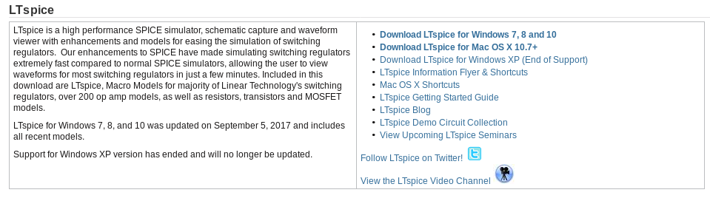
The above link also guides to start guide. However, basic start up instructions is discussed in this tutorial. You can get more information here: http://www.linear.com/docs/39806

Few Demo Circuits are available here:
http://www.linear.com/designtools/software/demo_circuits.php

LTspice Tool Description:

- How to draw Schematic:

- Once you open the LTspice, Left click on “new schematic”.

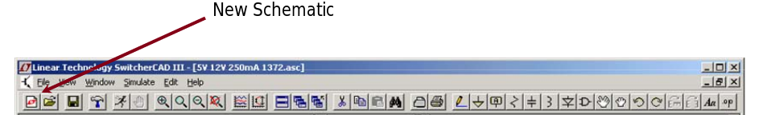

- Next step is getting used to basic circuit elements used frequently. All you need to do is left click on the element you want to use and place it in the schematic editor. You can also “Rotate” to rotate the elements respectively. “Mirror” is also used to change orientation.

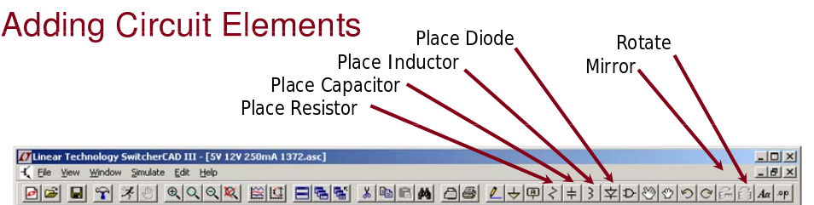

- Adding load and other components could be done using “Component” symbol in editor toolbar.

NOTE: NEVER FORGET TO ADD GROUND
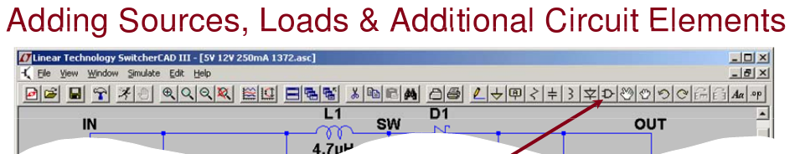

- Once you have all the required components placed in your schematic, you need to start wiring them. It is simply done by left clicking on “wire” to select wire followed by left clicking on both ends of the components which has to be connected.
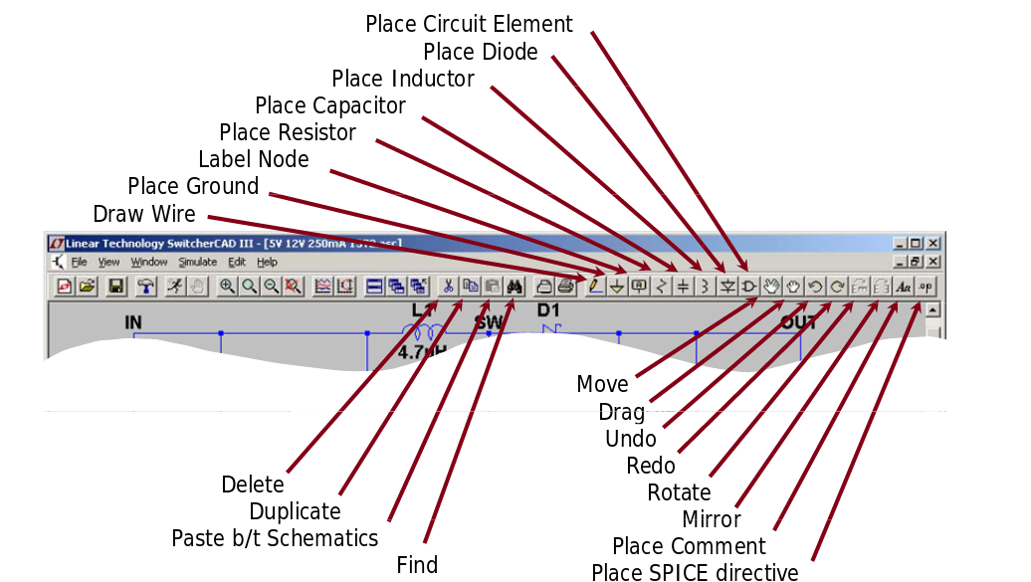
.

- Editing circuit element attributes:

Right click on the element you want to modify its attributes and enter the respective value.
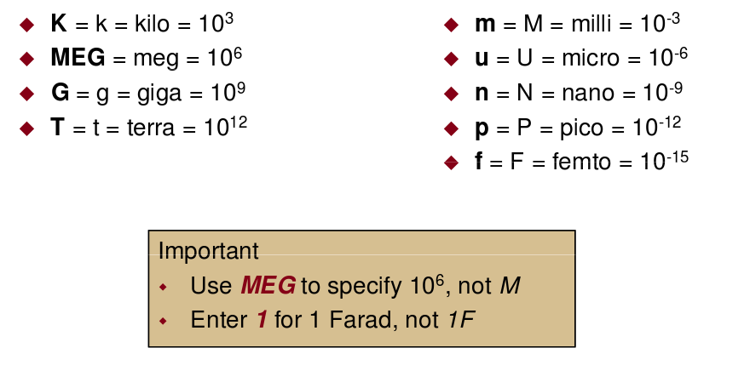

- How to Simulate:

- There are six types of analysis that can be performed by this tool.

1- Transient Analysis
2- Small signal AC
3- DC sweep
4- Noise
5- DC transfer function
6- DC operating point

NOTE: IF YOUR RUNNING DEMO CIRCUIT FROM OFFICIAL WEBSITE, IT HAS PRE-DEFINED SIMUATION COMMANDS

- Editing Simulation Commands:

1- Left click on “Simulate” in the toolbar.
2- Left click on “Edit Simulation CMD”.
3- Go to the transient tab and set the stop time (1ns)
4- Click ok.

- Simulating :

Click on the “run” icon in the toolbar.

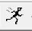

- Probing Voltage and current:

1- Left click on any wire to probe the voltage.
2- Left click on body of any component to probe the current.



Designing Simple Circuit and performing analysis:

This section deals with drawing a schematic and analyzing its characteristics. Let’s draw a band pass filter.

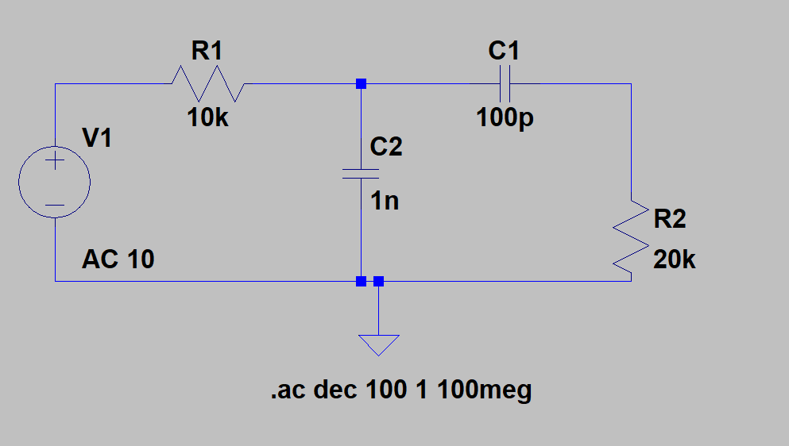

The above figure shows the band pass filter.

- Draw the Schematic using the appropriate elements from the toolbar.
- Once you have placed all the components, wire them up.
- Now right click on each component and change their attributes as shown in figure.
- Now to run the circuit, we have to perform AC analysis.
- Go to SIMULATE - > EDIT SIMULATION CMD.
- Select “AC ANALYSIS” tab, set
“ TYPE OF SWEEP -> DECADE”
“NUMBER OF POINTS PER DECADE-> 100”
“START FREQUENCY -> 1”
“STOP FREQUENCY -> 100meg”.

Once you set the output settings, please click “ Ok” and select “ RUN”

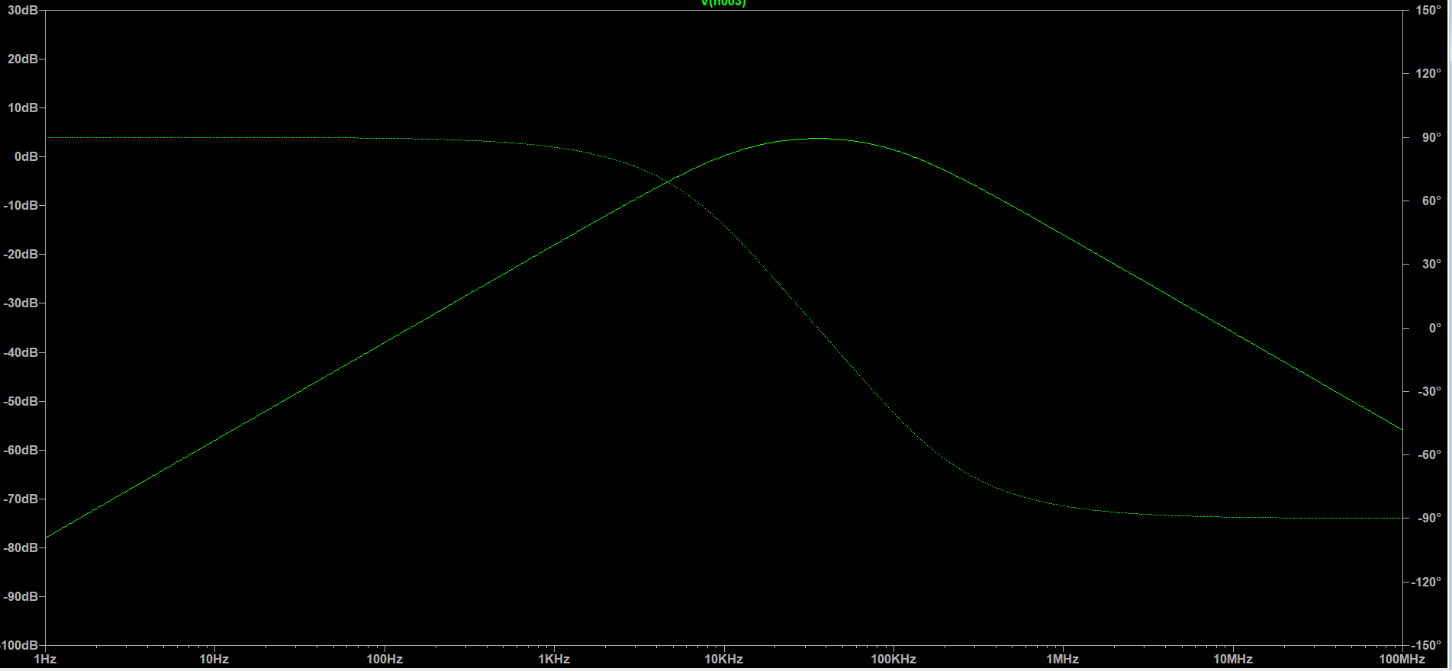

The output looks similar to this if you have same attributes for the components.

