**Lab Exercise for EEEE–380 SPICE Introduction Lab**

**(9/20–9/21/2017)**

**Cadence Version**

Do schematic capture to create this simple circuit (this bitmap is from LTspice):

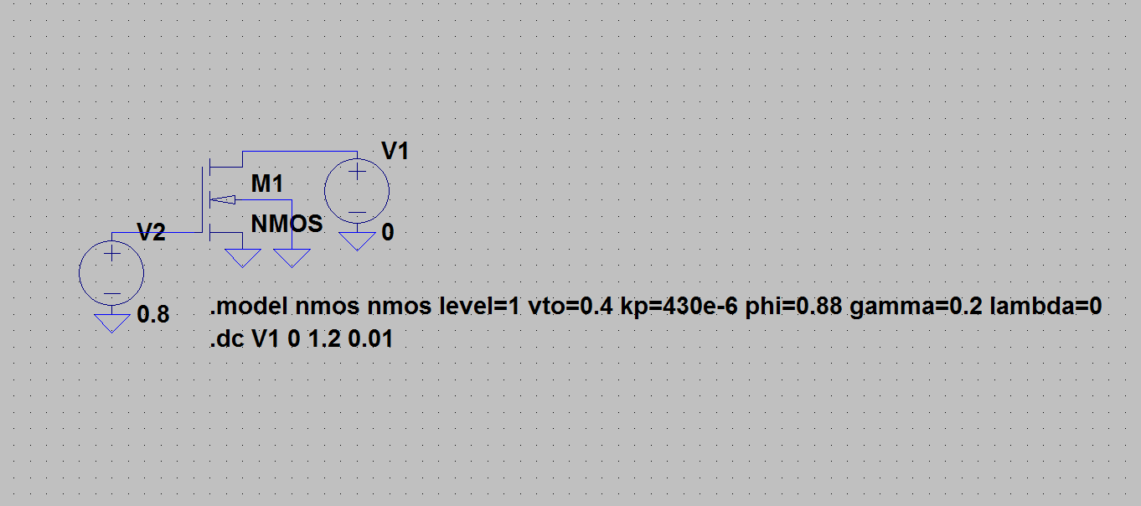

**Component selection:**

Pull down **Place … Part**. Under the Place Part set of boxes on the right side of the screen, add the **breakout** library.

For the MOSFET, choose **MbreakN** from the component pull-down listing (**MbreakN3** automatically connects body to source, which is OK here, but not in the future when there are stacked NMOS devices). Click in the schmatic field to place the part. Use Escape after placing one instance; otherwise, another instance will be placed everytime you click (you can delete by choosing (clicking) the part and hitting Delete).

For the voltage sources, use **Place … PSpice component … Source … Voltage Sources … DC** in the pull-down menu.

For grounds, use **Place … Ground … 0/SOURCE** in the pull-down menu.

Use the **wire** button to connect the components as shown.

**Modifying the components:**

Double-click on one of the voltage sources and enter the default voltage value, then Apply. Go back to the PAGE1 tab. Repeat for the other voltage source.

Double-click on the MOSFET and enter the length (the L field) as 0.1 μm (0.1u) and the width (the W field) as 1 μm (1u). Apply. Go back to the PAGE1 tab.

**Creating the operating statements:**

To edit the NMOS model, choose (click) the NMOS device, then use **Edit … PSpice model** to add the following information:

.model Mbreakn NMOS level=1 vto=0.4 kp=430u phi=0.88 gamma=0.2 lambda=0

Save the model changes (**File … Save**). Go back to the PAGE1 tab.

The DC sweep can be entered by using **Pspice … New simulation profile**. (New window will open at bottom.) Choose a DC sweep, then indicate the source that will be swept. Use the name of the one that corresponds to *VDS* of the MOSFET, not the one driving the gate. Choose a **Linear** sweep, and sweep from 0 to 1.2 V in 0.01 V increments. Hit Apply, then OK.

**Running the simulation:**

Click the **Run** button at the top (or pull down the **Pspice** menu and choose **Run**. (New window will open at bottom.) An empty graph will appear (unless you’ve had the foresight to tell the program what you want plotted). Attach a current probe (I) to the drain of the MOSFET. SPICE is very finicky about where you try to place it; you have to attach it to the drain pin, not just anywhere on the wire connecting the drain to the power supply.

**Sanity Check:**

If you did everything correctly, the saturation current should be 344 μA, and *VDSsat* should be 0.4 V, as shown below:

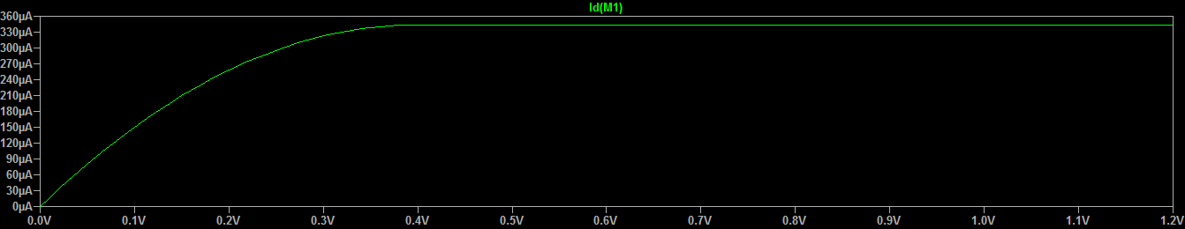

**Playing Around:**

You can easily edit an operating statement by choosing the MOSFET and using **Edit … PSpice model**. Change the SPICE model level to level 2 and re-run the simulation (just hit the Run button again) and observe the effect on your I-V curve. You should see less current and a lower *VDSsat*.