**Problem2:**

**Create a Maven enabled Java project in Eclipse. Create a sample java file in the /src/main/java folder. Complete the POM structure in the following Maven Build Process: Copy the code into pom.xml file. Build the project and attach the screen shots of the output in PDF format.**

**Step1:**

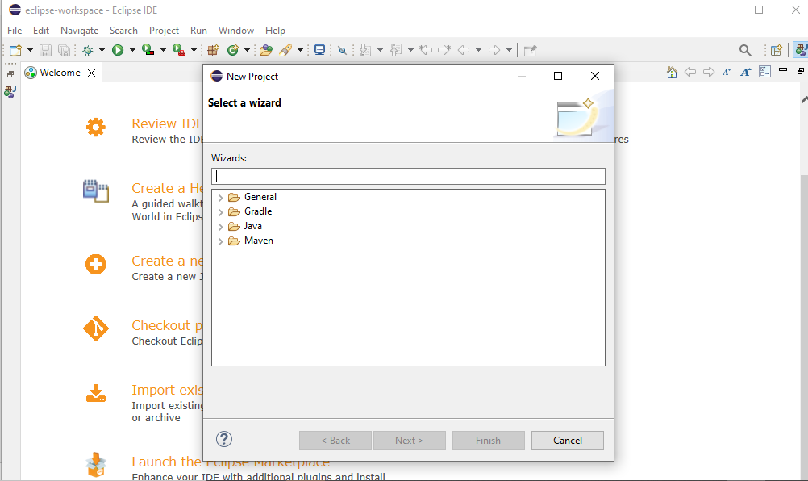

Step2:

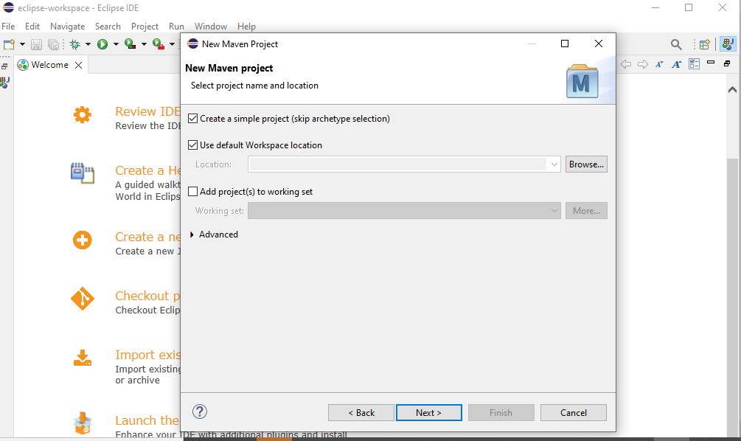

Step3:

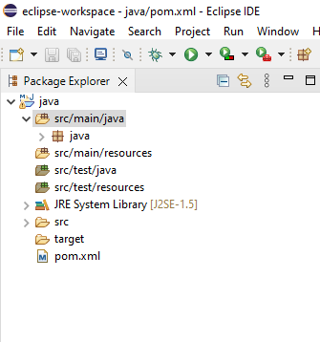

Step4:

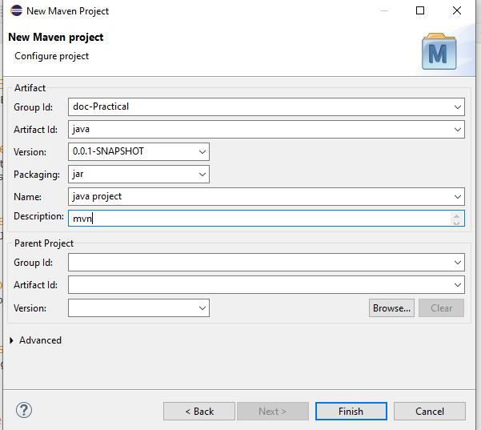

Step5:

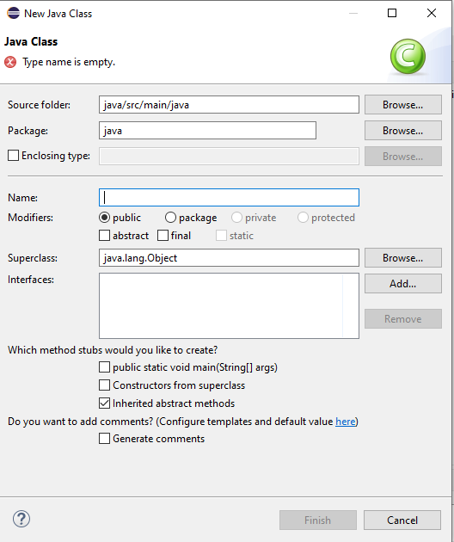

Step6:

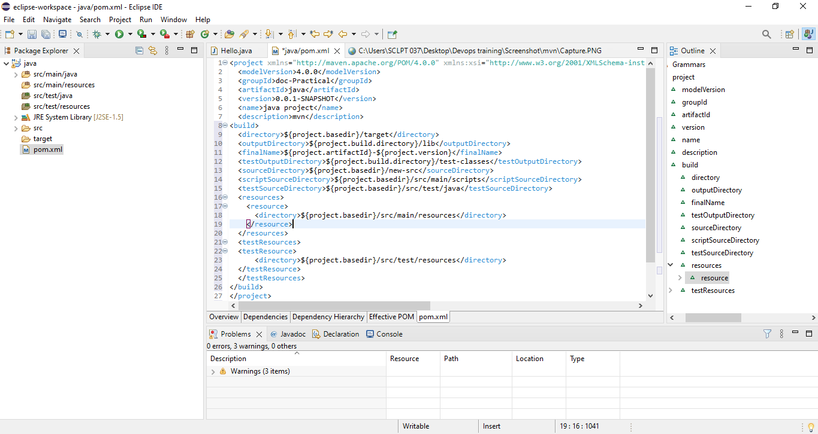

Step7:

