**Problem3:**

**Write the steps to create a repository named MySourceHub in GitHub and clone the repository using**[**Git**](https://mazenet-tms.com/mod/lesson/view.php?id=1246)**Commands. Push a sample application using**[**Git**](https://mazenet-tms.com/mod/lesson/view.php?id=1246)**Commands to GitHub Repository named MySourceHub and attach the screen shots in PDF format.**

**Step1:**

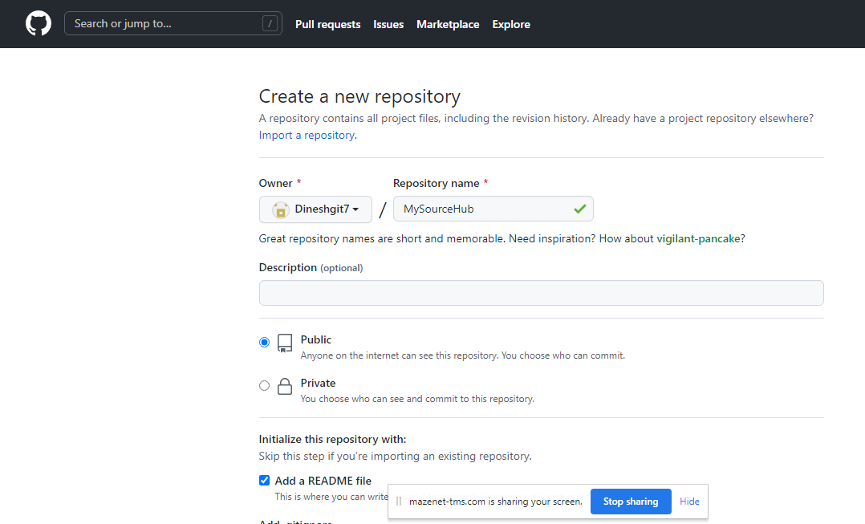

**Step2:**

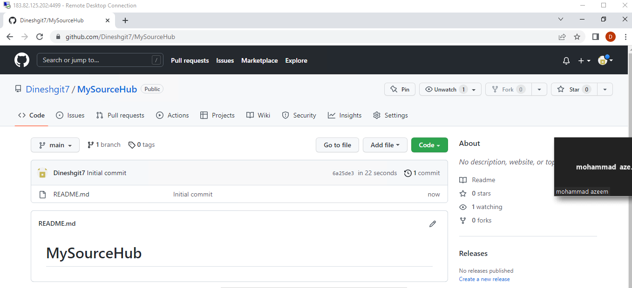

**Step3:**

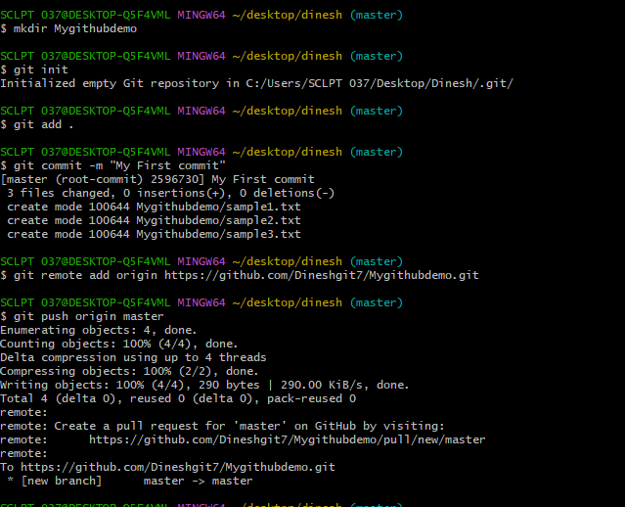

**Step4:**

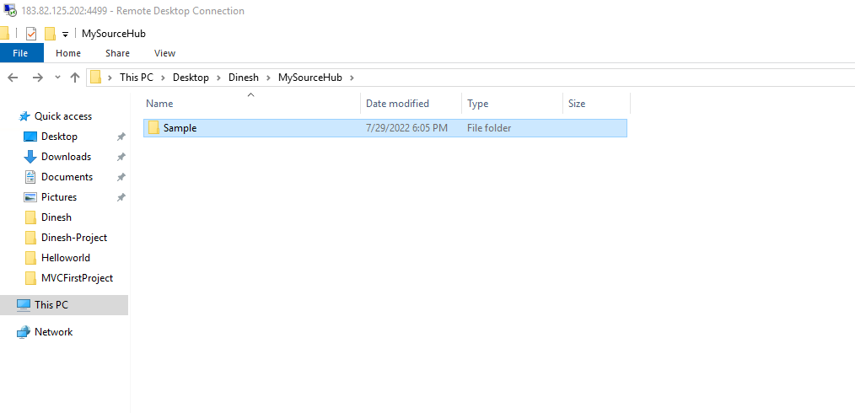

**Step5:**

