**Problem1:**

**Create a ASP.NET MVC project using C# and .NET Framework in Visual Studio 2019 Community Edition. Complete the build structure in the following MS Build Process. Copy the following targets at the end of the .csproj file before </Project>. Run the targets Build and Clean separately and attach the screen shots of the output in PDF format**.

Step1:

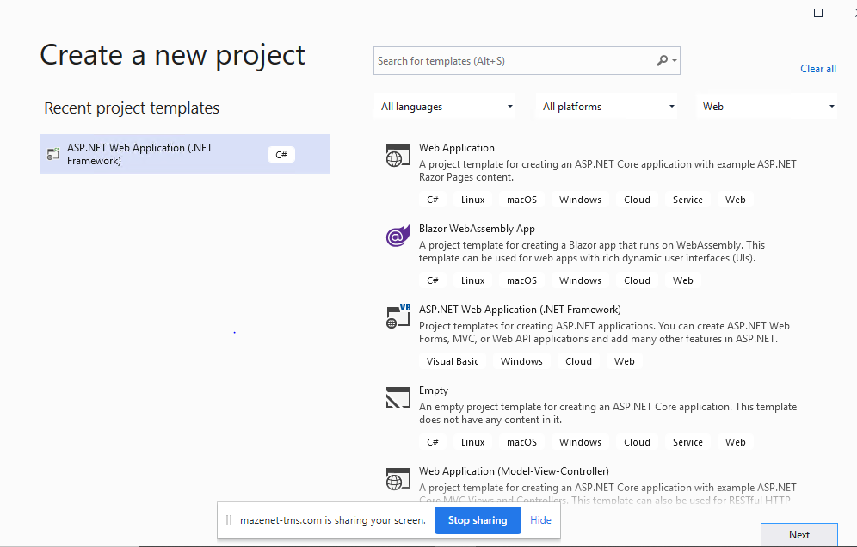

Step2:

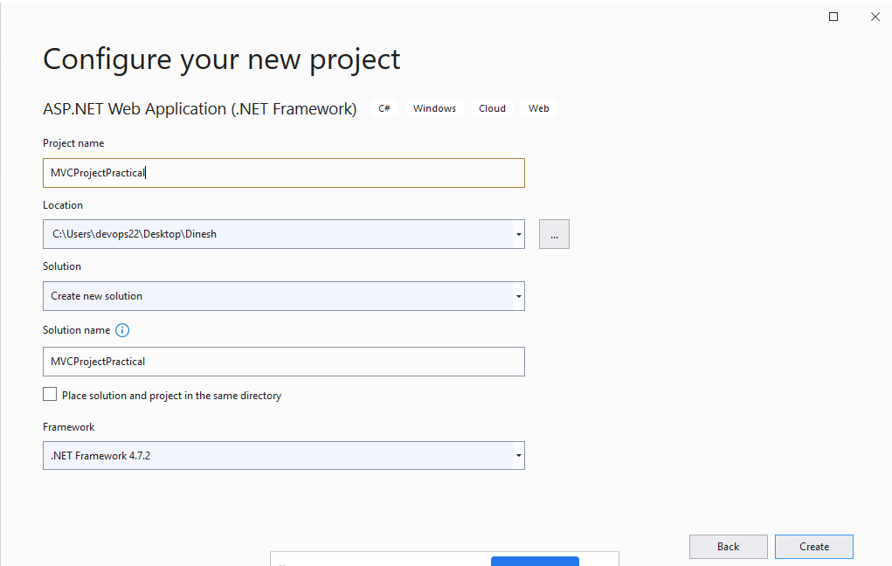

Step3:

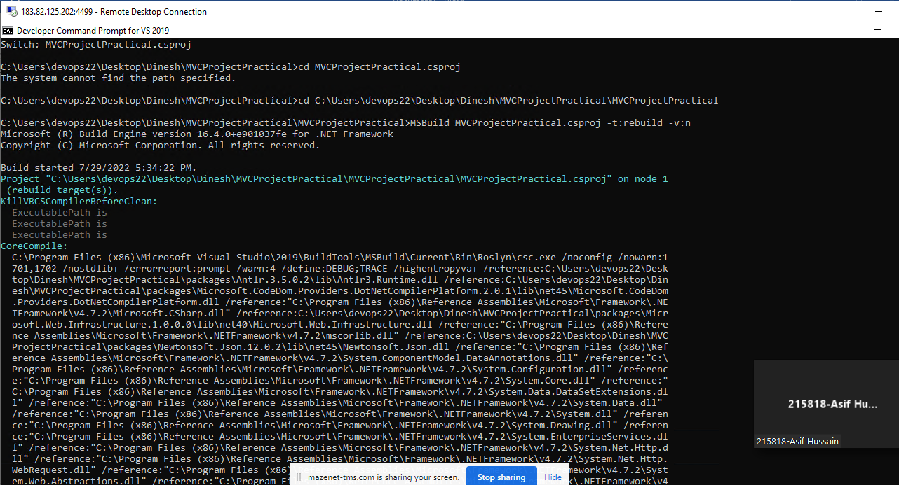

Step4:

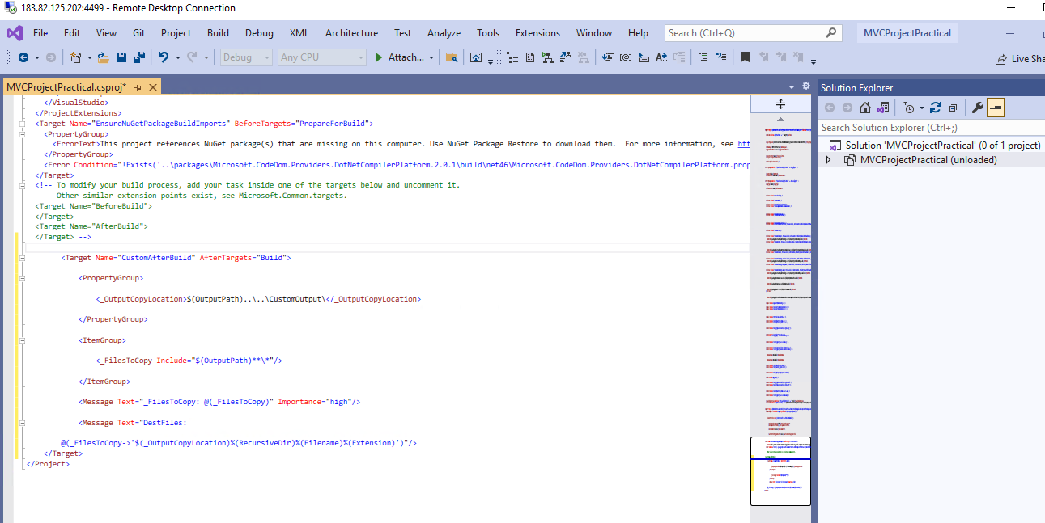

Step5:

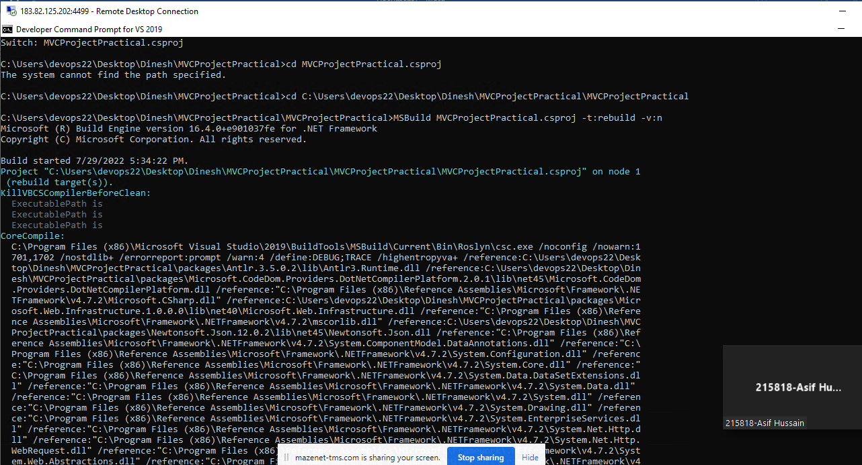

Step6:

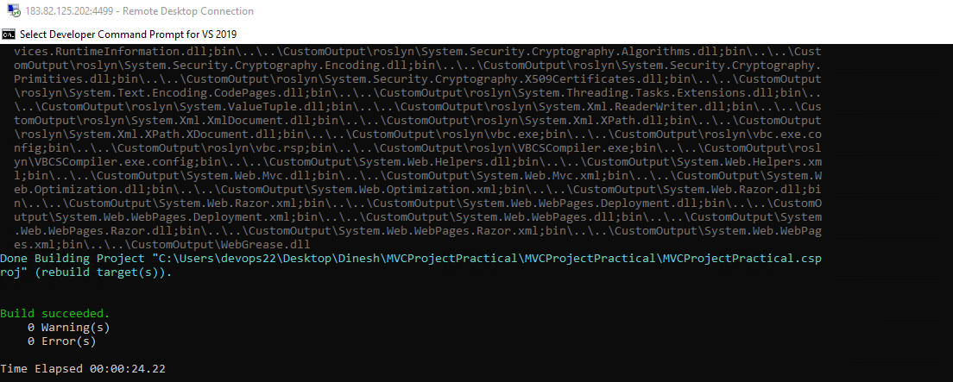

Step7:

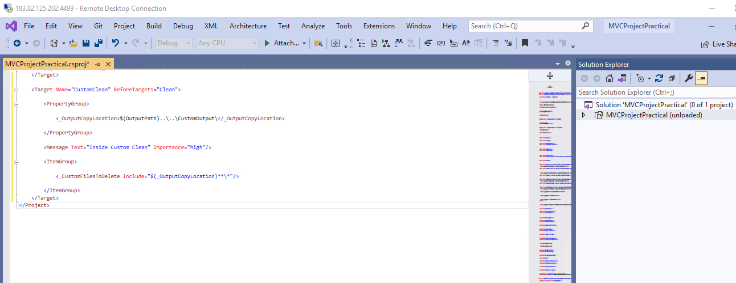

Step8:

