Lab 1: Requirements Engineering & UML Use-Case Modelling
Problem Statement #63 — Sustainability & Green Tech
Community Solar Credit Allocation Manager

Name: Dinesh Ashok Jadage
Course: Computer Science Engineering, PES University
Lab: Lab 1 — Requirements Engineering & UML Use-Case Modelling

1. Problem Context & Overview:-
A clean energy sharing portal ingesting rooftop solar generation metrics, facilitating peer-to-peer solar credit transfers within a neighborhood microgrid, and tracking monthly utility billing offsets.
Target Stakeholders / Actors: Prosumer Resident, Co-op Manager, Smart Meter (external system)

Functional Requirements :-
FR-001: The system shall record solar energy generated by each resident's smart meter.
FR-002: The system shall allow residents to transfer surplus solar credits to neighboring residents.
FR-003: The system shall display the current solar credit balance of each resident.
FR-004: The system shall calculate monthly electricity bill reductions using available solar credits.
FR-005: The system shall allow the Co-op Manager to view generation, transfer, and billing reports.

Non-Functional Requirements (NFR)
NFR-001: The system shall process data for up to 500 households with 99.9% uptime.
NFR-002: The system shall securely encrypt user data and solar credit transactions.
Source: Community Solar Credit Allocation Manager problem statement.

2. Requirements Table
Exactly five Functional Requirements (FR-001 to FR-005) and two Non-Functional Requirements (NFR-001 & NFR-002), each with Req ID, Type, Description, Priority, Acceptance Criteria, and Rationale.
Req ID | Type | Description | Priority | Acceptance Criteria | Rationale (short) | Comments
FR-001 | Functional | The system shall record solar generation units (kWh) from smart meter feeds for each resident. | High | Pass: When generation data is received from a smart meter, the system stores the correct kWh value in the resident's account within 5 minutes. Fail: Data is lost or not attributed to the correct account. | Essential for solar credit calculation.
FR-002 | Functional | The system shall allow prosumers to transfer surplus solar credits to neighboring residents' accounts. | High | Pass: Transferred credits are deducted from the sender's balance and added to the receiver's balance in the same transaction. Fail: Transfer proceeds when it exceeds the sender's available balance. | Supports peer-to-peer energy sharing.
FR-003 | Functional | The system shall display the current solar credit balance of each resident on demand. | Medium | Pass: When a resident opens their account dashboard, the balance shown matches the backend ledger to within the last completed transaction. Fail: Balance displayed differs from ledger value. | Helps residents track available credits.
FR-004 | Functional | The system shall calculate monthly utility bill offsets using each resident's available solar credits. | High | Pass: When the monthly bill is generated, eligible solar credits are automatically applied and the offset amount matches (credits x conversion rate). Fail: Bill is generated without applying eligible credits. | Reduces electricity costs accurately.
FR-005 | Functional | The system shall allow the Co-op Manager to view generation, transfer, and billing reports for the neighborhood. | Medium | Pass: When a report is requested, the system displays accurate neighborhood-wide data for the selected period within 10 seconds. Fail: Report data is missing households or is stale by more than 24 hours. | Supports monitoring and administration.
NFR-001 | Nonfunctional (Performance & Security) | The smart meter telemetry processing pipeline shall validate and store hourly generation data for up to 500 households with 99.9% uptime. | High | Pass: Benchmarking/load tests confirm the pipeline sustains 500 concurrent household feeds with 99.9% uptime over a 30-day monitoring window. Fail: Uptime falls below 99.9% or data validation errors exceed 0.1%. | Ensures reliable operation at neighborhood scale.
NFR-002 | Nonfunctional (Security) | The system shall encrypt all user data and solar credit transactions in transit and at rest. | High | Pass: Security testing verifies AES-256 (or equivalent) encryption for stored data and TLS 1.2+ for data in transit, with no plaintext sensitive data found. Fail: Any sensitive data found unencrypted in transit or storage. | Protects user information and transaction integrity.

3. Actors & Use Cases
Actors:
- Prosumer Resident — generates solar energy, transfers credits, views balance.
- Co-op Manager — monitors generation, transfers, and billing reports for the neighborhood.
- Smart Meter (external system) — feeds hourly generation telemetry into the system.
Use Cases:
- UC-01 — Record Solar Generation: Captures kWh readings from smart meter feeds (FR-001).
- UC-02 — Transfer Solar Credits: Prosumer transfers surplus credits to a neighbor (FR-002).
- UC-03 — View Credit Balance: Resident checks their current solar credit balance (FR-003).
- UC-04 — Calculate Bill Offset: System applies credits to reduce the monthly bill (FR-004).
- UC-05 — View Reports: Co-op Manager views generation/transfer/billing reports (FR-005).
- UC-06 — Validate Credit Balance: Checks sender has sufficient balance before a transfer completes — included by UC-02.
- UC-07 — Send Low Balance Alert: Optionally notifies a resident when their balance drops below a threshold — extends UC-02.

4. UML Use-Case Diagram
The diagram below models all actors, primary use cases, and includes one «include» relationship (Transfer Solar Credits includes Validate Credit Balance) and one «extend» relationship (Transfer Solar Credits is extended by Send Low Balance Alert).
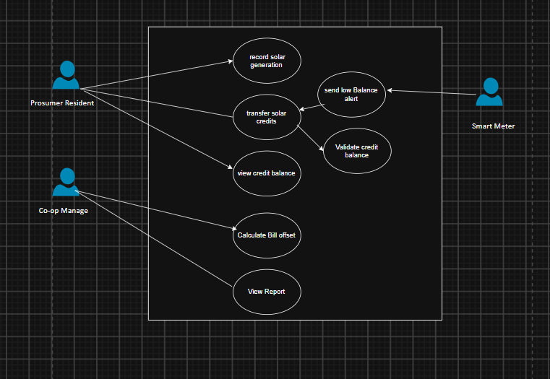

5. Use-Case Flow Specification
Use Case: UC-02 — Transfer Solar Credits
Primary Actor: Prosumer Resident
Preconditions: The sender is a registered, logged-in prosumer with a solar credit balance greater than zero; the receiving resident's account exists within the same neighborhood microgrid.
Postconditions: The sender's credit balance is reduced by the transferred amount and the receiver's balance is increased by the same amount; a transaction record is logged for billing and audit purposes.

Main Success Scenario
- Prosumer Resident selects "Transfer Solar Credits" from the account dashboard.
- System displays a form to enter the recipient's account ID and the credit amount to transfer.
- Resident enters a valid recipient account ID and credit amount, then confirms.
- System invokes UC-06 (Validate Credit Balance) to check the sender has sufficient available credits.
- System deducts the specified credits from the sender's balance.
- System adds the same amount of credits to the recipient's balance.
- System logs the transaction with a timestamp for billing and audit records.
- System displays a confirmation message showing the updated sender balance.
- Use case ends successfully.

Alternate Flow
4a. Insufficient Balance
- 4a1. System (via UC-06) determines the requested transfer amount exceeds the sender's available balance.
- 4a2. System displays an "Insufficient credits" message and rejects the transfer.
- 4a3. If the resulting balance is below the configured low-balance threshold, System triggers UC-07 (Send Low Balance Alert) to notify the resident.
- 4a4. Resident may revise the transfer amount and resubmit, or cancel the operation.
- 4a5. Use case ends (transfer not completed).

