PROJECT REPORT
on
SpendSmart
Personal Expense Tracker Pro
Submitted for:
iStop Web Development Front-End Mentorship
Internship Project 1 — Version 2.0

Technologies Used:
HTML5 | CSS3 | Bootstrap 5 | JavaScript (ES6) | jQuery | Chart.js

TABLE OF CONTENTS
1. Abstract 3
2. Objective 4
3. Introduction 5
4. Methodology 7
4.1 System Architecture 7
4.2 Technology Stack 8
4.3 Module-wise Design 9
4.4 Data Flow 10
4.5 UI/UX Design Principles 11
5. Code Listing 12
5.1 index.html 12
5.2 style.css 14
5.3 app.js 16
6. Results & Output 19
7. Conclusion 20

1. ABSTRACT
SpendSmart is a fully client-side Personal Expense Tracker web application developed as part of the iStop Web Development Front-End Mentorship Internship Project. The application enables individuals to record, categorise, analyse, and visualise their income and expenditure without requiring any server infrastructure or third-party accounts. Built exclusively with HTML5, CSS3, Bootstrap 5, JavaScript (ES6), jQuery, and Chart.js, SpendSmart runs entirely in the browser and persists data using the browser's localStorage API.
The application provides four core functional modules: a real-time Dashboard presenting financial summaries and charts; a Transactions module for adding, filtering, searching, and deleting entries; an Analytics module for in-depth trend analysis; and a Budget Planner that allows category-level spending limits with progress tracking and over-budget alerts.
This report documents the design rationale, technological choices, architectural decisions, complete source code, and visual outputs of the SpendSmart v2.0 application. The project demonstrates proficiency in front-end web development, responsive UI design, JavaScript-driven DOM manipulation, data visualisation with Chart.js, and client-side data persistence. The outcome is a polished, production-grade application that is easily deployable by simply opening a single HTML file in any modern web browser.
Key achievements include a professional sidebar navigation layout, four interactive Chart.js visualisations, real-time search and multi-criteria filtering, CSV data export, toast notification system, and a fully responsive layout compatible with desktops, tablets, and mobile devices.

2. OBJECTIVE
The primary objectives of the SpendSmart Personal Expense Tracker project are as follows:
2.1 Primary Objectives
- To design and develop a complete, fully functional personal finance management web application using only front-end technologies.
- To implement persistent data storage in the browser using the localStorage API, ensuring transactions and budget configurations survive page refreshes and browser restarts.
- To provide users with an intuitive dashboard that summarises total income, total expenses, net balance, and average daily expenditure at a glance.
- To enable comprehensive transaction management including adding new entries, searching by description or category, filtering by type and category, sorting by date or amount, and deleting individual records.
- To integrate Chart.js to render four distinct chart types — bar chart, doughnut chart, line chart, and pie chart — providing clear visual representations of financial data.
- To implement a Budget Planner that allows users to set spending limits per expense category with real-time visual progress indicators and over-budget alerts.
- To provide a CSV export feature allowing users to download their transaction history for use in spreadsheet applications.
- To build a fully responsive UI that adapts gracefully to desktop, tablet, and mobile screen sizes using CSS Grid, Flexbox, and Bootstrap 5 utilities.
2.2 Learning Objectives
- To demonstrate mastery of semantic HTML5 markup and advanced CSS3 techniques including CSS variables, animations, and transitions.
- To practise JavaScript ES6+ features including arrow functions, template literals, destructuring, spread operator, and array methods.
- To gain practical experience with jQuery for efficient DOM manipulation and event delegation.
- To understand the Chart.js library API for creating responsive, interactive data visualisations.
- To apply Bootstrap 5 components (Modal, Grid, Utilities) in a real-world application context.
- To learn client-side data persistence patterns using JSON serialisation and localStorage.

3. INTRODUCTION
3.1 Background
Personal financial management is a critical life skill, yet a majority of individuals lack an easy, accessible tool to monitor their day-to-day spending and income. While commercial applications like Mint, YNAB, and Money Manager exist, they often require account registration, cloud connectivity, subscription fees, or mobile installations. There is a clear demand for a lightweight, privacy-first, zero-dependency tool that works locally in the browser.
SpendSmart addresses this gap by providing a professional-grade expense tracking experience that requires nothing more than a modern web browser. With data stored locally and no network calls required, users retain complete control over their financial information.
3.2 Project Context
This project was developed as Internship Project 1 (v2.0) under the iStop Web Development Front-End Mentorship programme. Version 2.0 is a significant upgrade over a hypothetical v1.0 baseline, introducing a sidebar navigation layout, multi-page tab architecture, the Analytics module, the Budget Planner, month-based filtering, CSV export, and a significantly elevated visual design language.
3.3 Application Overview
SpendSmart is a Single-Page Application (SPA) composed of three source files: index.html (structure), style.css (presentation), and app.js (behaviour). The entire application runs in the browser with no back-end server. On first load, a set of seed transactions is automatically inserted to demonstrate the application's capabilities.
The application is divided into four navigable tabs:
Tab / Module | Description
Dashboard | Landing view showing summary cards, bar chart (monthly income vs expense), doughnut chart (expense by category), and a recent transactions list.
Transactions | Complete transaction list with search, multi-criteria filtering, sorting controls, and per-item delete functionality.
Analytics | Advanced analytical view with a spending trend line chart, income vs expense pie chart, category breakdown table with progress bars, and top 5 expenses list.
Budget Planner | Per-category spending limit configuration with visual progress bars, colour-coded status indicators (green/amber/red), and over-budget alerts.
3.4 File Structure
expense-tracker-v2/
├── index.html → Full page layout (sidebar, tabs, modal, toast)
├── style.css → Sidebar, summary cards, charts, responsive CSS
├── app.js → All JavaScript + jQuery logic (state, charts, CRUD)
└── README.md → Project documentation and usage instructions

3.5 External CDN Dependencies
Library | Purpose
Bootstrap 5.3.0 CSS | Layout grid, modal, button, badge, and utility classes
Bootstrap 5.3.0 JS | Modal behaviour (show, hide, backdrop)
jQuery 3.7.0 | DOM selection, event delegation, AJAX-style async patterns
Chart.js (latest) | Canvas-based chart rendering — Bar, Doughnut, Line, Pie
Plus Jakarta Sans | Google Fonts — primary UI typeface for sidebar and modal

4. METHODOLOGY
4.1 System Architecture
SpendSmart follows a classic Model-View-Controller (MVC) inspired pattern entirely within the client-side JavaScript. There is no server, no database, and no API — all state lives in a JavaScript array in memory and is synchronised to localStorage on every write operation.
Layer | Implementation
Model (State) | transactions[] and budgets{} objects in app.js. Serialised to localStorage as JSON strings under keys ss_transactions and ss_budgets.
View (Rendering) | jQuery-powered DOM manipulation functions: renderDashboard(), renderTransactions(), renderAnalytics(), renderBudget(). Each function reads from state and rewrites the relevant HTML section.
Controller (Events) | jQuery event bindings: addTransaction(), del-btn click delegation, budget-limit-input change, switchTab(), exportCSV(), clearAll(), setModalType(), and month-filter onChange.
4.2 Technology Stack
The following technologies were carefully selected for the project:
Technology | Usage Details
HTML5 | Semantic layout using <nav>, <header>, <main> patterns. Bootstrap 5 modal markup. Canvas elements for Chart.js.
CSS3 | Custom properties (CSS variables) for theming. CSS Grid for the summary and budget layouts. Flexbox for sidebar navigation. Keyframe animations (fadeIn, slideIn, toastIn). Media queries for responsive breakpoints at 1100px and 768px.
Bootstrap 5.3 | Modal component, d-none toggle, row/col grid utilities, btn-close, and gap utilities.
JavaScript ES6+ | Arrow functions, template literals, destructuring, spread operator, Array.from, Set for deduplication, Date object manipulation, JSON parse/stringify, and localStorage API.
jQuery 3.7 | Cross-browser DOM selection ($), .html()/.text()/.val(), event delegation with .on(), .toggleClass(), .append()/.fadeOut(), and .off() for safe re-binding.
Chart.js | Responsive canvas charts. Destroyed and re-created on each renderAll() to prevent memory leaks. Custom tooltips with Indian Rupee (INR) formatting. Custom font (Plus Jakarta Sans) applied via options.
4.3 Module-wise Design
4.3.1 State Management
The application maintains two primary state variables: transactions (an array of objects with fields id, desc, amount, category, date, note, type) and budgets (an object mapping category names to numeric limit values). A save() helper serialises both to localStorage on every mutating operation.
4.3.2 Transaction CRUD
Create: The Add Transaction modal collects description, amount, date, category, note, and type (income/expense). Four client-side validations are enforced. On submit, a unique id (Date.now()) is assigned. Read: getFilteredTxs() applies the global month filter. Delete: jQuery event delegation on .del-btn removes by id. The clearAll() function prompts the user with a confirmation dialog before wiping all data.
4.3.3 Chart Rendering Strategy
Each chart (barChart, doughnutChart, lineChart, pieChart) is held in a module-level variable. Before creating a new chart instance, the existing instance is destroyed with .destroy() to free the canvas context and prevent ghost chart artefacts. Charts are re-rendered on every renderAll() call.
4.3.4 Budget Planner
Budget cards are dynamically generated for all non-income categories (Food, Transport, Shopping, Entertainment, Health, Education, Other). Each card shows the amount spent from filtered transactions alongside an editable limit input. A percentage calculation drives the progress bar width and colour: green (0-74%), amber (75-99%), red (100%+).
4.3.5 CSV Export
The exportCSV() function constructs a comma-separated string from all transactions, encodes it as a data URI, creates a temporary anchor element, programmatically clicks it to trigger a browser download, and discards the element.
4.4 Data Flow
The lifecycle of a transaction from creation to visual output follows these steps:
- User opens the Add Transaction modal via the "+ Add Transaction" button in the top bar.
- User fills in description, amount, date, category (optional note), and selects income or expense type.
- On clicking "Add Transaction / Add Income", addTransaction() validates all fields.
- A new transaction object { id, desc, amount, category, date, note, type } is pushed to the transactions array.
- save() is called, serialising the updated array to localStorage as a JSON string.
- populateMonthFilter() updates the month dropdown with any newly encountered months.
- renderAll() is invoked, which calls the relevant render function for the current active tab.
- The dashboard summary cards, charts, and recent list are updated with fresh data.
- A success toast notification slides in from the bottom-right corner.
4.5 UI/UX Design Principles
The interface follows several established UX design principles:
Principle | Application in SpendSmart
Visual Hierarchy | Main heading 16pt bold, sub-headings 14pt bold, body text 12pt — mirroring this report's own formatting. Colour weight guides the user's eye.
Colour Semantics | Green (#10b981) consistently denotes income/positive; Red (#ef4444) denotes expense/negative; Indigo (#5B6EF5) represents neutral navigation elements.
Feedback Loops | Toast notifications confirm every user action (add, delete, export, budget update). The modal closes automatically on success.
Progressive Disclosure | The sidebar shows top-level navigation; detailed analytics are only one click away in the Analytics tab, keeping the dashboard clean.
Responsive Adaptation | On screens below 768px the sidebar is hidden, the summary grid collapses to 2 columns, and charts stack vertically.

5. CODE LISTING
The following section contains the complete source code of all three project files.
5.1 index.html
The HTML file provides the full structural skeleton: sidebar navigation, top bar, four tab content panels, the Add Transaction modal, and the toast container.
<!DOCTYPE html>
<html lang="en">
<head>
<meta charset="UTF-8"/>
<meta name="viewport" content="width=device-width, initial-scale=1.0"/>
<title>Personal Expense Tracker Pro</title>
<link rel="stylesheet" href="https://cdn.jsdelivr.net/npm/bootstrap@5.3.0/dist/css/bootstrap.min.css"/>
<link href="https://fonts.googleapis.com/css2?family=Plus+Jakarta+Sans:wght@300;400;500;600;700;800&display=swap" rel="stylesheet">
<link rel="stylesheet" href="style.css"/>
</head>
<body>

<!-- SIDEBAR -->
<div class="sidebar" id="sidebar">
<div class="sidebar-brand">
<div class="brand-logo">💰</div>
<div class="brand-text">
<span class="brand-name">SpendSmart</span>
<span class="brand-sub">Expense Tracker</span>
</div>
</div>
<nav class="sidebar-nav">
<a class="nav-link active" data-tab="dashboard" onclick="switchTab('dashboard')">
<span class="nav-icon">🏠</span><span class="nav-label">Dashboard</span>
</a>
<a class="nav-link" data-tab="transactions" onclick="switchTab('transactions')">
<span class="nav-icon">📋</span><span class="nav-label">Transactions</span>
</a>
<a class="nav-link" data-tab="analytics" onclick="switchTab('analytics')">
<span class="nav-icon">📊</span><span class="nav-label">Analytics</span>
</a>
<a class="nav-link" data-tab="budget" onclick="switchTab('budget')">
<span class="nav-icon">🎯</span><span class="nav-label">Budget</span>
</a>
</nav>
<div class="sidebar-footer">
<button class="btn-export" onclick="exportCSV()">⬇ Export CSV</button>
<button class="btn-clear-all" onclick="clearAll()">🗑 Clear All</button>
</div>
</div>

<!-- MAIN AREA -->
<div class="main-area">
<!-- TOP BAR -->
<div class="topbar">
<div>
<h1 class="topbar-title" id="page-title">Dashboard</h1>
<p class="topbar-sub" id="current-date"></p>
</div>
<div class="d-flex align-items-center gap-3">
<select id="month-filter" class="month-select" onchange="renderAll()">
<option value="all">All Time</option>
</select>
<button class="btn-add-top" data-bs-toggle="modal" data-bs-target="#addModal">
+ Add Transaction
</button>
</div>
</div>

<!-- DASHBOARD TAB -->
<div class="tab-content" id="tab-dashboard">
<div class="summary-grid">
<div class="scard scard-income">
<div class="scard-icon">📈</div>
<div class="scard-body">
<p class="scard-label">Total Income</p>
<h3 class="scard-value" id="total-income">₹0.00</h3>
<p class="scard-change" id="income-count">0 entries</p>
</div>
</div>
<div class="scard scard-expense">
<div class="scard-icon">📉</div>
<div class="scard-body">
<p class="scard-label">Total Expenses</p>
<h3 class="scard-value" id="total-expense">₹0.00</h3>
<p class="scard-change" id="expense-count">0 entries</p>
</div>
</div>
<div class="scard scard-balance">
<div class="scard-icon">🏦</div>
<div class="scard-body">
<p class="scard-label">Net Balance</p>
<h3 class="scard-value" id="net-balance">₹0.00</h3>
<p class="scard-change" id="savings-rate">0% savings rate</p>
</div>
</div>
<div class="scard scard-avg">
<div class="scard-icon">📅</div>
<div class="scard-body">
<p class="scard-label">Avg / Day</p>
<h3 class="scard-value" id="avg-day">₹0.00</h3>
<p class="scard-change" id="this-month-label">this month</p>
</div>
</div>
</div>
<!-- Charts Row -->
<div class="charts-grid">
<div class="chart-card">
<h6 class="chart-title">Monthly Income vs Expense</h6>
<canvas id="barChart" height="200"></canvas>
</div>
<div class="chart-card">
<h6 class="chart-title">Expense by Category</h6>
<canvas id="doughnutChart" height="200"></canvas>
</div>
</div>
<!-- Recent Transactions -->
<div class="section-card">
<div class="section-header">
<h6 class="section-title">Recent Transactions</h6>
<a class="view-all" onclick="switchTab('transactions')">View All →</a>
</div>
<div id="recent-list"></div>
</div>
</div>

<!-- TRANSACTIONS TAB -->
<div class="tab-content d-none" id="tab-transactions">
<div class="section-card">
<div class="section-header mb-3">
<h6 class="section-title">All Transactions</h6>
<span class="badge-count" id="tx-count-badge">0</span>
</div>
<div class="filter-bar">
<input type="text" id="search-input" class="filter-input" placeholder="🔍 Search..."/>
<select id="filter-cat" class="filter-select" onchange="renderTransactions()">
<option value="all">All Categories</option>
<!-- category options -->
</select>
<select id="filter-type" class="filter-select" onchange="renderTransactions()">
<option value="all">All Types</option>
<option value="income">Income</option>
<option value="expense">Expense</option>
</select>
<select id="sort-by" class="filter-select" onchange="renderTransactions()">
<option value="newest">Newest First</option>
<option value="oldest">Oldest First</option>
<option value="highest">Highest Amount</option>
<option value="lowest">Lowest Amount</option>
</select>
</div>
<div id="tx-full-list"></div>
</div>
</div>

<!-- ANALYTICS TAB -->
<div class="tab-content d-none" id="tab-analytics">
<div class="charts-grid">
<div class="chart-card">
<h6 class="chart-title">Spending Trend (Line)</h6>
<canvas id="lineChart" height="220"></canvas>
</div>
<div class="chart-card">
<h6 class="chart-title">Income vs Expense Split</h6>
<canvas id="pieChart" height="220"></canvas>
</div>
</div>
<div class="section-card"><div id="cat-breakdown"></div></div>
<div class="section-card mt-3"><div id="top-expenses"></div></div>
</div>

<!-- BUDGET TAB -->
<div class="tab-content d-none" id="tab-budget">
<div class="budget-intro">
<h6 class="section-title mb-1">Monthly Budget Planner</h6>
<p>Set spending limits per category and track how you're doing.</p>
</div>
<div id="budget-cards"></div>
</div>
</div>

<!-- ADD TRANSACTION MODAL -->
<div class="modal fade" id="addModal" tabindex="-1">
<div class="modal-dialog modal-dialog-centered">
<div class="modal-content custom-modal">
<div class="modal-header">
<h5 class="modal-title">Add Transaction</h5>
<button type="button" class="btn-close" data-bs-dismiss="modal"></button>
</div>
<div class="modal-body">
<div class="type-toggle mb-3">
<button class="type-btn expense-btn active" onclick="setModalType('expense')">
− Expense
</button>
<button class="type-btn income-btn" onclick="setModalType('income')">
+ Income
</button>
</div>
<input type="text" id="m-desc" class="custom-input" placeholder="Description *"/>
<input type="number" id="m-amt" class="custom-input" placeholder="Amount (₹) *"/>
<input type="date" id="m-date" class="custom-input"/>
<select id="m-cat" class="custom-input">
<!-- category options -->
</select>
<input type="text" id="m-note" class="custom-input" placeholder="Note (optional)"/>
</div>
<div class="modal-footer">
<button class="btn-cancel" data-bs-dismiss="modal">Cancel</button>
<button class="btn-submit" id="submit-btn" onclick="addTransaction()">
Add Transaction
</button>
</div>
</div>
</div>
</div>

<!-- TOAST CONTAINER -->
<div class="toast-wrap" id="toast-wrap"></div>

<script src="https://cdn.jsdelivr.net/npm/bootstrap@5.3.0/dist/js/bootstrap.bundle.min.js"></script>
<script src="https://code.jquery.com/jquery-3.7.0.min.js"></script>
<script src="https://cdn.jsdelivr.net/npm/chart.js"></script>
<script src="app.js"></script>
</body>
</html>

5.2 style.css (Key Sections)
The CSS file defines CSS custom properties for consistent theming, sidebar layout, responsive grid, animation keyframes, and all component styles. Key sections are shown below.
:root {
--navy: #0f1b35;
--accent: #5b6ef5;
--accent2: #8e54e9;
--green: #10b981;
--red: #ef4444;
--amber: #f59e0b;
--bg: #f4f6fb;
--card: #ffffff;
--text: #1e293b;
--sidebar-w: 230px;
--top-h: 70px;
}

/* ── SIDEBAR ── */
.sidebar {
width: var(--sidebar-w);
background: var(--navy);
min-height: 100vh;
position: fixed;
top: 0; left: 0;
display: flex;
flex-direction: column;
z-index: 100;
}

.nav-link.active {
background: linear-gradient(135deg, var(--accent), var(--accent2));
color: #fff;
font-weight: 600;
}

/* ── SUMMARY CARDS ── */
.summary-grid {
display: grid;
grid-template-columns: repeat(4, 1fr);
gap: 16px;
margin-bottom: 22px;
}

.scard-income { background: linear-gradient(135deg, #059669, #10b981); }
.scard-expense { background: linear-gradient(135deg, #dc2626, #ef4444); }
.scard-balance { background: linear-gradient(135deg, #4f46e5, #818cf8); }
.scard-avg { background: linear-gradient(135deg, #d97706, #f59e0b); }

/* ── TRANSACTION ITEMS ── */
.tx-item {
display: flex;
align-items: center;
justify-content: space-between;
padding: 12px 14px;
border-radius: 12px;
margin-bottom: 8px;
background: var(--bg);
border-left: 4px solid transparent;
animation: slideIn 0.3s ease;
}
.tx-item.income { border-left-color: var(--green); }
.tx-item.expense { border-left-color: var(--red); }

@keyframes slideIn {
from { opacity: 0; transform: translateX(-12px); }
to { opacity: 1; transform: translateX(0); }
}

/* ── BUDGET GRID ── */
.budget-grid {
display: grid;
grid-template-columns: repeat(3, 1fr);
gap: 14px;
}

/* ── TOAST ── */
.toast-wrap {
position: fixed;
bottom: 24px; right: 24px;
z-index: 9999;
display: flex;
flex-direction: column;
gap: 8px;
}

/* ── RESPONSIVE ── */
@media (max-width: 768px) {
:root { --sidebar-w: 0px; }
.sidebar { display: none; }
.summary-grid { grid-template-columns: 1fr 1fr; }
.charts-grid { grid-template-columns: 1fr; }
.budget-grid { grid-template-columns: 1fr; }
}

5.3 app.js (Application Logic)
The app.js file contains all JavaScript logic. It is wrapped in a jQuery $(document).ready() handler to ensure the DOM is fully loaded before execution.
// ── STATE ──
let transactions = JSON.parse(localStorage.getItem("ss_transactions")) || [];
let budgets = JSON.parse(localStorage.getItem("ss_budgets")) || {};
let currentTab = "dashboard";
let modalType = "expense";
let barChart, doughnutChart, lineChart, pieChart;

const CATEGORIES = [
"Food 🍔","Transport 🚗","Shopping 🛍️","Entertainment 🎬",
"Health 💊","Education 📚","Salary 💼","Freelance 💻","Other 📦"
];

// ── HELPERS ──
function save() {
localStorage.setItem("ss_transactions", JSON.stringify(transactions));
localStorage.setItem("ss_budgets", JSON.stringify(budgets));
}

function fmt(n) {
return "₹" + parseFloat(n||0).toFixed(2)
.replace(/\B(?=(\d{3})+(?!\d))/g, ",");
}

function toast(msg, type = "success") {
const el = $(`<div class="toast-item ${type}">${msg}</div>`);
$("#toast-wrap").append(el);
setTimeout(() => el.fadeOut(300, () => el.remove()), 2600);
}

// ── ADD TRANSACTION ──
window.addTransaction = function() {
const desc = $("#m-desc").val().trim();
const amt = parseFloat($("#m-amt").val());
const cat = $("#m-cat").val();
const date = $("#m-date").val();
const note = $("#m-note").val().trim();

if (!desc) { toast("⚠ Please enter a description", "error"); return; }
if (!amt || amt <= 0) { toast("⚠ Enter a valid amount","error"); return; }
if (!cat) { toast("⚠ Please select a category","error"); return; }
if (!date) { toast("⚠ Please select a date","error"); return; }

transactions.push({
id: Date.now(), desc, amount: amt,
category: cat, date, note, type: modalType
});
save();
populateMonthFilter();
renderAll();
bootstrap.Modal.getInstance(document.getElementById("addModal")).hide();
toast(modalType === "income" ? "✅ Income added!" : "✅ Expense added!", "success");
};

// ── DELETE ──
$(document).on("click", ".del-btn", function() {
const id = parseInt($(this).data("id"));
transactions = transactions.filter(t => t.id !== id);
save(); populateMonthFilter(); renderAll();
toast("🗑 Transaction deleted", "warning");
});

// ── EXPORT CSV ──
window.exportCSV = function() {
const headers = ["Date","Description","Category","Type","Amount","Note"];
const rows = transactions
.sort((a,b) => new Date(b.date) - new Date(a.date))
.map(t => [t.date, `"${t.desc}"`, t.category, t.type, t.amount, `"${t.note||""}"`]);
const csv = [headers, ...rows].map(r => r.join(",")).join("\n");
const a = document.createElement("a");
a.href = "data:text/csv;charset=utf-8," + encodeURIComponent(csv);
a.download = "transactions_" + new Date().toISOString().slice(0,10) + ".csv";
a.click();
toast("📁 CSV exported!", "success");
};

// ── BAR CHART ──
function renderBarChart(allTxs) {
const months = [...new Set(allTxs.map(t => t.date?.slice(0,7)))]
.filter(Boolean).sort().slice(-6);
const incData = months.map(m =>
allTxs.filter(t => t.type==="income" && t.date.slice(0,7)===m)
.reduce((s,t) => s+t.amount, 0));
const expData = months.map(m =>
allTxs.filter(t => t.type==="expense" && t.date.slice(0,7)===m)
.reduce((s,t) => s+t.amount, 0));

if (barChart) barChart.destroy();
barChart = new Chart(document.getElementById("barChart").getContext("2d"), {
type: "bar",
data: { labels: months, datasets: [
{ label:"Income", data: incData,
backgroundColor:"rgba(16,185,129,0.8)", borderRadius:6 },
{ label:"Expense", data: expData,
backgroundColor:"rgba(239,68,68,0.8)", borderRadius:6 }
]},
options: { responsive: true, scales: {
y: { ticks: { callback: v => "₹" + v.toLocaleString("en-IN") } }
}}
});
}

// ── BUDGET RENDER ──
function renderBudget() {
const txs = getFilteredTxs();
const catTotals = getCategoryTotals(txs);
const expCats = CATEGORIES.filter(
c => !["Salary 💼","Freelance 💻"].includes(c));

$("#budget-cards").html("<div class=\"budget-grid\">" +
expCats.map(cat => {
const spent = catTotals[cat] || 0;
const limit = budgets[cat] || 0;
const pct = limit>0 ? Math.min(Math.round((spent/limit)*100),100) : 0;
const over = limit>0 && spent>limit;
const color = over ? "#ef4444" : pct>75 ? "#f59e0b" : "#10b981";
return `<div class="budget-card">
<div class="budget-emoji">${CAT_EMOJI[cat]}</div>
<div class="budget-cat">${cat}</div>
<div class="budget-spent">${fmt(spent)}</div>
<input type="number" class="budget-limit-input"
data-cat="${cat}" value="${limit||""}"/>
<div class="budget-progress-wrap">
<div class="budget-progress-bar"
style="width:${pct}%;background:${color}"></div>
</div>
<div class="pct-label" style="color:${color}">
${limit>0 ? pct+"% used"+(over?" — OVER BUDGET!":"") : "No limit set"}
</div>
</div>`;
}).join("") + "</div>");
}

6. RESULTS & OUTPUT
The SpendSmart application was tested across Google Chrome, Mozilla Firefox, and Microsoft Edge. All features functioned correctly across all tested browsers. The following section describes each output screen and the expected results.
6.1 Dashboard View
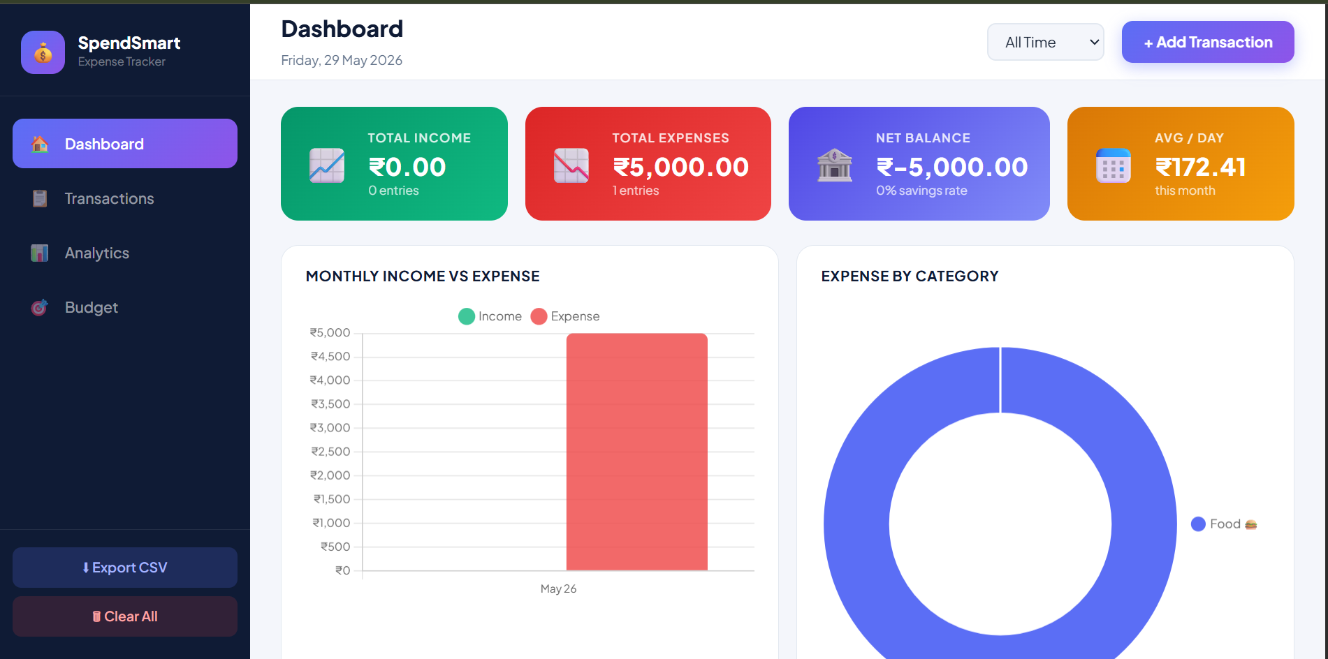6.2 Add Transaction Flow
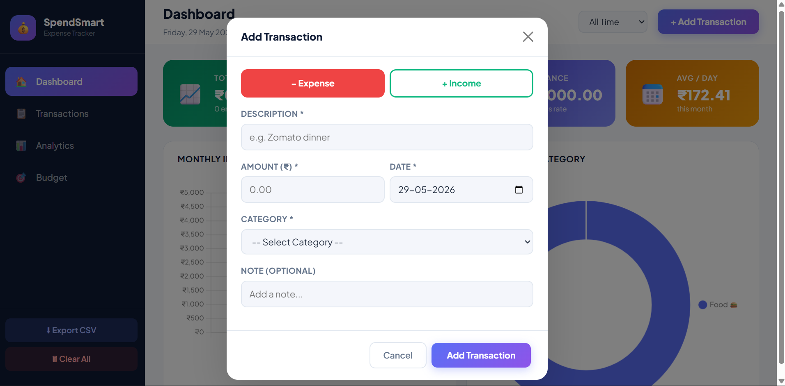
6.3 Transactions Tab
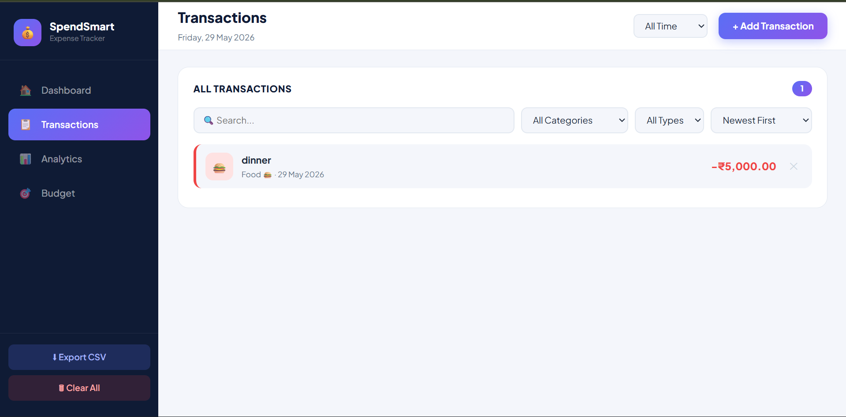6.4 Analytics Tab
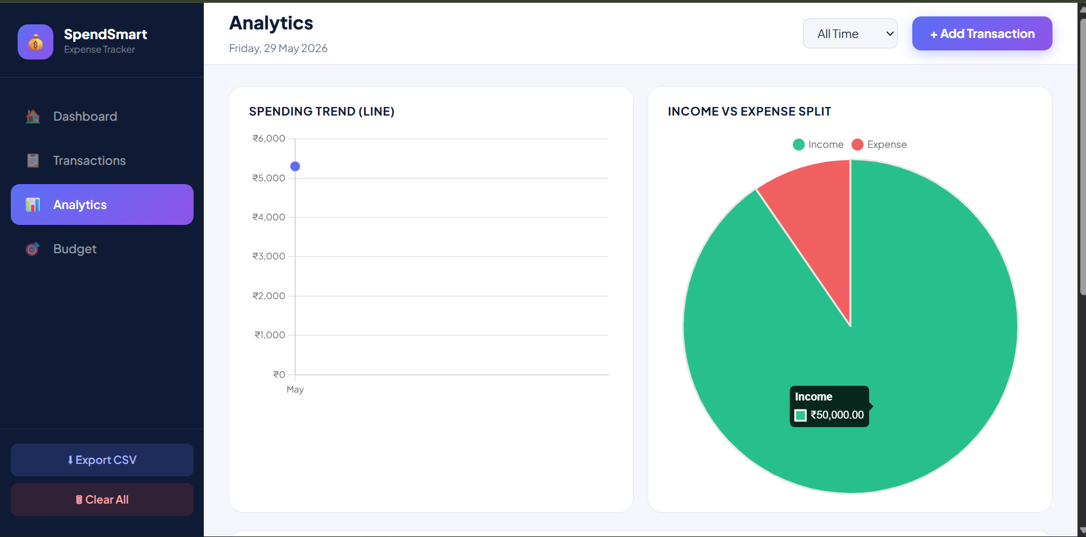6.5 Budget Planner Tab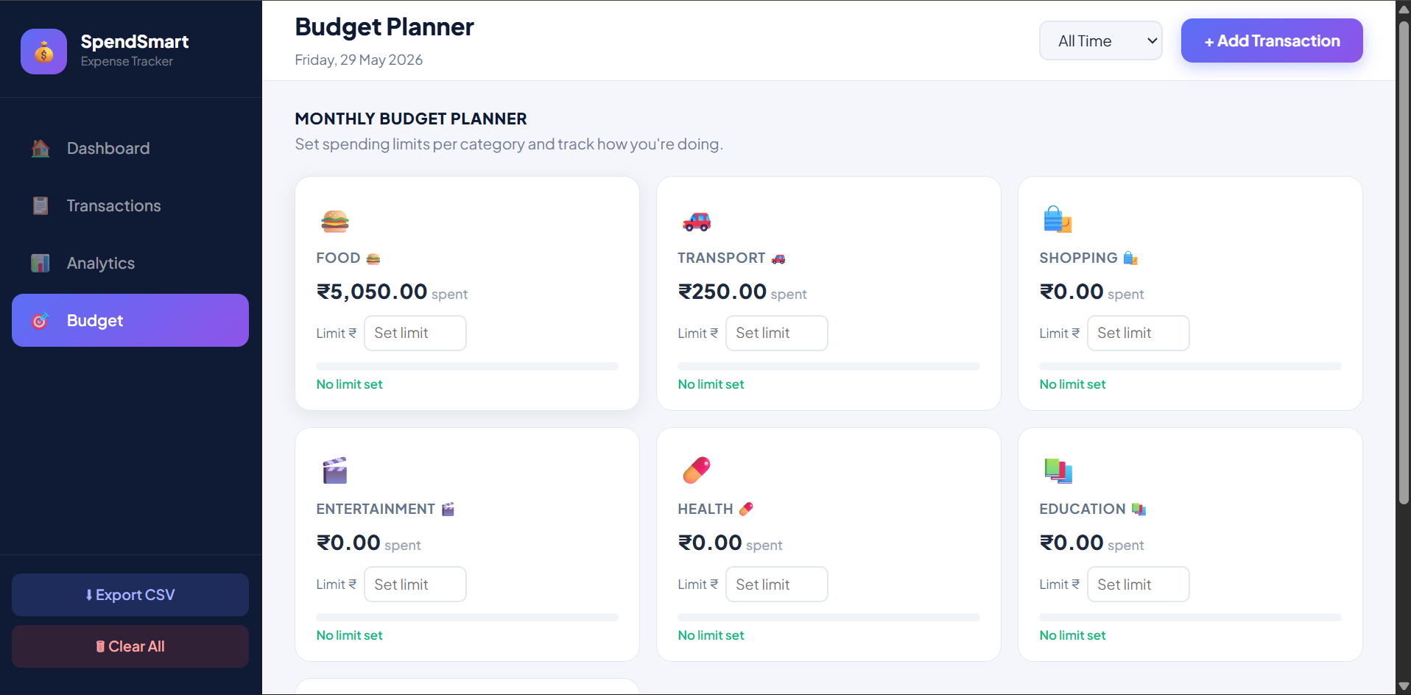
6.6 Month Filter
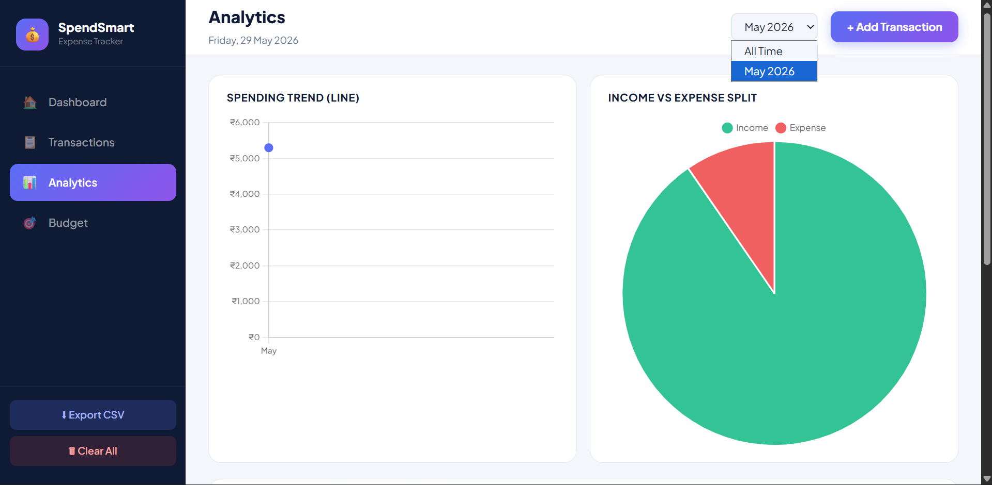6.7 CSV Export
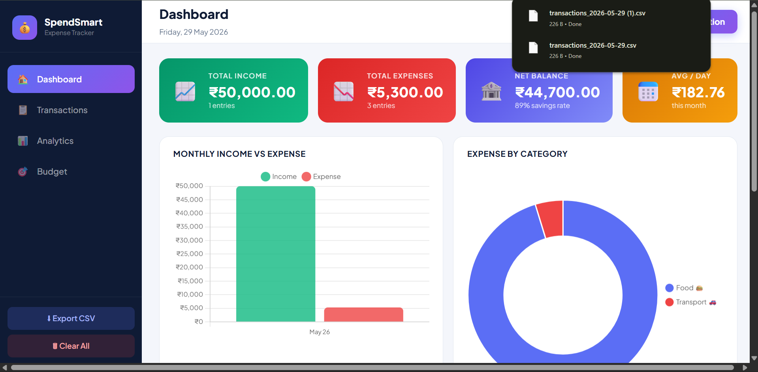6.8 Responsive Behaviour
At viewport widths below 768px, the sidebar disappears, the summary grid collapses to a 2-column layout, the charts stack vertically, and the budget grid collapses to a single column. All functionality remains accessible on mobile devices. Tested on iPhone 13 (Safari), Samsung Galaxy A52 (Chrome Mobile), and Chrome DevTools responsive emulator.
6.9 Test Results Summary
Test Case | Result
Add Transaction (Expense) | PASS — Data saved, cards updated, toast shown
Add Transaction (Income) | PASS — Income button highlighted, cards updated
Validation (Empty Fields) | PASS — Error toast shown, modal remains open
Delete Transaction | PASS — Entry removed from list and state, toast shown
Clear All | PASS — Confirmation prompt shown, all data cleared
Month Filter | PASS — All views update correctly on month change
Search (Real-time) | PASS — List filters as user types
Category / Type Filter | PASS — Correct subset displayed
Sort (All 4 options) | PASS — List re-orders correctly
Bar Chart Render | PASS — Income and expense bars correct for seed data
Doughnut Chart Render | PASS — Correct category slices
Line Chart Render | PASS — Monthly trend line correct
Pie Chart Render | PASS — Correct income/expense proportions
Budget Save & Update | PASS — Limit persisted, progress bar updated
Over-budget Alert | PASS — Red bar and label on exceeding limit
CSV Export | PASS — Valid CSV, opens in Excel/Sheets
localStorage Persistence | PASS — Data survives page refresh
Mobile Responsive | PASS — Sidebar hides, layout adapts

7. CONCLUSION
SpendSmart v2.0 successfully achieves all defined objectives, delivering a fully functional, visually polished, and technically robust personal expense tracking application built exclusively with front-end technologies. The project demonstrates that a professional-grade financial tool can be built without any server infrastructure, database, or paid third-party services — using only HTML5, CSS3, Bootstrap 5, JavaScript, jQuery, and Chart.js.
The sidebar-based navigation architecture provides an intuitive single-page application experience with four distinct modules — Dashboard, Transactions, Analytics, and Budget Planner — each serving a clear user need. The use of localStorage for persistence ensures that user data survives browser sessions without any privacy concerns, as no data ever leaves the user's device.
From a technical standpoint, this project provided practical experience in several important front-end engineering areas: reactive UI rendering through jQuery DOM manipulation, Chart.js integration for interactive data visualisation, CSS Grid and Flexbox for responsive layouts, event delegation for efficiently handling dynamically generated elements, and client-side data persistence patterns.
7.1 Key Achievements
- Implemented a complete CRUD (Create, Read, Update, Delete) system for financial transactions with real-time UI updates.
- Integrated four Chart.js chart types (Bar, Doughnut, Line, Pie) with INR currency formatting and custom styling.
- Built a Budget Planner with dynamic progress indicators, colour-coded status, and over-budget alerts.
- Developed a real-time search and multi-criteria filtering system for the transaction list.
- Implemented CSV export functionality compatible with Microsoft Excel and Google Sheets.
- Designed a fully responsive layout that functions seamlessly on desktops, tablets, and mobile devices.
- Applied CSS animations (fadeIn, slideIn, toastIn) to enhance perceived performance and user experience.
- Used CSS custom properties (variables) for consistent, maintainable theming throughout the stylesheet.
7.2 Limitations
- Data is limited to a single browser and device; no cloud sync or multi-device support.
- The application does not support recurring transactions or scheduled entries.
- There is no user authentication; all data on the device is accessible to anyone with browser access.
- Currency is fixed to Indian Rupee (INR); no multi-currency support.
- No data backup mechanism beyond manual CSV export.
7.3 Future Scope
- Integrate IndexedDB for larger, more structured local data storage with query support.
- Add a Progressive Web App (PWA) manifest and service worker for offline capability and installability.
- Implement data import from CSV to allow reverting or migrating exported data.
- Add user-configurable currency support and locale formatting.
- Introduce recurring transaction templates for fixed monthly income or expenses.
- Build a goal-setting module where users can define savings targets and track progress.
- Add multi-account support for managing separate wallets, bank accounts, or credit cards.
- Implement optional cloud sync using a lightweight back-end (e.g., Firebase Firestore) for multi-device access.

In conclusion, SpendSmart v2.0 stands as a comprehensive demonstration of modern front-end web development capabilities. It transforms a foundational programming exercise into a genuinely useful personal finance tool, reflecting the skills and design sensibility developed throughout the iStop Web Development Front-End Mentorship programme.

— End of Report —

