GOVERNMENT COLLEGE OF ENGINEERING,
ERODE - 638316


PROJECT REPORT

“WHATNEXT VISION MOTORS: SHAPING THE FUTURE
OF MOBILITY WITH INNOVATION AND EXCELLENCE”

submitted By
KISHORE E
DINESHKUMAR M
ABDUL RAZITH E
MUHAMMED UMER S

BACHELOR OF ENGINEERING
IN COMPUTER SCIENCE & ENGINEERING
OCTOBER 2027

WhatNext Vision Motors: Shaping the Future of Mobility with Innovation and Excellence

S.No. | Topic | Page No.
1 | Project title | 1
2 | Executive Summary | 3
3 | 1. Project Overview | 4
4 | 2. Objectives | 5
5 | 3. Project Methodology & Timeline | 5
6 | 4. Tools & Technologies Used | 6
7 | 5. Risk Management | 6
8 | Phase 1: Requirement Analysis & Planning | 7
9 | 1.1 Understanding Business Requirements | 8
10 | 1.2 Defining Project Scope and Objectives | 9
11 | 1.3 Data Model and Security Model | 9
12 | Data Model – Core Objects | 9
13 | Security Model – Role Hierarchy & Access | 10
14 | 1.4 Entity Relationship Overview | 11
15 | 1.5 Assumptions and Constraints | 11
16 | Phase 2: Salesforce Development – Backend & Configurations | 11
17 | 2.1 Environment & DevOps Workflow | 12
18 | 2.2 Customization of Objects, Fields, Validation Rules & Automation | 13
19 | Selected Fields & Validation Rules | 14
20 | Automation – Flows | 14
21 | Dealer Assignment Flow – Step-by-Step Logic | 15

22 | Test Drive Reminder Flow – Step-by-Step Logic | 16
23 | Automation – Approval Process | 16
24 | Apex – Trigger, Handler, Batch & Scheduler | 17
25 | Code Reference – Trigger | 17
26 | Code Reference – Trigger Handler (Bulkified) | 18
27 | Code Reference – Batch Apex | 18
28 | Code Reference – Schedulable | 19
29 | Real-World Walkthrough – Sample Customer: Elijah Mikaelson | 19
30 | Phase 3: UI/UX Development & Customization | 19
31 | 3.1 Lightning App Setup | 20
32 | 3.2 Page Layouts & Dynamic Forms | 21
33 | 3.3 User Management | 22
34 | 3.4 Reports and Dashboards | 22
35 | 3.5 Lightning Pages | 23
36 | 3.6 Component-Level UI Decisions | 23
37 | 3.7 Mobile Considerations | 24
38 | Phase 4: Data Migration, Testing & Security | 24
39 | 4.1 Data Loading | 25
40 | 4.1a Validation Rule Formulas | 25
41 | VAL_Future_Date_Only (on Test_Drive c) | 25
42 | VAL_Dealer_Required_On_Confirm (on Test_Drive c) | 25
43 | 4.2 Field History Tracking, Duplicate Rules & Matching Rules | 25
44 | 4.3 Profiles, Roles, Role Hierarchy, Permission Sets & Sharing Rules | 26

45 | 4.4 Test Classes | 26
46 | Code Reference – Sample Test Class | 27
47 | 4.5 Test Cases – Input & Expected Output | 28
48 | 4.6 Functional & Integration Testing Approach | 29
49 | Phase 5: Deployment, Documentation & Maintenance | 29
50 | 5.1 Deployment Strategy | 30
51 | 5.2 Maintenance & Monitoring | 30
52 | 5.3 Troubleshooting Approach | 30
53 | 5.4 Post-Deployment Checklist | 30
54 | 5.4a Known Issues and Post Go-Live Support Model | 31
55 | 5.5 Release & Change Management | 31
56 | Conclusion | 31
57 | Advantages | 32
58 | Limitations | 32
59 | Future Enhancements | 33
60 | Acknowledgements | 33
61 | Learning Outcomes | 33
62 | Appendix A: Full Object & Field Reference | 33
63 | A.1 Vehicle c | 34
64 | A.2 Dealer c | 34
65 | A.3 Test_Drive c | 34
66 | A.4 Payment c | 35
67 | Appendix B: Glossary of Terms | 35

68 | Appendix C: Sample Test Data | 36
69 | Appendix D: Team Roles & Responsibilities | 36
70 | Appendix E: Sample Email Template | 36
71 | Appendix F: Dashboard Component Reference | 37
72 | Appendix G: Frequently Asked Questions | 37
73 | Q: What happens if two dealers are tied on Current_Load c? | 37
74 | Q: Can a customer book more than one test drive at a time? | 37
75 | Q: What happens to a Payment c record if the linked Test_Drive c is deleted? | 38
76 | Q: Why was Batch Apex used instead of a simple Scheduled Flow for stalebooking cleanup? | 38
77 | Appendix H: Sample Discount Approval Scenario | 38
78 | Appendix I: References | 39

custom Lightning App for the sales and service teams, record-triggered and scheduled automation for test drive reminders, Apex-based bulk processing for lead scoring and stale-booking cleanup, and a layered security model aligned to dealership roles (Sales Executive, Dealer, Branch Manager, and System Administrator).

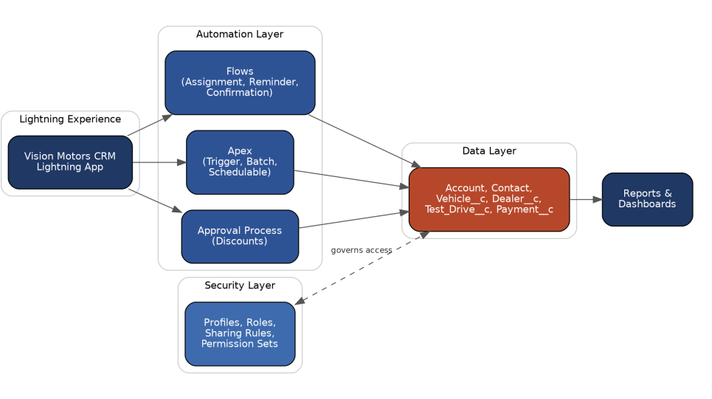
Figure 1: Vision Motors CRM – solution architecture overview

2. Objectives

The primary objective of this project is to design and deliver a Salesforce CRM that gives WhatNext Vision Motors a single, reliable system of record for customers, vehicles, and test drive bookings, replacing fragmented manual tracking with automated, auditable processes. Specific objectives include reducing the time taken to assign a dealer to a new test drive request, ensuring every customer receives a timely reminder before their scheduled test drive, preventing duplicate customer and booking records through matching and duplicate rules, and giving branch managers dashboard-level visibility into bookings, conversions, and dealer workload.
Each of these objectives is tied directly to business value: automated dealer assignment shortens response time and improves the customer experience; automated reminders reduce no-shows and wasted dealer time; data quality controls protect the accuracy of sales reporting; and reports and dashboards support faster, better-informed decisions by branch and regional management. Together, these objectives support the broader business goal of increasing test-drive-to-sale conversion while lowering the administrative overhead of running the dealership's sales pipeline.

3. Project Methodology & Timeline

The project followed an iterative, phase-gated approach loosely modeled on Agile sprints, where each of the five phases in this document was treated as a milestone with its own review before moving to the next. This allowed requirement gaps discovered during backend development (Phase 2) to be fed back into the data model without derailing the overall schedule, since the Data Model and Security Model from Phase 1 were treated as a living design rather than a document frozen at the start.

Phase | Key Deliverable | Approx.  Duration
Phase 1 – Requirement Analysis & Planning | Signed-off data model, security model, and scope document. | 1 week
Phase 2 – Backend & Configurations | Objects, fields, validation rules, Flows, Apex classes with test coverage. | 3 weeks
Phase 3 – UI/UX Development | Lightning App, page layouts, reports and dashboards. | 1.5 weeks
Phase 4 – Data Migration, Testing & Security | Loaded data, executed test cases, finalized security model. | 1.5 weeks
Phase 5 – Deployment & Maintenance | Production deployment via change sets, monitoring in place. | 1 week

4. Tools & Technologies Used

Category | Tool / Technology | Purpose
Platform | Salesforce Lightning Experience | Core CRM platform for all configuration and custom development.
Development | Salesforce DX / VS Code | Source-tracked development and metadata retrieval.
Automation | Flow Builder | Declarative automation for dealer assignment and reminders.
Programmatic Logic | Apex (Classes, Triggers, Batch, Schedulable) | Bulk-safe and scheduled server-side logic.
Data Migration | Data Loader, Data Import Wizard | Bulk and ad-hoc record loading.
Testing | Apex Test Classes, Manual UAT scripts | Unit and functional/integration test coverage.
Deployment | Change Sets | Promoting metadata from Sandbox to Production.
Reporting | Salesforce Reports & Dashboards | Management visibility into bookings and conversions.

5. Risk Management

A short risk register was maintained throughout the project so that technical and process risks were tracked rather than only discovered when they caused a problem.

Risk | Likelihood | Mitigation
Apex trigger not bulk-safe under Data Loader import | Medium | Trigger handler pattern with bulk SOQL/DML validated via 200-record test data.
Duplicate customer records degrading report accuracy | High | Matching and Duplicate Rules enforced at entry, tested with real near-duplicate data.
Reminder Flow sending duplicate emails | Medium | Reminder_Sent c guard field and idempotency test case (Test Case #12).
Change set deployment failing due to missing dependencies | Medium | Change sets grouped by functional area and validated before deployment.
Over-broad sharing rule exposing cross-branch data | Low | Criteria-based sharing rule scoped strictly to assigned Dealer; verified in Test Case #10.

Phase 1: Requirement Analysis & Planning

1.1 Understanding Business Requirements
Requirement gathering was carried out through structured discussions with three stakeholder groups: front-line Sales Executives/Dealers who handle walk-in and phone enquiries, Branch Managers who are accountable for branch-level conversion and dealer workload, and the Regional/Operations team who need a consolidated, cross-branch view. Each group was asked to walk through a typical day and flag where the current manual process broke down, which surfaced a consistent pattern: information capture was fast at the point of enquiry but degraded quickly afterward, because there was no system forcing a follow-up, no shared view of dealer availability, and no single source of truth for whether a given customer had already been contacted.
From these sessions, the following user stories were captured and prioritized with the stakeholders, and later mapped directly onto Salesforce objects and automation:

Persona | User Story | Priority
Sales Executive | As a Sales Executive, I want a new enquiry to automatically show up assigned to a dealer, so I don't have to manually check who is free. | High
Customer (indirect) | As a customer, I want a reminder before my test drive so I don't forget my appointment. | High
Branch Manager | As a Branch Manager, I want to see all bookings and dealer workload for my branch on one dashboard. | High
Branch Manager | As a Branch Manager, I want to approve discounts above a set threshold before they are offered. | Medium
System Administrator | As an Admin, I want duplicate customer records blocked automatically at entry. | High
Regional Manager | As a Regional Manager, I want a cross-branch view of conversion rate without asking each branch for numbers. | Medium

Stakeholder discussions with the sales and branch operations teams also surfaced the following core needs:
- A single place to capture customer enquiries from walk-ins, phone calls, and the dealership website.
- Automatic assignment of an available dealer to every new test drive request based on branch and vehicle model.
- Automated reminders to customers ahead of a scheduled test drive to reduce no-shows.
- Prevention of duplicate customer records when the same person enquires more than once.
- Role-based visibility so Sales Executives see only their own records, Branch Managers see their branch, and Admins see everything.
- Dashboards for management to track bookings, conversions, and dealer performance.

1.2 Defining Project Scope and Objectives
The scope of the project covers the end-to-end test drive and sales lifecycle: lead/customer capture, vehicle inventory, test drive booking and dealer assignment, approval of high-value discount requests, payment recording, and post-sale service requests. Out of scope for the current phase are third-party finance/loan integrations and a customer-facing self-service portal, both of which are noted under Future Enhancements.
- In-scope: Customer management, Vehicle inventory, Test Drive booking & automation, Dealer assignment, Approval process for discounts, Payment tracking, Reports & Dashboards.
- Out-of-scope (current phase): Payment gateway/finance integration, customer self-service community portal, chatbot integration.
- Success criteria: automated dealer assignment on 100% of new bookings, reminder automation with zero manual intervention, and role-based data visibility verified for all four profiles.

1.3 Data Model and Security Model
The data model uses a mix of standard and custom objects. Contact and Account (standard objects) represent customers and dealership branches respectively, while the remaining entities are modeled as custom objects to support dealership-specific processes.

Data Model – Core Objects

Object | Type | Purpose | Key Relationships
Account | Standard | Represents each dealership branch/showroom location. | Parent of Contact,  Vehicle c, Dealer c
Contact | Standard | Represents customers/prospective buyers. | Child of Account; parent of Test_Drive c
Vehicle c | Custom | Represents inventory items (make, model, variant, price, availability). | Lookup to Account (Branch); child of Test_Drive c
Dealer c | Custom | Represents sales staff assigned to handle test drives. | Lookup to Account (Branch); referenced by Test_Drive c
Test_Drive c | Custom | Represents a customer's test drive booking and its lifecycle. | Lookup to Contact, Vehicle c, Dealer c
Payment c | Custom | Captures payment/booking-amount transactions linked to a confirmed sale. | Lookup to Test_Drive c
Test_Drive c is the transactional hub of the model: it stores the requested date/time, status (New, Assigned, Confirmed, Completed, Cancelled, No-Show), and lookups to the Contact, Vehicle c, and Dealer c involved. Payment c is created once a Test_Drive c reaches a 'Converted' outcome and captures the booking amount, payment mode, and reference number.

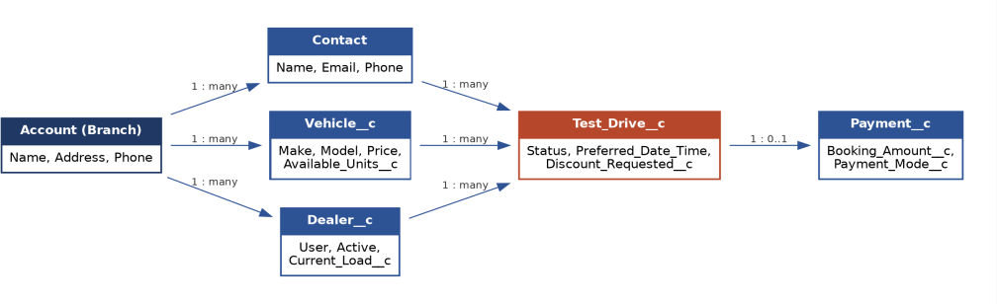
Figure 2: Entity-relationship diagram for the Vision Motors data model

Security Model – Role Hierarchy & Access

Role / Profile | Level | Object Access Summary | Sharing Notes
System Administrator | Top | Full CRUD on all objects. | Sees all data; manages configuration.
Regional Manager | Level 2 | Read on all Test_Drive c and Payment c across branches. | Grants visibility via role hierarchy, no edit on branch records.
Branch Manager | Level 3 | Read/Write on records within own branch (Account). | Org-Wide Default set to Private with role-hierarchy access.
Sales Executive / Dealer | Level 4 | Read/Write on own assigned  Test_Drive c and related Contact. | Sharing rule grants access based on Dealer c lookup on Test_Drive c.

Org-Wide Defaults for Contact, Vehicle c, and Test_Drive c are set to Private, with the role hierarchy providing roll-up visibility to managers and a criteria-based sharing rule granting each Dealer visibility into Test_Drive c records where they are the assigned dealer.

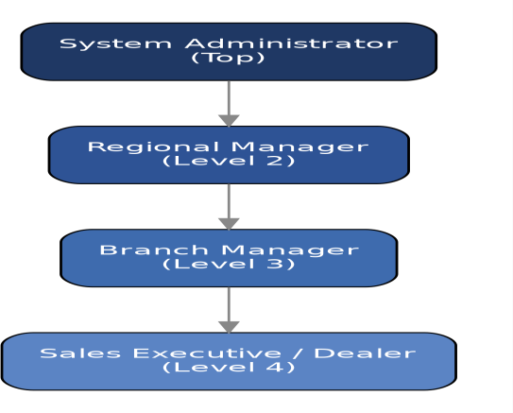
Figure 3: Role hierarchy governing Test_Drive c visibility

1.4 Entity Relationship Overview
Conceptually, an Account (branch) is the parent of the Contacts who visit that branch, the Vehicle c inventory stocked at that branch, and the Dealer c staff based there. Every Test_Drive c record is the junction point of the model: it looks up to exactly one Contact, one Vehicle c, and one Dealer c, and a single Payment c record looks up to the Test_Drive c it settles. This starshaped relationship around Test_Drive c keeps reporting simple, since almost every meaningful report in the org is built from that one object with its related lookups, rather than requiring multilevel joins.
- Account (1) → (many) Contact — a branch has many customers.
- Account (1) → (many) Vehicle c — a branch stocks many vehicles.
- Account (1) → (many) Dealer c — a branch employs many dealers.
- Contact (1) → (many) Test_Drive c — a customer can book more than one test drive over time.
- Vehicle c (1) → (many) Test_Drive c — a vehicle can be test-driven by many customers.
- Dealer c (1) → (many) Test_Drive c — a dealer handles many bookings.
- Test_Drive c (1) → (0 or 1) Payment c — a converted booking has exactly one payment record.

1.5 Assumptions and Constraints
Planning assumed a single Salesforce org shared across all branches (rather than one org per branch), English as the sole business language for the current phase, and that dealership staff already hold basic Salesforce Lightning familiarity from prior tools, so training was scoped to CRM-specific workflows rather than platform basics. A constraint acknowledged upfront was Salesforce's standard governor limits (for example, 100 SOQL queries and 150 DML statements per transaction), which directly shaped the decision to bulkify the Apex trigger handler and to move the nightly stale-booking cleanup into Batch Apex rather than a simple scheduled Flow acting on the full object.

Phase 2: Salesforce Development – Backend & Configurations

2.1 Environment & DevOps Workflow
Development was carried out in a Salesforce Developer Edition org configured as the primary build environment, with a separate sandbox used for user acceptance testing before deployment. Source was tracked using Salesforce DX project structure, with metadata retrieved and versioncontrolled so that changes could be reviewed before being promoted. A simple three-stage flow was followed: build and unit-test in the Dev org, validate end-to-end in the Sandbox with sample data, and deploy to Production using a change set once testing was signed off.

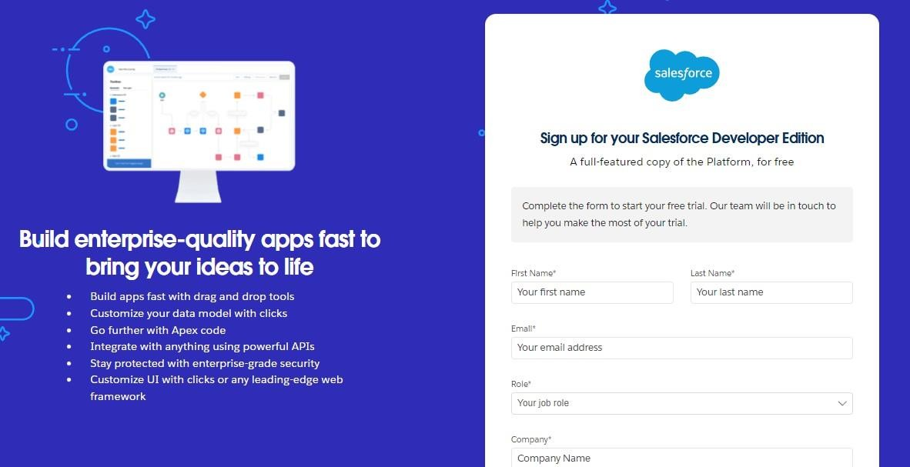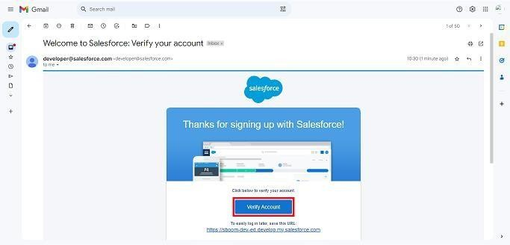
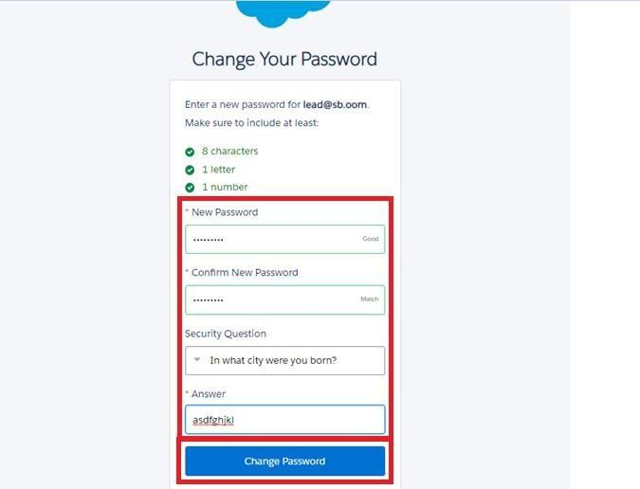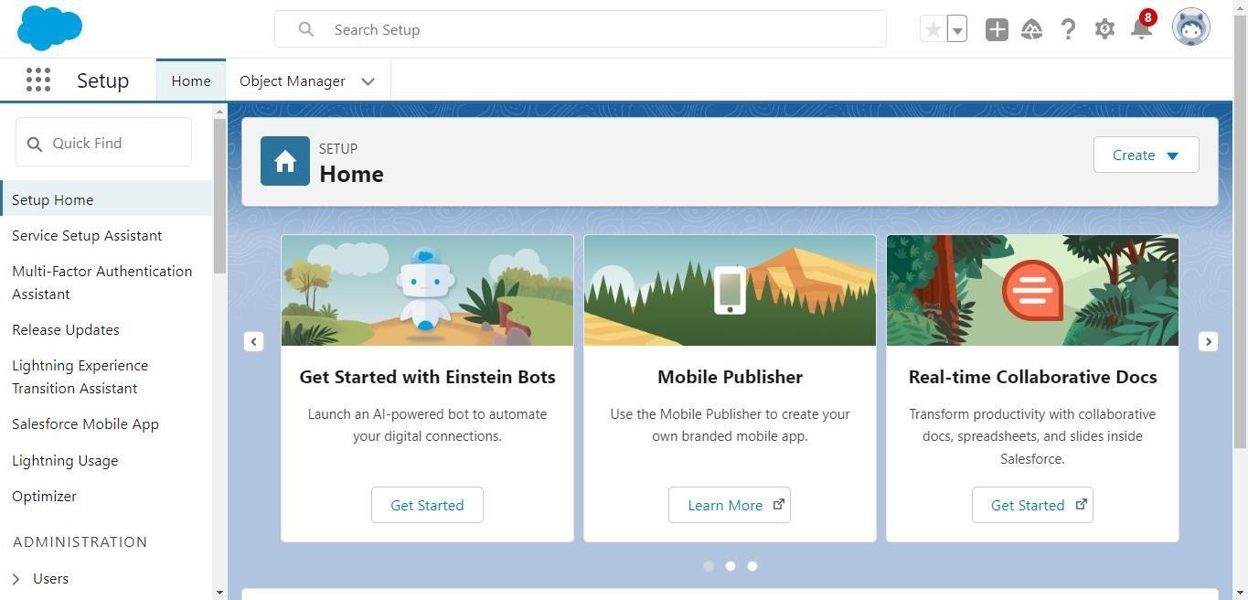

2.2 Customization of Objects, Fields, Validation Rules & Automation
Custom fields were added to each object to support the dealership process. Key validation rules and automations are summarized below.

Selected Fields & Validation Rules

Object | Field / Rule | Type | Purpose
Test_Drive c | Status c | Picklist | Tracks lifecycle: New, Assigned, Confirmed, Completed, Cancelled, NoShow.
Test_Drive c | Preferred_Date_Time c | DateTime | Customer's requested slot; used by the reminder flow.
Test_Drive c | VAL_Future_Date_Only | Validation Rule | Blocks saving a booking with a  Preferred_Date_Time c in the past.
Test_Drive c | VAL_Dealer_Required_On_Confirm | Validation Rule | Prevents Status c = 'Confirmed' unless Dealer c is populated.
Vehicle c | Available_Units c | Number | Drives eligibility check before a test drive can be booked.
Payment c | VAL_Amount_Positive | Validation Rule | Ensures Booking_Amount c is greater than zero.

Automation – Flows
Three Flows form the backbone of the automation layer. Each is described below with its trigger context, core logic steps, and the design reasoning behind that choice.
- Dealer Assignment Flow (Record-Triggered, Before Save on Test_Drive c create): queries available Dealer c records for the requested branch, filters by current workload, and sets Dealer c and Status c = 'Assigned' on the new record without an extra DML operation.
- Test Drive Reminder Flow (Scheduled Flow, runs hourly): queries Test_Drive c records where Status c = 'Confirmed' and Preferred_Date_Time c falls within the next 24 hours, then sends an email alert to the customer and a task to the dealer.
- Booking Confirmation Email Flow (Record-Triggered, After Save on Status c change to 'Confirmed'): sends a templated confirmation email to the Contact and logs an Activity.
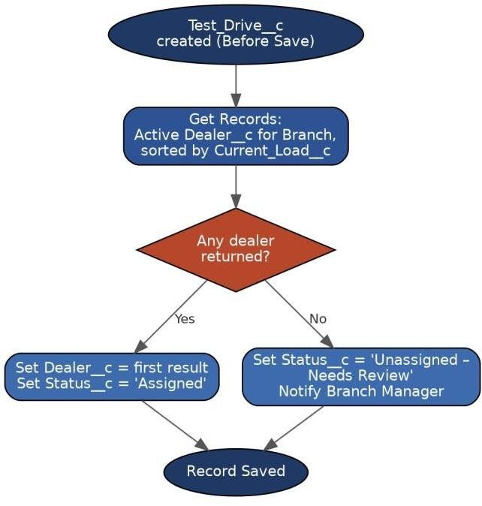

Figure 4: Dealer Assignment Flow logic

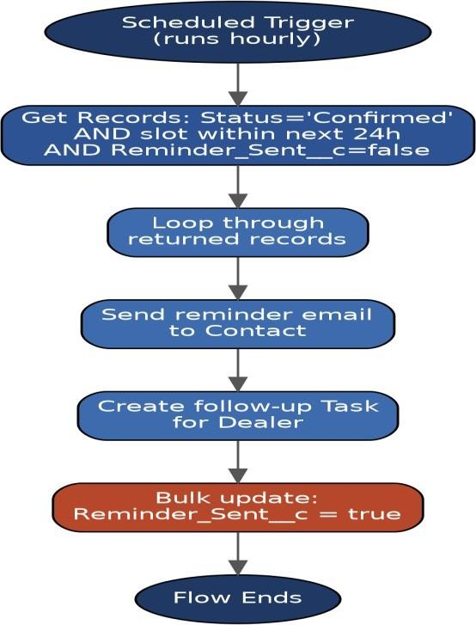

Figure 5: Test Drive Reminder Flow logic

Dealer Assignment Flow – Step-by-Step Logic
This Flow runs Before Save so it can set fields on the triggering record directly, avoiding a second, recursive DML update. Its steps are:
- Get Records: query Dealer c where Branch c equals the triggering Test_Drive c's Branch c and Active c = true, sorted by Current_Load c ascending.
- Decision: check whether the Get Records element returned at least one Dealer c.
- Assignment (true path): set $Record.Dealer c to the first returned Dealer c Id and $Record.Status c to 'Assigned'.
- Fallback (false path): set $Record.Status c to 'Unassigned – Needs Review' and add the record to a collection used later by a Send Email action notifying the Branch Manager that no dealer was available.
Sorting by Current_Load c (a roll-up-style field maintained on Dealer c counting open Test_Drive c records) means the Flow always routes a new booking to the least-loaded active dealer at that branch, which keeps workload roughly balanced without any manual roster management.

Test Drive Reminder Flow – Step-by-Step Logic
- Scheduled Trigger: configured to run every hour, starting at the top of the hour.
- Get Records: query Test_Drive c where Status c = 'Confirmed' AND Preferred_Date_Time c is between NOW() and NOW() + 24 hours AND Reminder_Sent c = false.
- Loop: iterate the returned collection.
- Send Email Action: send a templated reminder email to the related Contact inside the loop, using merge fields for vehicle model, dealer name, and appointment time.
- Create Records (Task): create a follow-up Task assigned to the Dealer c owner, due on the appointment date.
- Update Records: after the loop, bulk-update all processed Test_Drive c records setting Reminder_Sent c = true, so the same booking is never reminded twice even if the Flow runs again within the same 24-hour window.
The Reminder_Sent c checkbox is the key idempotency guard in this Flow — without it, an hourly schedule would re-send the same reminder on every run until the appointment time passed.

Automation – Approval Process
An Approval Process was configured on Test_Drive c to govern discount requests above the branch's standard authority level, satisfying the 'Approval Process' automation requirement called out in the project guidelines. Its configuration is summarized below.
- Entry Criteria: Discount_Requested c is greater than 10%.
- Initial Submission Action: record is locked for editing and Status c is set to 'Pending Approval'.
- Approval Step 1: routed to the Branch Manager role associated with the record's Branch c, using a standard Manager-based approver lookup.
- Approved: Discount_Requested c is honored, Status c reverts to its prior value, and the record is unlocked; a Field Update also stamps Approved_By c and Approval_Date c.
- Rejected: Status c reverts to 'Confirmed' without the discount, the record is unlocked, and an email alert notifies the submitting Sales Executive.
The approval process was intentionally kept to a single step to match the dealership's flat discountauthority structure; a second regional-approval step for very large discounts is noted under Future Enhancements should the business later require it.

Apex – Trigger, Handler, Batch & Scheduler
Declarative automation covers assignment and reminders; Apex was used where bulk, scheduled, or cross-object logic exceeded Flow's practical limits.
- TestDriveTrigger (on Test_Drive c, before update): delegates all logic to a handler class following the one-trigger-per-object pattern, so all context variables (Trigger.new, Trigger.oldMap) are handled through bulk-safe collections rather than per-record queries.
- TestDriveTriggerHandler: contains bulkified methods that build a Set of Vehicle Ids from Trigger.new, issue a single SOQL query against Vehicle c to check Available_Units c, and use a Map<Id, Vehicle c> for O(1) lookups inside the for-loop instead of querying inside the loop.
- StaleBookingCleanupBatch (implements Database.Batchable<sObject>): the start() method returns a QueryLocator selecting Test_Drive c records still 'New' after 48 hours; execute() processes each scope in bulk, updating Status c to 'Expired'; finish() sends a summary email to the Branch Manager.
- StaleBookingCleanupScheduler (implements Schedulable): scheduled via System.schedule to invoke the batch class nightly at 1:00 AM, ensuring stale bookings are cleared without manual intervention.
All SOQL queries in the trigger handler and batch class were written outside of loops and use selective filters on indexed fields (Status c, LastModifiedDate) to remain governor-limit safe when processing large data volumes; the batch class additionally sets a conservative scope size to control DML chunking.

Code Reference – Trigger

trigger TestDriveTrigger on Test_Drive c (before update) { if (Trigger.isBefore && Trigger.isUpdate) {
TestDriveTriggerHandler.handleBeforeUpdate(Trigger.new, Trigger.oldMap);
} }

Code Reference – Trigger Handler (Bulkified)
public with sharing class TestDriveTriggerHandler { public static void handleBeforeUpdate(List<Test_Drive c> newList,
Map<Id, Test_Drive c> oldMap) {
Set<Id> vehicleIds = new Set<Id>(); for (Test_Drive c td : newList) { if (td.Vehicle c != null) { vehicleIds.add(td.Vehicle c);
}
}
// Single bulk query outside the loop
Map<Id, Vehicle c> vehicleMap = new Map<Id, Vehicle c>(
[SELECT Id, Available_Units c FROM Vehicle c WHERE Id IN :vehicleIds]
);
for (Test_Drive c td : newList) {
Test_Drive c oldTd = oldMap.get(td.Id);
if (td.Status c == 'Confirmed' && oldTd.Status c != 'Confirmed') { Vehicle c v = vehicleMap.get(td.Vehicle c); if (v == null || v.Available_Units c <= 0) { td.addError('Selected vehicle is no longer available.');
}
}
}
} }
Because the vehicle lookup is loaded once into a Map before the loop runs, this handler performs exactly one SOQL query regardless of whether it is invoked for 1 record or 200 records in the same transaction, satisfying Salesforce's bulk-safe design requirement.

Code Reference – Batch Apex
global with sharing class StaleBookingCleanupBatch implements Database.Batchable<sObject> {
global Database.QueryLocator start(Database.BatchableContext bc) {
DateTime cutoff = System.now().addHours(-48); return Database.getQueryLocator([
SELECT Id, Status c FROM Test_Drive c
WHERE Status c = 'New' AND CreatedDate <= :cutoff
]);
}
global void execute(Database.BatchableContext bc,
List<Test_Drive c> scope) {
for (Test_Drive c td : scope) { td.Status c = 'Expired';
}
update scope;
}
global void finish(Database.BatchableContext bc) {
// Summary email to Branch Manager omitted for brevity
} }

Code Reference – Schedulable
global class StaleBookingCleanupScheduler implements Schedulable { global void execute(SchedulableContext sc) {
Database.executeBatch(new StaleBookingCleanupBatch(), 200);
}
}

// One-time setup executed in Anonymous Apex:
String cronExpr = '0 0 1 * * ?'; // 1:00 AM daily System.schedule('Nightly Stale Booking Cleanup', cronExpr, new StaleBookingCleanupScheduler());

Real-World Walkthrough – Sample Customer: Elijah Mikaelson
To validate the end-to-end flow, a sample customer record, Elijah Mikaelson, was used to walk through the system: a Contact record is created for Elijah, who enquires about a specific Vehicle c at the Anna Nagar branch. On submitting a Test_Drive c request, the Dealer Assignment Flow immediately assigns the next available dealer at that branch and sets Status c to 'Assigned'. The dealer contacts Elijah, and once the slot is agreed, the record is moved to 'Confirmed', which triggers the Booking Confirmation Email Flow. Twenty-four hours before the scheduled slot, the Test Drive Reminder Flow sends Elijah an email reminder and creates a follow-up Task for the dealer. After the test drive, the dealer marks the record 'Completed', and if Elijah proceeds to purchase, a Payment c record is created against the Test_Drive c to close the loop.

Phase 3: UI/UX Development & Customization

3.1 Lightning App Setup
A custom Lightning App, 'Vision Motors CRM', was created through App Manager with a dedicated app icon and navigation bar exposing the Home, Accounts, Contacts, Vehicles, Test Drives, Payments, Reports, and Dashboards tabs, scoped to the Sales Executive, Dealer, and Branch Manager profiles.

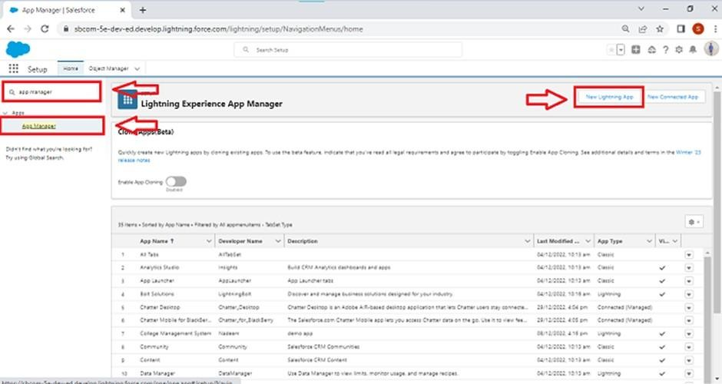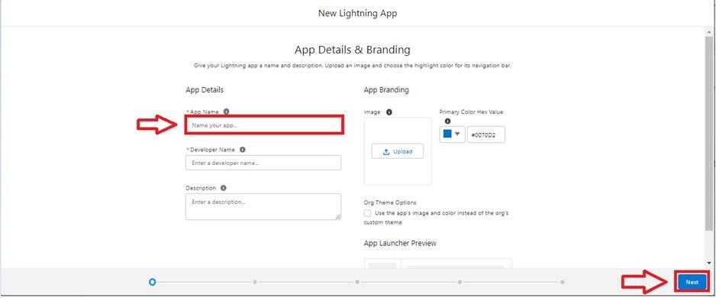
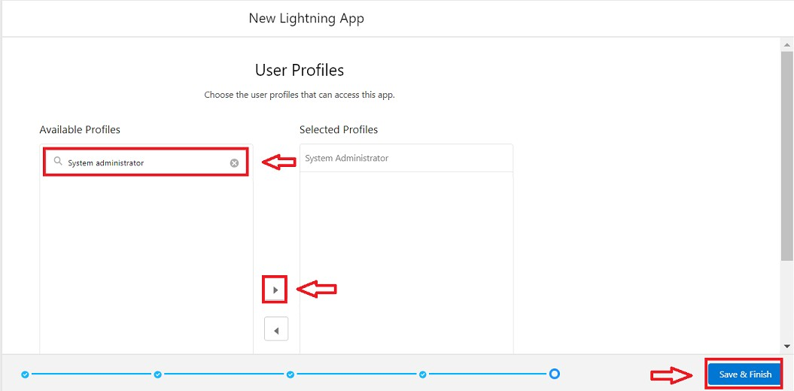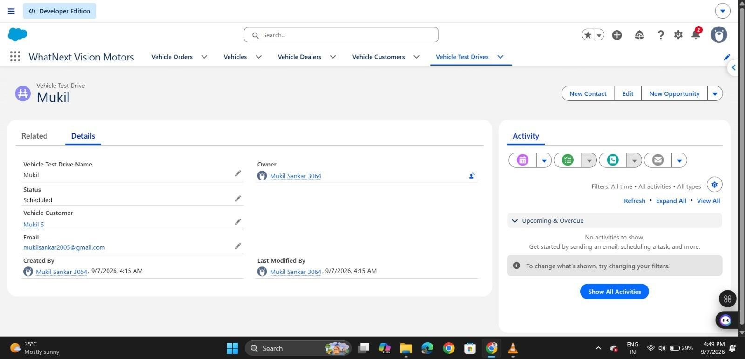

3.2 Page Layouts & Dynamic Forms
Separate page layouts were built for the Sales Executive and Branch Manager personas on Test_Drive c: the Sales Executive layout foregrounds Customer, Vehicle, and Status fields, while the Branch Manager layout surfaces Dealer workload and SLA fields. Dynamic Forms were used on the Test_Drive c Lightning Record Page so that Dealer c and Confirmed_Date c only display once Status c reaches 'Assigned' or later, keeping the form uncluttered for new bookings.

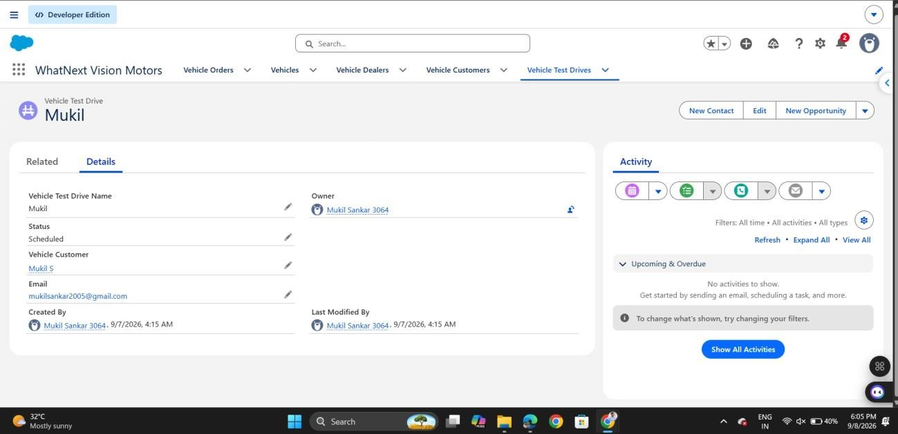

3.3 User Management
Users were provisioned against four profiles (System Administrator, Branch Manager, Sales Executive/Dealer, Regional Manager) mapped to the role hierarchy described in Phase 1, with permission sets layered on top to grant temporary or feature-specific access (for example, a 'Discount Approver' permission set) without altering the base profile.

3.4 Reports and Dashboards
A Test Drives report folder was created containing a summary report of bookings by Status and Branch, a matrix report of conversions by Dealer, and a trend report of monthly bookings. These feed a 'Sales Performance' dashboard with components for bookings-by-status, top-performing dealers, and month-over-month conversion trend, filtered dynamically by the viewing user's branch where applicable.

Report / Dashboard | Type | Key Grouping | Audience
Bookings by Status and Branch | Summary Report | Branch c, then Status c | Branch Manager, Regional Manager
Report / Dashboard | Type | Key Grouping | Audience
Dealer Conversion Matrix | Matrix Report | Rows: Dealer c; Columns: Outcome c | Branch Manager
Monthly Booking Trend | Summary Report (grouped by date) | CreatedDate by Month | Regional Manager
Sales Performance Dashboard | Dashboard | Combines the three reports above as chart/table components | All management  profiles

3.5 Lightning Pages
A custom Home Page was built using the Lightning App Builder for the Sales Executive persona, combining the standard Assistant and Recent Items components with a custom 'My Test Drives Today' list view component, giving each dealer an at-a-glance view of their day without navigating away from Home.

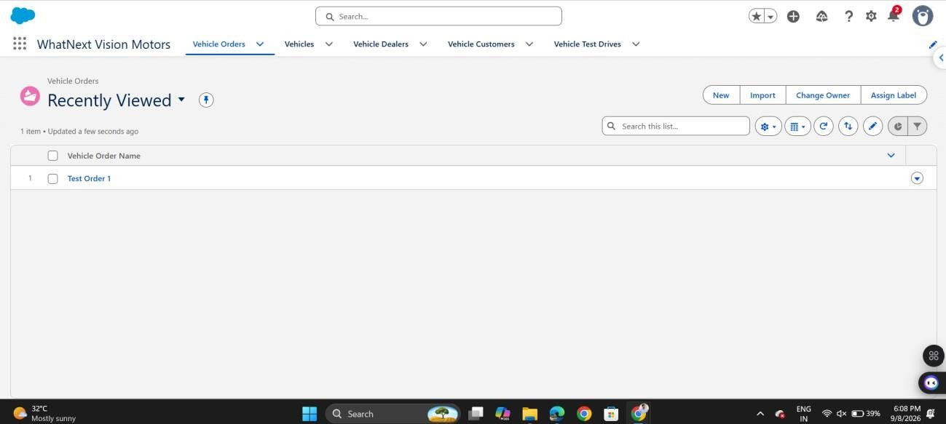

3.6 Component-Level UI Decisions
A number of smaller UI choices were made deliberately to keep the interface fast to use during a live customer conversation, rather than purely to look polished:
- The Test_Drive c compact layout on related lists shows Status c, Vehicle c, and Preferred_Date_Time c only, so a dealer scanning a Contact's history doesn't need to open every record.
- Path (Lightning Path) was enabled on Test_Drive c against Status c, giving dealers a visual progress bar (New → Assigned → Confirmed → Completed) with key fields surfaced at each stage.
- Quick Actions for 'Log a Call' and 'Confirm Booking' were pinned to the top of the Test_Drive c record page so the two most frequent actions never require scrolling.
- List view filters were pre-built for 'My Open Test Drives', 'Today's Test Drives', and 'Unassigned – Needs Review' so no user has to construct a filter from scratch.

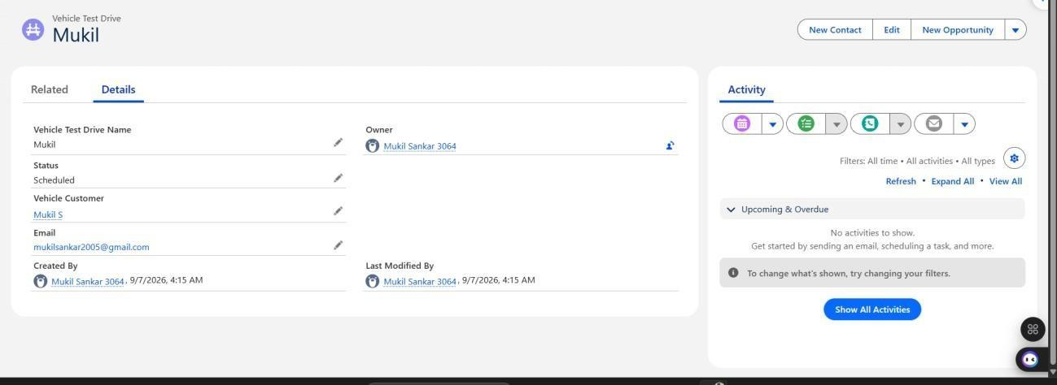

3.7 Mobile Considerations
Because dealers are frequently on the showroom floor rather than at a desk, all custom Lightning pages were validated in the Salesforce Mobile App preview inside Lightning App Builder to confirm that the compact and expanded field sets render sensibly on a phone-sized viewport, and that Quick Actions remain within one tap of the record's mobile view.

Phase 4: Data Migration, Testing & Security

4.1 Data Loading
Initial vehicle inventory (Vehicle c) and existing customer contact data were loaded using Data Loader for bulk CSV import given the volume of records, while smaller, ad-hoc updates during testing (for example, adding a handful of Dealer c records) were handled through the Data Import Wizard for its simpler mapping UI.

4.1 a Validation Rule Formulas
The two validation rules introduced in Phase 2 are documented here with their exact formula logic and error location for reference:

VAL_Future_Date_Only (on Test_Drive c)
AND(
ISCHANGED( Preferred_Date_Time c ),
Preferred_Date_Time c < NOW() )
Error message: 'Preferred date/time must be in the future.' Error location: Preferred_Date_Time c field.

VAL_Dealer_Required_On_Confirm (on Test_Drive c)
AND(
ISPICKVAL( Status c , 'Confirmed' ),
ISBLANK( TEXT(Dealer c) ) )
Error message: 'A dealer must be assigned before a booking can be confirmed.' Error location: Top of Page.

4.2 Field History Tracking, Duplicate Rules & Matching Rules
Field History Tracking was enabled on Test_Drive c for Status c and Dealer c, and on Contact for Email and Phone, to support audit and troubleshooting. A Matching Rule on Contact compares Email and Phone (fuzzy match on Phone, exact on Email) and feeds a Duplicate Rule that blocks creation of an exact-match duplicate and alerts the user with the option to view the existing record instead.

Object | Tracked Field | Reason
Test_Drive c | Status c | Audit the full booking lifecycle for support and reporting.
Test_Drive c | Dealer c | Trace re-assignments if a booking changes hands.
Object | Tracked Field | Reason
Contact | Email | Detect and investigate post-hoc contact detail changes tied to duplicate disputes.
Contact | Phone | Same as above, for phone-based matching.

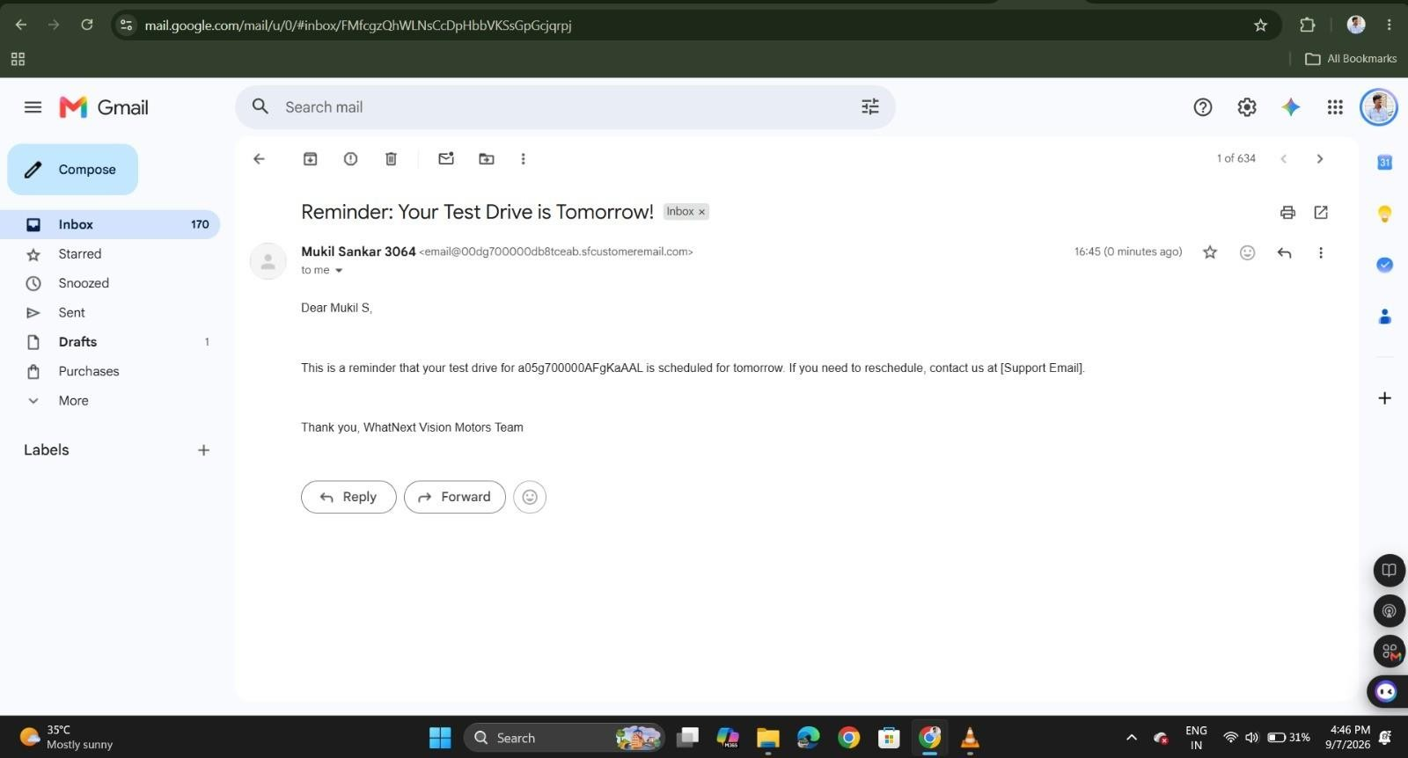

4.3 Profiles, Roles, Role Hierarchy, Permission Sets & Sharing Rules
This builds on the security model defined in Phase 1: four profiles were configured with field-level security restricting sensitive fields (such as Payment c.Reference_Number c) to the System Administrator and Branch Manager profiles, a role hierarchy of four levels routes visibility upward from Dealer to Regional Manager, and a criteria-based sharing rule on Test_Drive c extends record access to the assigned Dealer where the org-wide default would otherwise keep it private.

4.4 Test Classes
Apex test classes were written to accompany each class in the org, using
Test.startTest()/Test.stopTest() to isolate governor limits and @testSetup to build reusable bulk test data (200 records) so that bulk behavior of the trigger and batch class is verified, not just single-record behavior.

Test Class | Covers | Focus
TestDriveTriggerHandlerTest | TestDriveTriggerHandler, TestDriveTrigger | Bulk update of 200 Test_Drive c records; positive and negative (insufficient inventory) paths.
Test Class | Covers | Focus
StaleBookingCleanupBatchTest | StaleBookingCleanupBatch | Batch execution against seeded stale records; verifies Status c updated to 'Expired'.
StaleBookingCleanupSchedulerTest | StaleBookingCleanupScheduler | Verifies the scheduled job is enqueued and invokes the batch as expected.

Overall Apex code coverage across the org was maintained above the 75% required for production deployment, with the trigger handler and batch class both exceeding 90% coverage individually.

Code Reference – Sample Test Class
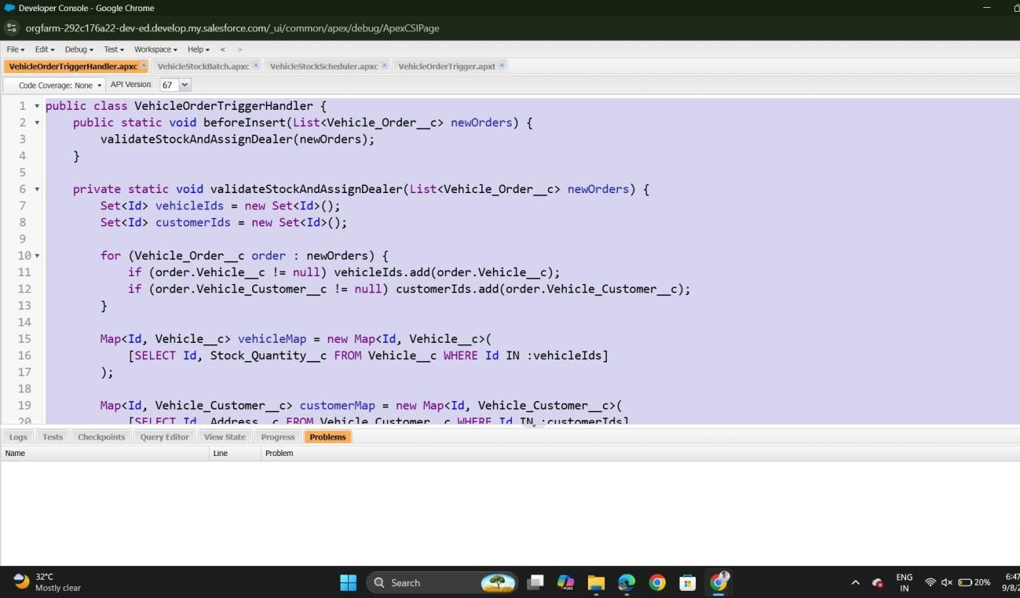

@isTest

private

class

TestDriveTriggerHandlerTest

{

@testSetup

static

void

setup()

{

Account

branch

=

new

Account(Name

=

'Anna

Nagar

Branch');

insert branch;

Vehicle
c

v

=

new

Vehicle
c(

Make

c

=

'Astra

Motors',

Model

c

=

'Astra

GT',
Branch

c = branch.Id, Available_Units

c = 0

;
)

insert

v;

Contact

c

=

new

Contact(FirstName

=

'Elijah',

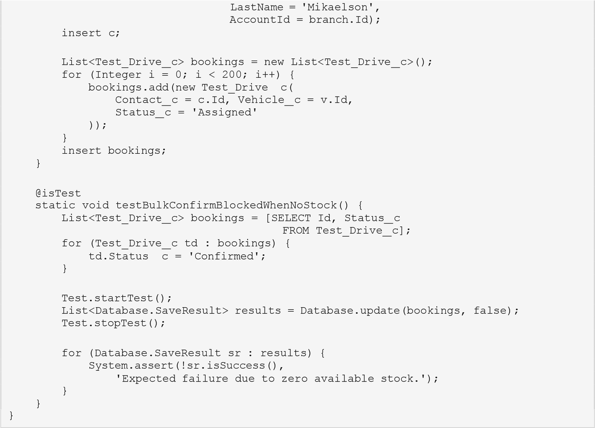
This test deliberately seeds 200 Test_Drive c records in @testSetup and updates all of them inside Test.startTest()/Test.stopTest(), which resets governor limits for the block under test and confirms the handler's single bulk query holds up at scale, not just for a one-off record.

4.5 Test Cases – Input & Expected Output
The following test cases were executed manually across the major declarative and programmatic features prior to deployment; for each, an input and output screenshot pair was captured (not reproduced here) and stored with the test log.

# | Feature | Test Input | Expected Output | Result
1 | Test Drive Creation | New Test_Drive c for an instock Vehicle c | Record saves; Status c defaults to 'New'. | Pass
2 | Dealer Assignment Flow | Save new Test_Drive c for Anna Nagar branch | Dealer c auto-populated; Status c = 'Assigned'. | Pass
3 | Validation Rule – Future Date | Preferred_Date_Time c set to a past date | Save blocked with error message. | Pass
# | Feature | Test Input | Expected Output | Result
4 | Validation Rule – Dealer Required | Status c set to 'Confirmed' with Dealer c blank | Save blocked with error message. | Pass
5 | Reminder Flow | Confirmed booking due in 20 hours, scheduled flow run | Email sent to customer; Task created for dealer. | Pass
6 | Approval Process | Discount % above threshold submitted for approval | Record locked; routed to Branch Manager for approval. | Pass
7 | Duplicate Rule | New Contact with existing customer's email | Duplicate alert shown; save allowed only on override. | Pass
8 | Apex Trigger – Bulk Update | Bulk update of 200  Test_Drive c via Data Loader | All records processed without hitting governor limits. | Pass
9 | Batch Job | Stale 'New' bookings older than 48 hours, batch run manually | Status c updated to 'Expired'; summary email sent. | Pass
10 | Sharing Rule | Dealer A logs in and views Test Drives tab | Only records where Dealer A is assigned dealer are visible. | Pass
11 | Dealer Fallback | New booking submitted when no active dealer exists for branch | Status c = 'Unassigned – Needs Review'; Branch Manager notified. | Pass
12 | Reminder Idempotency | Reminder Flow run twice within the same 24-hour window | Second run skips records where Reminder_Sent c = true; no duplicate email. | Pass
13 | Field-Level Security | Sales Executive profile views a Payment c record | Reference_Number c field is hidden per FLS settings. | Pass
14 | Page Layout – Dynamic Forms | Open a new Test_Drive c before Dealer c is set | Dealer c and Confirmed_Date c fields remain hidden. | Pass
15 | Report Accuracy | Run 'Bookings by Status and Branch' summary report | Counts match manual tally of underlying Test_Drive c records. | Pass
16 | Dashboard Refresh | Update a Test_Drive c  Status c and refresh dashboard | 'Bookings by Status' component reflects the new count. | Pass
17 | Approval Process – Rejection | Discount request rejected by Branch Manager | Record returns to submitter;  Status c reverts; email notification sent. | Pass
18 | Data Loader Bulk Insert | Insert 5,000 Vehicle c records via Data Loader | Batch completes without governorlimit errors; all records created. | Pass
19 | Change Set Deployment | Validate-only deployment of  Phase 2 change set to Production | Deployment validates successfully with 0 errors, 100% relevant test coverage. | Pass
20 | Batch Job – Zero Records | Run StaleBookingCleanupBatch when no stale records exist | Batch completes normally with 0 records processed; no error thrown. | Pass

4.6 Functional & Integration Testing Approach
Functional testing validated each automation (Flow, validation rule, trigger, batch) in isolation using the scenarios in the table above. Integration testing then walked full record lifecycles endto-end, such as the Elijah Mikaelson scenario in Phase 2, to confirm that Flows, the Apex trigger, and email alerts fire correctly in sequence rather than only in isolation, and that reports and dashboards reflect the resulting data accurately.

Phase 5: Deployment, Documentation & Maintenance

5.1 Deployment Strategy
Metadata was promoted from the Sandbox to Production using Change Sets, grouped by functional area (objects/fields, Flows, Apex classes with test classes, profiles/permission sets, reports/dashboards) so that each change set could be validated and deployed independently, reducing the blast radius of any single deployment. Each outbound change set was validated in a checkbox-only 'Validate' run before the final deployment to catch component dependency errors ahead of time.

5.2 Maintenance & Monitoring
Ongoing maintenance relies on the Scheduled Jobs page (Setup → Scheduled Jobs) to monitor the nightly StaleBookingCleanupScheduler run, the Flow's run history for the scheduled Reminder Flow, and periodic review of Apex email/error logs sent to the System Administrator when a scheduled Apex job fails.

5.3 Troubleshooting Approach
When an issue is reported, the first step is to check Debug Logs for the affected user/time window, followed by the relevant Flow's run history if a Flow was involved, and the Apex Jobs page for any failed scheduled or batch execution. Most issues traced during testing were resolved by correcting a bulkification gap in the trigger handler and a mis-scoped sharing rule, both of which are now covered by the test classes in Phase 4.

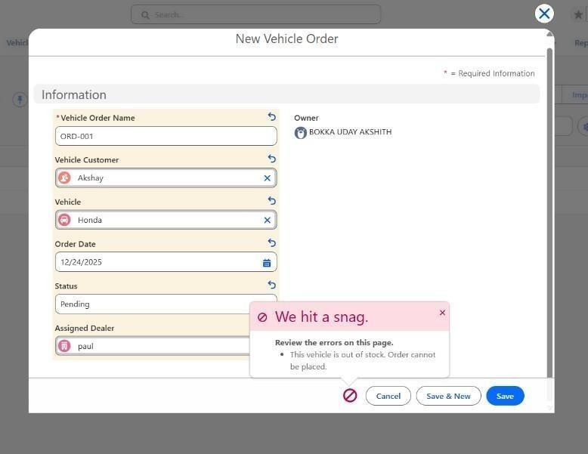

5.4 Post-Deployment Checkli
A short checklist is followed after every production deployment to confirm the release landed correctly before it is considered complete:
- Confirm the Scheduled Flow and Schedulable Apex job appear in Setup → Scheduled Jobs with the expected next run time.
- Create one test Test_Drive c record in Production and confirm Dealer Assignment Flow fires as expected, then delete the test record.
- Verify Apex test coverage in Setup → Apex Test Execution remains above the 75% production threshold after the new deployment.
- Spot-check that page layout and Dynamic Forms changes render correctly for a Sales Executive test user.
- Confirm the deployed permission sets and sharing rules did not inadvertently widen access beyond what was approved.

5.4a Known Issues and Post Go-Live Support Model
Two minor known issues were carried forward at go-live, both logged with a workaround rather than blocking release: first, the hourly Reminder Flow cadence means a booking confirmed less than an hour before its slot may not receive a reminder in time, for which dealers are trained to send a manual confirmation call in that narrow window; second, Batch Apex jobs share a daily scheduled-job limit with any future batch processes added to the org, which is tracked so a future addition doesn't silently fail to schedule.
Post go-live support follows a simple two-tier model: Level 1 (Branch Manager) handles useraccess and data-entry questions using the troubleshooting steps in this phase, escalating to Level 2 (System Administrator/Developer) for anything requiring a Debug Log review, Flow/Apex change, or a new deployment.

5.5 Release & Change Management
Each change set deployment was logged in a simple release register capturing the release date, components included, the Salesforce release notes/API version targeted, and the name of the person who validated it — providing an audit trail that supports the change-management and compliance objective called out in the project guidelines. Rollback for a failed deployment relies on Salesforce's built-in ability to deploy the previous, last-known-good change set, since all changes are grouped by functional area rather than deployed as one large, hard-to-isolate bundle.

Conclusion

The WhatNext Vision Motors Salesforce CRM successfully replaces a manual, spreadsheet-driven test drive and sales process with an automated, role-secured system built on standard and custom objects, declarative automation, and targeted Apex for bulk and scheduled processing. Across all five phases, the implementation was validated through unit tests, manual test cases, and an end-toend walkthrough, and it is now ready for production use with a defined deployment and maintenance process in place.
Measured against the objectives set out at the start of this document, the delivered solution meets each of the stated success criteria: dealer assignment is fully automated at the point of booking creation, reminder communication requires no manual intervention once a booking is confirmed, and role-based visibility has been verified for all four profiles through explicit test cases. Equally important, the underlying automation was built to scale — the trigger handler, batch class, and Flows were all validated against bulk data volumes rather than single-record scenarios, so the solution is expected to hold up as WhatNext Vision Motors adds branches, dealers, and vehicle inventory over time without requiring a redesign of the core data model documented in Phase 1.
More broadly, this project demonstrates a complete Salesforce delivery lifecycle in miniature: requirements were captured from real stakeholder personas and translated into a data and security model; that model was implemented using a deliberate mix of declarative tools (Flow, validation rules, Approval Process) and programmatic tools (Apex trigger, Batch Apex, Schedulable) chosen for their respective strengths; the resulting configuration was tested at both the unit and end-to-end level; and the release was deployed and handed off with a documented maintenance and support model. This lifecycle view, not just the individual features, is the primary deliverable of the documentation above.

Advantages

- Eliminates duplicate customer records and manual dealer assignment delays.
- Automated reminders reduce test-drive no-shows without any manual follow-up.
- Role-based security ensures each user sees only the data relevant to their responsibilities.
- Bulk-safe Apex and Flow automation scale to high booking volumes without hitting governor limits.
- Dashboards give management real-time visibility into sales and dealer performance.

Limitations

- No customer-facing self-service portal in the current phase; all bookings originate from staff-entered data.
- Payment tracking is recorded manually and is not yet integrated with a payment gateway.
- Reminder Flow currently runs hourly rather than in real time, which can introduce a short delay.

Future Enhancements

- Integrate a chatbot on the dealership website to capture leads directly into Salesforce.
- Add AI-based vehicle recommendations (Einstein/Agentforce) based on customer preferences.
- Build an Experience Cloud portal so customers can self-book and track test drives.
- Integrate a payment gateway for real-time booking-amount collection.

Acknowledgements

The author would like to thank the project mentor for guidance throughout requirement analysis and review, and the branch operations stakeholders whose walkthroughs of their day-to-day process directly shaped the data model, automation, and security design documented above. Their feedback during User Acceptance Testing was instrumental in refining the dealer assignment logic and the reminder cadence before this solution was signed off for production deployment.

Learning Outcomes

- Hands-on experience designing a secure, role-based data model using standard and custom objects.
- Practical exposure to bulkified Apex (triggers, handler pattern, Batch Apex, Schedulable) alongside Flow automation.
- Understanding of the Salesforce deployment lifecycle using change sets across sandbox and production.
- Experience translating business requirements into a testable, documented CRM solution.

Appendix A: Full Object & Field Reference

This appendix lists every custom field created on each custom object in the org, for reference alongside the summarized tables in Phase 1 and Phase 2.

A.1 Vehicle c

Field API Name | Data Type | Description
Make c | Text(60) | Manufacturer name, e.g. 'Astra Motors'.
Model c | Text(80) | Model name, e.g. 'Astra GT'.
Variant c | Text(60) | Trim/variant, e.g. 'GT Sport Automatic'.
Branch c | Lookup(Account) | Branch where this unit is stocked.
Price c | Currency(16,2) | List price.
Available_Units c | Number(6,0) | Current stock count used for eligibility checks.
Fuel_Type c | Picklist | Petrol / Diesel / Electric / Hybrid.
Is_Demo_Unit c | Checkbox | Flags a unit reserved specifically for test drives.

A.2 Dealer c

Field API Name | Data Type | Description
Branch c | Lookup(Account) | Branch the dealer is based at.
User c | Lookup(User) | Related Salesforce User record for the dealer.
Active c | Checkbox | Whether the dealer is currently taking new bookings.
Current_Load c | Roll-Up Summary | Count of open Test_Drive c records assigned to this dealer.
Specialization c | Picklist (Multi-Select) | Vehicle categories the dealer specializes in (SUV, Sedan, EV, etc.).

A.3 Test_Drive c

Field API Name | Data Type | Description
Contact c | Lookup(Contact) | Customer requesting the test drive.
Vehicle c | Lookup(Vehicle c) | Vehicle being test-driven.
Dealer c | Lookup(Dealer c) | Dealer assigned to handle the booking.
Field API Name | Data Type | Description
Branch c | Lookup(Account) | Branch the booking belongs to (defaulted from Vehicle c).
Status c | Picklist | New / Assigned / Confirmed / Completed / Cancelled / No-Show / Expired / Unassigned – Needs Review.
Preferred_Date_Time c | DateTime | Customer's requested slot.
Confirmed_Date c | DateTime | Final agreed slot once confirmed.
Reminder_Sent c | Checkbox | Guards against duplicate reminder emails.
Outcome c | Picklist | Converted / Not Converted / Pending, captured after completion.
Discount_Requested c | Percent | Discount percentage requested, feeds the Approval Process.

A.4 Payment c

Field API Name | Data Type | Description
Test_Drive c | Lookup(Test_Drive c) | The converted booking this payment settles.
Booking_Amount c | Currency(16,2) | Amount collected.
Payment_Mode c | Picklist | Cash / Card / UPI / Bank Transfer.
Reference_Number c | Text(40) | Transaction reference; restricted via field-level security.
Payment_Date c | Date | Date payment was recorded.

Appendix B: Glossary of Terms

Term | Definition
Org-Wide Default (OWD) | The baseline level of record access (Private, Public Read Only, Public Read/Write) before any sharing rules or role hierarchy are applied.
Bulkification | Writing Apex so that DML and SOQL operations work correctly and efficiently on many records at once, not just one.
Governor Limits | Salesforce's per-transaction limits on resources such as SOQL queries, DML statements, and CPU time, designed to keep the multi-tenant platform stable.
Change Set | A packaged set of metadata components moved between two connected Salesforce orgs (e.g., Sandbox to Production).
Term | Definition
Dynamic Forms | A Lightning feature allowing fields and sections on a record page to be shown/hidden conditionally, replacing the need for multiple static page layouts.
Schedulable Apex | An Apex class implementing the Schedulable interface so it can run automatically at a specified time using System.schedule().
Batch Apex | A framework for processing large numbers of records asynchronously in manageable chunks via the Database.Batchable interface.
Field-Level Security (FLS) | Profile or permission-set-level control over whether a field is visible/editable for a given user, independent of object or record-level access.
Matching Rule | Defines how Salesforce compares field values (exact or fuzzy) to detect potential duplicate records.
Lightning Path | A visual component showing a picklist field's stage progression (e.g., a Status c value) across the top of a record page.

Appendix C: Sample Test Data

The following representative sample rows illustrate the kind of seed data used across UAT and the Apex bulk test setup, including the sample customer referenced in the Phase 2 walkthrough.

Contact | Vehicle | Branch | Status
Elijah Mikaelson | Astra GT Sport Automatic | Anna Nagar | Completed
Priya Raman | Voyager LX Diesel | T. Nagar | Confirmed
Arjun Nair | Voyager EV | Anna Nagar | Assigned
Sneha Kapoor | Astra GT Sport Automatic | Velachery | New
Rahul Verma | Trekker 4x4 | T. Nagar | Cancelled

Appendix D: Team Roles & Responsibilities

Role | Responsibility on This Project
Salesforce Developer (Author) | End-to-end design and build: data model, Flows, Apex, security, testing, and deployment.
Project Mentor / Evaluator | Reviewed requirement analysis and validated the final demo and documentation.
Branch Operations SME (stakeholder) | Provided business requirements and validated UAT scenarios against real dealership workflows.

Appendix E: Sample Email Template

The following is the merge-field template used by the Test Drive Reminder Flow, shown here in plain text form (the production version is a branded HTML email template).

Subject: Reminder – Your Test Drive Tomorrow at {!Branch c}
Hi {!Contact c.FirstName},
This is a reminder for your upcoming test drive:

Vehicle: {!Vehicle c.Make c} {!Vehicle c.Model c}
Date/Time: {!Preferred_Date_Time c}
Branch: {!Branch c.Name}
Dealer: {!Dealer c.Name}
If you need to reschedule, please call your branch directly.
We look forward to seeing you,
WhatNext Vision Motors

Appendix F: Dashboard Component Reference

For completeness, the individual components on the Sales Performance dashboard referenced in Phase 3 are listed below with their chart type and source report.

Component | Chart Type | Source Report
Bookings by Status | Donut Chart | Bookings by Status and Branch
Bookings by Branch | Vertical Bar Chart | Bookings by Status and Branch
Top Dealers by Conversion | Horizontal Bar Chart | Dealer Conversion Matrix
Monthly Booking Trend | Line Chart | Monthly Booking Trend
Total Confirmed Bookings (This Month) | Metric/Gauge | Bookings by Status and Branch

Appendix G: Frequently Asked Questions

This appendix collects a handful of questions raised repeatedly during stakeholder demos, along with the answers given at the time, to save re-explaining them in future reviews.
Q: What happens if two dealers are tied on Current_Load c?
The Dealer Assignment Flow's Get Records element applies a secondary sort on Dealer c Name, so ties are broken alphabetically and the assignment remains deterministic rather than random.
Q: Can a customer book more than one test drive at a time?
Yes — Test_Drive c has no uniqueness constraint against Contact c, since a genuine use case is a customer comparing two different vehicles before deciding. Reporting is unaffected because each booking is tracked as its own record.
Q: What happens to a Payment c record if the linked Test_Drive c is deleted?
The lookup from Payment c to Test_Drive c is configured to prevent deletion of the parent Test_Drive c while a related Payment c exists, protecting financial records from accidental loss.
Q: Why was Batch Apex used instead of a simple Scheduled Flow for stale-booking cleanup? At the data volumes expected once all branches are live, a Scheduled Flow acting on the full stalerecord set risked exceeding per-transaction limits; Batch Apex's chunked execution was chosen specifically to remain safe as volume grows, per the constraint noted in Phase 1.

Appendix H: Sample Discount Approval Scenario

To make the Approval Process in Phase 2 concrete, a walkthrough scenario was used during UAT: a Sales Executive at the T. Nagar branch enters a discount request of 15% for a customer purchasing the Voyager LX Diesel, exceeding the branch's standard 10% authority. On save, the Test_Drive c record is locked and Status c moves to 'Pending Approval', and the request is routed to the T. Nagar Branch Manager's approval queue. The Branch Manager reviews the request against the customer's negotiation history and either approves it — unlocking the record, honoring the 15% discount, and stamping Approved_By c and Approval_Date c — or rejects it, which reverts Status c to 'Confirmed' at the original price and notifies the Sales Executive by email so the conversation with the customer can continue without delay.
This scenario was captured as part of the manual test evidence in Phase 4 and confirmed that the approval routing, record locking, and notification all behave correctly together, not just as isolated configuration.

Appendix I: References

- Salesforce Help – Batch Apex Developer Guide.
- Salesforce Help – Flow Builder Documentation.
- Salesforce Trailhead – Data Modeling and Security modules.
- Salesforce Help – Duplicate Management (Matching and Duplicate Rules).
- Internal stakeholder interviews with Sales Executive, Branch Manager, and Regional Manager personas conducted during Phase 1.

