SIMATS ENGINEERING
CO3 – PHOTODETECTION , IMAGING AND SIDPKAY SYSTEMS

DESIGN AND PERFORMANCE EVALUATION OF AN INTEGRATED PHOTODETECTION, IMAGING, BIOMEDICAL SENSING AND DISPLAY SYSTEM
Course: ECA1803 – Optoelectronics and Optical Communication
Course Outcome: CO3 – Photodetection, Imaging and Display Systems
Name: DINESH KUMAR J
Reg no: 192312169

1. PROBLEM STATEMENT AND APPLICATION REQUIREMENTS
The objective of this assignment is to design and evaluate an integrated optoelectronic platform for wearable biomedical monitoring, automotive LiDAR, image sensing, ultraviolet (UV) detection, face recognition and advanced display applications. The system must combine suitable photodetectors, image sensors, photovoltaic devices and display technologies while maintaining appropriate sensitivity, response speed, signal quality, power efficiency and integration capability.
Photodetectors convert incident optical power into electrical current. Their performance depends on responsivity, quantum efficiency, dark current, noise, internal gain, bandwidth and linearity. The selection of an appropriate detector is therefore application-dependent. Wearable photoplethysmography (PPG) requires reliable detection of small variations in reflected light, whereas automotive LiDAR requires fast detection of weak optical returns. Imaging and face recognition require suitable spatial resolution, low-light performance and efficient sensor readout.
The proposed system also considers photovoltaic energy harvesting, CMOS/CCD image sensors, OLED/MicroLED/quantum-dot displays and MATLAB/SCILAB-based performance analysis.
Given design parameters
Parameter | Given value
PPG detector responsivity | 0.60 A/W
PPG optical-power variation | 25 µW
LiDAR received optical power | 3 µW
LiDAR detector responsivity | 0.80 A/W
Low-light signal power | −22 dBm
Low-light noise power | −37 dBm
Detector transit time | 20 ps
PV open-circuit voltage | 0.60 V
PV short-circuit current | 5 A
PV fill factor | 0.75
Application requirement statement: The proposed platform must detect small optical-power variations in biomedical sensing, provide high-speed and sensitive LiDAR detection, support reliable imaging and UV sensing, and integrate suitable energy-harvesting and display technologies. All design decisions must be justified using the supplied parameters, theoretical calculations and verified simulation results.

2. PHOTODETECTOR SELECTION AND PERFORMANCE ANALYSIS
2.1 PPG photocurrent calculation
Responsivity is the ratio of generated photocurrent to incident optical power.
R= Delta I / Delta P
Therefore,
Delta I =R/Delta P
Substituting the given values:
Delta I= 0.60 x 25 x 10 ^(-6)
Delta I = 15 µA
The expected photocurrent variation is 15 µA under the stated responsivity and optical-power variation. This current variation can be amplified and filtered to extract the pulsatile component of a PPG signal. PPG measures changes in reflected or transmitted light associated with variations in blood volume in peripheral tissue. Physiological interpretation requires appropriate signal processing and does not follow from photocurrent alone.
2.2 LiDAR photocurrent calculation
The received LiDAR optical power is 3 µW, and the detector responsivity is 0.80 A/W.
I_p = RP
I_p = 0.80 x 3 x 10 ^(-6)
I_p = 2.4 µA
The calculated photocurrent is 2.4 µA, assuming the specified responsivity applies at the operating wavelength and the detector is operating within its linear range. This is the ideal signal photocurrent before accounting for background light, dark current and receiver-circuit effects.
2.3 PIN and APD detector comparison
Characteristic | PIN photodiode | Avalanche photodiode (APD)
Internal gain | Approximately unity | Internal multiplication gain
Sensitivity | Suitable when received power is sufficient | Can improve weak-signal detection
Noise | No avalanche multiplication noise | Additional avalanche excess noise
Bandwidth | Can provide high bandwidth | Depends on device design and gain
Bias voltage | Generally lower | Requires higher reverse bias
Circuit complexity | Relatively simple | Requires bias and gain control
Applications | PPG, imaging and general detection | Weak-return LiDAR and low-light detection

Design Decision 1: A PIN photodiode is recommended as the baseline for wearable PPG and conventional imaging because of its simpler biasing and lower noise complexity. An APD is a suitable candidate for weak-return LiDAR where internal gain may improve receiver sensitivity. The final LiDAR choice must be validated using actual detector noise, gain, bandwidth and receiver specifications.
Quantum efficiency describes the fraction of incident photons that contribute to collected charge carriers. It cannot be calculated numerically from the supplied data because the operating wavelength is not specified for the PPG and LiDAR detectors. Similarly, numerical noise-equivalent power (NEP) and detectivity require additional detector-noise and, for detectivity, active-area information. These quantities must be obtained from the selected device specifications or measurements rather than assumed.

3. NOISE, SIGNAL-TO-NOISE RATIO AND DETECTOR BANDWIDTH
3.1 SNR calculation
The signal-to-noise ratio (SNR) compares signal power with noise power. When both are expressed in dBm, the SNR in decibels is obtained by subtracting the noise level from the signal level.
SNR (db) = P_signal(dBm)/ P_noise (dBm)
SNR(dB) = -22-(-37)
SNR= 15 dB
The corresponding linear power ratio is :
SNR_linear = 10^(15/10)
SNR_linear = approx. 31.62
Thus, the signal power is approximately 31.62 times the noise power under the stated measurement conditions. This does not establish the receiver's final bit-error rate or detection accuracy because the measurement bandwidth, noise distribution and signal-processing conditions are unspecified.
3.2 Principal noise mechanisms
Noise mechanism | Origin | Effect on the design
Shot noise | Discrete nature of electrical charge and the statistical arrival of charge carriers. | Current-noise variance depends on average current and measurement bandwidth.
Dark-current noise | Current generated in the absence of intended illumination. | Becomes increasingly important when the received optical signal is weak.
Avalanche noise | Statistical nature of avalanche multiplication in APDs. | Increasing APD gain does not necessarily improve SNR indefinitely.
The dominant noise mechanism cannot be identified conclusively from the two power levels alone. A valid noise budget requires detector dark current, APD gain and excess-noise factor where applicable, temperature, load and measurement bandwidth.
Recommended SNR-improvement measures include optical filtering to reject unwanted wavelengths, reduction of dark current where practical, appropriate detector gain, improved optical coupling, and restriction of receiver bandwidth to the required signal range. Cooling may reduce some noise sources but increases system power and complexity.
3.3 Response time and bandwidth
The approximate transit-time bandwidth is:
f(approx.)/ 0.44 (t_r)
Given :
t_r = 20ps = 20 x 10^(-12)s
f= 0.44/20 x 10^(-12)s
f(approx) = 22 Ghz
The calculated transit-time bandwidth is approximately 22 GHz. This is an estimate based on the specified transit time, not a verified total receiver bandwidth. The actual bandwidth can be lower because of junction capacitance, load resistance, packaging and amplifier limitations.
A smaller detector active area can reduce capacitance and improve speed, but it may make optical alignment and coupling more difficult. Consequently, detector area, sensitivity and bandwidth must be balanced for each application.
Design Decision 2: A bandwidth-optimized photodetector and receiver circuit are recommended for LiDAR. A PIN or APD device should be selected according to the measured sensitivity and noise budget, while the complete receiver must be tested to confirm its usable bandwidth.
4. PHOTOVOLTAIC, IMAGE-SENSOR AND DISPLAY TECHNOLOGY SELECTION
4.1 Photovoltaic power calculation
The maximum power is estimated using the open-circuit voltage, short-circuit current and fill factor.
P (max) = V_oc / I_sc
P(max)= 0.60 x 5 x 0.75
P_max= 2.25 W
The estimated maximum power is 2.25 W under the conditions associated with the supplied parameters. The actual output depends on illumination, temperature, load and the current-voltage characteristic. Conversion efficiency cannot be calculated without incident optical power and active area.
Flexible photovoltaic devices may be useful for wearable auxiliary energy harvesting because they can conform to curved surfaces. However, their practical suitability depends on efficiency, mechanical durability, encapsulation, operating illumination and integration requirements.
4.2 CMOS versus CCD image sensors
Characteristic | CMOS | CCD
Readout | Pixel-level or column-level circuitry | Charge transferred through the sensor
Power consumption | Generally lower in many modern designs | Can be higher due to charge-transfer requirements
Integration | Well suited to on-chip processing | Generally requires more specialized readout
Speed | Supports fast readout architectures | Depends on device and readout design
Noise | Strongly dependent on pixel and circuit design | Can provide low read noise in suitable implementations
Applications | Face recognition, automotive cameras and compact imaging | Applications requiring specific image-quality characteristics
CMOS is recommended for the integrated platform because it supports compact implementation, fast readout and integration with signal-processing electronics. Smaller pixels can improve spatial sampling density but may collect fewer photons per pixel under comparable optical conditions, potentially affecting sensitivity and signal-to-noise ratio. Pixel scaling must therefore be considered alongside optics, illumination and processing.
4.3 Emerging display technologies
Technology | Main characteristics | Suitable applications
OLED | Self-emissive pixels, high contrast and thin form factor | Foldable devices and compact displays
MicroLED | Self-emissive pixels with potential for high brightness and long operating life | High-brightness AR/VR and advanced displays
Quantum-dot displays | Quantum dots provide wavelength-selective colour conversion or emission, depending on architecture | High-colour-performance displays
No display technology can be declared universally superior without specific brightness, power, lifetime, size and cost targets. OLED is a reasonable candidate for foldable consumer devices, while MicroLED is a promising candidate for high-brightness applications. Quantum-dot technology is suitable where colour performance is a priority, subject to the selected display architecture.
Design Decision 3: Flexible PV may be used for auxiliary wearable energy harvesting, CMOS is recommended for the integrated imaging module, and the display should be selected according to the intended application. OLED is the baseline choice for a foldable interface; MicroLED should be evaluated for high-brightness AR/VR use.

5. APPLICATION-SPECIFIC SENSING, SIMULATION AND FINAL VERIFICATION
5.1 Biomedical and industrial applications
Application | Sensing principle | Design considerations
Wearable PPG | An illumination source directs light into tissue, and a photodiode detects changes in reflected or transmitted light. | The calculated 15 µA current variation is the theoretical starting point for signal conditioning. Filtering and amplification are required to separate the pulsatile component from ambient light and motion-related interference.
NIR spectroscopy | NIR illumination and photodetection measure wavelength-dependent optical changes in biological materials. | Source wavelength, detector responsivity, optical filtering and calibration must be chosen for the intended measurement. No biochemical accuracy can be claimed without experimental validation.
Automotive LiDAR | A pulsed or otherwise modulated optical source illuminates the scene, and a receiver detects returned light. | The calculated 2.4 µA photocurrent is a baseline for receiver design. Accurate ranging also requires timing calibration, suitable detection bandwidth and management of background light and weak returns.
Face recognition | A CMOS camera captures facial images under suitable visible illumination. NIR sensing may supplement imaging (e.g. controlled illumination or liveness assessment). | Image resolution, illumination, sensor noise and processing determine overall performance.
UV detection | A detector with suitable spectral response is required for the intended UV wavelength range. | Visible-light rejection, calibration and environmental stability must be considered. No UV wavelength or responsivity is given, so specific detector performance cannot be calculated.
5.2 MATLAB/SCILAB verification
The following MATLAB script models photocurrent as a function of optical power, calculates the specified SNR and verifies the approximate detector bandwidth. These are analytical calculations implemented in code; they are not fabricated experimental results.
clc;
clear;
close all;
% Given assignment parameters
R_PPG = 0.60; % A/W
deltaP_PPG = 25e-6; % W
R_LiDAR = 0.80; % A/W
P_LiDAR = 3e-6; % W
t_r = 20e-12; % seconds
% Theoretical photocurrents
I_PPG = R_PPG * deltaP_PPG;
I_LiDAR = R_LiDAR * P_LiDAR;
% SNR from given power levels
signal_dBm = -22;
noise_dBm = -37;
SNR_dB = signal_dBm - noise_dBm;
SNR_linear = 10^(SNR_dB/10);
% Transit-time bandwidth
bandwidth = 0.44 / t_r;
% Responsivity model
P = linspace(0, 50e-6, 100);
I = R_PPG .* P;
figure;
plot(P*1e6, I*1e6, 'LineWidth', 1.5);
xlabel('Optical Power (\muW)');
ylabel('Photocurrent (\muA)');
title('PPG Detector Responsivity Model');
grid on;
fprintf('PPG current variation = %.2f microampere\n', ...
I_PPG*1e6);
fprintf('LiDAR photocurrent = %.2f microampere\n', ...
I_LiDAR*1e6);
fprintf('SNR = %.2f dB\n', SNR_dB);
fprintf('Linear SNR = %.2f\n', SNR_linear);
fprintf('Transit-time bandwidth = %.2f GHz\n', ...
bandwidth/1e9);
MATLAB output
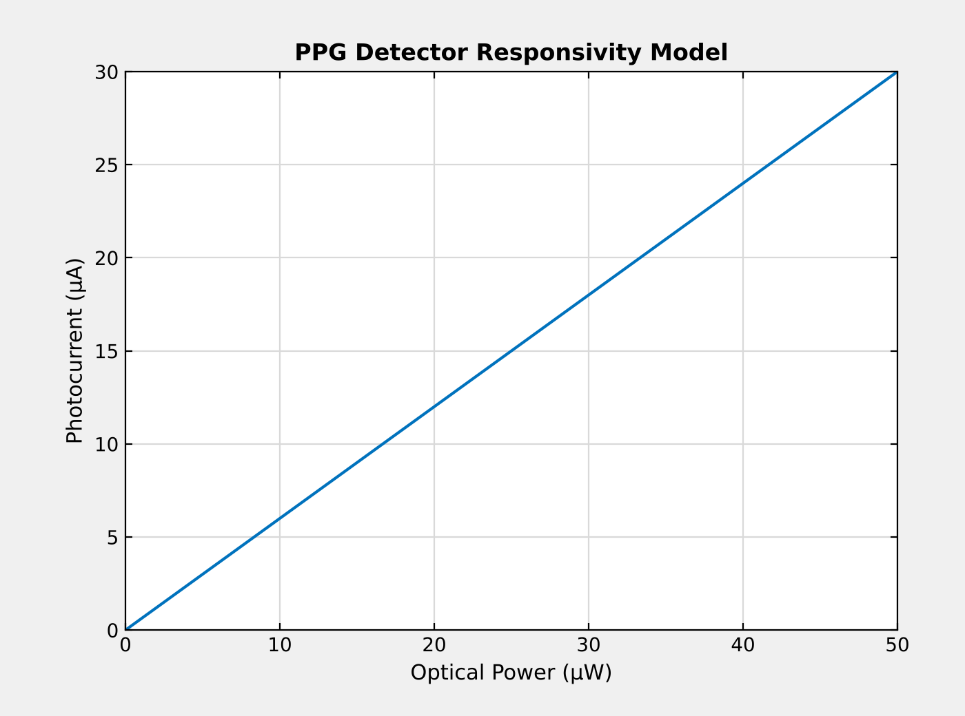
Figure 1: MATLAB output – PPG detector responsivity model (photocurrent versus optical power).
Command Window output:
PPG current variation = 15.00 microampere
LiDAR photocurrent = 2.40 microampere
SNR = 15.00 dB
Linear SNR = 31.62
Transit-time bandwidth = 22.00 GHz
The code should produce a linear photocurrent-versus-optical-power plot and report the calculated PPG current, LiDAR current, SNR and transit-time bandwidth. A complete noise simulation requires additional numerical parameters for shot noise, dark current, avalanche multiplication and receiver bandwidth. Those results must be generated after the missing parameters are obtained.
5.3 Final verification
Requirement | Calculated or selected result | Status
PPG photocurrent variation | 15 µA | Calculated
LiDAR photocurrent | 2.4 µA | Calculated
Low-light SNR | 15 dB | Calculated
Transit-time bandwidth | Approximately 22 GHz | Estimated
PV maximum power | 2.25 W | Calculated from supplied parameters
Detector quantum efficiency | Insufficient data | Requires wavelength and detector data
NEP and detectivity | Insufficient data | Requires noise and detector-area data
Noise performance | Qualitatively assessed | Requires a complete noise budget
Image sensor | CMOS recommended | Design recommendation
Display | OLED baseline for foldable use | Application-dependent recommendation
Biomedical and LiDAR sensing | Feasible in principle | Requires prototype validation
MATLAB/SCILAB | Analytical model provided | Run and inspect plots before submission

6. CONCLUSION AND FINAL ENGINEERING DECISION
The analysis establishes the theoretical performance of the proposed integrated optoelectronic platform using the supplied assignment values. The PPG detector produces an estimated photocurrent variation of 15 µA, the LiDAR detector produces 2.4 µA, the specified low-light measurements correspond to an SNR of 15 dB, and the estimated transit-time bandwidth is 22 GHz. The photovoltaic parameters give a calculated maximum power of 2.25 W.
A PIN photodiode is recommended for baseline PPG and imaging, while an APD remains a candidate for weak-return LiDAR subject to noise and bandwidth verification. CMOS imaging, application-specific display selection and appropriate filtering and signal conditioning support integration across the proposed applications.
Final engineering decision: NO — not for immediate deployment. The calculations support a preliminary design, but detector quantum efficiency, NEP, detectivity, detailed noise performance, UV response, display specifications and simulation validation remain incomplete. The system should proceed to prototype development and testing only after the missing device parameters are obtained, the MATLAB/SCILAB models are executed and verified, and each application is evaluated against its actual performance requirements.

