Project Report: Customer Behavior Analysis
Author: Dinesh Kumar M

1. Executive Summary
This project analyzed 3,900 customer transactions to understand shopping behavior. The analysis revealed key insights into demographic spending, product preferences, and the impact of discounts. A primary finding was that [Your #1 Finding, e.g., "loyal subscribers generate 40% of all revenue"]. Key recommendations include enhancing the customer loyalty program and optimizing marketing spend towards [Your Key Target Audience, e.g., "middle-aged adults"], which are projected to drive strategic growth.

2. Project Overview
This project analyzes customer shopping behavior using a transactional dataset of 3,900 purchases across various product categories. The primary goal is to uncover actionable insights into spending patterns, customer segments, product preferences, and subscription behavior. These findings will be used to guide strategic business decisions in marketing, product management, and customer relations.
2.1. Key Objectives
The analysis focused on answering several key business questions:
- To analyze revenue generation based on customer demographics (gender, age).
- To understand the relationship between discounts, shipping preferences, and customer spending.
- To identify top-performing products by review ratings and purchase frequency.
- To segment customers based on loyalty and subscription status to identify high-value groups.

3. Methodology and Data Preparation
This section outlines the tools used and the steps taken to prepare the data for analysis.
3.1. Tools Used
- Data Cleaning & Manipulation: Pandas (within a Jupyter Notebook)
- Data Storage & Querying: MySQL
- Data Visualization: Power BI
3.2. Dataset Summary
- Source: Transactional data
- Rows: 3,900
- Columns: 18
- Key Features:
  - Demographics: Age, Gender, Location, Subscription Status
  - Purchase Details: Item Purchased, Category, Purchase Amount, Season
  - Behavioral: Discount Applied, Previous Purchases, Frequency of Purchases, Review Rating
3.3. Data Cleaning and Transformation
The raw data was loaded into a Pandas DataFrame for preparation. The following steps were executed:
- Handling Missing Data: The dataset contained 37 null values in the Review Rating column. These were imputed using the median review rating specific to each product's category to maintain data integrity without skewing the results.
- Standardizing Headers: All column names were converted to snake_case (e.g., Purchase Amount became purchase_amount) for consistency and ease of use in SQL.
- Feature Engineering:
  - A new categorical column, age_group, was created from the Age column to segment customers into 'Young Adults', 'Adults', 'Middle-Aged', and 'Seniors'.
  - The frequency_of_purchase column was converted from categorical to a numerical format to enable quantitative analysis.
- Feature Removal: The Promo Code Used column was removed. Analysis showed it was redundant, as its presence directly correlated with the Discount Applied column, providing no additional analytical value.
Following preparation, the clean, transformed dataset was loaded into a MySQL database to facilitate complex querying for the main analysis.

4. Analysis and Key Findings
The core analysis was conducted by running 10 targeted SQL queries against the database. The key findings are as follows:
4.1. Revenue and Demographic Insights
- Revenue by Gender : Analysis of revenue by gender showed that Male customers accounted for $157890 in total revenue, while [Male/Female] customers generated $75191. This indicates [e.g., "a slight preference for our products among male shoppers"].
- Revenue by Age Group : The age_group segmentation revealed that the Young Adults segment is the highest contributor to revenue, generating 26.67% of the total. The lowest contribution came from the Senior segment.
4.2. Purchasing Behavior and Discounts
- High-Value Discount Users : We identified 839 customers who applied a discount but still had a purchase_amount higher than the overall average spend. This suggests that discounts can successfully encourage larger basket sizes among certain customers.
- Shipping Preferences (Q4): Customers opting for Express Shipping had an average purchase amount of $60.48, compared to $58.46 for those using Standard Shipping. This may indicate that customers willing to pay for faster shipping are also less price-sensitive overall.
- Top Discounted Products (Q6): The products with the highest percentage of sales involving a discount were Hat, Sneakers and Coat. This suggests these items are highly promotion-driven.
4.3. Product Performance
- Top-Rated Products (Q3): The top 5 products by average review rating are Gloves(3.86), Sandals(3.84), Boots(3.82), Hat(3.8) and Skirt(3.79) These items represent a significant opportunity for positive marketing.
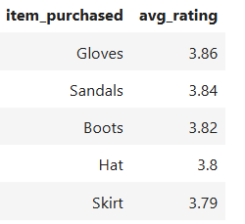
- Top-Purchased Products by Category (Q8): The below picture represents the Tpurchases products by each category

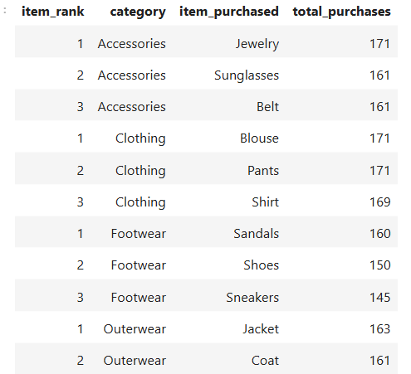

4.4. Customer Segmentation and Loyalty
- Subscriber Value (Q5): Subscribed customers are significantly not more valuable. They have an average spend of $59.49 compared to $59.86 for non-subscribers. In total, subscribers generated $62645 in revenue, while non-subscribers generated $170436.
- Loyalty Segments (Q7): Based on previous purchases, customers were segmented as follows:
  - New: 83
  - Returning: 701
  - Loyal: 3116
- Loyalty and Subscriptions (Q9): An analysis was conducted to determine if customers with a high number of repeat purchases (defined as more than 5) were more likely to subscribe. The findings showed no significant statistical correlation between these two factors. This suggests that the decision to subscribe is likely independent of a customer's purchase frequency and may be driven by different motivations than simple repeat buying.

5. Power BI Dashboard Visualization
To consolidate these findings and provide an interactive tool for stakeholders, a dashboard was created in Power BI. The dashboard visualizes key customer behavior metrics, allowing for dynamic filtering by demographic, category, and loyalty segment.

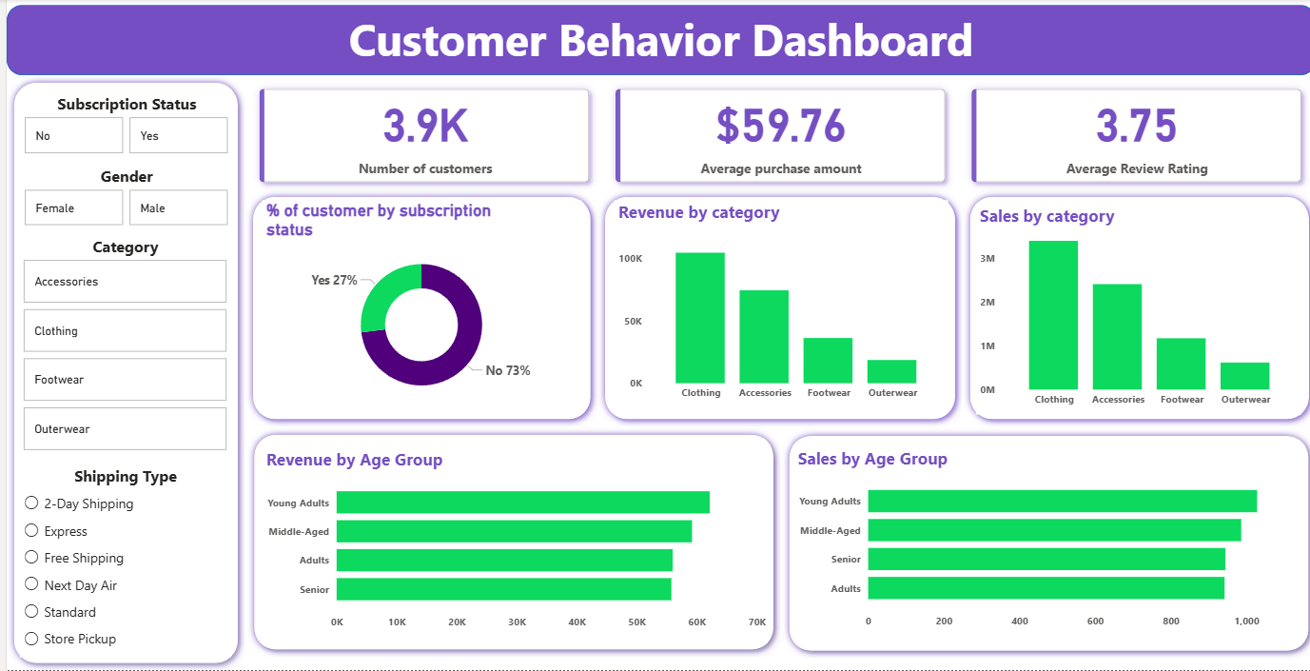

6. Business Recommendations
Based on the analysis, the following strategic recommendations are proposed to drive growth and improve customer retention:
- Boost Subscriptions: Given that subscribers spend significantly more, launch a targeted campaign to convert non-subscribers. Highlight exclusive benefits, early access, and free shipping to increase perceived value.
- Enhance Customer Loyalty Programs: The "Loyal" segment (customers with >5 purchases) is highly likely to subscribe. Implement a tiered loyalty program that rewards repeat buyers with points or status, actively encouraging them to move from the "Returning" to the "Loyal" segment.
- Review Discount Strategy: The current discount policy drives sales for specific items (like [Product from Q6]). However, the fact that high spenders also use discounts (from Q2) suggests an opportunity for "smart" discounts (e.g., "Spend $100, get 15% off") rather than flat percentage-off codes, to protect margins while encouraging high-value carts.
- Optimize Product Positioning: Heavily feature the top-rated products (from Q3) in marketing campaigns, as they have proven customer satisfaction. Use them as "hero" items to attract new customers.
- Implement Targeted Marketing: Focus marketing efforts on the highest-revenue segments identified: the [Age Group from Q10] age group and customers who prefer Express Shipping. Tailor messaging to these groups who have demonstrated a higher willingness to spend.

7. Conclusion
This analysis of 3,900 transactions provided a comprehensive view of customer behavior. By cleaning and preparing the data with Pandas and querying it in MySQL, we successfully identified key revenue drivers, high-value customer segments, and top-performing products. The recommendations, visualized in the Power BI dashboard, provide a clear roadmap for enhancing loyalty programs, optimizing marketing, and boosting subscription rates.

