**TECHNOLOGY NAME: ENVIRONMENTAL MONITORING**

**INTRODUCTION:**

Environmental monitoring solutions have evolved over the years into Smart Environmental Monitoring (SEM) systems that now incorporate modern sensors, Machine Learning (ML) techniques, and the Internet of Things (IoT). Technologies such as loT devices and wireless sensor networks have made advanced environmental monitoring using loT a more streamlined and Artificial Intelligence- controlled process.

IoT for environmental monitoring facilitates the development of wireless, remote environmental monitoring systems, which enable operations to remove much of the human interaction in system function, which reduces human labour, increases the range and frequency of sampling and monitoring, facilitates sophisticated on-site testing, provides lower latency, and connects detection systems to response teams, ultimately resulting in higher rates of significant disaster and contamination prevention.

**DEFINITION:**

The project involves setting up IoT devices to monitor environmental conditions in public parks, including temperature and humidity. The primary objective is to provide real-time environmental data to park visitors through a public platform, enabling them to plan their outdoor activities accordingly. This project includes defining objectives, designing the IoT sensor system, developing the environmental monitoring platform, and integrating them using IoT technology.

**OVERVIEW OF PROJECT:**

Environmental monitoring includes not only the examination and analysis of ambient materials such as water, soil and air but also examination of other species, animal or plant that may provide useful information on pathogens and toxic or radioactive substances in the locality.

**OBJECTIVE:**

* To manage and minimize the impact an organization's activities have on and environment.
* To ensure compliance with laws and regulations or to mitigate risks of harmful effects on the natural environment and protect the health of human beings.

**BLOCK DIAGRAM:**

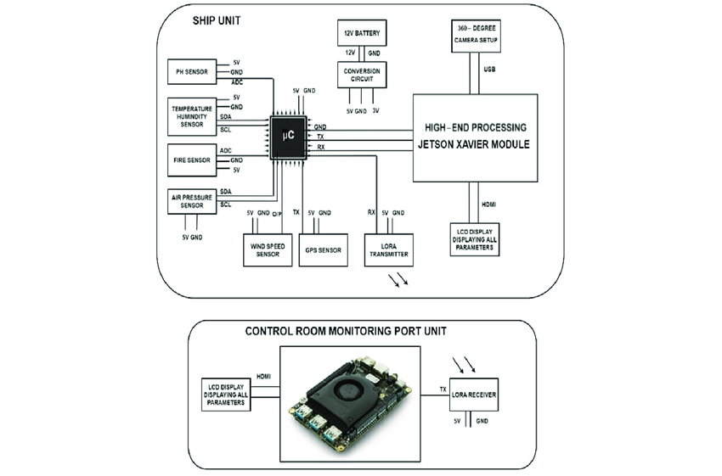

**FLOWCHART:**

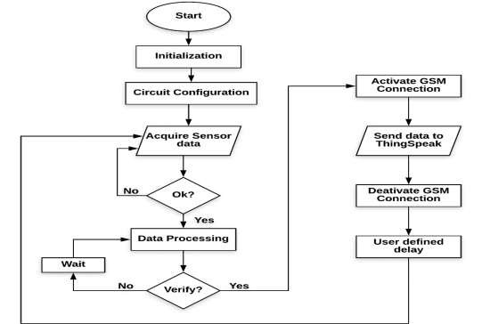

**CONCLUSION**:

From above mentioned sensors ,we can get information about Temperature, Air quality, Rainfall, Ph values, Wind speed etc,.By using these sensors advanced techniques will be provided and our Environment will be Enhanced and mainted successfully.