ShopEase - Microservices-Based E-Commerce Management System
Service Responsibilities
Document 2 - Responsibilities of each microservice
Prepared by: Dineshkumar S | Day 1 Deliverable

1. Overview
ShopEase has six microservices. Each one has a clear job. A service does only its own job and asks other services through APIs when it needs something else. The diagram below shows the full system.
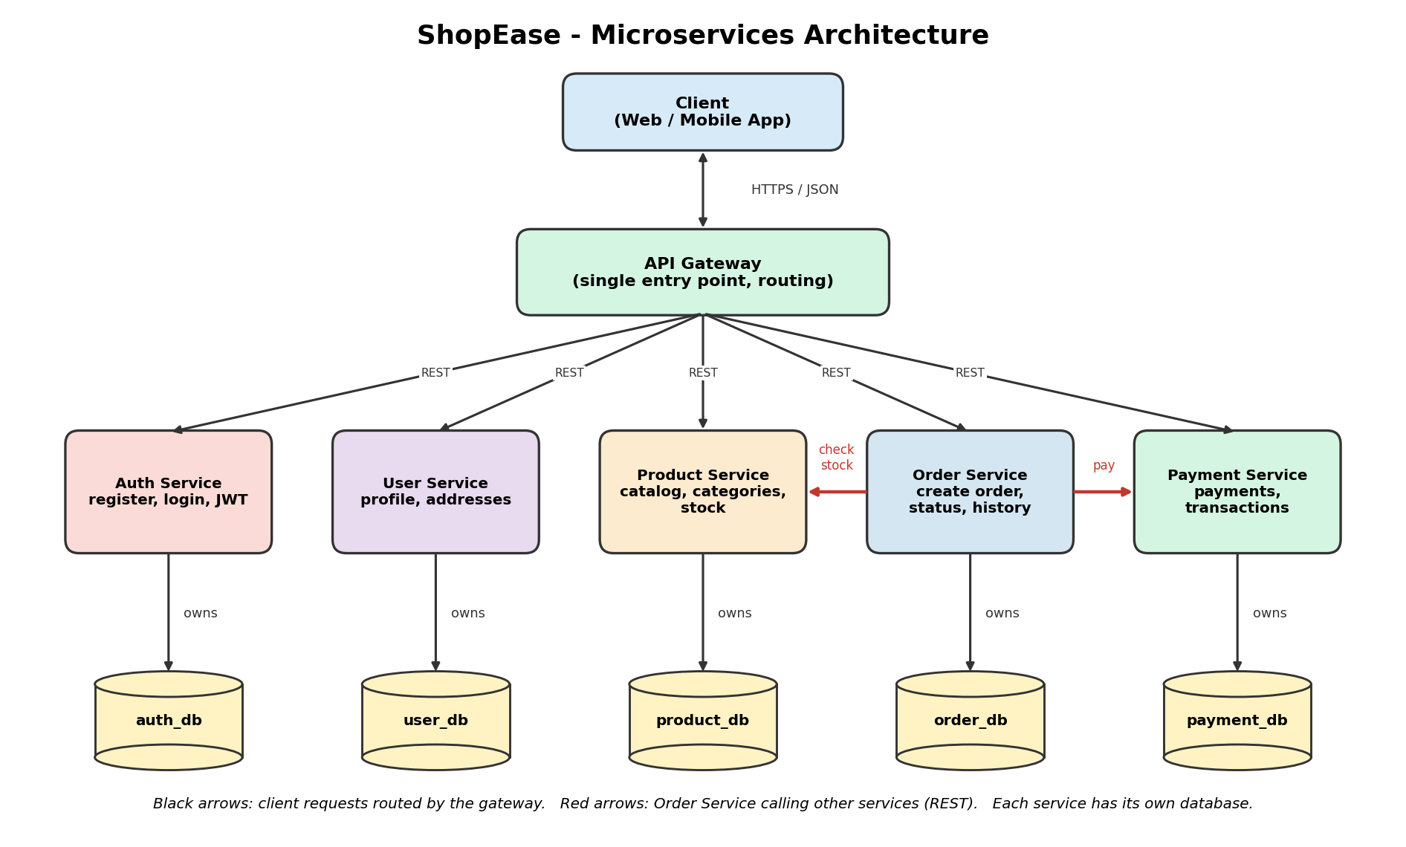

2. Authentication Service
Purpose: Takes care of who the user is and whether they are allowed to enter the system.

Responsibilities
- Register new users (email and password).
- Store passwords safely as hashed values, never as plain text.
- Login and check the email and password.
- Create a JWT (JSON Web Token) after a successful login.
- Verify JWT tokens when other services ask.
Does not do: It does not store profile details, addresses, products or orders.
Database: auth_db (users, credentials)

3. User Service
Purpose: Manages the profile information of customers.

Responsibilities
- View and update the user profile (name, phone number).
- Add, update, list and delete delivery addresses.
Does not do: It does not handle login or passwords.
Database: user_db (profiles, addresses)

4. Product Service
Purpose: Manages everything about the items we sell.

Responsibilities
- Product catalog: add, view, update and delete products.
- Categories: group products such as Mobiles, Laptops and Clothes.
- Inventory: keep the stock count of every product.
- Reduce stock when an order is placed and increase it again if the order fails.
Does not do: It does not create orders or take payments.
Database: product_db (products, categories, inventory)

5. Order Service
Purpose: Handles the customer's orders from start to finish.

Responsibilities
- Create a new order with a list of items.
- Check product availability by calling the Product Service.
- Start the payment by calling the Payment Service.
- Keep the order status: PENDING, PAID, FAILED, CANCELLED.
- Show order history and order details for a customer.
Does not do: It does not store product details or payment details itself. It asks the other services.
Database: order_db (orders, order_items)

6. Payment Service
Purpose: Handles money related records.

Responsibilities
- Create a payment record for an order.
- Keep the transaction history.
- Keep the payment status: SUCCESS, FAILED, PENDING.
Does not do: It does not create orders or change stock.
Database: payment_db (payments, transactions)

7. API Gateway
Purpose: It is the single entry point for all client requests.

Responsibilities
- Receive every request from the client (web or mobile app).
- Route the request to the correct service, for example /products goes to the Product Service.
- Check the JWT token before sending protected requests forward.
- Hide the internal services, so the client only knows one address.
Database: The gateway has no database of its own.

8. Summary Table
Service | Main job | Database
Authentication | Register, login, JWT | auth_db
User | Profile and addresses | user_db
Product | Catalog, categories, inventory | product_db
Order | Create orders, status, history | order_db
Payment | Payments, transactions, status | payment_db
API Gateway | Routing, single entry point | None

