ShopEase - Microservices-Based E-Commerce Management System
Database Ownership
Document 3 - Database per service
Prepared by: Dineshkumar S | Day 1 Deliverable

1. Database Per Service
In microservices, every service has its own database. Only that service is allowed to read or write it. Other services cannot connect to it. If they need the data, they must ask the owner service through its API.
In ShopEase we use MySQL, and each service has its own database: auth_db, user_db, product_db, order_db and payment_db. The API Gateway has no database.
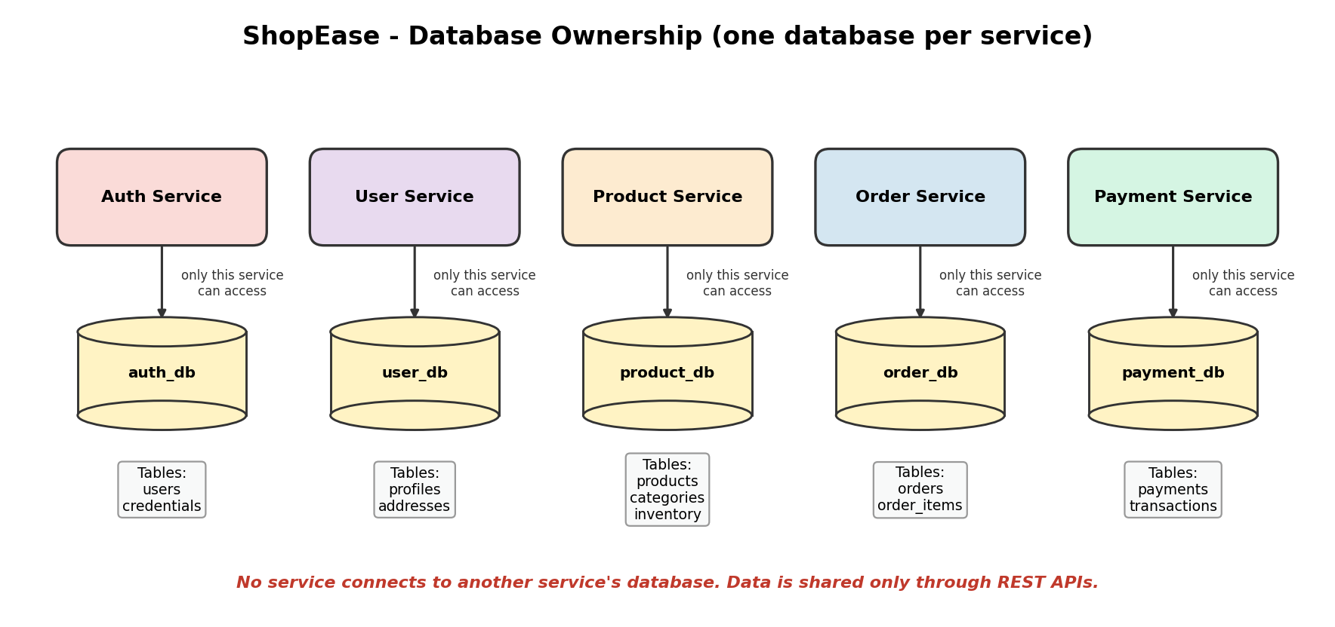

2. Tables in Each Database
Database | Owner | Main tables
auth_db | Authentication Service | users (id, email, password_hash, created_at)
user_db | User Service | profiles (id, user_id, name, phone); addresses (id, user_id, line1, city, pincode)
product_db | Product Service | categories (id, name); products (id, name, price, category_id); inventory (product_id, stock_quantity)
order_db | Order Service | orders (id, user_id, total_amount, status, created_at); order_items (id, order_id, product_id, quantity, price)
payment_db | Payment Service | payments (id, order_id, amount, status); transactions (id, payment_id, reference, created_at)

3. Database Isolation and Service Independence
- Isolation: A problem in one database, such as a slow query or a crash, does not affect the other services.
- Independent changes: A service can change its tables without breaking other services.
- Independent scaling: A busy database, like product_db, can be scaled alone.
- Technology freedom: Each service can choose the database type that suits it best.
- Security: Sensitive data, such as passwords and payments, stays in its own protected database.

4. Why Not Access Another Service's Database Directly?
Suppose the Order Service reads product_db directly to check stock. This causes problems:
- Tight coupling: If the Product team renames a column, the Order Service breaks without warning.
- No business rules: The Product Service has rules about stock. Reading the database directly skips those rules.
- Security risk: Many services holding passwords to the same database is unsafe.
- Hard to scale or replace: We cannot change or move product_db easily because other services depend on it.
The correct way is to call the Product Service API, for example GET /products/5. The Product Service checks its own rules and returns only the data that is needed.

5. Data Across Services
Because the data is split, an order only stores the product_id and the user_id, not the full product or user details. When details are needed, the Order Service calls the Product Service or the User Service. The price is saved inside order_items at the time of purchase, so old orders remain correct even if the price changes later.

6. Conclusion
Database per service keeps the services independent and safe. The cost is that data must be fetched through APIs and some consistency work is needed, but this is the standard approach in microservices.

