ShopEase - Microservices-Based E-Commerce Management System
Service-to-Service Communication Workflow
Document 5 - Order flow and error handling
Prepared by: Dineshkumar S | Day 1 Deliverable

1. How Services Communicate
In ShopEase, services talk to each other using REST APIs over HTTP. A service never reads another service's database. For example, if the Order Service needs product details, it sends an HTTP request to the Product Service and gets a JSON response.

2. Complete Project Flow
Customer registration and login, JWT authentication, product browsing, order creation, product availability check, payment processing, order status update, and order history and reporting.
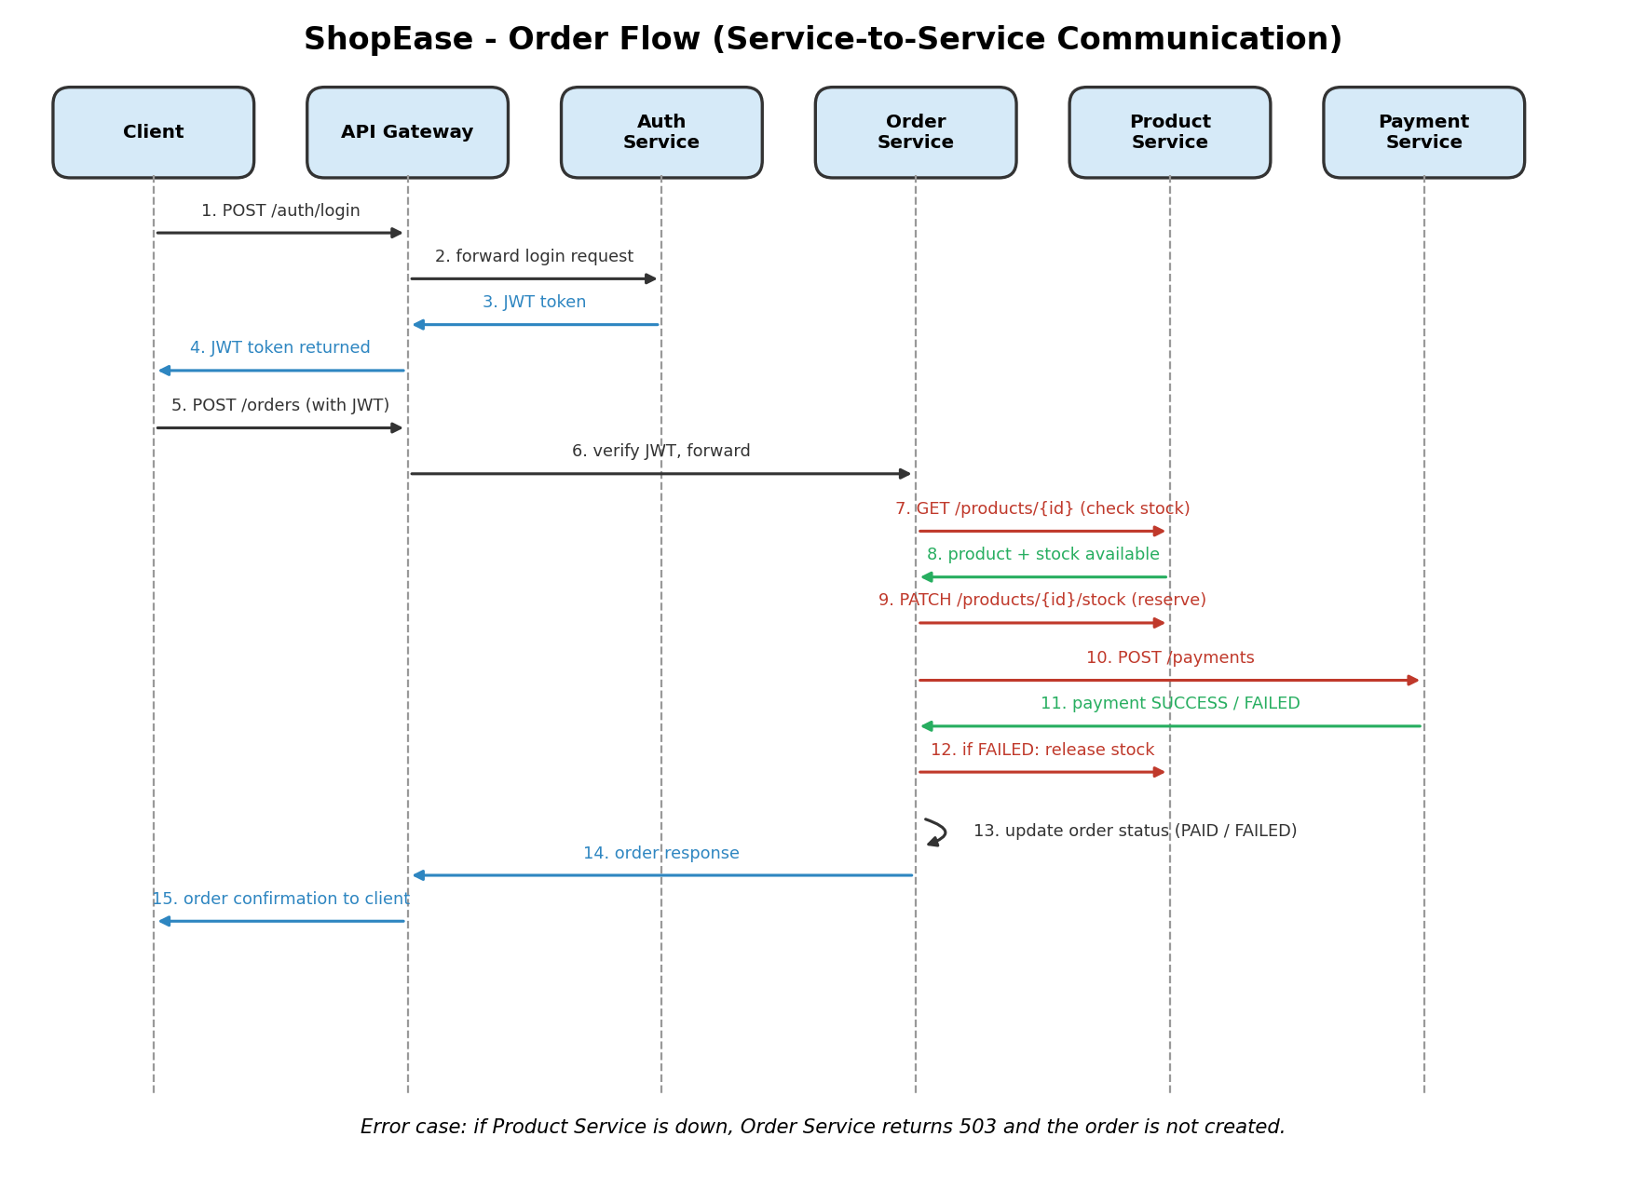

3. Step by Step Flow

Step 1: Registration and login
The customer registers using POST /auth/register. Then the customer logs in using POST /auth/login. The Authentication Service checks the email and password and returns a JWT token.

Step 2: JWT authentication
The client keeps the token and sends it in the Authorization header with every next request. The API Gateway checks the token before forwarding the request. If the token is missing or wrong, it returns 401 Unauthorized.

Step 3: Product browsing
The customer calls GET /products. The gateway routes the request to the Product Service, which returns the list of products.

Step 4: Order creation
The customer places an order with POST /orders. The gateway sends it to the Order Service. The Order Service saves the order with the status PENDING.

Step 5: Product availability validation
The Order Service calls GET /products/{id} on the Product Service for each item. If the stock is enough, the Order Service asks the Product Service to reduce the stock using PATCH /products/{id}/stock.

Step 6: Payment processing
The Order Service calls POST /payments on the Payment Service with the order id and the amount. The Payment Service saves the payment and returns SUCCESS or FAILED.

Step 7: Order status update
If the payment is SUCCESS, the Order Service changes the order status to PAID. If the payment is FAILED, it changes the status to FAILED and asks the Product Service to put the reserved stock back.

Step 8: Order history and reporting
The customer can see all past orders using GET /orders and one order using GET /orders/{id}. The Order Service reads these from its own order_db.

4. Order Service Communication Summary
Order Service calls | Endpoint | Why
Product Service | GET /products/{id} | Check the product and the stock
Product Service | PATCH /products/{id}/stock | Reduce stock, or restore it if the order fails
Payment Service | POST /payments | Process the payment

5. Error Handling When a Service Is Unavailable
In a microservices system, a service can be down or slow at any time. The calling service must handle this properly instead of crashing.

If the Product Service is down
The Order Service cannot check the stock. It should not create the order. It returns 503 Service Unavailable with a clear message, such as: "Product service is not available, please try again later."

If the Payment Service is down
The stock was already reserved, so the Order Service must put the stock back by calling the Product Service. Then it marks the order as FAILED (or keeps it PENDING so the payment can be tried again) and returns 503 to the client.

If the payment fails
The Order Service marks the order as FAILED and releases the reserved stock. The customer is told that the payment did not go through.

Useful techniques
- Timeout: Do not wait forever for a service. Stop waiting after a few seconds (for example 5 seconds).
- Retry: Try again two or three times for temporary problems, with a short wait between tries.
- Circuit breaker: If a service keeps failing, stop calling it for a short time and return an error quickly.
- Clear error messages and logs: Always log which service failed, so it is easy to find the problem.
- Compensation: If a later step fails, undo the earlier step (for example release the stock).

Error response example
HTTP/1.1 503 Service Unavailable
{
"detail": "Product service is not available. Please try again later."
}

6. Conclusion
Services in ShopEase work together only through REST APIs. The Order Service is the main coordinator that talks to the Product and Payment services. Good error handling with timeouts, retries and undoing earlier steps keeps the system safe even when one service fails.

