Plugin Arch

Folder Structure
```
└── 📁platform
└── 📁Announcement
└── 📁Config
└── 📁Database
└── 📁Migrations
├── 2026_01_01_000000_create_announcements_table.php
└── 📁Seeders
└── 📁Http
└── 📁Controllers
├── AnnouncementController.php
└── 📁Requests
└── 📁Models
├── Announcement.php
└── 📁Providers
├── AnnouncementServiceProvider.php
└── 📁Resources
└── 📁Lang
└── 📁Views
└── 📁Partials
├── create.blade.php
├── edit.blade.php
├── index.blade.php
└── 📁Routes
├── web.php
└── 📁Services
├── helpers.php
├── plugin.json
```

Service Provider
File: AnnouncementServiceProvider.php
The Service Provider registers plugin services, loads routes, views, and migrations, handles dynamic registration, manages boot logic.
plugin.json
The plugin.json file manages plugin metadata, version control, provider registration path, module identification, and upgrade tracking.
Config Folder[system behavior]
add-ons, media handling, authentication rules, and system-level
Layers
- Repository
- Service
- Support classes
- Jobs
- Console Commands
Plugin Installation
command to install the plugin:
php artisan plugins:raiyaaninfo
plugin will be registered, database migrations will execute, and the plugin index page will become accessible.
Plugin Features
- Activate Plugin
- Deactivate Plugin
- Remove Plugin Completely
- Version Control
- Upgrade to Latest Version

Database
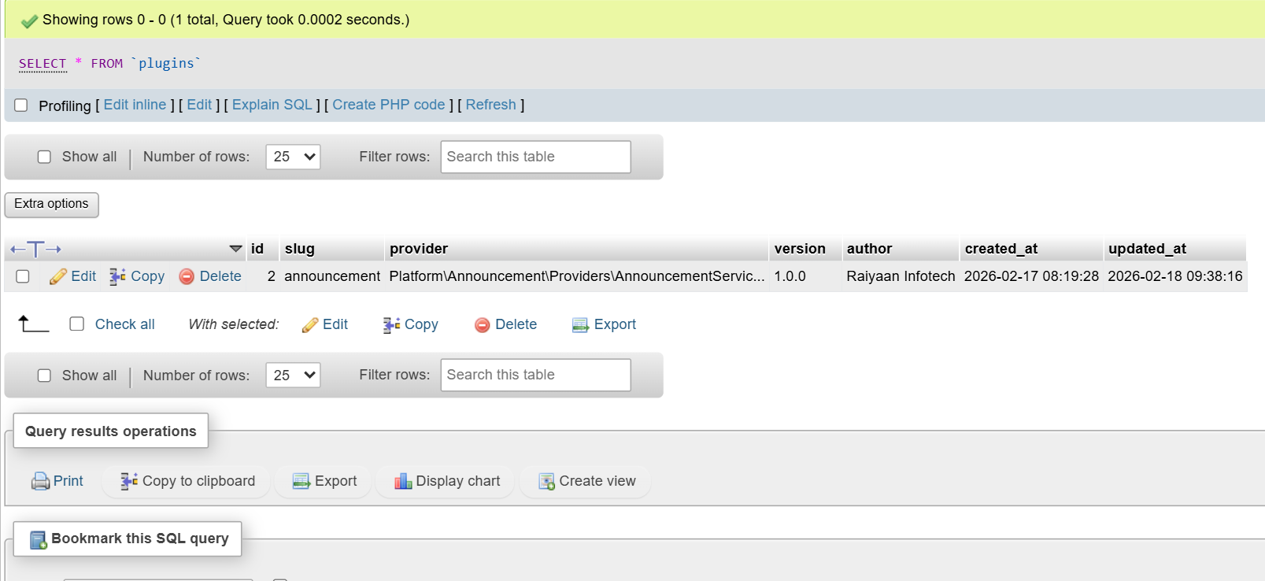

Announcement Module

Index Page
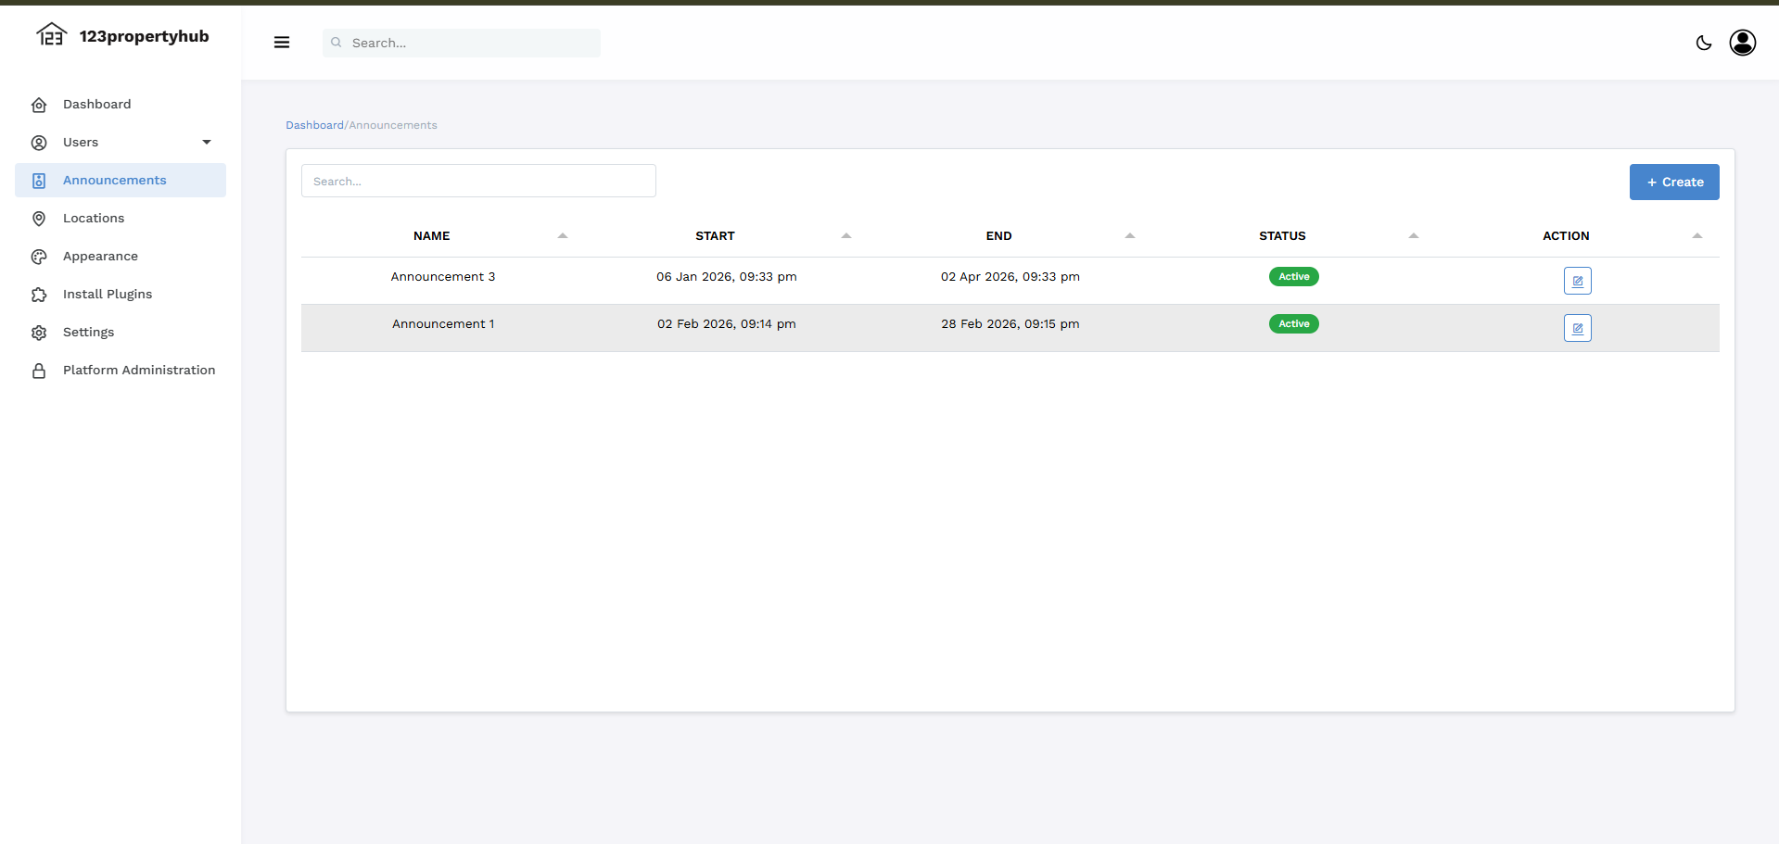

Add Announcement
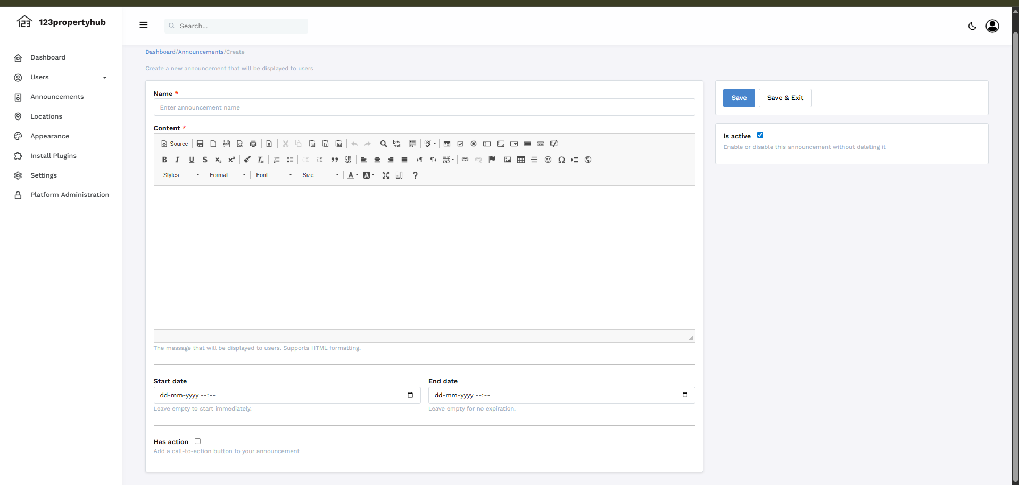

Update Announcement
