HR Workforce Intelligence Dashboard

1. Project Overview
This project focuses on designing and developing an HR Workforce Intelligence Dashboard using Microsoft Power BI. The objective was to convert raw HR data into meaningful insights to support workforce planning, performance tracking, payroll analysis, employee engagement, and leadership decision-making.

2. Objective of project
HR departments often manage large datasets but lack structured visualization systems to interpret trends. This project was built to centralize HR metrics into a single interactive dashboard, allowing organizations to monitor workforce health, retention risks, compensation allocation, diversity metrics, and talent acquisition performance.

3. Dataset Description
The dataset includes Employee ID, Department, Salary, Gender, Hiring Date, Termination Date, Marital Status, Performance Score, Employee Satisfaction Score, Recruitment Source, Employment Status, and State. The dataset covers multiple years and departments.

4. Data Cleaning and Preparation
Power Query was used to remove duplicates, standardize naming conventions, handle missing termination dates, format salary values, extract year from date columns, group satisfaction ratings, and calculate tenure. These steps ensured accurate and reliable analysis.

5. Data Modeling
A structured data model was built to support filtering across Department, Gender, Year, Employment Status, and Location. Relationships were optimized to ensure interactive reporting across all visuals.

6. DAX Measures and Calculations
Custom DAX measures were created including Total Headcount, Active Employee Count, Terminated Employee Count, Gender Percentage, Total Salary, Department Salary, Satisfaction Group Count, Performance Rating Count, and KPI percentage metrics.

7. KPI – Headcount
Purpose: Show total number of employees. Calculation: COUNT(EmployeeID). Chart Type: KPI Card. Insight: Provides workforce size overview.
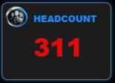

8. KPI – Active Employees
Purpose: Track active workforce. Calculation: Employees where Status = Active. Chart Type: KPI Card. Insight: Indicates workforce availability.
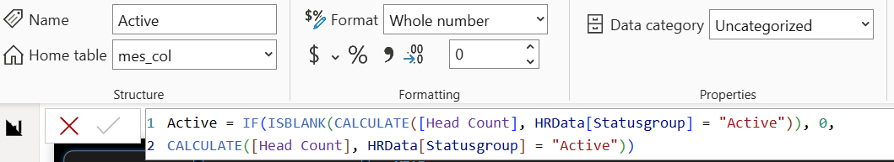
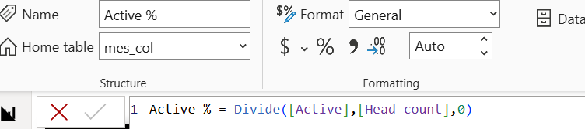
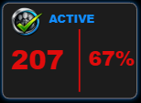

9. KPI – Terminated Employees
Purpose: Measure attrition. Calculation: Employees where Termination Date exists. Chart Type: KPI Card. Insight: Helps HR monitor turnover patterns.-
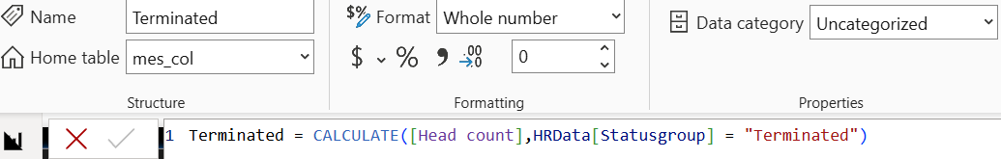
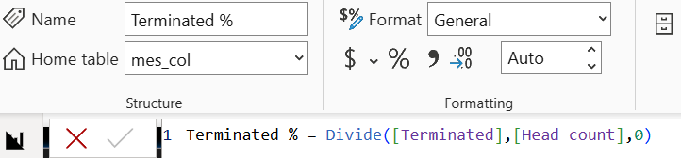
--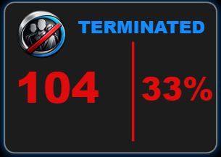

10. KPI – Gender Distribution
Purpose: Monitor workforce diversity. Calculation: Male vs Female count and percentage. Chart Type: KPI Cards. Insight: Tracks gender representation.
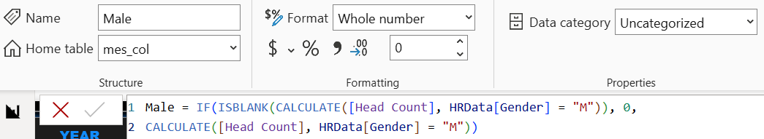
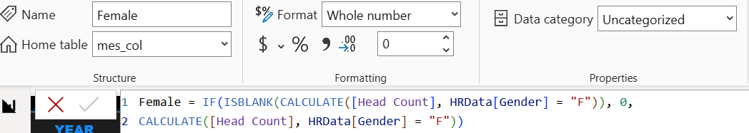
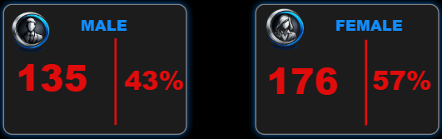

11. Salary Overview
Purpose: Display total salary and department-wise payroll. Calculation: SUM(Salary). Chart Type: KPI and stacked panel. Insight: Identifies payroll cost drivers.
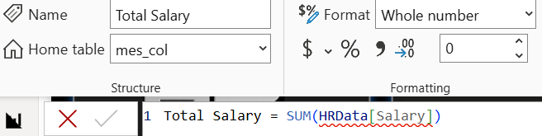
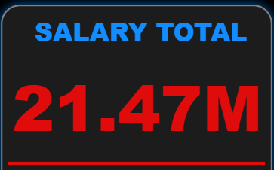

12. Department Salary Breakdown
Purpose: Compare payroll spending by department. Calculation: Aggregate Salary by Departments. Department wise Salary = CALCULATE(SUM(HRData[Salary]),HRData[Department] = "Department name"). Insight: Production, IT/IS, Sales, Software Engineering department, Admin office and Executuive office drive total payroll costs.
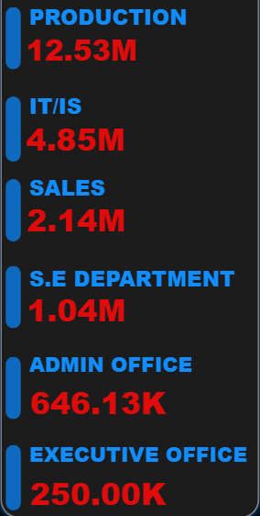

13. Marital Status Distribution
Purpose: Analyze workforce demographics. Calculation: Count grouped by marital status. Chart Type: Donut Chart. Insight: Shows demographic composition.
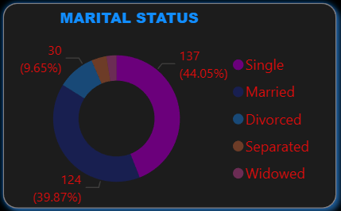

14. Employees by Department
Purpose: Visualize employee distribution. Calculation: Count(EmployeeID) by Department. Chart Type: Horizontal Bar Chart. Insight: Highlights workforce concentration.
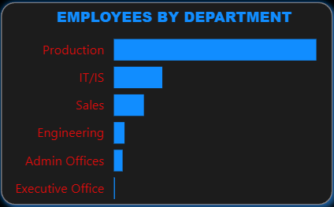

15. Recruitment Source Effectiveness
Purpose: Evaluate hiring channels. Calculation: Count employees by recruitment source. Chart Type: Bar Chart. Insight: Identifies best-performing recruitment sources.
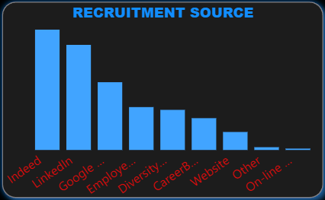

16. Employee Performance Analysis
Purpose: Assess employee performance distribution. Calculation: Count employees by performance rating. Chart Type: Pie Chart. Insight: Most employees meet expectations.
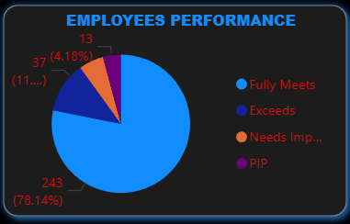

17. Employee Satisfaction Trends
Purpose: Analyze satisfaction levels. Calculation: Group satisfaction scores. Chart Type: Line Chart. Insight: Identifies engagement improvement areas.
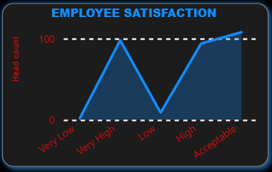--

18. Geographic Employee Distribution
Purpose: Show workforce spread across states. Calculation: Count employees by state. Chart Type: Map Visual. Insight: Shows regional concentration.
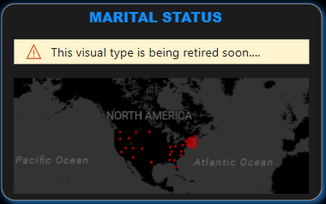

19. Key Business Insights
Production leads payroll spending, female representation is higher, attrition is department-specific, recruitment channels impact talent quality, satisfaction correlates with performance, and workforce density varies regionally.

20. Business Impact
The dashboard supports workforce optimization, payroll planning, retention improvement, diversity tracking, and strategic HR planning.

21. Challenges and Solutions
Challenges included inconsistent data, missing values, and performance optimization. These were resolved through Power Query and optimized DAX.

Results and Outcomes
The final dashboard delivers an interactive HR analytics solution improving decision-making and workforce transparency.

23.Conclusion

This project showcases how Power BI can be used to turn raw HR data into clear, meaningful insights that support better decision-making. Through careful data cleaning, structured data modeling, and well-designed DAX calculations, the dashboard brings together important workforce metrics such as employee headcount, salary trends, performance levels, satisfaction scores, recruitment effectiveness, and geographic distribution in a single interactive view.
The dashboard helps HR teams and leadership gain a deeper understanding of workforce patterns, identify departments with higher payroll costs, track employee turnover, evaluate the success of hiring sources, and monitor overall employee engagement. More than just a technical exercise, this project reflects the ability to understand real business needs and present insights in a visual and easy-to-understand way that supports planning and strategy.
Overall, this work highlights strong analytical skills, practical business awareness, and hands-on Power BI expertise. It demonstrates how data-driven dashboards can play a meaningful role in improving HR decisions, strengthening workforce planning, and supporting more informed organizational strategies.

