YAML
yaml aint markup language
Markup - in html we have tag inside we have title inside we have paragraph ie parent child relationship(how to page content look like)
Yaml is used to store the data ie store info abt configurations.In yaml u can only store data not able to perform commands to perform that we need to use ansible or docker etc
Serilization:
if we have android, java, ml application.if we want to move object from android to java or ml, we cannot directly move so we need to convert andriod obj into stream of bytes then store in db or yaml file then move to other application.
Deserilization:
opp to serialization, take bytes from db or yaml file then convert to bytes then into object

serilization is nothing but store data or object in file and pass to other application.file may be yaml, json, xml
obj to file is serilization
file to object is de serilization
all above thing ae about yaml
mark up is to store document,yaml is able to store data or object thatsy its aint

Yaml - its maily used as configuration file and while writing indentation is important which is space

yaml file
---(rep end of one document)
...(rep end of yaml file)
In yaml file we can have key value pair, list etc
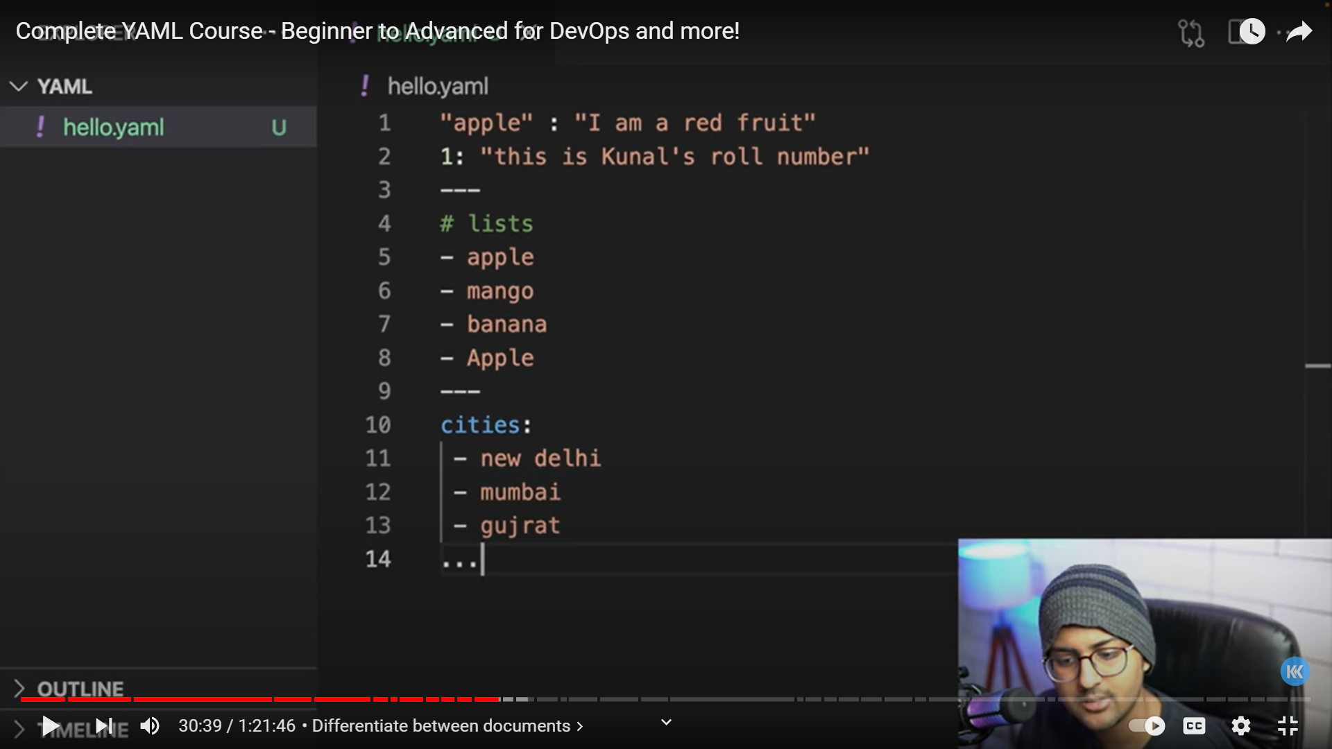
Instead of storing data in block we can store in single line like wise for key value pair as well
# is used to comment
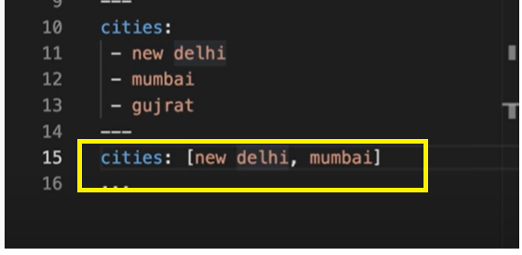
Data types:

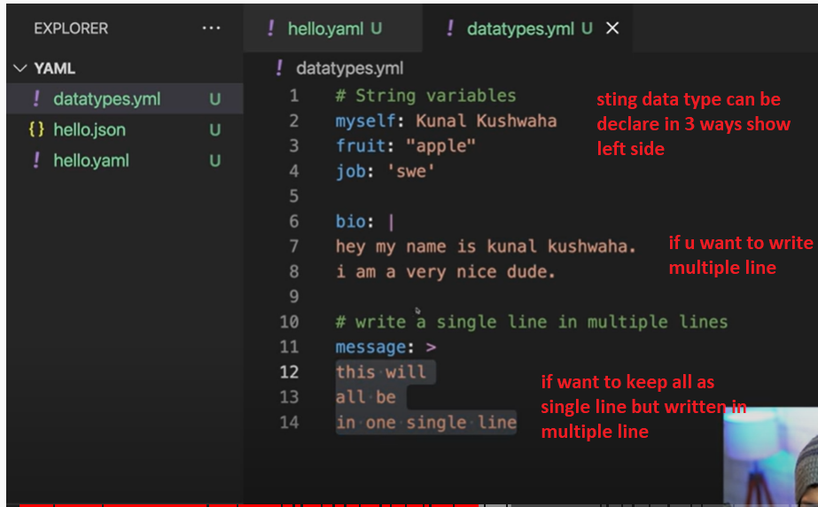
Data type for int ,float, Boolean
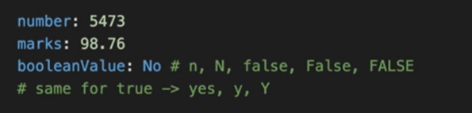
Specifying the datatypes in yaml file need to use !!then data type like below
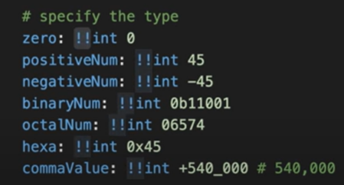
For float data type
Below example for float,infinite and not a number are shown
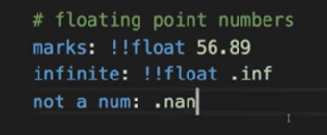
Foe Boolean need to declare as bool, for string need to keep as str
To keep null value in yaml file
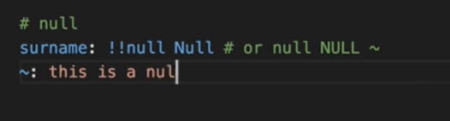
If the list seq is empty then called sparsh sequence like below
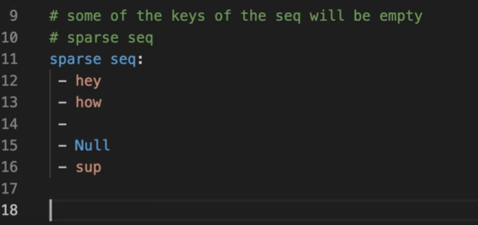
Nested item:
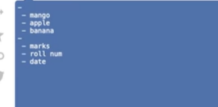
Nested map:
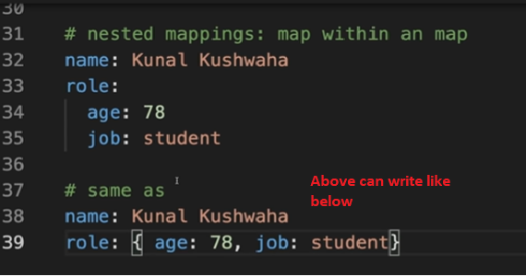

Dictonaries
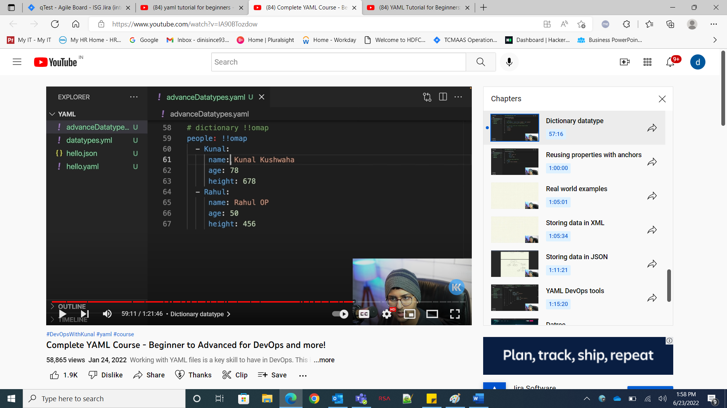

Using anchor
If we want to use the data which we written in one should be used in other then use anchor. U should use &then any name ie at place which u r gng to reuse.then in place where u r gng to reuse that then write like <<: *likes
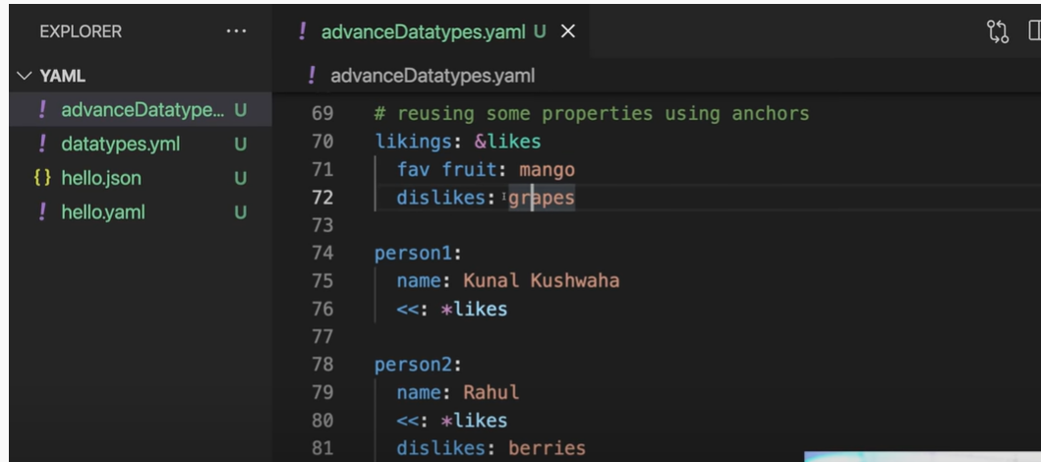
A b
B
n

