Arizona Public Service
Performance Test Strategy

S.C.O.R.E Program
Non-Functional Testing
Detailed Test Strategy/Plan
Version 0.3
Document Modification Control
Date | Author | Role | Version | Comments
11/06/2021 | Aravindraj P  Udhaya Kumar Tamilselvan | Technical Lead  Senior Test Engineer | 0.1 | Draft Version
16/06/2021 | Balaji Kasinathan | Test Consultant | 0.2 | Review & Update
12/07/2021 | Aravindraj P  Udhaya Kumar Tamilselvan | Technical Lead  Senior Test Engineer | 0.3 | Review & Update
Table of Contents
1. S.C.O.R.E Program Objective 4
2. Document Purpose and Intent 4
3. SCO Solution 5
4. Technical Architecture Diagram (TAD) 6
5. Performance Test Strategy 10
5.1 Performance Test Scope 10
5.2 Performance Test – Out of Scope Items 11
5.3 Maximo Performance Test Objective 11
5.4 High Level Strategy 12
5.5 SLA Traceability Matrix 12
6. Transaction Volumes for Testing 13
6.1 Online Transaction Volumes 13
6.1.1 Maximo NFR 13
6.1.2 Critical Scenarios SCO Integration 14
6.1.3 Interfaces NFR 15
6.1.4 API Details & NFR 18
6.1.5 Maximo/Interfaces Workstream wise NFR 18
7. Test Data 18
7.1 Data Required 18
7.2 Test Account and Access Required 19
8. Detailed Test Approach 19
8.1 Execution Phase 19
8.2 Performance Tests 20
8.2.1 Load Test 20
9. Testing Risks, Assumptions and Dependencies 20
10. Test Environment, Tools & Reporting 22
10.1 Performance Test Environment 22
10.2 Test Tools 22
10.3 Reporting – Performance Metrics 23
11. Overall Test Schedule 24
12. Appendix 25
12.1 Document References 25
12.2 Distribution List for Information 25
12.3 Roles/Responsibilities 26
12.4 Glossary 27
12.5 Document Approval/Signatures 28

S.C.O.R.E Program Objective
The primary objective of this Program is the implementation of the Supply Chain Optimization (SCO) Solution for APS.
As part of the performance test consulting, it was confirmed that, Maximo & it’s interfaces are the key impacted application/modules for this release and Wipro’s QA performance team need to execute performance tests to validate that the application shows no signs of performance degradation.

Document Purpose and Intent
The purpose of this strategy document is to provide a reference at any time, for the resources working on the performance testing and engineering activities related to the S.C.O.R.E program - Maximo performance testing project. This document is source for directions related to performance test coverage, test execution, test monitoring and analysis approach.
This document defines -
- Performance testing scope, objectives, high level strategy for performance tests execution, SLA Traceability Matrix, transactional volumes, test data requirement, test environment, tools required, reporting of the relevant performance metrics, schedule, and potential risks.
Any changes in the project scope will affect the strategy document and will be communicated to the concerned stakeholders once the changes are made.

SCO Solution

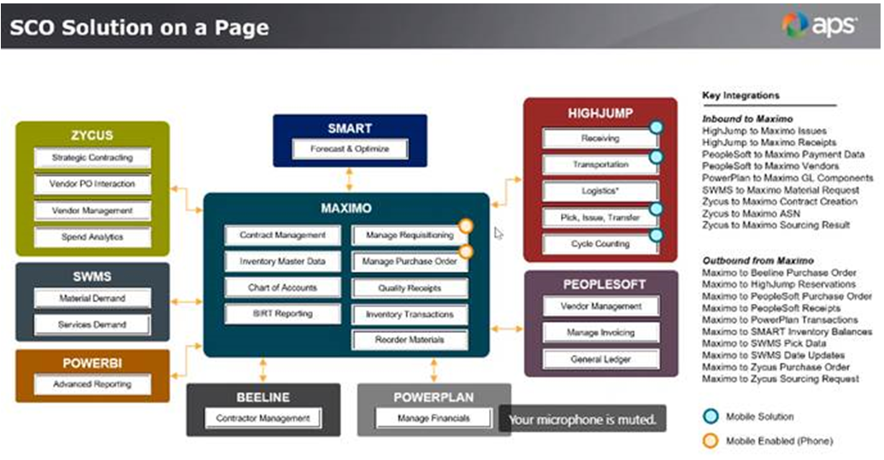

Technical Architecture Diagram (TAD)

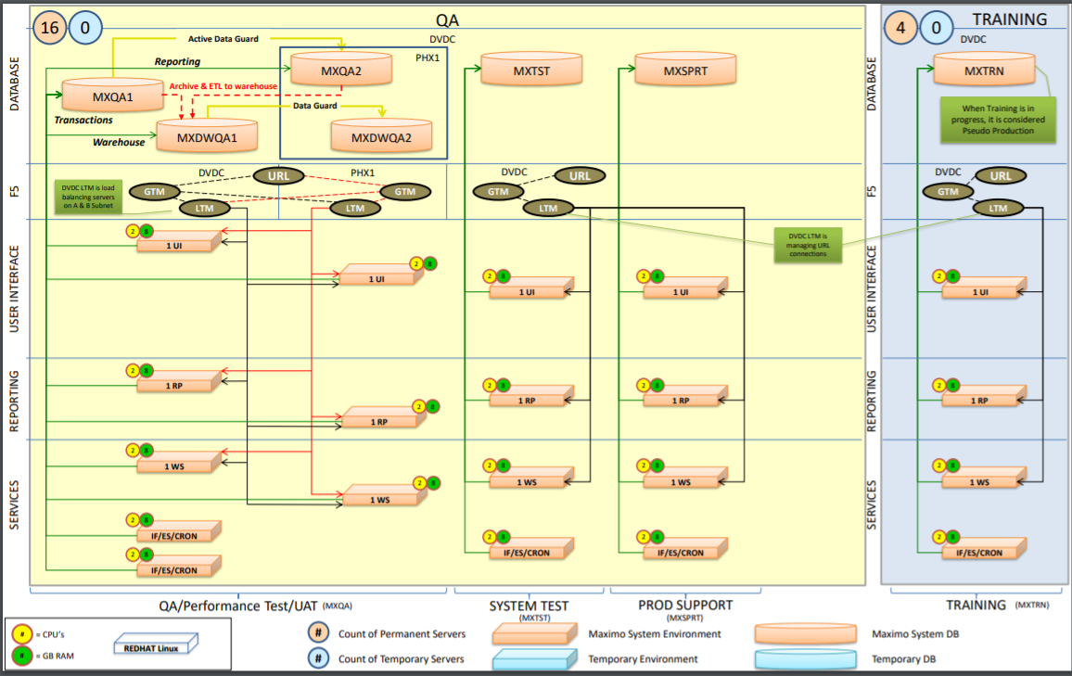
Figure1: Logical QA Environment
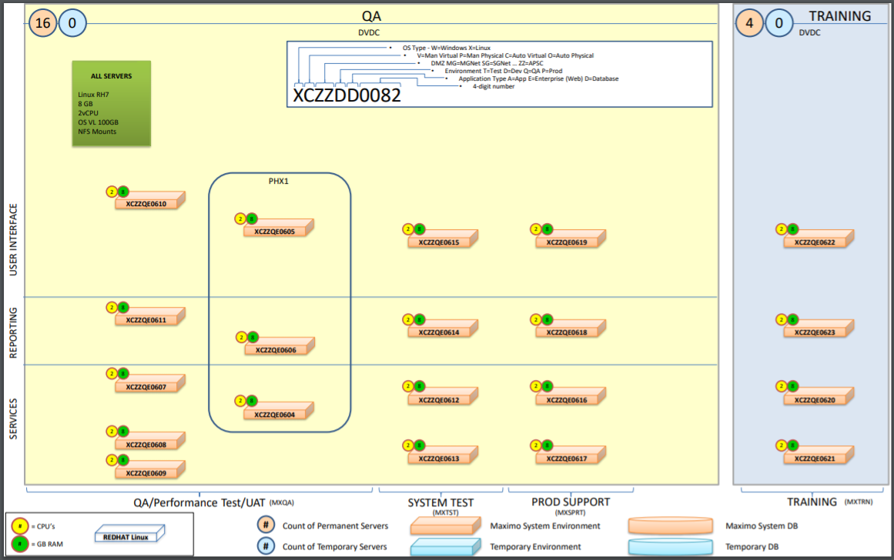
Figure2: Physical QA Environment

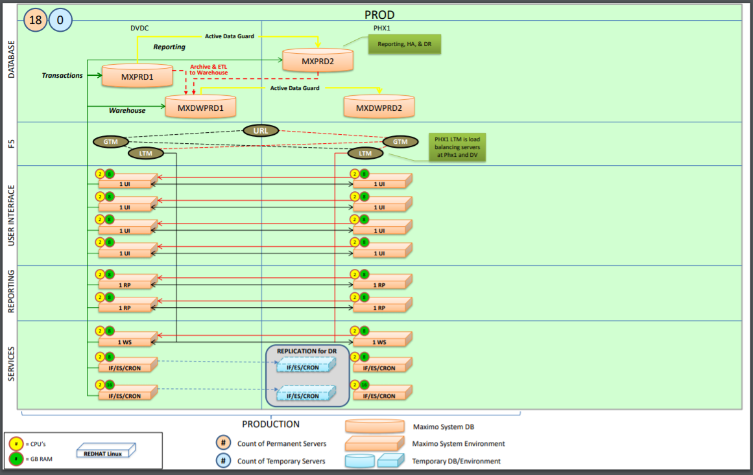
Figure3: Logical PROD Environment

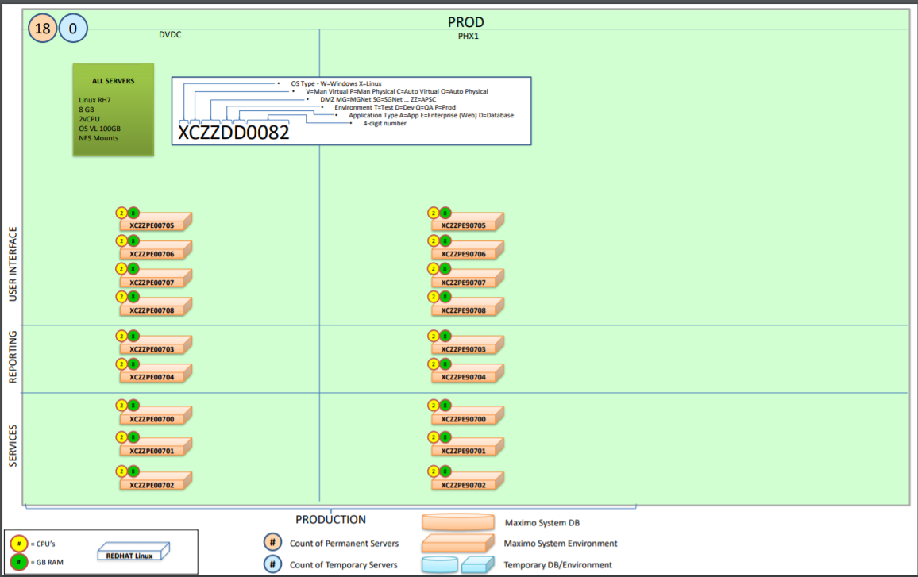
Figure4: Physical PROD Environment

Performance Test Strategy

5.1 Performance Test Scope
Maximo and Interface layers have been identified to be in scope of the performance test, however, these need to be prioritized given the timelines and scope of this activity. Components other than Maximo & its interface layers are considered Out of Scope. Please see the files provided confirming the prioritized scenarios in Section 12.1
Sl. No. | Impacted  Application | Non-Functional Test Scope
Sl. No. | Impacted  Application | Performance  Testing | OAT |  | NPNFT |  | Security
Sl. No. | Impacted  Application | Performance  Testing | Core | Supplementary | Accessibility | Compatibility | DAST
1 | Maximo
2 | Interfaces of Maximo
# | Activity | Scope | Rationale | Owner
 | Test Data Preparation | In Scope | Required test data will be made available to the Wipro Performance test team. | Kishore
 | Baseline Test | In Scope | 1-hour load test to find the baseline load that the application can handle without any failures. | Wipro Performance Test Team
 | Load Test | In Scope | 1-hour load test will be executed to replicate “live-like” scenario and validate the application performance. | Wipro Performance Test Team
 | Soak Test | In Scope | 4-hour load test to verify the system’s stability & performance characteristics. | Wipro Performance Test Team
 | Test for futuristic growth | In Scope | 1-hour load test with 3-year futuristic growth volume. | Wipro Performance Test Team
 | Bell Curve Test | In Scope | 24-hour load test with distributed load including spike & stress scenarios. | Wipro Performance Test Team
 | Performance Monitoring | In Scope | Performance Monitoring is in scope and will be done using Kibana for application monitoring & OEM for database. <PWC to confirm if it’s available in Pre-PROD> | <To be provided by PWC>
 | Performance Tuning | In Scope | Performance Tuning is in scope. Respective (Dev/Infra) Team will fix the performance issues based on the test results. | Dev/Infra Team

5.2 Performance Test – Out of Scope Items
- Data center level performance testing.
- Failover/Disaster Recovery testing.
- Hardware/Network level performance testing (example: BigIP).
- Product related performance issues are out-of-scope & to be taken up with the respective vendors by APS.

5.3 Maximo Performance Test Objective
The primary objective of the performance testing assessment is:
- Maximo system:
Validate the performance of the Maximo system for the identified critical scenarios & APIs (Create/View/Update Workorders, Create Labor Reporting transactions, Query Inventory, Create Material Requests, Query Storerooms, Create Material Issues and Transfers, Create Inventory Usage transactions, Create/Update Purchase Requisitions, Create/Update Purchase Orders, Create Receiving transactions, Create/Update Service requests, Create/View Desktop Requisitions, Create/Update Quick Reporting, View PM's, View Job Plans, View Assets, View Locations, View Companies, View/Update Meters, View Lock Out/Tag Out, View Safety Hazards, View Safety Plans, View Safety Precautions, View Safety Permits & Routes).

- Interfaces to Maximo:
Validate the performance of the various in-scope interfaces (Finance & Settlement, Manage Operations: Inventory, Item Master, Logistics & Approval, Receiving, WMS, Purchasing & Sourcing) for the given volume of data.

5.4 High Level Strategy
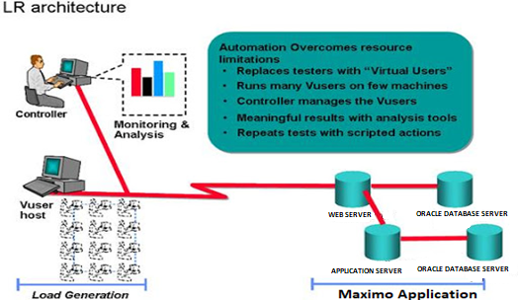
Following are the different types of performance tests which will be performed to cover the scope.
- Load Test will be executed with identified SCORE Scenarios and APIs in isolation to mimic a live like scenario
- LoadRunner scripts will be used to invoke the same as depicted in this diagram
- Impacted Score and API scenarios will be tested against the volumes mentioned in section#6
- Test will be executed with incremental TPS approach (50, 100, 150, 200…), if the UI and APIs are not able to withstand the projected load

5.5 SLA Traceability Matrix
The following SLAs should be met in the test & will be a requirement of the exit criteria.
SLA Reference | SLA Type | Description | Acceptance Criteria
SLA01 | Performance - Speed | To ensure that the performance of UI and APIs are not degraded. | Response Time  GREEN: Response time of all UI and API transactions is less than <<x seconds>> <To be provided by Bhawani>  RED: More than 5% of transactions take more than <<x seconds to process>> <To be provided by Bhawani>
SLA02 | Performance - Capacity | To ensure that the resource utilization is not degraded. | CPU and memory Utilization  GREEN: Average application server CPU should be <= 70% and Average application server Memory should be <= 70%  RED: If the utilization is more.

Transaction Volumes for Testing

6.1 Online Transaction Volumes
Prioritized SCORE and APIs (as agreed) will be tested with the following volumes (specified in the doc) for a steady state of 1 hour.

6.1.1 Maximo NFR
Sl. No | Performance Testing Scenarios | Type (Web Service/MQ/Web) | TPS | # of Users | Functional POC | Dev POC
1 | Create/View/Update Workorders | Web | <To Be Provided by Kishore>
2 | Create Labour Reporting transactions | Web
3 | Query Inventory | Web
4 | Create Material Requests | Web
4 | Query Storerooms | Web
5 | Create Material Issues and Transfers | Web
6 | Create Inventory Usage transactions | Web
7 | Create/Update Purchase Requisitions | Web
8 | Create/Update Purchase Orders | Web
9 | Create Receiving transactions | Web
10 | Create/Update Service requests | Web
11 | Create/View Desktop Requisitions | Web
12 | Create/Update Quick Reporting | Web
13 | View PM's | Web
14 | View Job Plans | Web
15 | View Assets | Web
16 | View Locations | Web
17 | View Companies | Web
18 | View/Update Meters | Web
19 | View Lock Out/Tag Out | Web
20 | View Safety Hazards | Web
21 | View Safety Plans | Web
22 | View Safety Precautions | Web
23 | View Safety Permits | Web
24 | Routes | Web

Note: Any 1 of the above-mentioned scenarios will be picked up to do proof of concept upfront to check the feasibility with Load Runner. Based on the outcome, scenarios count might differ.

Critical Scenarios SCO Integration
ADO ID | Scenarios | TPS | # of Users | Functional POC | DEV POC
68298 | Outbound – Maximo to Peoplesoft for Item Master application. | <To Be Provided by Kishore>
68299 | Outbound – Maximo to Peoplesoft for Purchase Orders.
68301 | Outbound – Maximo to Peoplesoft for Return to Vendor.
68300 | Outbound – Maximo to Peoplesoft Receipt.
67943 | Outbound – Maximo to Peoplesoft Service Item.
68264 | PeopleSoft to Maximo Invoice Matching data.
68262 | PeopleSoft to Maximo for Vendor creation and details.
68258 | Smart to Maximo Item Storeroom records.
68257 | SPHERA to Maximo.
75635 | SWMS to Maximo Location
68254 | SWMS to Maximo Material Returns.
68256 | SWMS to Maximo Reservation.
67944 | SWMS to Maximo PM Item Dates on Assets.
75634 | SWMS to Maximo WO Create and Update
68252 | Zycus to Maximo Contract
68250 | Zycus to Maximo Purchase Orders Integration
70126 | Zycus to Maximo Sourcing Award Result
68245 | Korber to Maximo for Issues and Transfers

Note: Any 1 of the above-mentioned scenarios will be picked up to do proof of concept upfront to check the feasibility with Load Runner. Based on the outcome, scenarios count might differ.

Interfaces NFR

Interface | Interface ID | Message Size (Maximum – Bytes) | Average number of messages per month | Average number of messages per day | Average response time | Response Time at Peak | Peak hours
SCO_Finance&Settlement | IN-SCO-ADO068302-001 |  | 7500 | 400 | <1 s | <To be provided by Bhawani> | business hours
SCO_Finance&Settlement | IN-SCO-ADO068303-001 |  | 7500 | 400 | <1 s | <To be provided by Bhawani> | business hours
SCO_Finance&Settlement | IN-SCO-ADO068261-001 |  | 5000 | 250 | <1 s | <3 s | business hours
SCO_Finance&Settlement | IN-SCO-ADO068260-001 |  | 5000 | 250 | <1 s | <3 s | business hours
SCO_Finance&Settlement | IN-SCO-ADO068264-001 |  | 2000 | 100 | <1 s | <3 s | business hours
SCO_ManageOperations_Inventory | IN-SCO-ADO068282-001, IN-SCO-ADO082590-001, IN-SCO-ADO068289-001,  IN-SCO-ADO097637-001 |  | 10 | 1 | <1 s | <3 s | business hours
SCO_ManageOperations_Inventory | IN-SCO-ADO087599-001, IN-SCO-ADO096218-001 |  | 3100 | 150 | 1 minute | 1.5 minutes | business hours
SCO_ManageOperations_Inventory | IN-SCO-ADO068293-001, IN-SCO-ADO082744-001,  IN-SCO-ADO087450-001 |  | 100 | 5 | <1 s | <3 s | business hours
SCO_ManageOperations_Inventory | IN-SCO-ADO068278-001 |  | Less than 1 | 0 | <1 s | <3 s | business hours
SCO_ManageOperations_Inventory | IN-SCO-ADO068279-001 |  | 10000 | 500 | 1 minute | 1.5 minutes | business hours
SCO_ManageOperations_Inventory | IN-SCO-ADO068305-001 |  | 20 | 1 | <1 s | <3 s | business hours
SCO_ManageOperations_Inventory | IN-SCO-ADO068306-001 |  | 20 | 1 | Less than 1 minute | a minute | business hours
SCO_ManageOperations_Inventory | IN-SCO-ADO085316-001 |  | 13000 | 1100 | <1 s | <3 s | business hours
SCO_ManageOperations_Inventory | IN-SCO-ADO085319-001 |  | 1000 | 50 | <1 s | <3 s | business hours
SCO_ManageOperations_Inventory | IN-SCO-ADO068256-001 |  | 50 | 3 | <1 s | <3 s | business hours
SCO_ManageOperations_Inventory | IN-SCO-ADO067944-001 |  | 50 | 3 | <1 s | <3 s | business hours
SCO_ManageOperations_Inventory | IN-SCO-ADO075634-001 |  | 50 | 3 | <1 s | <3 s | business hours
SCO_ManageOperations_Inventory | IN-SCO-ADO075635-001 |  | 100 | 25 | <1 s | <3 s | business hours
SCO_ManageOperations_Inventory | IN-SCO-ADO087600-001 |  | 50 | 3 | <1 s | <3 s | business hours
SCO_ManageOperations_Inventory | IN-SCO-ADO087602-001 |  | 50 | 3 | <1 s | <3 s | business hours
SCO_ManageOperations_Inventory | IN-SCO-ADO068258-001 |  | 50 | 3 | <1 s | <3 s | business hours
SCO_ManageOperations_ItemMaster | IN-SCO-ADO068276-001, IN-SCO-ADO068280-001, IN-SCO-ADO068281-001, IN-SCO-ADO068290-001,  IN-SCO-ADO068298-001,  IN-SCO-ADO068304-001 | <500 KB | 3000 | 150 | <1 s | <3 s | business hours
SCO_ManageOperations_Logistics&Approval | Interface ID: IN-SCO-ADO082592-001, IN-SCO-ADO068300-001 |  | 4300 | 200 | <1 s | <3 s | business hours
SCO_ManageOperations_Logistics&Approval | IN-SCO-ADO068071-001, IN-SCO-ADO087109-001 |  | 40 | 2 | <1 s | <3 s | business hours
SCO_ManageOperations_Logistics&Approval | IN-SCO-ADO068301-001, IN-SCO-ADO082593-001 |  | 30 | 1 | <1 s | <3 s | business hours
SCO_ManageOperations_Logistics&Approval | IN-SCO-ADO077838-001 |  | 20 | 1 | <1 s | <3 s | business hours
SCO_ManageOperations_Logistics&Approval | IN-SCO-ADO068294-001 |  | 400 | 20 | <1 s | <3 s | business hours
SCO_ManageOperations_Logistics&Approval | IN-SCO-ADO068262-001 |  | 20 | 1 | <1 s | <3 s | business hours
SCO_ManageOperations_Logistics&Approval | IN-SCO-ADO068247-001 |  | 400 | 20 | <1 s | <3 s | business hours
SCO_ManageOperations_Logistics&Approval | IN-SCO-ADO109062-001 |  | 20 | 1 | <1 s | <3 s | business hours
SCO_ManageOperations_Receiving | IN-SCO-ADO068277-001 |  | <10 |  | <1 s | <3 s | business hours
SCO_ManageOperations_Receiving | IN-SCO-ADO068273-001 |  | 100 | 20 | <1 s | <3 s | business hours
SCO_ManageOperations_Receiving | IN-SCO-ADO068254-001 |  | 30 | 1 | Less than 1 minute | Less than 1.5 minutes | business hours
SCO_ManageOperations_Receiving | IN-SCO-ADO068255-001 |  | 50 | 5 | Less than 1 minute | Less than 1.5 minutes | business hours
SCO_ManageOperations_Receiving | IN-SCO-ADO068251-001 |  | 400 | 100 | <1 s | <3 s | business hours
SCO_ManageOperations_WMS | IN-SCO-ADO084775-001 |  | 23,000 | 1000 | <1 s | <3 s | business hours
SCO_ManageOperations_WMS | IN-SCO-ADO094039-001 |  | 100 | 5 | <1 s | <3 s | business hours
SCO_ManageOperations_WMS | IN-SCO-ADO095351-001 |  | 100 | 5 | <1 s | <3 s | business hours
SCO_ManageOperations_WMS | IN-SCO-ADO095772-001 |  | 100 | 5 | <1 s | <3 s | business hours
SCO_ManageOperations_WMS | IN-SCO-ADO096983-001 |  | 100 | 5 | <1 s | <3 s | business hours
SCO_ManageOperations_WMS | IN-SCO-ADO068245-001 |  | 22,000 | 1000 | 1 Minute | 1.5 Minutes | business hours
SCO_ManageOperations_WMS | IN-SCO-ADO068246-001 |  | 30,000 | 1500 | <1 s | <3 s | business hours
SCO_ManageOperations_WMS | IN-SCO-ADO084774-001 |  | 40 | 2 | <1 s | <3 s | business hours
SCO_ManageOperations_WMS | IN-SCO-ADO085241-001 |  | 220 | 10 | <1 s | <3 s | business hours
SCO_ManageOperations_WMS | IN-SCO-ADO068242-001 |  | 100 | 5 | <1 s | <3 s | business hours
SCO_ManageOperations_WMS | IN-SCO-ADO068241-001 |  | 1,000 | 50 | <1 s | <3 s | business hours
SCO_ManageOperations_WMS | IN-SCO-ADO068244-001 |  | 100 | 5 | <1 s | <3 s | business hours
SCO_ManageOperations_WMS | IN-SCO-ADO094040-001 |  | 100 | 5 | <1 s | <3 s | business hours
SCO_ManageOperations_WMS | IN-SCO-ADO096990-001 |  | 100 | 5 | <1 s | <3 s | business hours
SCO_Purchasing | IN-SCO-ADO068268-001, IN-SCO-ADO068283-001, IN-SCO-ADO068291-001, IN-SCO-ADO068299-001, IN-SCO-ADO073640-001, IN-SCO-ADO085317-001 | <500 KB | 5000 | 250 | <1 s | <3 s | business hours
SCO_Purchasing | IN-SCO-ADO068250-001 | <100 KB | 3000 | 150 | <1 s | <3 s | 7PM-8PM
SCO_Sourcing | IN-SCO-ADO067941-001 | <1 MB | 50 | 3 | <1 s | <3 s | business hours
SCO_Sourcing | INC-SCO-ADO097746-001 | <1 MB | 50 | 3 | <1 s | <3 s | business hours
SCO_Sourcing | IN-SCO-ADO068252-001 | <100 KB | 50 | 3 | <1 s | <3 s | business hours
SCO_Sourcing | IN-SCO-ADO070116-001 | <100 KB | 50 | 3 | <1 s | <3 s | business hours
SCO_Sourcing | IN-SCO-ADO070126-001 | <100 KB | 50 | 3 | <1 s | <3 s | business hours
SCO_Sourcing | IN-SCO-ADO068249-001 | <100 KB | 50 | 3 | <1 s | <3 s | business hours
Note: Any 1 of the above-mentioned scenarios will be picked up to do proof of concept upfront to check the feasibility with Load Runner. Based on the outcome, scenarios count might differ.

API Details & NFR
APS Maximo PT – API Details <To be provided by Kishore>
Sl. No. | Service Module | Service Name | Method | Description | Request Type | Priority  P1/P2/P3 | Target TPS | # of Users | Functional PoC | Dev PoC
1 | Login
2

6.1.5 Maximo/Interfaces Workstream wise NFR
<To be provided by Kishore>
Work Stream | Peak Concurrent Users | Interface Transaction Throughput | Remarks
Work Management | 120 |  | <Need real numbers from existing systems>
Supply Chain | 100 as per ADO 113706 & 300 as per ADO 113762 |  | <Need real numbers from existing systems>
Fossil | 400 |  | <Need real numbers from existing systems>
T&D | 250 |  | <Need real numbers from existing systems>

Test Data

7.1 Data Required
<To be provided by Kishore>
Performance test environment (PROD like) will be loaded with a mix of production cut and manufactured data before start of the testing.

7.2 Test Account and Access Required
To commence performance test, required number of access/test credentials to the APS network (Username and Password) and Pre-PROD (PROD like) environment should be given to the testing team and consultants.

Detailed Test Approach

8.1 Execution Phase
Entry Criteria
- The test plan must be fully approved by the relevant stakeholders. This sign off means the signatories have agreed to the scope, volumes, processes, acceptance criteria, support and overall test approach and strategy.
- Dedicated environment (configurations – like production) is made available to execute performance test.
- Data validation and smoke tests are completed to evidence that the test environment is in a suitable state to start the test.
- Required test data is populated in the test environment.
Exit Criteria
- Acceptance criterion are met. If not, risks with appropriate mitigating actions are raised and agreed with all stakeholders.
- All defects are closed or accepted.
- Any issues observed have been explained and must not materially impact the performance or acceptance criteria.
- Any residual risk is documented and agreed.
- Test results have been published and signed off

8.2 Performance Tests

8.2.1 Load Test
NFT Reference | NFTPT01_Load Test
SLA Reference | SLA 01
Tools required | LoadRunner
Volume | Peak
Description | - A load test scenario will be executed with all the UI and APIs running in isolation for a steady state of 1 hour to validate application’s performance.  - UI and APIs performance observed from these runs will be baselined.  - CPU and Memory utilisation of servers will be monitored during (if applicable) or post the test.
Test Design | Ramp Up | <<x user or x TPS >> every 2 seconds <To be provided by Kishore>
Test Design | Steady State | 1 hour
Test Design | Ramp Down | <<x user or x TPS >> every 2 seconds <To be provided by Kishore>
Test Design | Script Names | <<TBU – when scripts are ready by PT Team>>
# of Rounds | 2
Metrics | Transaction Response Time, CPU & Memory Utilization of Servers
Acceptance Criteria | - Response time of all Uis and APIs will be calculated.  - CPU and Memory should be within accepted limits, as defined in 5.5 SLA Traceability Matrix

Testing Risks, Assumptions and Dependencies
- Risks
ID # | Risk Title | Risk Description | Impact | Status | Severity | Probability | Mitigation
1 | Stable Code Base | There’s a risk if performance is not tested on a stable code base. | The risk would increase the test efforts and timelines due to repeated testing. | Open | Critical | Medium | - Ensure the build is completed as per the plan  - All the code is system tested with 100% coverage and 100% pass
2 | High SCORE and API Count | There’s a risk on timelines if all Uis and APIs have to be tested in this release. | The risk would increase the test efforts and may impact timelines. | Open | Critical | Medium | - P1 SCORE can be included in scope of test for this release  - Other priority scenarios can be tested in forthcoming releases.
3 | Performance Engineering | TBU | TBU | Open | Critical | Medium | - Utilizing client server-side metrics  - Taking support from infra team to monitor the required stats
4 | Open Defects | There’s a risk if there are open P1/S1 or P2/S2 defects from SIT. | The risk would increase the test efforts and timelines due to repeated testing. | Open | Critical | Medium | - Performance test to begin only when SIT has completed 50% with no open P1/S1 or P2/S2 defects.

- Dependencies & Assumptions
Below are some of the identified assumptions and constraints prior to peak performance testing exercise:
- All priority 1 and 2 defects have been fixed and verified prior to testing
- Functionally stable and should be smoke tested before handing over to performance engineering team
- Test environment (Stage) will be used for testing and would be made available throughout the performance testing
- It is assumed that there will not be any changes happening in the application/server/configuration during the time of testing unless a part of engineering analysis when SLAs are not met
- Test data quantity to simulate scale and volume should be available for the testing
- Test data needs to be reviewed with performance team to ensure proper coverage before it is provisioned in the environment
- Database size and record volumes should match the production to test peak volumes
- PT Schedule assumes that all pre-test criteria will be met on time. Any lapse in fulfilling the criteria will have an impact in the test schedules.
- Support from APS application team to discuss on performance monitoring and RCAs
- Regarding cleanup: Performance Team will need support from Dev team to understand data population and clean up strategy. Alongside, Performance Team would use same strategy that of functional team, the only difference would be that we will have bigger volumes for clean up

Test Environment, Tools & Reporting

10.1 Performance Test Environment
The benchmarks and tuning activity will be carried out in stage/Performance Test environment. The starting point setup and configuration of the environment is depicted below. <Below details to be provided by PWC>
 |  |  | Per Instance OS Config
Description | Component | No. of Instances | Disk space (GB) | Ram (GB) | No. of cores | Remarks
Web Server |  |  |  |  |  | Following details will be appended:  JVM Heap Config.
App Server |  |  |  |  |  | 1. All Maximo JVMs on single server? No load balancers involved?  2. Is WebLogic finalized or will be moving to WebSphere?  3. Hosted on-prem on physical servers? Not cloud?  4. “Their SLAs now wants multiple nodes in 2 data centres in a Rack system probably on a storage array.”  5. “Single server (not rack) on a hard drive at Raid 0. No redundancy.”
DB Server |  |  |  |  |  | *Will be appended with configuration with DB access details.

10.2 Test Tools
# | Activity/Phase | Tools
1 | Script Creation and Performance Test | LoadRunner
2 | Performance Monitoring | SiteScope
3 | Functional Validation | Postman
4 | Defect Raising | <To be provided by Kishore>

10.3 Reporting – Performance Metrics
The table below lists some of the high-level performance metrics to be measured at different layers of application during performance testing. These are analysed to understand performance of application under test as well as to find out performance bottlenecks.
Layer | Metrics | Description
Application KPIs | Average Transaction Response Time | The Average Response Time is the average time taken for every round trip request.
Application KPIs | Transactions Per Second | TPS is the number of transactions executed per second.
Application KPIs | Connections Per Second | It gives information about the Transmission Control Protocol/Internet Protocol (TCP/IP) connections that are opened & closed every second.
Application KPIs | Page Downloaded Per Second | Displays the number of pages received from the web server during the load test.
Application KPIs | Hits Per Second | It is the number of HTTP requests sent by the user(s) to the web server in a second.
Application KPIs | Throughput Per Second | How many requests an application will be able to process per second.
Application KPIs | Throughput | How many requests an application will be able to process per second, per minute or hour.
Server Stats | <PWC Team to confirm the monitoring tool availability in Pre-PROD>

Overall Test Schedule
The business outlined a set of deliverables to be delivered and hence the project is spilt into multiple phases.
Wave 1 Performance Testing
Activities | June’21 |  |  |  | Jul’21 |  |  |  | Jun’22 |  |  |  | Jul’22 |  |  |  | Aug’22 |  |  |  | Sep’22
Activities | W  1 | W  2 | W  3 | W  4 | W  5 | W  6 | W  7 | W  8 | W  9 | W  10 | W  11 | W  12 | W  13 | W  14 | W  15 | W  16 | W  17 | W  18 | W  19 | W  20 | W  21 | W  22 | W  23 | W  24
S.C.O.R.E Program Requirement Gathering and Stakeholder Identification
Test Strategy/Plan Preparation for Maximo & Interfaces
Sign-off for Test Strategy/Plan
LoadRunner Tool License Procurement
Load Generator Machines Setup in Multiple Locations
Understanding the Functional Flows
Setting up Systems with VPN Access
LoadRunner Tool Installation and PoC
Preparation of Test Scripts in Pre-Prod
Preparation of Test Data in Pre-Prod
Load Generator s/w, License Installation and Validation
Validation of Existing Scripts in Pre-Prod
Dry Run
Baseline Run
Analysis & Reporting
Sign-off
Resources | W  1 | W  2 | W  3 | W  4 | W  5 | W  6 | W  7 | W  8 | W  9 | W  10 | W  11 | W  12 | W  13 | W  14 | W  15 | W  16 | W  17 | W  18 | W  19 | W  20 | W  21 | W  22 | W  23 | W  24
Performance Test Lead | 1 | 1 | 1 | 1 | 1 | 1 | 1 | 1 | 1 | 1 | 1 | 1 | 1 | 1 | 1 | 1 | 1 | 1 | 1 | 1 | 1 | 1 | 1 | 1
Senior Performance Test Engineer | 1 | 1 | 1 | 1 | 1 | 1 | 1 | 1 | 1 | 1 | 1 | 1 | 1 | 1 | 1 | 1 | 1 | 1 | 1 | 1 | 1 | 1 | 1 | 1
Junior Performance Test Engineer |  |  |  |  |  |  | 2 | 2 | 2 | 2 | 2 | 2 | 2 | 2 | 2 | 2 | 2 | 2 | 2 | 2 | 2 | 2 | 2 | 2

12. Appendix

12.1 Document References
# | Document | Location/Attachment
1 | Detailed Architecture | 
2 | Prioritized List of Scenarios & NFR | 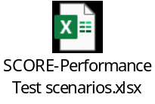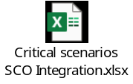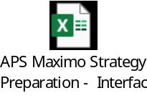  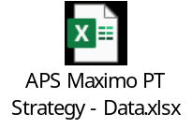

12.2 Distribution List for Information
# | Name | Role | Email
1 | Balaji Kasinathan | Test Consultant | balaji.kasinathan@wipro.com
2 | Aravindraj P | Technical Lead | aravindraj.p14@wipro.com
3 | Udhaya Kumar Tamilselvan | Senior Test Engineer | udhaya.tamilselvan@wipro.com
4 | Kishore Siddabasavaiah | Associate Consultant | kishore.siddabasavaiah@wipro.com
5 | Vidyadhar T P | Developer | vidyadhar.p33@wipro.com
6 | Sibashis Patnaik | Program Manager | sibashis.patnaik@wipro.com
7 | Bhawani Dutt Sharma | Partner | bhawani.sharma1@wipro.com
8 | Sheetal Ramchandra Gadale | Architect | sheetal.gadale@wipro.com
9 | Ramdev Venkata Satya Badam | Technical Lead | ramdev.badam@wipro.com
10 | Grandhi Pulla Rao | Performance Test Lead | PullaRao.Grandhi@aps.com

12.3 Roles/Responsibilities
G = Governance | The accountability to set the policies, rules, and broad boundaries that guide the development of methods, procedures, and practices to achieve the outcomes assigned to a function. Define “what good is,” what the rules are, and broadly who is accountable for what
O = Oversight | The accountability to critically monitor work to ensure the desired functional outcomes are met
S = Support | The accountability to provide supplemental resources to performing organizations on an as-needed basis
P = Perform | The accountability to provide plans, schedules, scope, and detailed implementing procedures and to implement those plans to deliver the work products of the function

Activities/Roles | PT Consultant | PT Engineer | PT Lead | Test Manager | Technical Lead | Developer | Architect | S.C.O.R.E Program Manager
PT Requirement Gathering | P | P | G,O,S | G,O,S | O,S | O,S | S | G,O
PT Strategy/Plan creation | P | P | G,O,S | G,O,S | O,S | O,S | S | G,O
PT Strategy/Plan review & approval | P | P | G,O,S | G,O,S | O,S | O,S | S | G,O
Workload creation | O,S | P | G,O,S | G,O,S | O,S | O,S | S | G,O
Workload review & signoff | O,S | P | G,O,S | G,O,S | O,S | O,S | S | G,O
Test data creation | O,S | P | G,O,S | G,O,S | O,S,P | O,S,P | S | G,O
Test data review & signoff | O,S | P | G,O,S | G,O,S | O,S,P | O,S,P | S | G,O
PT scripts creation | O,S | P | G,O,S | G,O,S | O,S | O,S | S | G,O
PT execution | O,S | P | G,O,S | G,O,S | O,S | O,S | S | G,O
PT analysis, monitoring, tuning & reporting | O,S | P | G,O,S | G,O,S | O,S,P | O,S,P | O,S,P | G,O
PT results review & signoff | O,S | P | G,O,S | G,O,S | O,S,P | O,S,P | O,S | G,O
Note: Product related performance issues are out-of-scope & to be taken up with the respective vendors by APS.
.

12.4 Glossary
Term | Meaning
S.C.O.R.E | Supply Chain Optimization Reliability Efficiency
SCO | Supply Chain Optimization
TAD | Technical Architecture Diagram
NFR | Non-Functional Requirements
API | Application Programming Interface
QA | Quality Assurance
OAT | Operational Acceptance Testing
NPNFT | Non-Performance Non Functional Testing
DAST | Dynamic Application Security Testing
PWC | PricewaterhouseCoopers
OEM | Original Equipment Manufacturer
WMS | Warehouse Management System
TPS | Transactions Per Second
UI | User Interface
CPU | Central Processing Unit
MQ | Message Queue
POC | Proof Of Concept
WO | Work Order
PT | Performance Testing
PoC | Point of Contact
NFTPT | Non-Functional Testing – Performance Testing
TBU | To Be Updated
RCA | Root Cause Analysis
JVM | Java Virtual Machine
DB | Data Base
KPI | Key Performance Indicator
HTTP | Hypertext Transfer Protocol
s/w | Software
VPN | Virtual Private Network

12.5 Document Approval/Signatures
# | Name | Role | Email | Version | Approval
1
2
3
4
5

