**CS4243 Mini Project**

**Group 30**

**Members:**

1. S Dinesh Raj
2. Myat Htet Kyaw
3. Yong Ray Wen Joshua
4. Muhammad Hanif Bin Muhammad Kamal

**Setup**

This folder contains the notebooks which were used in our CS4243 mini project. This code, model weights, and the datasets used can be found in this shared folder:

<https://drive.google.com/drive/folders/1lL1dCMD754gcws6p-RygR7zvteZO4gk2?usp=share_link>

**Run the code using Google Colab. Add a shortcut to this folder to your drive.**

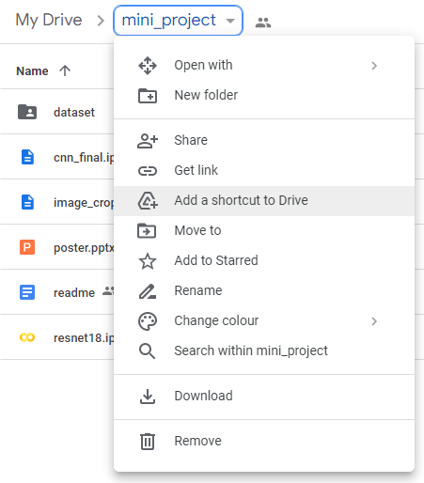

**Dataset**

The dataset folder contains the following folders:

1. *raw*: Original dataset
2. *cleaned*: Filtered dataset
3. *cropped*: Filtered dataset cropped using pose and weapon detection
4. *pose:* Filtered dataset with pose outlines
5. *split:* Filtered dataset split between test and train for resnet18

**Models**

The models folder contains the following files:

1. *yolov7-w6-pose.pt*: Weights for Yolov7 model pose detection
2. *Weapon_trained_model-1.0a.pt*: Weights for FastRCNN

**Files**

1. Final Baseline CNN model
   1. *cnn_final.ipynb*
2. Transfer learning
   1. *resnet18.ipynb*
3. Object detection
   1. *gun_detection.ipynb*
   2. *pose_detection.ipynb*
   3. *image_crop.ipynb*

The best accuracy was achieved using *resnet18*. However, since *resnet18* is not very explainable, we attempted to match *resnet18* accuracy using a CNN. While the final accuracy was still slightly lower than *resnet18*, it was achieved by:

1. Manually cleaning the dataset (*cleaned* folder)
2. Performing gun and pose detection using *gun_detection.ipynb* and *pose_detection.ipynb*
3. Cropping the images in the cleaned dataset using *image_crop.ipynb* and the bounding box information output by the previous step
4. Running the tuned CNN using this dataset as the training set with *cnn_final.ipynb*

**References**

1. Deep learning playlist -<https://www.youtube.com/playlist?list=PLeo1K3hjS3uu7CxAacxVndI4bE_o3BDtO>
2. ResNet18 -<https://www.youtube.com/watch?v=5rD8f1oiuWM&t=1207s>
3. Object detection - <https://www.youtube.com/watch?v=5nsmXLyDaU4>
4. RCNN gun detection - <https://www.kaggle.com/datasets/atulyakumar98/gundetection>
5. YOLOv7 gun dataset - <https://universe.roboflow.com/mahad-ahmed/gun-and-knife-detection>
6. YOLOv7 pose detection - <https://stackabuse.com/pose-estimation-and-keypoint-detection-with-yolov7-in-python/>
7. Data augmentation - <https://blog.roboflow.com/why-and-how-to-implement-random-crop-data-augmentation/>  
   <https://www.youtube.com/watch?v=mTVf7BN7S8w>