|  |  |
| --- | --- |
| **Ex. No. 1** | **SIMPLE WEB DESIGN USING HTML** |
| **Date of Exercise** | **21.07.2025** |
| **Git-hub Host Link** | <https://urk23cs1262.github.io/EX---1-WT-LAB/> |

**Aim**

The aim is to build a web page that conforms to HTML5 standards and has the following elements: doctype, html, meta (in the revised html5 format), title, head, body, header, footer, nav, section, div, p, span, headings, image, anchor, table, list, html comment, etc.

**Description**

The code starts with standard HTML5 tags (<!DOCTYPE html>, <html>). The <body> holds the form's visible content, styled simply with inline CSS. The form is organized into div "sections" for clarity. These sections include:

* Personal Details: Student photo, contact info, and a LinkedIn link.
* Academic Details: Academic information presented in <table> format.
* Required Documents: A list using <ul> and <li> tags.
* Footer Navigation: Links for easy navigation within the form.

**Procedure:**

**Step 1:** Save the Code: Copy the entire HTML code into a plain text editor (like Notepad on Windows or TextEdit on Mac) and save it as an .html file (e.g., form.html).

**Step 2:** Open in Browser: Double-click the saved .html file. It should automatically open in your computer's default web browser, displaying the College Admission Form.

**Step 3:** Make Changes (Optional): If you want to modify the content (e.g., text, links, image source), open the .html file again in your text editor, make the desired changes, and save the file.

**Step 4:** Refresh Browser: Go back to your browser and refresh the page (usually by pressing F5 or clicking the refresh icon) to see your changes reflected.

**Program**

<!DOCTYPE html>

<html lang="en">

<head>

  <meta charset="UTF-8">

  <meta name="viewport" content="width=device-width, initial-scale=1.0">

  <meta name="description" content="Landing page for the new MyApp mobile application.">

  <title>MyApp - The Travel App</title>

</head>

<body>

  <header>

    <h1>Welcome to <span>MyApp, WhereToGo</span></h1>

    <p>Your ultimate travel companion!</p>

  </header>

    <ul>

      <li><a href="#features">Features</a></li>

      <li><a href="#pricing">Pricing</a></li>

      <li><a href="#contact">Contact</a></li>

    </ul>

  </nav>

  <section id="features">

    <h2>App Features</h2>

    <p>MyApp helps you manage tasks, track habits, and increase productivity &mdash; all in one place.</p>

    <h3>Top Features:</h3>

    <ul>

      <li>Task Management</li>

      <li>Daily Reminders</li>

      <li>Goal Tracking</li>

    </ul>

    <h3>Comparison Table:</h3>

    <table border="1">

      <thead>

        <tr>

          <th>Feature</th>

          <th>MyApp</th>

          <th>Others</th>

        </tr>

      </thead>

      <tbody>

        <tr>

          <td>Reminders</td>

          <td>&check;</td>

          <td>&times;</td>

        </tr>

        <tr>

          <td>Offline Mode</td>

          <td>&check;</td>

          <td>&check;</td>

        </tr>

        <tr>

          <td>Free Plan</td>

          <td>&check;</td>

          <td>&times;</td>

        </tr>

      </tbody>

    </table>

  </section>

  <section id="pricing">

    <h2>Pricing Plans</h2>

    <p>We offer flexible pricing for everyone.</p>

    <ol>

      <li>Free - $0/month</li>

      <li>Pro - $9.99/month</li>

      <li>Enterprise - Contact us</li>

    </ol>

  </section>

  <section id="gallery">

    <h2>App Preview</h2>

    <img src="applanding.png" alt="Screenshot of MyApp UI" width="500">

  </section>

   <section>

    <h1>Video</h1>

    <video src="applandingpage.mp4" width="400  " controls></video>

    <div style="margin-top: 2rem;">

      <audio src="my-app-audio.mp3" controls></audio>

    </div>

   </section>

  <section id="contact">

    <h2>Contact Us</h2>

    <p>Have questions? <a href="mailto:support@myapp.com">Email us</a>.</p>

    <p>Go back to <a href="#features">Features</a>.</p>

  </section>

  <footer>

    <p>&copy; 2025 MyApp Inc. All rights reserved.</p>

  </footer>

</body>

</html>

**Output**

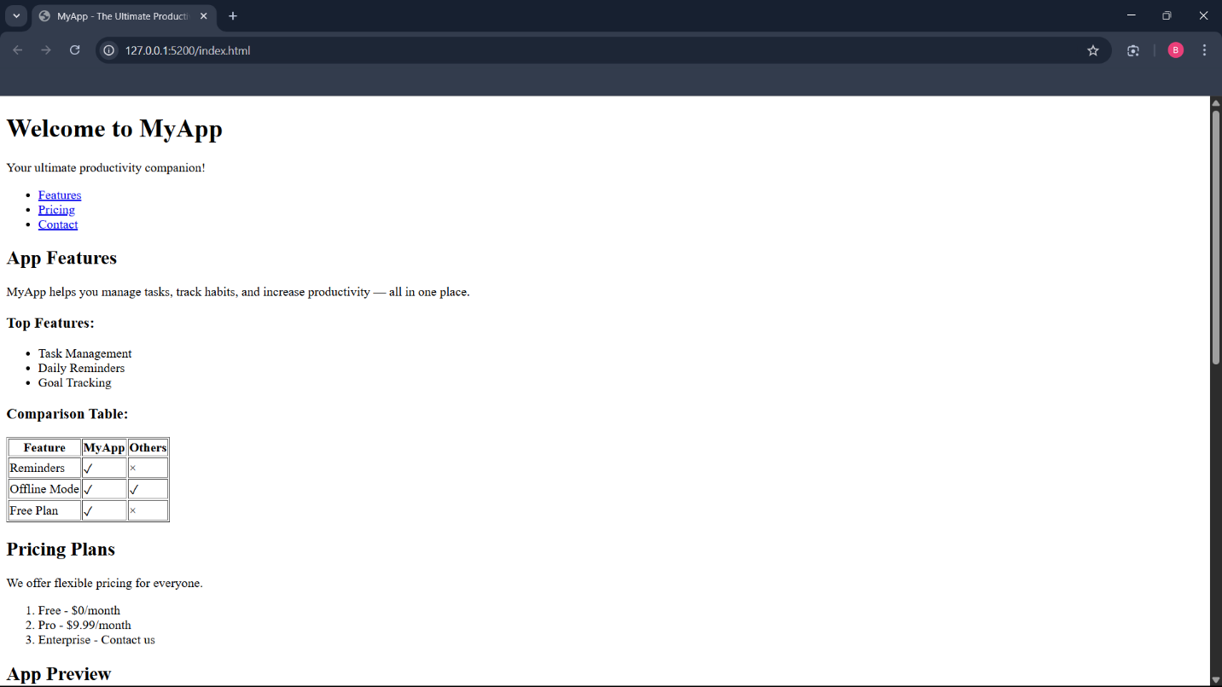

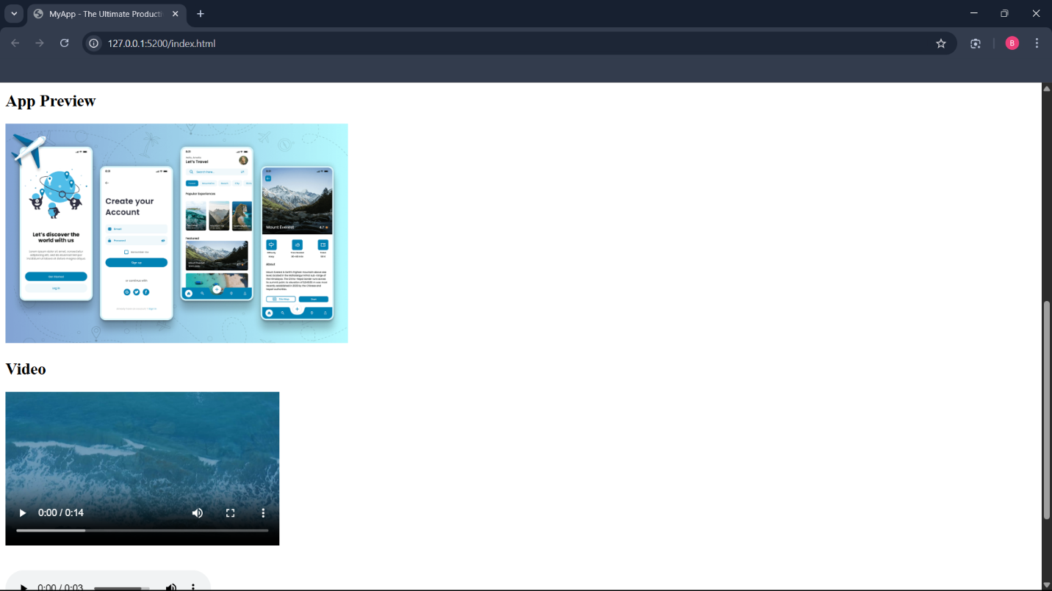

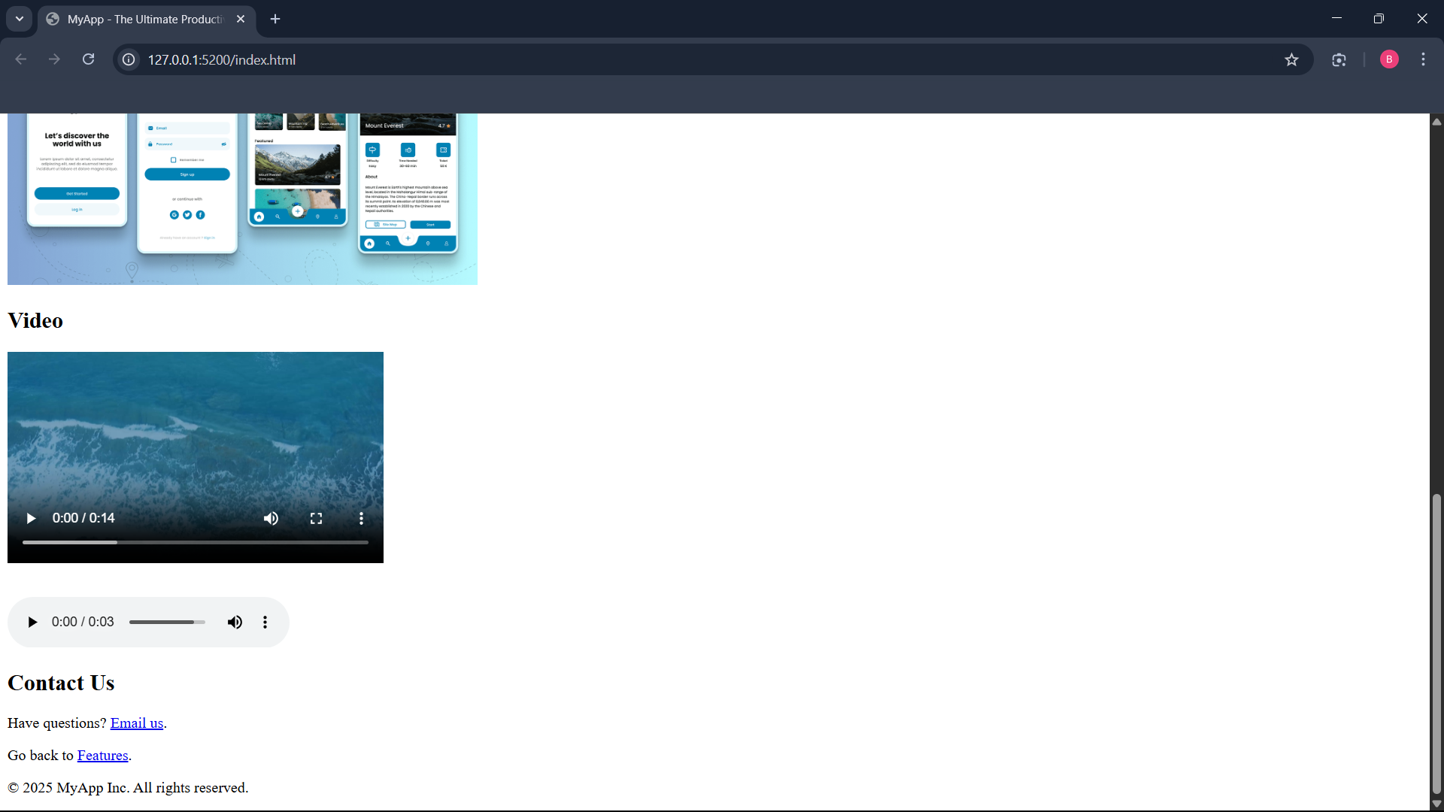

**Result**

The program is executed successfully.