Exercise 1: Basic HTML5 Structure

Objective: Understand the basic structure of an HTML5 document.

Task:

Create a webpage with the following:

● A title “My First HTML Page”

● A heading (<h1>) with your name

● A paragraph (<p>) describing your hobbies

● A horizontal line and a line break

<html>

<title> My First HTML Page </title>

<head>

    <h1>DINESH P</h1>

    <p>Hobbies</p>

    <p>My Hobbies are Listening to Music <br> Exploring the Literarture <br> Historical  Aspect Of  Tamil  Language</p>

    <hr>

    <h2>My Favorite Movies</h2>

    <p>All Rajini Movies </p>

    <hr>

    <p>All Ajith Movies including hit and flop in which the ratio of flop isb more than the number of hit movies  </p>

    <hr>

    <p>All Vijay Movies acted by him in 90's</p>

</head>

</html>

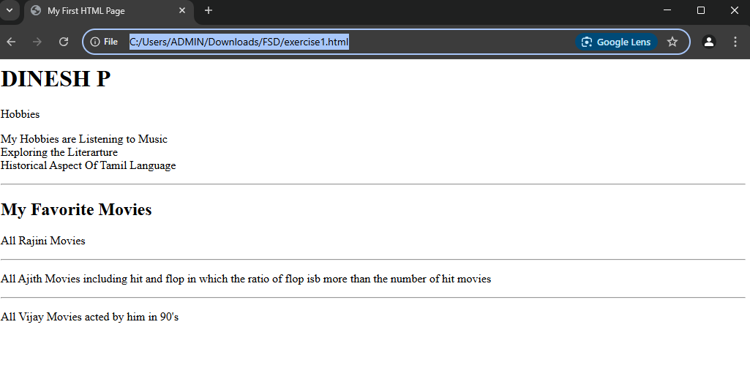

Exercise 2: Use of Lists and Links

Objective: Practice using different list types and hyperlinks.

Task:

Create a page that includes:

● An unordered list of your favorite fruits

● An ordered list of top 3 movies

● A hyperlink to your favorite website (open in a new tab)

<html>

<head>

    <h1>Unordered list of fruits</h1>

    <ul>

        <li>Pineapple</li>

        <li>Strawberry</li>

        <li>Cherry</li>

    </ul>

    <h1>Ordered list of Movies</h1>

    <ol>

        <li>Basha</li>

        <li>Jailer</li>

        <li>Maari</li>

    </ol>

    <a href="https://en.wikipedia.org/wiki/Palani" target="_blank">CLICK TO EXPLORE PALANI </a>

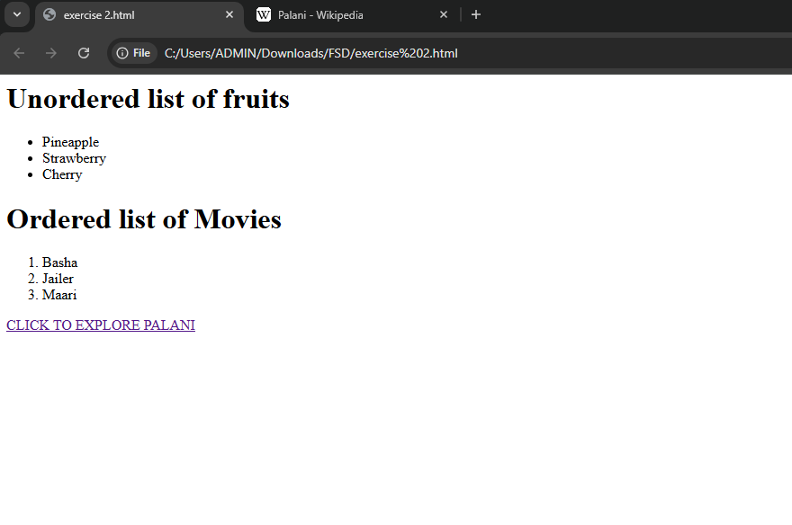

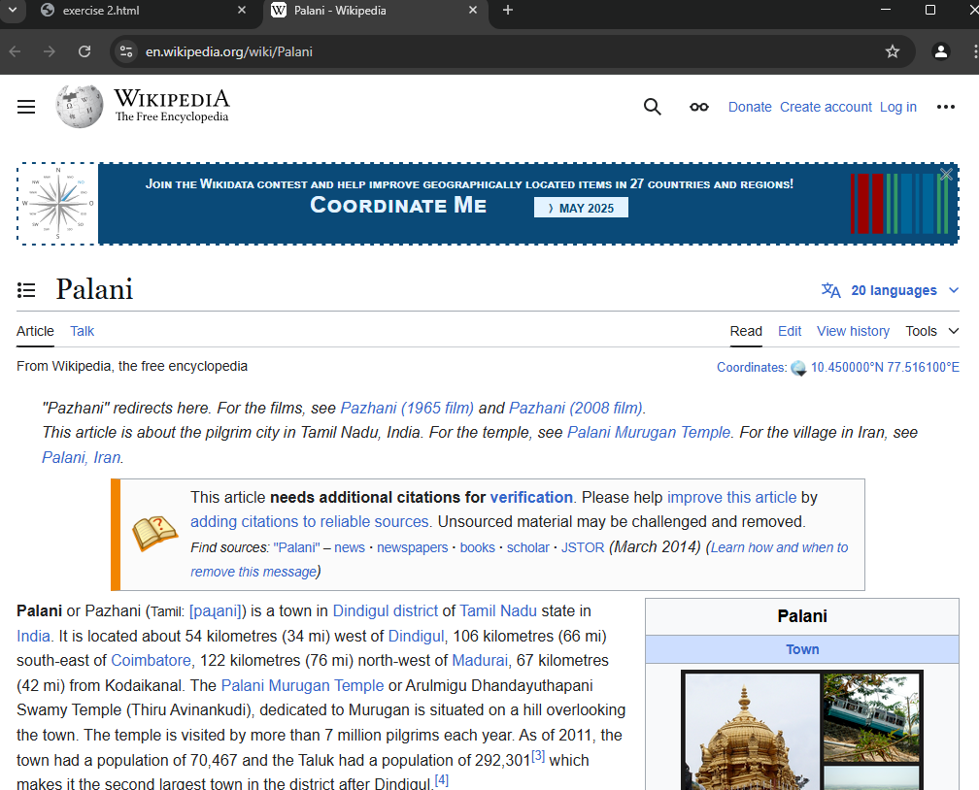

Exercise 3: Adding Images and Tables

Objective: Insert images and create tables using HTML.

Task:

● Insert an image using the <img> tag (use a placeholder URL or

local image)

● Create a table with 3 rows and 3 columns showing:

○ Student Name, Age, and Favorite Subject

<html>

    <img src="Healthy.png" alt="Not Healthy">

<table>

        <style>

            table {

              font-family: arial, sans-serif;

              border-collapse: collapse;

              width: 100%;

            }

            td, th {

              border: 1px solid #dddddd;

              text-align: left;

              padding: 8px;

            }

            </style>

        <tr>

          <th>Student Name</th>

          <th>Age</th>

          <th>Favorite Subject</th>

        </tr>

        <tr>

          <td>Ajith</td>

          <td>35</td>

          <td>Maths</td>

        </tr>

        <tr>

          <td>Vijay</td>

          <td>45</td>

          <td>Science</td>

        </tr>

        <tr>

            <td>Surya</td>

            <td>46</td>

            <td>Physics</td>

          </tr>

      </table>

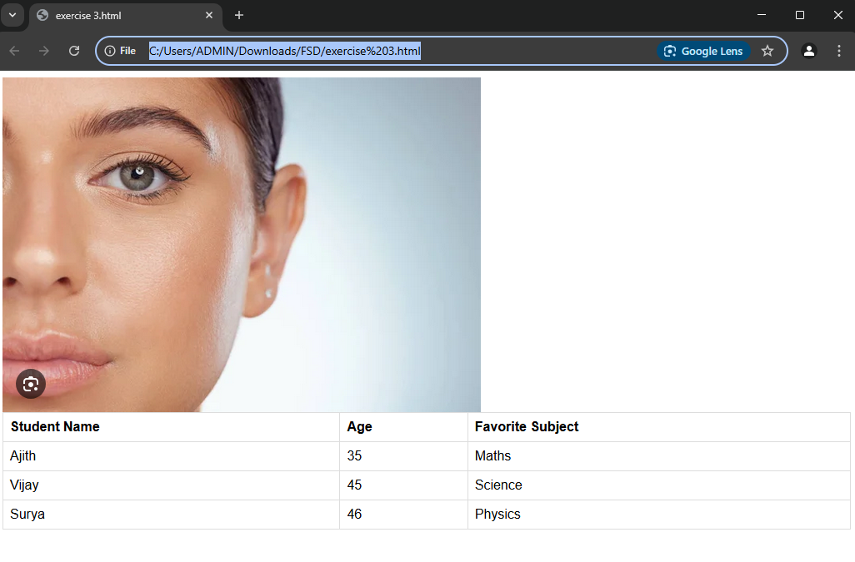

Exercise 4: Introduction to CSS (Internal CSS)

Objective: Apply basic styles to HTML using <style> tag.

Task:

● Create a heading styled with:

○ Background color: lightblue

○ Text color: darkblue

○ Font size: 30px

● Style a paragraph with:

○ Font family: Arial

○ Text alignment: justify

<html>

<head>

    <h1>WELCOME TO DINESH PALANI GLOBAL TECH SOLUTIONS</h1>

    <p1>hi Welcome to the family of Dinesh Palani Global Solutions ,How can we Help you  </p1>

    <STYLE>h1 {

        background-color: green;

        color: white;

        font-size: 30px;

      }

      .p1{

        font-family: Arial;

        text-align: justify;

      }

      </STYLE>

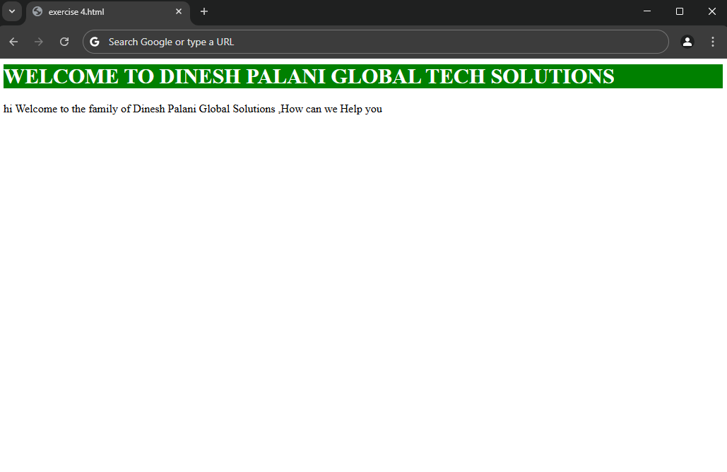

Exercise 5: CSS Classes and IDs

Objective: Learn to differentiate and apply CSS classes and IDs.

Task:

● Create two <div> blocks:

○ One with ID intro styled with a border and padding

○ One with class highlight styled with a yellow background

● Add text to both and observe the styles

<html>

<head>

<h1>WELCOME TO DINESH PALANI GLOBAL TECH SOLUTIONS</h1>

<p1>hi Welcome to the family of Dinesh Palani Global Solutions ,How can we Help you  </p1>

<STYLE>

      h1 {

        background-color: green;

        color: white;

        font-size: 30px;

      }

      .p1 {

        font-family: Arial;

        text-align: justify;

      }

      #intro {

        border: 2px solid black;

        padding: 10px;

      }

      .highlight {

        background-color: yellow;

      }

</STYLE>

</head>

<body>

    <div id="intro">

        Welcome to our introductory section. We are here to assist you!

    </div>

    <div class="highlight">

        This is a highlighted section with important information.

    </div>

</body>

</html>

