**Objective:**

To analyze the customer shopping behaviour and trends using SQL for data processing and POWER BI for interactive visualizations.

**Database Summary:**

**Source :** [Excel_Shopping_Data](C:\\Users\\DINESH\\Downloads\\shopping_trends.csv)

**Number of Records :**  3900+ rows

**Number of Fields :** 15 Columns

**Key Columns :**

* Customer_ID
* Age
* Gender
* Item_Purchased
* Category
* Purchase_Amount_USD
* Location
* Size
* Color
* Season
* Review_Rating
* Subscription_Status
* Payment_Method
* Shipping Type
* Discount_Applied
* Promo_Code
* Previous_Purchases
* Payments_Method
* Frequency_Purchase
* Purchase_Amount_INR

**SQL Environment setup:**

**Database Used :** MySQL

**Tools :** MySQL Workbench

**SQL Queries**

**Query Title : Total Purchase Amount Across All Transactions (USD)**

**Output :**

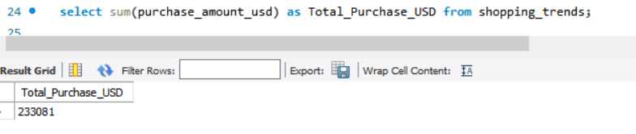

**Query Title : Total Purchase Amount Across All Transactions (INR)**

**Output :**

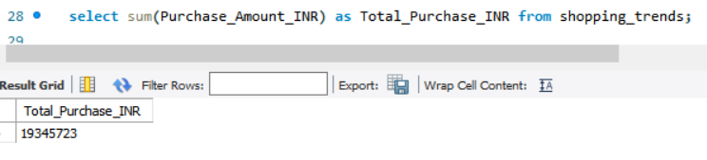

**Query Title : Total count of Male and Female**

**Output : Male count**

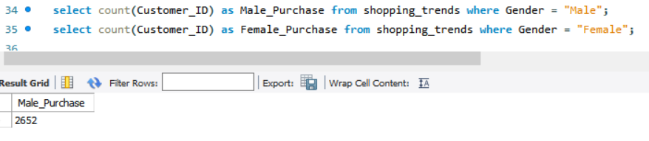

**Output : Female count**

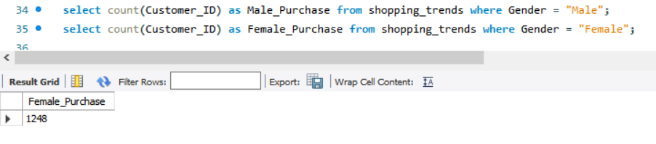

**Query Title : Average Purchase Amount INR**

**Output :**

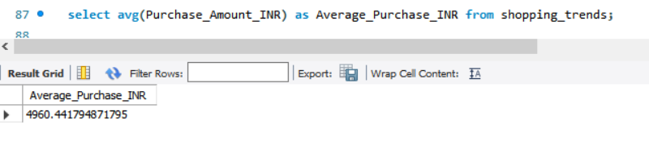

**Query Title : Top 5 Highest Item Purchased INR**

**Output :**

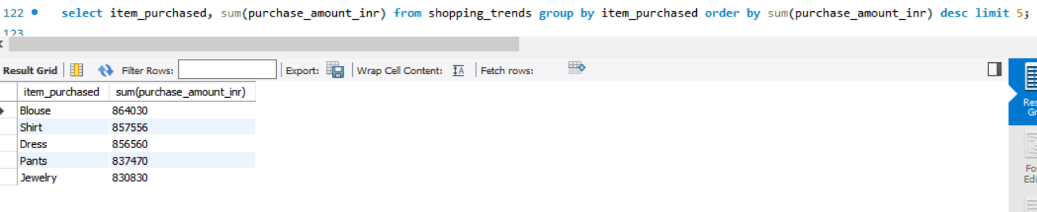

**Query Title : Total Sales For Each Category**

**Output :**

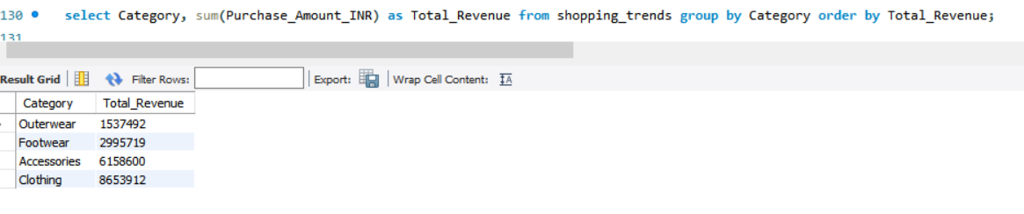

**Query Title : Find the Total Purchase for Top 5 Location**

**Output :**

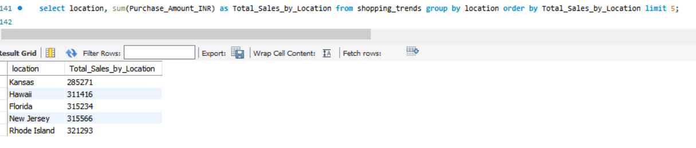

**Query Title : Find the who are all Purchased with Discounts ?**

**Output :**

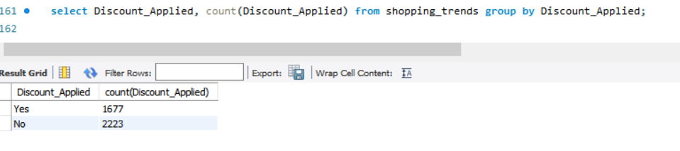

**Query Title : Find the Count of Customers Who Purchased the Products regularly ?**

**Output :**

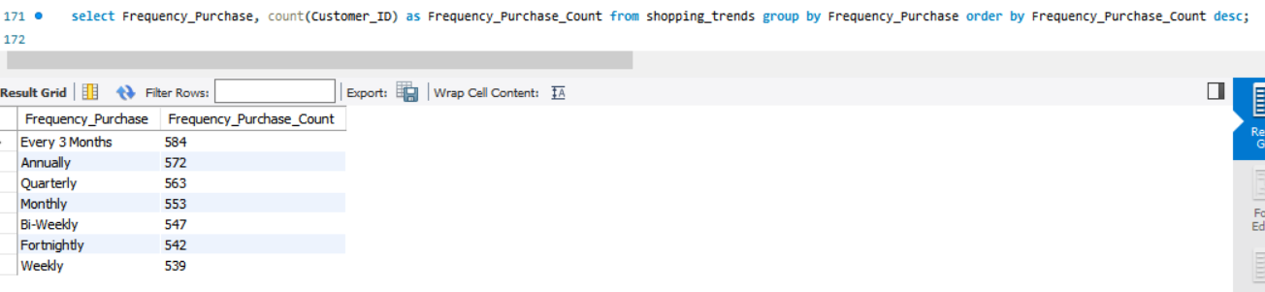

**Query Title : Find the Top 2 Payment Method with Total Sales**

**Output :**

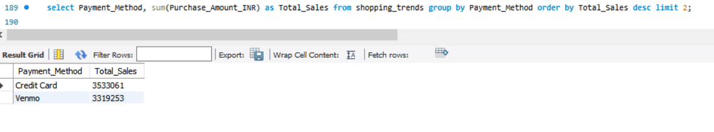

**Query Title : Find the 3RD Highest Item Purchased using CTE**

**Output :**

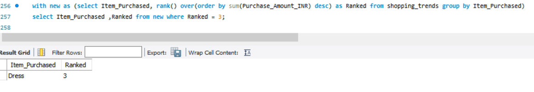

**Query Title : Find the 2ND Highest Purchased Category using CTE**

**Output :**

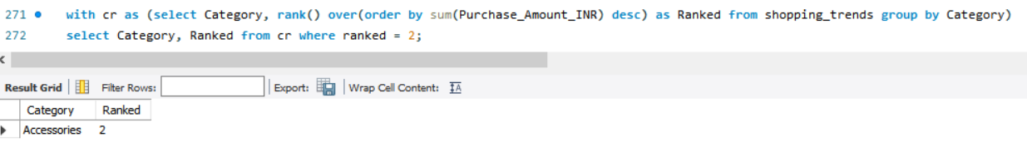

**Query Title : Find the Average Sales on each Age Group**

**Output :**

