**Student Name:**  S.Dinesh Vaibhav

**Register Number:** 510623205013

**Institution:** C.Abdul Hakeem College of Engineering

AND Technology

**Department:** B.Tech Information and Technology

**Date of Submission:** 04/05/2025

**Github Repository Link:**

1. Problem Statement:

Real-World Problem:

“In rapidly urbanizing cities like Delhi, Mumbai, and Chennai, air pollution levels frequently cross safe thresholds, severely impacting public health, especially for vulnerable groups like children, the elderly, and individuals with respiratory illnesses. Despite available data, city administrations struggle to make proactive decisions due to the lack of accurate, location-specific, and timely air quality predictions. There is an urgent need for a machine learning-based predictive system that can forecast air quality levels, identify high-risk periods, and provide actionable environmental insights to support early interventions and public awareness.”

Refinement based on Dataset Understanding:

“Analysis of publicly available air quality datasets, such as those from the Central Pollution Control Board (CPCB) and OpenAQ, reveals frequent spikes in pollutant levels like PM2.5, NO2, and O3 during specific time frames—particularly in urban zones with dense traffic and low wind conditions. However, current monitoring systems are largely reactive and fail to provide early warnings. By leveraging machine learning algorithms on multi-source environmental data (e.g., pollutant concentrations, temperature, humidity, wind speed, and time-based features), we can build a predictive model that forecasts short-term air quality levels. This will enable city authorities to implement proactive measures and empower the public with timely alerts to minimize health risks.”

Problem Type:

"This is a supervised learning problem where we predict air quality levels using either regression or classification based on the target variable."

Why Solving this Matters:

**"Solving this problem helps protect public health by providing early warnings about poor air quality, so that people and authorities can take timely action to reduce exposure and control pollution."**

2.Project Objectives:

Key Technical Objectives:

• **Collect and preprocess air quality and weather data** from reliable sources.

• **Analyze patterns** in pollutant levels based on time, weather, and location.

• **Build and compare advanced machine learning models** (e.g., Random Forest, XGBoost, LSTM) for predicting air quality levels.

• **Classify or forecast AQI categories** to provide early warnings.

• **Evaluate model performance** using suitable metrics like accuracy, RMSE, or F1-score.

• **Interpret model results** to understand key contributing factors to air pollution.

• **Visualize predictions and insights** through graphs or a simple dashboard.

Model Goals:

**Accuracy:** The performance of the machine learning models will be measured using appropriate accuracy metrics:

* **For Classification** (e.g., predicting AQI category):  
  👉 Accuracy, Precision, Recall, F1-Score, Confusion Matrix
* **For Regression** (e.g., predicting PM2.5 value):  
  👉 RMSE (Root Mean Square Error), MAE (Mean Absolute Error), R² Score.

**Interpretability:** **Interpretability** refers to understanding how the model makes decisions and which features are most important in predicting air quality levels.

**Real-World Applicability:**.

• **Public Health**:  
The model helps identify high-pollution periods and locations, allowing individuals to take protective measures (e.g., wearing masks, avoiding outdoor activities) to **reduce health risks**, especially for children, the elderly, and those with respiratory conditions.

• **Government & Urban Planning**:  
Cities can use this tool to **proactively manage pollution**, for example by imposing traffic restrictions or shutting down certain factories during peak pollution times. This can contribute to creating **healthier urban environments**.

• **Environmental Awareness**:  
The model’s predictions can be used to **inform the public** through apps or websites about expected air quality levels, raising awareness and encouraging better lifestyle choices, such as using public transport or reducing emissions.

• **Early Warnings**:  
Authorities can use the model to issue **early warnings** about upcoming pollution spikes, helping them implement measures like distributing clean air masks, or advising vulnerable populations to stay indoors.

**Evolution of Goal:**

• **Initial Goal**:

* The initial goal was to **develop a predictive model** for air quality levels, using historical environmental data and machine learning techniques, to forecast pollution levels and AQI in real-time or short-term predictions.

• **Refinement of Goal**:

* After analyzing the available datasets, the goal evolved to include not just prediction, but also **interpretability**, where we understand which environmental factors (e.g., weather, traffic, geographical location) contribute most to air pollution.

• **Expanded Goal**:

* With further analysis, the goal expanded to involve **proactive decision-making**. The model aims to help authorities take actions to mitigate pollution, like issuing alerts, controlling traffic, or regulating factories, especially during high pollution days.

• **Current Goal**:

* The refined goal now is to **build a robust, interpretable machine learning model** that accurately predicts air quality and provides actionable insights to both the public and government, improving public health and urban environmental quality.

3.Flowchart of the Project Workflow:

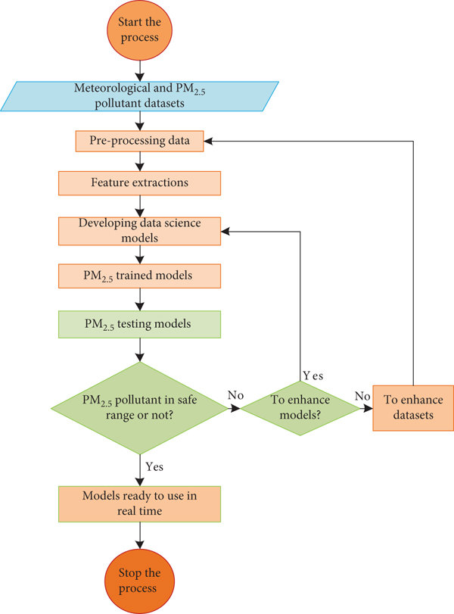

4.Data Description:

The dataset used for this project contains **historical air quality and meteorological data** collected from sources like **CPCB (Central Pollution Control Board)**, **OpenAQ**, or other government/environmental APIs.

**🔹 Key Features (Input Variables):**

* **PM2.5** – Fine particulate matter (µg/m³)
* **PM10** – Coarse particulate matter (µg/m³)
* **NO2** – Nitrogen dioxide (µg/m³)
* **SO2** – Sulfur dioxide (µg/m³)
* **CO** – Carbon monoxide (mg/m³)
* **O3** – Ozone (µg/m³)
* **Temperature** – Ambient temperature (°C)
* **Humidity** – Relative humidity (%)
* **Wind Speed** – Speed of wind (m/s)
* **Date/Time** – Timestamp of the recorded values
* **Location** – City or monitoring station

**🔹 Target Variable:**

* **AQI (Air Quality Index)** – A numerical value representing the pollution level.
  + Can be treated as a **continuous variable** (for regression).
  + Or converted into **categories** like "Good", "Moderate", "Poor" (for classification).

**🔹 Data Characteristics:**

* **Time-Series Data**: Values change over time (hourly, daily).
* **Multi-location**: Can include data from different cities or stations.
* **Missing Values**: May contain gaps that need preprocessing.
* **Units**: Each pollutant has a specific unit (important for interpretation).

5. Data Preprocessing:

**1. Handling Missing Values**

* Check for NaN or missing entries in pollutant or weather columns.
* Fill missing values using techniques like:
  + **Mean/Median imputation**
  + **Forward/Backward fill** for time-series data
  + Or **dropping** rows/columns if too many values are missing

**🔹 2. Removing Duplicates**

* Remove any duplicate rows to avoid data imbalance and redundancy.

**🔹 3. Datetime Conversion**

* Convert the **date/time** column into a proper datetime format.
* Extract useful features like **hour**, **day**, **month**, **weekday**, etc.

**🔹 4. Outlier Detection and Removal**

* Identify outliers in pollutant values (e.g., PM2.5 > 1000) and either remove or cap them.
* Use **boxplots**, **z-score**, or **IQR** method.

**🔹 5. Feature Scaling**

* Normalize or standardize features like temperature, humidity, wind speed using:
  + **Min-Max Scaling** or
  + **Standardization (Z-score)**

**🔹 6. Label Encoding (if Classification)**

* Convert AQI categories like "Good", "Moderate", "Poor" into numerical labels.

**🔹 7. Data Splitting**

* Split the dataset into:
  + **Training Set** (e.g., 80%)
  + **Testing Set** (e.g., 20%)
  + Optionally a **Validation Set** for hyperparameter tuning

6.Exploratory Data Analysis (EDA):

#### 1. Understanding the Distribution

* Plot histograms or KDE plots for:
  + PM2.5, PM10, NO2, O3, etc.
* Check if data is skewed or normally distributed.

**🔹 2. Correlation Analysis**

* Use a **correlation heatmap** to identify how features are related.
  + For example: PM2.5 may have a high correlation with AQI.
* Helps in **feature selection**.

**🔹 3. Time-Series Trends**

* Line plots of pollutants over **time** (hourly/daily trends).
* Helps identify peak pollution hours, seasonal variations (e.g., winter spikes).

**🔹 4. Pollutant Levels by Category**

* Boxplots or violin plots to compare pollutant levels across AQI categories ("Good", "Poor", etc.).
* Useful for understanding how pollutants affect air quality labels.

**🔹 5. Geographic/Location-wise Analysis**

* Compare pollution levels across different **cities or locations**.
* Bar charts or maps (if spatial data is available).

**🔹 6. Outlier Detection**

* Use boxplots or scatter plots to find extreme values in pollutants or weather data.

7.Feature Engineering:

New Features:

**1. Feature Selection**

* Identify the **most relevant features** that impact AQI or pollutant levels:
  + PM2.5, PM10, NO2, O3, Temperature, Humidity, Wind Speed, etc.
* Use:
  + **Correlation matrix**
  + **Feature importance** from models like Random Forest/XGBoost
  + **Statistical tests** (e.g., ANOVA, Chi-square)

**🔹 2. Datetime Feature Extraction**

* From the Date/Time column, extract:
  + **Hour**, **Day**, **Month**, **Day of Week**
* Useful for modeling **seasonal or daily pollution patterns**.

**🔹 3. Handling Categorical Features**

* If any categorical variables exist (like location, weather type):
  + Apply **Label Encoding** or **One-Hot Encoding**

**🔹 4. Creating New Features**

* Example:
  + **PM Ratio** = PM2.5 / PM10 → can indicate particle size dominance.
  + **Pollution Index** = weighted combination of pollutants.
  + **Humidity × Temperature** → can influence dispersion of pollutants.

**🔹 5. Scaling/Normalization**

* Scale continuous features to bring them to a similar range:
  + Use **Min-Max Scaler** or **StandardScaler** (Z-score normalization)

**🔹 6. Dimensionality Reduction (if needed)**

* Apply **PCA (Principal Component Analysis)** to reduce redundant features while keeping key patterns.

8.Model Building:

#### 1. Choosing the Right Model

Depending on your goal (regression or classification), select suitable algorithms:

* **For Regression** (predicting continuous AQI or PM2.5 values):
  + Linear Regression
  + Decision Tree Regressor
  + Random Forest Regressor
  + XGBoost Regressor
  + Neural Networks
* **For Classification** (predicting AQI category: Good, Moderate, Poor):
  + Random Forest Classifier
  + XGBoost Classifier
  + Support Vector Machine (SVM)
  + Logistic Regression
  + K-Nearest Neighbors (KNN)

**2. Training the Model**

* Split the data into **Training** and **Testing** sets (e.g., 80%-20%).
* Use the **training data** to fit the model and learn patterns.

**3. Hyperparameter Tuning**

* Optimize model performance using:
  + **Grid Search** or **Randomized Search**
  + **Cross-validation** to avoid overfitting

**4. Prediction**

* Use the trained model to predict values on **new or test data**.

**5. Model Comparison**

* Train multiple models and compare them based on metrics like:
  + **RMSE, MAE, R²** (for regression)
  + **Accuracy, F1-score, Confusion Matrix** (for classification)

9.Visualization of Results & Model Insights:

**1. Actual vs Predicted Plot**

* Plot the **actual AQI values** vs the **predicted values** using a line or scatter plot.
* Helps you visually assess how close the model’s predictions are to reality.

**🔹 2. Residual Plot**

* Plot of **residuals (errors)** vs predicted values.
* Helps detect if there are patterns in prediction errors.

**🔹 3. Feature Importance Plot**

* Bar chart showing which features (e.g., PM2.5, NO2) had the **most influence** on the model’s predictions.
* Extracted from models like **Random Forest** or **XGBoost**.

**🔹 4. SHAP (SHapley Additive exPlanations) Values**

* Visualizes how **each feature affects individual predictions**.
* SHAP summary plot shows:
  + Which features pushed the prediction higher or lower.
  + Impact of each feature across the dataset.

**🔹 5. Confusion Matrix *(if classification is used)***

* A table that shows how many times each AQI category was correctly or incorrectly predicted.

**🔹 6. Time-Series Forecast Plot**

* Overlay actual and predicted AQI values on a time-series chart.
* Useful for evaluating model performance over time.

10.Tools and Technologies Used:

* Programming Language: Python
* IDE/Notebook: Jupyter Notebook (or Google Colab for cloud-based solutions) • Libraries: pandas, numpy, scikit-learn, seaborn, matplotlib.
* Visualization Tools: Matplotlib, Seaborn, Plotly.

11.Team Members and Contributions:

|  |  |  |
| --- | --- | --- |
| **Team Member** | **Key Responsibilities** | **Detailed Contributions** |
| S.Dinesh Vaibhav | Data Collection, Data  Preprocessing,  Documentation | Collected news articles from various sources; handled missing values, duplicates, and outliers; prepared data for model training; maintained documentation. |
| Arcot Mohammed Fuzail | Feature Engineering, Model  Development, Hyperparameter  Tuning | Engineered new features; developed and trained machine learning models; performed hyperparameter tuning for optimal model performance. |
| S.Maroof Hussain | Model Evaluation, Visualization,  Reporting | Evaluated models using metrics like accuracy, precision, recall, and F1-score; created visualizations; compiled and presented results. |
| B.Mohammed Rafid | Data Analysis, EDA, Insight  Generation | Conducted data analysis and exploratory data analysis (EDA); identified correlations and trends; generated insights into fake news behavior. |
| C.Mohammed afnan squib chingi | Final Report Writing, Deployment,  Project Management | Authored the final report; researched deployment strategies; managed the overall project timeline, coordination, and resource allocation. |