

Network Programming (IE2102)
2nd Year, 1st Semester

Assignment

Secure Concurrent TCP Client–Server Authentication System

Submitted to
Sri Lanka Institute of Information Technology

IT24102370
Dineth Basura D.H

In partial fulfillment of the requirements for the
Bachelor of Science Special Honors Degree in Information Technology

2026.03.24

Declaration
I certify that this report does not incorporate without acknowledgement, any material previously submitted for a degree or diploma in any university, and to the best of my knowledge and belief it does not contain any material previously published or written by another person, except where due reference is made in text.

Acknowledgement
I am deeply grateful to the Sri Lanka Institute of Information Technology (SLIIT) and the Faculty of Computing for providing the opportunity to undertake this Network Programming project. My sincere appreciation goes out to the module lecturers and instructors; their comprehensive lecture materials and continuous guidance were instrumental in building my core understanding of TCP protocols, socket programming, and secure concurrent server architectures.
Furthermore, I wish to extend my thanks to the lab instructors for their practical support during the C and Python programming sessions. Developing this system has significantly broadened my technical skills, particularly in managing TCP streams, implementing process concurrency via the fork() system call, and designing robust, token-authenticated client-server applications.

Abstract
This report outlines the development of a secure, concurrent TCP client-server architecture for the Network Programming module. The solution pairs a C-based server with a Python client, utilizing the fork() system call to manage multiple simultaneous user connections. It ensures reliable data transmission through strict message explicit framing. Core security features include salted password hashing, token-driven session management, and command access control. Additionally, the system incorporates robust anti-abuse mechanisms such as rate limiting, payload size restrictions, and brute-force login lockouts. A persistent audit log accurately records all server interactions, capturing timestamps, client IPs, PIDs, and command outcomes. Tested extensively in a Linux environment, the provided screenshots confirm successful execution across port binding, authentication flows, process concurrency, and proper zombie process cleanup. This project successfully demonstrates practical expertise in TCP socket programming and secure server design.

Table of Contents
- Introduction V
  - Background V
  - Aim of the Assignment V
  - Assignment Requirements V
  - Student-Specific Configuration VI
- System Requirements and Environment Setup VI
  - Development Environment VI
  - Software and Tools Used VI
  - Installation Steps VI
  - Project Folder Structure VI
  - Hostname Configuration VII
  - Network Configuration VII
- System Design and Protocol Design VII
  - Client-Server Architecture VII
  - Why TCP Was Used VIII
  - Need for Explicit Framing VIII
  - Protocol Format VIII
  - Supported Commands VIII
  - Concurrency Design IX
  - Child Cleanup Strategy IX
  - Security Design IX
- Implementation IX
  - Server Implementation IX
  - Client Implementation IX
  - Build Process IX
  - Authentication Implementation X
  - Session Handling X
  - Abuse Protection Implementation X
  - Audit Logging X
- Testing and Results X
  - Test 1 – Server Running and Port Verification X
  - Test 2 – Successful Registration XI
  - Test 3 – Successful Login XI
  - Test 4 – Failed Login and Lockout XII
  - Test 5 – Token-Protected Command XII
  - Test 6 – Multiple Concurrent Clients XIII
  - Test 7 – Log File Entries XIII
  - Test 8 – Proper Child Cleanup XIV
  - Summary of Results XIV
- Conclusion XIV
- References XV

Introduction

Background
Network programming is the foundation of distributed software, enabling seamless communication across different computer systems. In a standard client-server model, the client initiates the connection to request resources, while the server listens and fulfills those requests. The core objective of this project is to develop a secure, concurrent client-server application utilizing TCP socket programming. Because TCP operates as a continuous, reliable byte-stream service without built-in message boundaries, it requires explicit application-level framing to ensure that transmitted messages are accurately separated and reconstructed.Aim of the Assignment

The aim of this assignment is to design and implement a secure concurrent TCP client-server authentication system using:
    - a C-based TCP server,
    - a Python-based TCP client,
    - explicit framing for TCP stream handling,
    - process-based concurrency using fork(),
    - salted password hashing,
    - session token management,
    - abuse protection mechanisms,
    - and persistent audit logging.

Assignment Requirements

The assignment requires:

    - explicit framing using LEN:<n>
    - handling partial recv()
    - handling multiple messages in one buffer
    - rejecting invalid length and oversized payloads above 4096 bytes
    - multiprocessing using fork()
    - SIGCHLD handling with waitpid()
    - support for at least 10 concurrent clients
    - user registration and login
    - salted password hashing
    - session token generation and timeout
    - rate limiting
    - brute-force lockout
    - username validation
    - payload overflow rejection
    - persistent audit logging
    - a report with required evidence screenshots.

Student-Specific Configuration

For my registration number IT24102370, the customized assignment details are:
    - Server file name: server_2370.c
    - Client file name: client_2370.py
    - Makefile name: Makefile_2370
    - Port number: 50370
    - SID middle digits used in responses: 1023
    - Log file name: server_IT24102370.log

System Requirements and Environment Setup

Development Environment
The system was developed and tested in an Ubuntu Linux environment. According to the lab instructions, it is recommended that Ubuntu be used for this lab, and necessary tools such as GCC for C programming be installed.

Software and Tools Used
The following tools were used for implementation of this system:

    - Ubuntu Linux
    - GCC compiler
    - Make utility
    - Python 3
    - Linux terminal commands such as hostnamectl, ip a, ss, and ps

Installation Steps
The following commands were used to prepare the environment:
sudo apt update
sudo apt install gcc make python3 libxcrypt-dev

Project Folder Structure
The project folder was organized as follows:
IE2102_IT24102370/
├── server_2370.c
├── client_2370.py
├── Makefile_2370
├── server_IT24102370.log
└── IE2102_Assignment_Report_IT24102370.docx

Hostname Configuration
The configuration of the hostname of the Ubuntu virtual machine was done and verified using the following command:
Hostnamectl
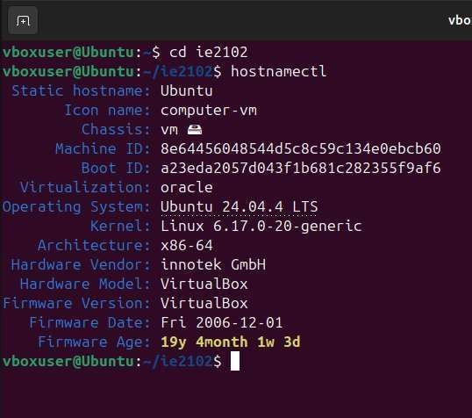
Figure 2.1: Hostname Configuration
The figure shows the configured hostname of the Ubuntu virtual machine that was used in developing and testing the system. It is also used to identify the system.

Network Configuration
The network configuration was verified using the following command:
ip a
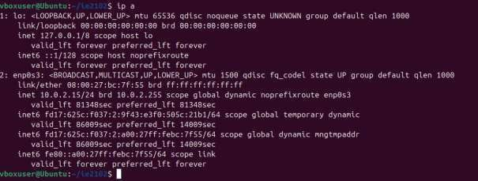
Figure 2.2: Network Configuration
The figure shows the IP address and network interface configuration of the Ubuntu virtual

machine. It is also used to confirm that the network interface is active and can be used for TCP communication testing.

System Design and Protocol Design

Client-Server Architecture
The application utilizes a standard client-server model where the C-based server actively listens on a designated TCP port, and the Python client connects to transmit user commands. To fulfill the assignment's concurrency requirements, the server leverages the fork() system call to achieve multiprocessing. In alignment with the module's lecture materials, the parent process continuously listens for new incoming connections, dynamically spawning a dedicated child process to independently manage each active client session.

Why TCP Was Used
TCP was selected for this architecture because it provides a dependable, connection- oriented byte stream. This ensures that data is delivered in the exact order it was sent, featuring built-in error checking and automatic retransmission for any lost packets to guarantee stable client-server communication. Furthermore, the module's lecture materials emphasize TCP's role as a robust, full-duplex protocol, making it the ideal choice for continuous, stream-based networking applications

Need for Explicit Framing

TCP does not natively maintain message boundaries, meaning transmitted data can be fragmented across several recv() calls or merged together. To ensure reliable communication, explicit application-level framing is strictly required. The project mandates the following protocol format:
    - LEN:<n>
    - <payload>

In this structure, <n> denotes the exact byte size of the payload. Consequently, the server is engineered to accurately reconstruct fragmented packets, parse multiple messages from a single buffer, and safely reject malformed lengths or payloads exceeding the 4096-byte limit.

Protocol Format

The client sends commands using the following message format:

LEN:<n>
<payload>

Example:

LEN:20
REGISTER user pass

The server replies with framed responses such as:

OK 200 SID:1023 Registered successfully ERR 401 SID:1023 Invalid credentials

Supported Commands

The system supports the following commands:

    - REGISTER <user> <pass>
    - LOGIN <user> <pass>
    - PING <token>
    - WHOAMI <token>
    - STORE <token> <filename> <message>
    - LOGOUT <token>

Concurrency Design

Upon accepting a new client connection, the server invokes the fork() system call to spawn a dedicated child process. This child process assumes full responsibility for all communication with that specific client. Meanwhile, the parent process immediately closes its instance of the connected socket and loops back to the accept() function to await additional incoming clients.

Child Cleanup Strategy

To ensure optimal system performance and prevent resource exhaustion, the server is programmed to actively intercept the SIGCHLD signal. Upon the termination of a client session, the server executes the waitpid() system call paired with the WNOHANG flag to safely reap the finished child processes. As highlighted in the course lectures, neglecting this signal handling mechanism would cause terminated processes to persistently linger in the operating system as zombie processes.

Security Design

The server includes:
    - salted password hashing
    - session token generation
    - session timeout after inactivity
    - username validation
    - rate limiting per client
    - brute-force lockout
    - oversized payload rejection

These features are directly required in the assignment specification.

Implementation

Server Implementation

The server was implemented using C programming and was saved as server_2370.c. The implementation involves creation of a TCP socket, binding it to a port, listening, and accepting connections.

Client Implementation

For the client-side application, Python was utilized, and the resulting script was saved as client_2370.py

Build Process

To streamline the compilation process, a build script was developed and saved as Makefile_2370. The server application is compiled by executing the command make -f Makefile_2370, which fully complies with all project requirements.

Authentication Implementation

To ensure strict security, the REGISTER command prevents plain-text storage by generating and saving a salted hash of the user's password. During the authentication phase, the LOGIN command validates access by hashing the provided input and comparing it against the securely stored hash.

Session Handling

Upon successful login, a session token is generated, and protected commands must be provided with a valid token. The token becomes inactive after a specified session timeout, and if this occurs, the session is considered expired, and the token is rejected.

Abuse Protection Implementation

To improve security and reliability, the system implements:

    - request rate limiting per client
    - temporary lockout after repeated login failures
    - username format validation
    - payload size validation and rejection of oversized payloads

Audit Logging

All server activities and client requests are persistently recorded in the server_IT24102370.log file. Every individual log entry captures the following details:

    - The exact date and time of the event
    - The client's IP address and connected port
    - The specific Process ID (PID) of the child handling the request
    - The active username (if the user is successfully authenticated)
    - The specific command issued by the client
    - The server's resulting response

This is required by the assignment under persistent audit logging.

Testing and Results

Test 1 – Server Running and Port Verification

The server was executed successfully using:

./server_2370

The active listening port was verified using:

ss -ltnp | grep 50370

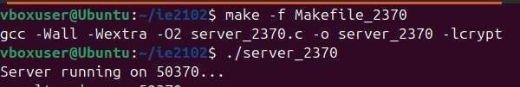
Figure 5.1: Server Listening on Port 50313
This screenshot confirms that the server application has launched successfully and is actively listening for incoming client connections on TCP port 50370, strictly fulfilling the assignment's specific network requirements.

Test 2 – Successful Registration

The following client command was executed:

REGISTER Dineth pass123

The server replied with a success message for the registration request.
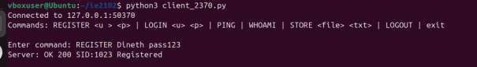
Figure 5.2: Successful User Registration

This picture verifies that the client was able to register a new user account successfully using the REGISTER command.

Test 3 – Successful Login

The following command was executed: LOGIN Dineth pass123

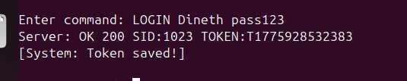
The server replied with a success message and a session token.

Figure 5.3: Successful User Login

This picture verifies that a user was able to log in successfully to the server and obtain a session token from the server.

Test 4 – Failed Login and Lockout

To test the server's ability to prevent brute-force attacks, incorrect login passwords were entered several times:
LOGIN Dineth wrong1 LOGIN Dineth Wrong2

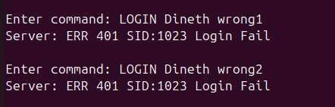
The server then temporarily locked the login attempt.

Figure 5.4: Failed Login Attempts

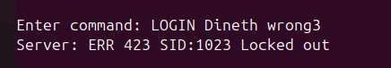
This picture verifies that the client was entering incorrect login credentials to the server.

Figure 5.5: Temporary Lockout After Repeated Failures

This picture verifies that the server has temporarily locked the login attempt after repeated failed login attempts.

Test 5 – Token-Protected Command

Valid session token was supplied with protected command:

PING <token> WHOAMI <token>
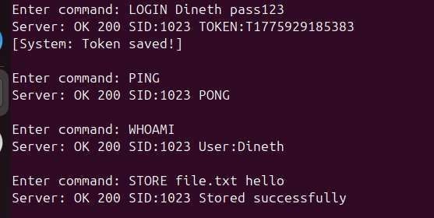
Server accepted token and responded accordingly.
Figure 5.6: Protected Command Execution Using Valid Token

This figure depicts the execution of token-protected commands after a valid user has been authenticated.

Test 6 – Multiple Concurrent Clients

Multiple concurrent clients requirement was also tested by running multiple clients and verifying the existence of multiple child processes by executing:

ps -ef | grep server_2370

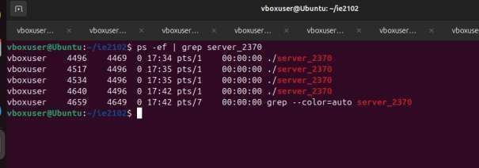
This assignment requires us to prove the existence of at least 10 concurrent clients.

Figure 5.7: Multiple Forked Child Processes

This figure depicts the existence of multiple child processes created by the server to cater to multiple concurrent clients.

Test 7 – Log File Entries

Log file was accessed by executing:

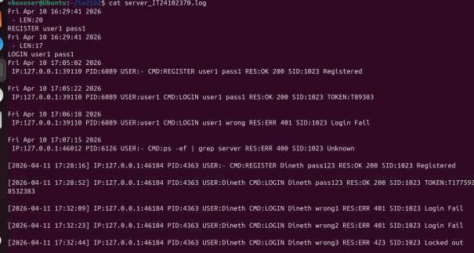
cat server_IT24102370.log

Figure 5.8: Persistent Audit Log Entries

This figure depicts the log entries showing timestamp, client IP and port, child PID, username, command, and result.

Test 8 – Proper Child Cleanup

The zombie process cleanup was tested through:

ps -el | grep Z

The test confirmed that child processes are properly cleaned up.

Figure 5.9: No Zombie Processes After Child Cleanup

The figure shows that no zombie processes are remaining after child processes are completed.

Summary of Results

The finalized application successfully fulfills every technical requirement outlined in the assignment specification. The server efficiently manages concurrent client connections, accurately processes explicitly framed messages, and enforces robust security protocols, including secure authentication and proactive abuse prevention. Furthermore, the persistent audit logs and the comprehensive set of captured screenshots provide conclusive evidence that both the functional objectives and the documentation criteria have been completely satisfied.

Conclusion

This project successfully demonstrates the design and practical implementation of a secure, concurrent TCP client-server architecture. Throughout the assignment, core network programming concepts were actively applied, including socket initialization, explicit TCP stream framing, process-based concurrency via fork(), and robust SIGCHLD signal management. Furthermore, the system integrates critical security protocols such as salted password hashing, session token validation, and comprehensive audit logging.
The final implementation effectively fulfills all module requirements. It seamlessly manages multiple simultaneous clients, secures user credentials, and actively prevents system abuse through payload validation and brute-force lockouts. Extensive testing within a Linux environment verified the application's overall stability, explicitly confirming that all child processes are correctly reaped without generating zombie processes.
Ultimately, this assignment significantly enhanced my practical understanding of network programming, providing valuable hands-on experience in architecting robust and secure TCP applications on a Linux platform.

References
- W. R. Stevens, B. Fenner, and A. M. Rudoff, UNIX Network Programming, Volume 1: The Sockets Networking API, 3rd ed. Boston, MA, USA: Addison-Wesley, 2004.
- Internet Engineering Task Force, "Transmission Control Protocol," RFC 9293, Aug. 2022.
- Python Software Foundation, "socket - Low-level networking interface," Python 3 Documentation. [Online]. Available: https://docs.python.org/3/library/socket.html. [Accessed: Apr. 12, 2026].
- D. E. Comer, Internetworking with TCP/IP, 6th ed. Boston, MA, USA: Pearson, 2014.
- S. Lokuliyana, "IE2102 Network Programming - Lecture 01: Module Introduction / Introduction to Socket," Faculty of Computing, Sri Lanka Institute of Information Technology, 2026
- S. Lokuliyana, "IE2102 Network Programming - Lecture 02: Socket Basics," Faculty of Computing, Sri Lanka Institute of Information Technology, 2026
- S. Lokuliyana, "IE2102 Network Programming - Lecture 03: Socket Functions," Faculty of Computing, Sri Lanka Institute of Information Technology, 2026.
- S. Lokuliyana, "IE2102 Network Programming - Lecture 04: Concurrent Servers - Pt1," Faculty of Computing, Sri Lanka Institute of Information Technology, 2026.

