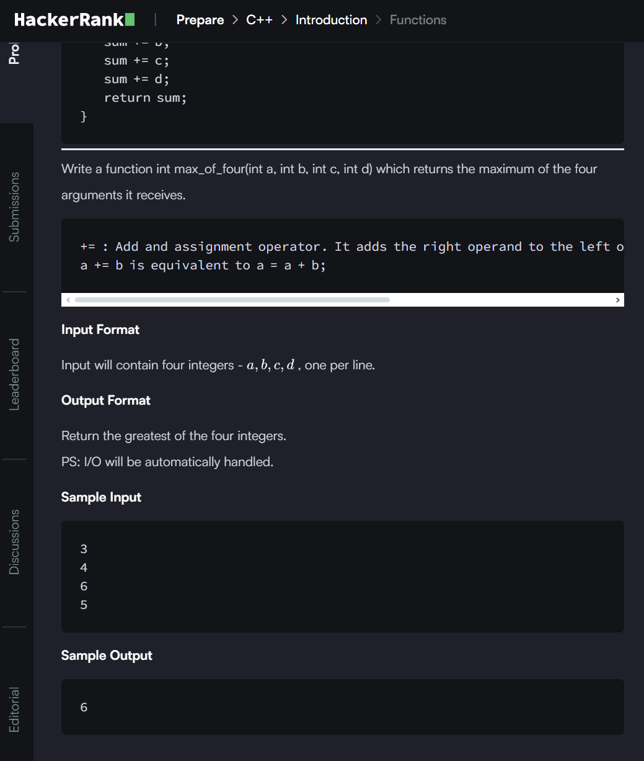

**ANSWER**

#include <iostream>

#include <cstdio>

#include <algorithm> // used to find the max

using namespace std;

int max_of_four(int a, int b, int c, int d){

//function to return the maximum

    int Max=max({a,b,c,d});

    return Max;

}

int main() {

    int a, b, c, d;

    scanf("%d %d %d %d", &a, &b, &c, &d);

    int ans = max_of_four(a, b, c, d);

    printf("%d", ans);

    return 0; }