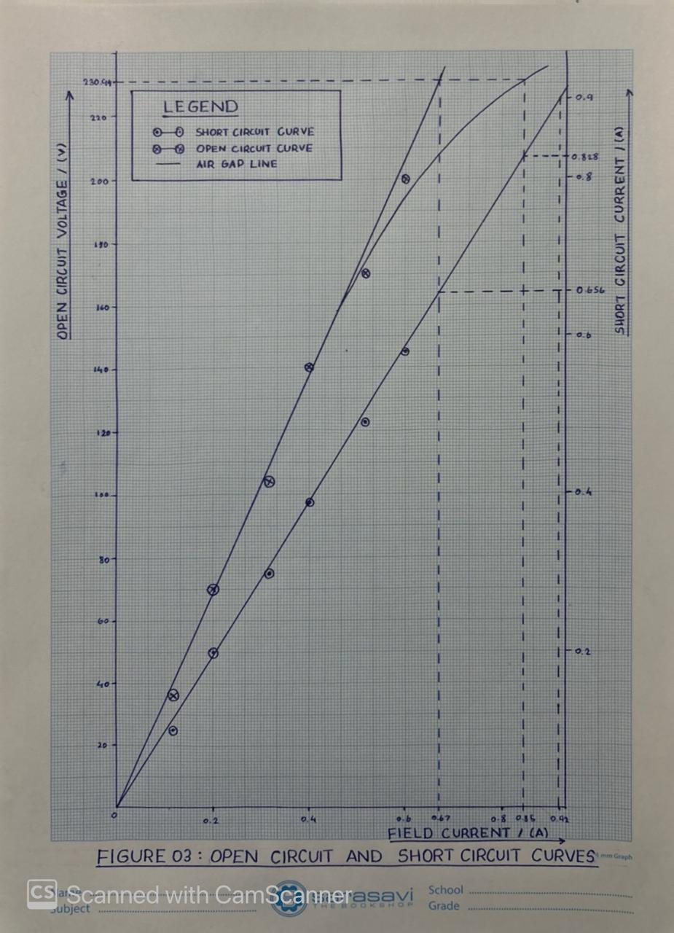

Field Current, I_{f} / A | Open Circuit Voltage, V_{OC} / V
0.0 | 0
0.1 | 36
0.2 | 70
0.3 | 104
0.4 | 140
0.5 | 170
0.6 | 200
OBSERVATIONS

Table 01: Open circuit test

Field Current, I_{f} / A | Short Circuit Current, I_{SC} / A
0.0 | 0.00
0.1 | 0.1
0.2 | 0.2
0.3 | 0.3
0.4 | 0.39
0.5 | 0.49
0.6 | 0.58
Table 02: Short circuit test

CALCULATIONS
01) Assuming high X / R ratio, calculate synchronous reactance (saturated and unsaturated) using open circuit and short circuit curves.
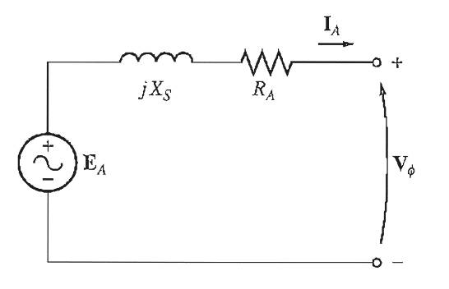

Figure 02: Equivalent Circuit of per phase Synchronous Generator
Internal impedance of the generator is,
$$Z_{S} =\sqrt{{R_{A}}^{2}+{X_{S}}^{2}}$$
$R_{A} →armature resistance$
$$X_{S} →synchronous reactance$$
By assuming high X / R ratio, (neglect R_{A})
$$X_{S} = \frac{E_{A}}{I_{A}}$$
From figure 03,
For unsaturated conditions,
$${ X}_{S,unsat} = \frac{E_{A,}}{I_{sc,unsat}}$$
$X_{S,unsat} = \frac{230 .94V}{0.656A}$
$X_{S,unsat} = 352.04Ω$

For saturated conditions,
$$X_{S,sat} = \frac{E_{A,}}{I_{sc,sat}}$$
$${ X}_{S,sat} = \frac{230.94 V}{0.828 A}$$
$$X_{S,sat} = 278.91Ω$$

02) Find the value of short circuit ratio (SCR) of the machine.
$$SCR= \frac{Field current that produces rated voltage on open circuit}{Field current that produces rated current on short circuit}$$
Rated open circuit voltage $= {400}/{\sqrt{3}} V=230.94 V$
Rated short circuit current$= 0.9 A$

From figure 03,
$$SCR = \frac{I_{F,OC}}{I_{F,SC}}$$
$$SCR = \frac{I_{F,OC}}{I_{F,SC}}$$
$$= \frac{0.85A}{0.920A}$$
$$= 0.924$$

03) Find the voltage regulation at full load at unity power factor and 0.8 power factor (lagging) using the synchronous impedance method.
a) for unity power factor
$$V_{ph} = 230.94 V$$
$$I_{a}= 0.9A$$
$$X_{S} = 278.91Ω$$
$${ E}_{ph} = \sqrt{{{(V}_{ph}\cos{ϕ}+I_{a}R_{a})}^{2}+{{(V}_{ph}\sin{ϕ}+I_{a}X_{S})}^{2}}$$
$=\sqrt{{(230.94+0)}^{2}+{(0.9×278.91)}^{2}}$
$${ E}_{ph} = 341.09 V$$
Voltage regulation $= \frac{E_{ph}-V_{ph}}{V_{ph}} ×100 \%$
$$= \frac{341.09- 230.94}{230.94} ×100\%$$
= 47.70%
b) for 0.8 unity power factor lagging
$$\cos{ϕ=0.8,}\sin{ϕ=0.6}$$
$$E_{ph} = \sqrt{{{(V}_{ph}\cos{ϕ}+I_{a}R_{a})}^{2}+{{(V}_{ph}\sin{ϕ}+I_{a}X_{S})}^{2}}$$
$=\sqrt{{(230.94 ×0.8)}^{2}+{(230.94 ×0.6+0.9×278.91)}^{2}}$
$$= 431.17 V$$

Voltage regulation $= \frac{E_{ph}-V_{ph}}{V_{ph}} ×100 \%$
$$= \frac{431.17- 230.94}{230.94} ×100\%$$
$$=86.73 \%$$
$=$263.72
04) Draw the performance chart of the synchronous generator.
$$P ={(3V_{ph}I_{a}\cos{θ)}}/{X_{S}}=S.\cos{θ}$$
$$Q ={(3V_{ph}I_{a}\sin{θ)}}/{X_{S}}=S.\sin{θ}$$
$$S ={(3V_{ph}I_{a})}/{X_{S}}$$
$$P_{max} ={(3V_{ph}I_{a})}/{X_{S}}$$
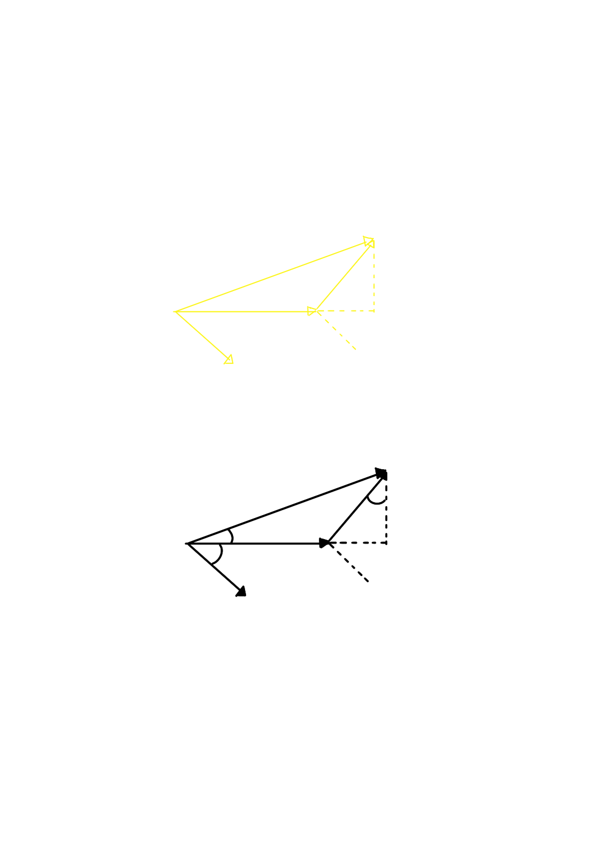
Phasor diagrams in volts axes
B
OA = jX_{S}I_{A}sinθ
OB = jX_{S}I_{A}cosθ
X_{S} >> R_{A}

jX_{S}I_{A}cosθ
jX_{S}I_{A}
θ
E_{A}
O
V_{ph}
A
X
θ
δ
(-V_{ph} , 0)
jX_{S}I_{A}sinθ
I_{a}
Figure 04: phasor diagram of a synchronous generator
Conversion factor to change scale of axes from voltage to power is $\frac{{3V}_{ph}}{X_{S}}$

Corresponding power diagram,
$$AB^{/} = 3V_{ph}I_{a}\cos{θ}$$
$$OA^{/} = 3V_{ph}I_{a}\sin{θ}$$
$$X^{/}B^{/}= \frac{{3V}_{ph}E_{a}}{X_{S}}$$
$$O^{/}B^{/} = \frac{{3V}_{ph}I_{a}}{1}=S$$
$$X^{/} = \left(\frac{{-3V}_{ph}^{2}}{X_{S}},0\right)$$
$X^{/} = Origin of the powewr diagram$

B/

A/
O/
X/

Figure 05: power diagram of a synchronous generator

$$V_{ph} = 230.94 V$$
$$I_{a} = 0.9 A$$
$$X_{S} = 278.91 Ω$$
$$\cos{ϕ=0.8} lagging$$
$$X^{/}= \left(\frac{{-3V}_{ph}^{2}}{X_{S}},0\right)$$

$$= \left(\frac{{-3×230.94}^{2}}{278.91},0\right)$$
$$= \left(-573.51 , 0\right)$$

$$O^{/}B^{/}= \frac{{3V}_{ph}I_{a}}{1}= \frac{3×230.94 V×0.9}{1}$$
$$O^{/}B^{/}=0.6235kVA$$

Rated apparent power of the generator = S $\sin{ϕ}$
= 0.3741 kvar
Rated active power of the generator = S $\cos{ϕ}$
= 0.4988 kW
$$X^{/}B^{/}= \frac{V_{ph}E_{a}}{X_{S}}$$
$E_{a}= \sqrt{{{(V}_{ph}+I_{a}X_{S}\sin{ϕ})}^{2}+{{(I}_{a}X_{S}\cos{ϕ})}^{2}}$
$$=\sqrt{{(230.94+0.9×278.91×0.6)}^{2}+{(0.9×278.91×0.8)}^{2}}$$

$=$ 431.17 V

D_{E} $= \frac{3×230.94}{278.91}×$431.17

$=$ 1071.04 W

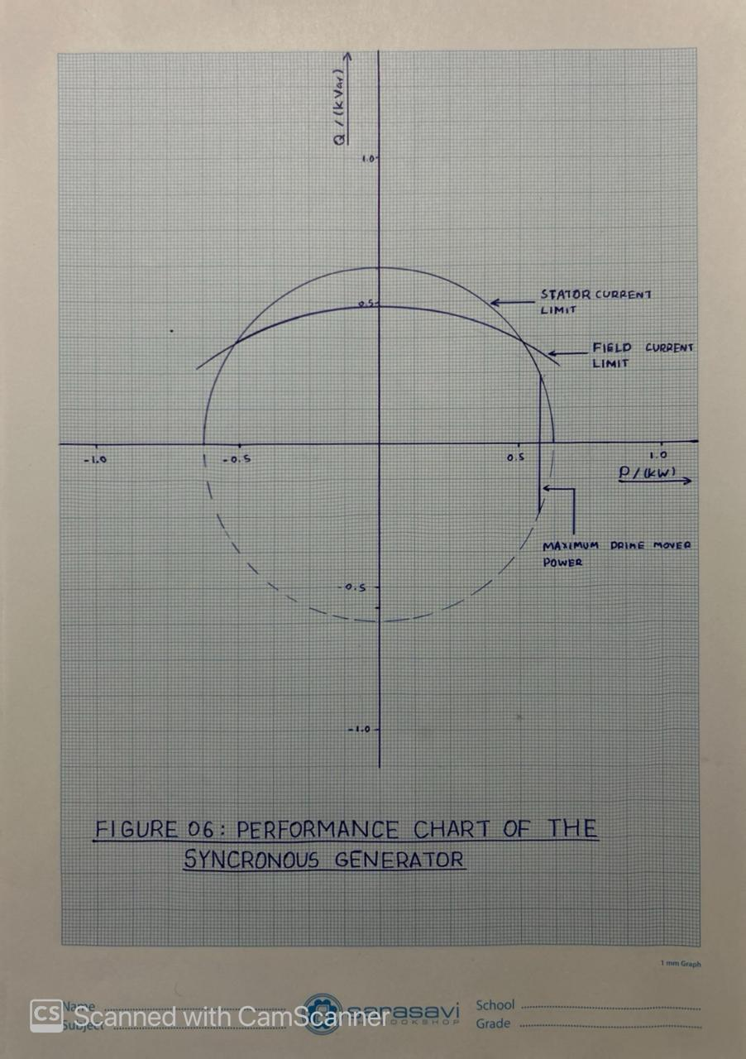

DISCUSSION
- What are the factors to be considered when connecting a synchronous generator to the
National grid?

- Phase Sequence
- Magnitude of the voltage
- Frequency
- Phase angle

- Mention methods to verify the phase sequences of the generator and national grid?

Before connecting a generator to the grid, it is very important to make sure that both have the same phase sequence. If the phase sequence is wrong, it can cause mechanical stress and electrical damage. To avoid this, the phase sequence is checked using the following methods.

- Motor Method

In this method, a three-phase induction motor is used.
First, the motor is connected to the normal grid supply, and the direction of rotation of the motor is observed. This direction is taken as the reference. Then, the motor is disconnected from the grid and connected to the three-phase output of the generator. The direction of rotation is checked again. If the motor rotates in the same direction in both cases, it means the generator phase sequence is the same as the grid. If the motor rotates in the opposite direction, the phase sequence is incorrect. To correct this, any two phase terminals of the generator are interchanged, and the test is repeated until the motor rotates in the same direction as it did with the grid.

- Lamp method

In the three-lamp method, three incandescent lamps are used.
The lamps are connected across the open circuit breaker contacts as follows

Generator Phase A to Grid Phase A
Generator Phase B to Grid Phase B
Generator Phase C to Grid Phase C

The lamps act as voltage difference indicators between the generator and grid phases.
If the phase sequence is correct the voltage difference of all three phases’ changes at the same time all three lamps glow bright together and go dark together this shows that the generator and grid are in the same phase sequence. If the phase sequence is incorrect the voltage peaks occur at different times the lamps do not glow simultaneously Instead, they glow one after another in a rotating pattern this rotating glow indicates a phase sequence mismatch.

- Motor-Based Phase Sequence Indicator

This method uses a phase sequence indicator meter.
Inside the meter, there is a small three-phase motor or a light aluminum disc. The three test leads marked R, Y, and B are connected to the three-phase supply. If the phase sequence is positive (ABC), the internal disc rotates clockwise, as shown by the arrow on the meter. If the phase sequence is negative (ACB), the disc rotates counterclockwise. By checking both the grid side and generator side, we can confirm whether their phase sequences match. These methods are used to ensure that the generator and grid have the same phase sequence before synchronization. The motor method and three-lamp method are simple and easy to understand, while the phase sequence indicator provides a fast and reliable result.

- Discuss how can you change frequency of the generated voltage?

The frequency of the voltage generated by an AC generator depends on the speed of rotation of the rotor and the number of poles of the generator. This relationship is given by
$$F_{e}= \frac{n_{syn P } }{120}$$

$$n_{syn }-Synchronous Speed$$
$$F_{e}-Electrical Frequency$$
$$P -Number of Poles$$

The most common and practical method is to change the speed of the prime mover driving the generator. Increasing the rotor speed increases the frequency decreasing the rotor speed decreases the frequency. In practice, this is done using a speed governor, which controls the fuel input. This method is widely used for frequency control in power systems.
From the frequency equation, it is clear that the frequency is directly proportional to the number of poles increasing the number of poles increases the frequency for a given speed decreasing the number of poles reduces the frequency. However, changing the number of poles is not practical during normal operation, as it requires a different machine design. Therefore, this method is mainly used at the design stage of the generator.
In practical systems, the frequency of the generated voltage is mainly controlled by adjusting the speed of the prime mover. The number of poles is fixed once the generator is manufactured, so it cannot be changed during operation.

REFERENCES

- S. J. Chapman, *Electric Machinery Fundamentals*, 5th Ed. New York, NY, USA: McGraw-Hill, 2012.[Accessed: Jan 24, 2026]

- IEEE Power System Relaying and Control (PSRC) Committee, *Practices for Generator Synchronizing Systems*, Working Group J20, IEEE, Apr. 2024. Available: https://www.pes-psrc.org/kb/report/119.pdf [Accessed: Jan. 26, 2026].

- C. Joubert, “Simulation of a Pelton turbine coupled to a synchronous generator,” Simulations Génie Électrique, Université Claude Bernard Lyon 1. Available: https://perso.univ-lyon1.fr/charles.joubert/web_anim/sim_Pelton_couplee_1.html [Accessed: Jan. 26, 2026].

