CALCULATIONS
Calculation of the modulation index ($μ$)
Time domain representation
When the Time domain representation is used,
$$μ= \frac{X_{AM/MAX}-X_{AM/MIN}}{X_{AM/MAX}+X_{AM/MIN}}$$

a). Sinusoidal Signal
- When $μ= 0.25$,
From figure 01,
$$X_{AM/MAX}= 750 mV$$
$X_{AM/MIN }=450 mV$
$$μ= \frac{750-450}{750+450}$$
$μ=0.25$

- When $μ= 0.5$,
From figure 02,
$$X_{AM/MAX}= 900 mV$$
$X_{AM/MIN }= 300 mV$
$$μ= \frac{900-300}{900+300}$$
$μ=0.50$

- When $μ= 1.0$,
From figure 03,
$$X_{AM/MAX}= 1175 mV$$
$X_{AM/MIN }=25 mV$
$$μ= \frac{1175-25}{1175+25}$$
$μ=0.96$

b) Square Wave Signal
- When $μ= 0.25$,
From figure 07,
$$X_{AM/MAX}= 700 mV$$
$X_{AM/MIN }= 425 mV$
$$μ= \frac{700-425}{700+425}$$
$μ=0.24$

- When $μ= 0.5$,
From figure 09,
$$X_{AM/MAX}= 900 mV$$
$X_{AM/MIN }= 300 mV$
$$μ= \frac{900-300}{900+300}$$
$μ=0.50$

- When $μ= 1.0$,
From figure 08,
$$X_{AM/MAX}= 1175 mV$$
$X_{AM/MIN }=25 mV$
$$μ= \frac{1175-25}{1175+25}$$
$μ=0.96$

c) Triangular Pulse Signal
- When $μ= 0.25$,
From figure 15,
$$X_{AM/MAX}= 750 mV$$
$X_{AM/MIN }= 450 mV$
$$μ= \frac{750-450}{750+450}$$
$μ=0.2$5

- When $μ= 0.5$,
From figure 17,
$$X_{AM/MAX}= 900 mV$$
$X_{AM/MIN }=300 mV$
$$μ= \frac{900-300}{900+300}$$
$μ=0.50$

- When $μ= 1.0$,
From figure 16,
$$X_{AM/MAX}= 1175 mV$$
$X_{AM/MIN }=25 mV$
$$μ= \frac{1175-25}{1175+25}$$
$μ=0.96$

Frequency domain representation
When the frequency domain representation is used,
$$μ= \frac{2×sideband RMS value }{Carrier RMS voltage}$$
$$P_{C}=Carrier Power$$
$$P_{S}=Sideband Power$$
$$A_{C,RMS}=RMS voltage Carrier$$
$$A_{S,RMS}=RMS voltage Sideband$$

$$P_{C}=\frac{{A_{C,RMS}}^{2}}{2}-------(1)$$
$$P_{S}=\frac{{{μ^{2}A}_{C,RMS}}^{2}}{4}------(2)$$

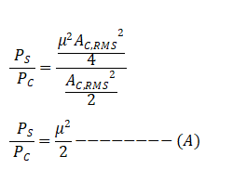
(2)/(1),
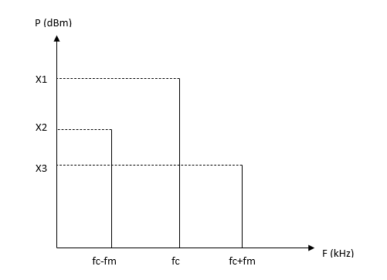

$${ 10log}_{10}{P_{C}×{10}^{3}=x_{1}}$$
$${ P}_{C}= {10}^{\frac{(x1-30)}{10}}----------(3)$$
$${ P}_{S}= {10}^{\frac{(x2-30)}{10}}+{10}^{\frac{(x3-30)}{10}}-------(4)$$
(4)/(3),
$$\frac{P_{S}}{P_{C}}=\frac{{10}^{\frac{(x2-30)}{10}}+{10}^{\frac{(x3-30)}{10}}}{{10}^{\frac{(x1-30)}{10}}}-------(B)$$

(A)=(B),

$$\frac{μ^{2}}{2}=\frac{{10}^{\frac{(x2-30)}{10}}+{10}^{\frac{(x3-30)}{10}}}{{10}^{\frac{(x1-30)}{10}}}$$
$$μ=\sqrt{\frac{2\left({10}^{\frac{(x2-30)}{10}}+{10}^{\frac{(x3-30)}{10}}\right)}{{10}^{\frac{(x1-30)}{10}}}}$$

a). Sinusoidal signal
- When $μ= 0.25$,
From figure 04,
$$μ=\sqrt{\frac{2\left({10}^{\frac{\left(-52.9-30\right)}{10}}+{10}^{\frac{\left(-52.9-30\right)}{10}}\right)}{{10}^{\frac{\left(-34.9 -30\right)}{10}}}}$$
$$μ=0.25$$

- When $μ= 0.5$,
From figure 05,
$$μ=\sqrt{\frac{2\left({10}^{\frac{\left(-46.8-30\right)}{10}}+{10}^{\frac{\left(-46.8-30\right)}{10}}\right)}{{10}^{\frac{\left(-34.9-30\right)}{10}}}}$$
$μ=0.$51

- When $μ= 1.0$,
From figure 06,
$$μ=\sqrt{\frac{2\left({10}^{\frac{\left(-40.8-30\right)}{10}}+{10}^{\frac{\left(-40.8-30\right)}{10}}\right)}{{10}^{\frac{\left(-34.9-30\right)}{10}}}}$$
$$μ=1.00$$

b). Square Wave signal
- When $μ= 0.25$,
From figure 11,
$$μ=\sqrt{\frac{2\left({10}^{\frac{\left(-60.5-30\right)}{10}}+{10}^{\frac{\left(-60.5-30\right)}{10}}\right)}{{10}^{\frac{\left(-42.9-30\right)}{10}}}}$$
$μ=0.$26

- When $μ= 0.5$,
From figure 13,
$$μ=\sqrt{\frac{2\left({10}^{\frac{\left(-44.5-30\right)}{10}}+{10}^{\frac{\left(-44.5-30\right)}{10}}\right)}{{10}^{\frac{\left(-34.6-30\right)}{10}}}}$$
$$μ=0.64$$

- When $μ= 1.0$,
From figure 12,
$$μ=\sqrt{\frac{2\left({10}^{\frac{\left(-39-30\right)}{10}}+{10}^{\frac{\left(-39-30\right)}{10}}\right)}{{10}^{\frac{\left(-19.6-30\right)}{10}}}}$$
$$μ=1.21$$

c). Triangular pulse signal
- When $μ= 0.25$,
From figure 19,
$$μ=\sqrt{\frac{2\left({10}^{\frac{\left(-53.5-30\right)}{10}}+{10}^{\frac{\left(-54.5-30\right)}{10}}\right)}{{10}^{\frac{\left(-34.6-30\right)}{10}}}}$$
$μ=$0.20

- When $μ= 0.5$,
From figure 21,
$$μ=\sqrt{\frac{2\left({10}^{\frac{\left(-48.5-30\right)}{10}}+{10}^{\frac{\left(-48.5-30\right)}{10}}\right)}{{10}^{\frac{\left(-14-30\right)}{10}}}}$$
$μ=0.$40

- When $μ= 1.0$,
From figure 20,
$$μ=\sqrt{\frac{2\left({10}^{\frac{\left(-42.5-30\right)}{10}}+{10}^{\frac{\left(-42.5-30\right)}{10}}\right)}{{10}^{\frac{\left(-14-30\right)}{10}}}}$$
$μ=0.8$1

Efficiency of the modulated signal
$$Efficiency=\frac{Power of the sidebands}{Total power}$$
For a sinusoidal wave,
$$μ=0.25,$$
$$η=\frac{{10}^{\frac{\left(-52.9-30\right)}{10}}+{10}^{\frac{\left(-52.9-30\right)}{10}}}{{10}^{\frac{\left(-52.9-30\right)}{10}}+{10}^{\frac{\left(-52.9-30\right)}{10}}+ {10}^{\frac{\left(-34.9-30\right)}{10}}}$$
$η$ = 3.07%

$$μ=0.5,$$
$$η=\frac{\left({10}^{\frac{\left(-46.8\right)}{10}}+{10}^{\frac{\left(-46.8\right)}{10}}\right)}{{{10}^{\frac{\left(-46.8\right)}{10}}+10}^{\frac{\left(-46.8\right)}{10}}+{10}^{\frac{\left(-34.9\right)}{10}}}$$
$η$ = 11.44%

$$μ=1.0,$$
$$η=\frac{\left({10}^{\frac{\left(-40.8\right)}{10}}+{10}^{\frac{\left(\left(-40.8\right)\right)}{10}}\right)}{{{10}^{\frac{\left(\left(-40.8\right)\right)}{10}}+10}^{\frac{\left(\left(-40.8\right)\right)}{10}}+{10}^{\frac{\left(-34.9\right)}{10}}}$$
$η$ =33.95%

Part 3: Simulation of AM Demodulation using a Synchronous Detector
# Lab 2: AM Synchronous Demodulation Simulation
import numpy as np
import matplotlib.pyplot as plt
from scipy.signal import butter, filtfilt

# Parameters
fm = 1000
fc = 20000
fs = 400000
duration = 0.005
t = np.linspace(0, duration, int(fs*duration), endpoint=False)

# 1. Generate Basic Signals (Part 1 of Procedure)
Am1 = 1.0
Ac = 2.0
m_t_basic = Am1 * np.cos(2 * np.pi * fm * t)
c_t = Ac * np.cos(2 * np.pi * fc * t)

# 2. Generate AM Signal (Part 2 of Procedure)
mu = 0.8
Am_mod = mu * Ac
m_t_mod = Am_mod * np.cos(2 * np.pi * fm * t)

# AM Signal
s_t = (Ac + m_t_mod) * np.cos(2 * np.pi * fc * t)

# 3. Synchronous Demodulation
local_carrier = np.cos(2 * np.pi * fc * t)
v_t = s_t * local_carrier

# Step B: Low Pass Filter (Specifics: 5kHz cutoff, 2nd order)
def butter_lowpass_filter(data, cutoff, fs, order=5):
nyq = 0.5 * fs
normal_cutoff = cutoff / nyq
b, a = butter(order, normal_cutoff, btype='low', analog=False)
y = filtfilt(b, a, data)
return y
# Cutoff = 5 kHz, Order = 2
demodulated_raw = butter_lowpass_filter(v_t, 5000, fs, order=2)
# Remove DC Component (0.5 * Ac) to recover AC message
demodulated_ac = demodulated_raw - np.mean(demodulated_raw)
# Scale to match original amplitude (Factor of 0.5 introduced by mixing)
demodulated_scaled = demodulated_ac * 2
# Plotting
plt.figure(figsize=(12, 14))

# 1. Message Signal
plt.subplot(5, 1, 1)
plt.plot(t * 1000, m_t_basic)
plt.title(f'Message Signal $m(t)$')
plt.ylabel('Amplitude (V)')
plt.grid(True)

# 2. Carrier Signal
plt.subplot(5, 1, 2)
plt.plot(t * 1000, c_t)
plt.title(f'Carrier Signal $c(t)$')
plt.ylabel('Amplitude (V)')
plt.grid(True)

# 3. AM Signal
plt.subplot(5, 1, 3)
plt.plot(t * 1000, s_t)
plt.plot(t * 1000, Ac + m_t_mod, 'g', linewidth=1, label='Upper Envelope')
plt.title(f'AM Signal $s(t)$ ($\mu=0.8$)')
plt.ylabel('Amplitude (V)')
plt.legend(loc='upper right')
plt.grid(True)

# 4. Product Signal v(t)
plt.subplot(5, 1, 4)
plt.plot(t * 1000, v_t)
plt.title(f'Product Signal $v(t) = s(t) \cdot c_{{LO}}(t)$')
plt.ylabel('Amplitude (V)')
plt.grid(True)

# 5. Demodulated Signal comparison
plt.subplot(5, 1, 5)
plt.plot(t * 1000, m_t_mod, 'r--',label='Original Message (Scaled)', linewidth=2, alpha=0.5)
plt.plot(t * 1000, demodulated_scaled, label='Demodulated Output')
plt.title('Demodulation Result (2nd Order LPF, $f_c=5$kHz)')
plt.xlabel('Time (ms)')
plt.ylabel('Amplitude (V)')
plt.legend(loc='upper right')
plt.grid(True)

plt.tight_layout()

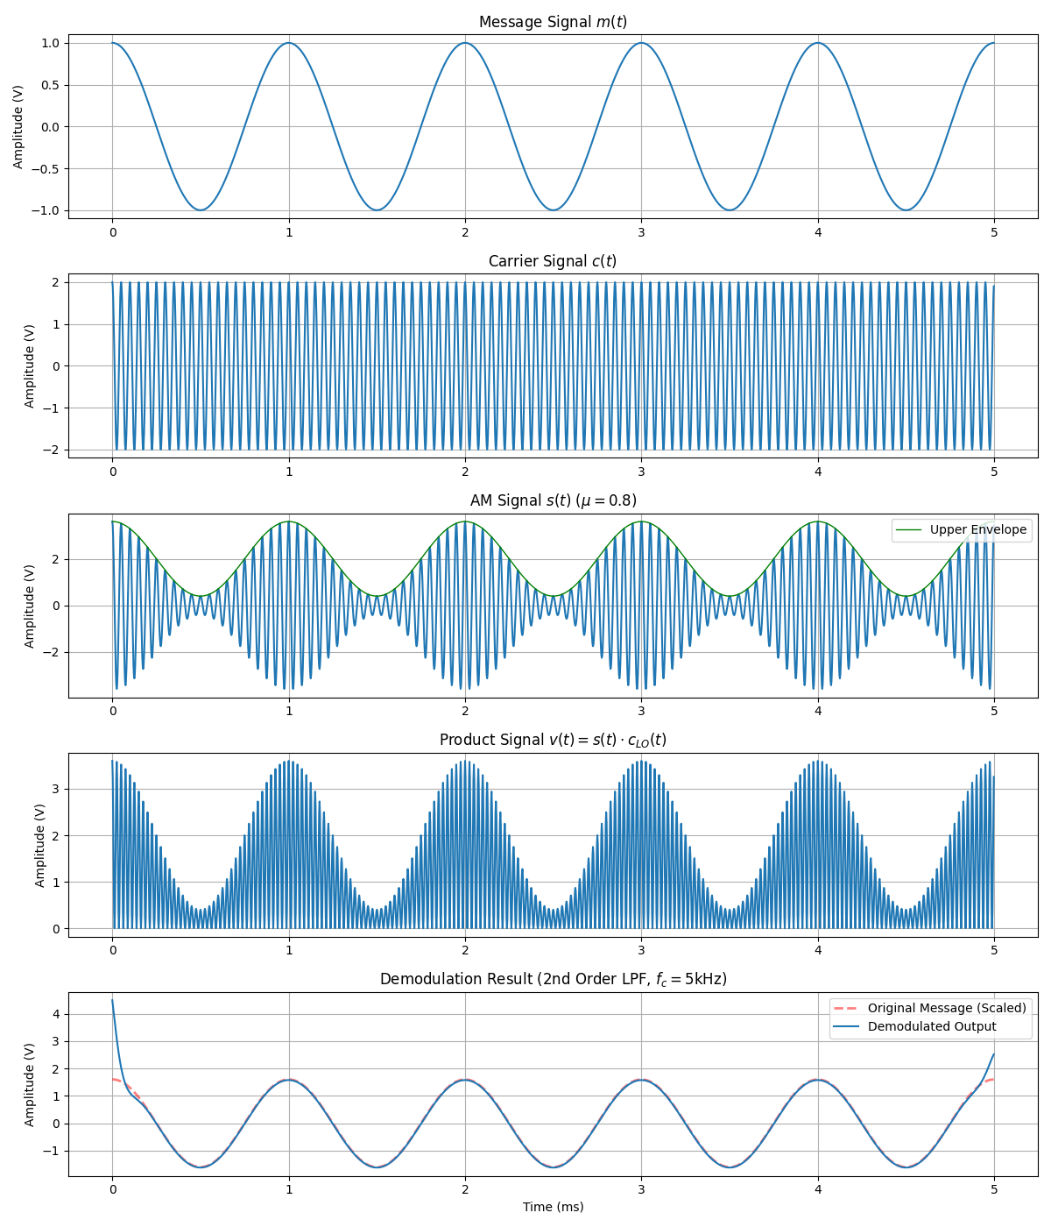
Figure 25: Time domain representation of message signal, carrier signal, amplitude modulated signal, demodulated output signal and filter output signal

