Part 3: Simulation of AM Demodulation using a Synchronous Detector simulation session

OBSERVATIONS

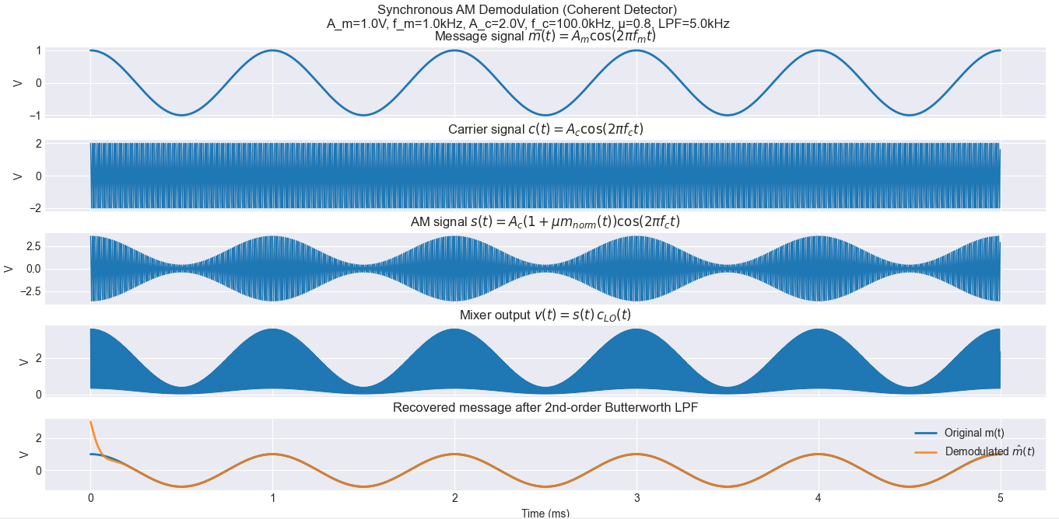

Figure 29

Code
import numpy as np
import matplotlib.pyplot as plt
from scipy import signal

def simulate_synchronous_am_demodulation(
*,
A_m: float = 1.0,
f_m: float = 1_000.0,
A_c: float = 2.0,
f_c: float = 100_000.0,
mu: float = 0.8,
fs: float = 1_000_000.0,
duration: float = 0.005,
lpf_cutoff: float = 5_000.0,
butter_order: int = 2,
):

if fs <= 2 * max(f_c * 2, lpf_cutoff):
raise ValueError("Sampling frequency fs is too low for the chosen f_c/cutoff.")
if mu <= 0:
raise ValueError("Modulation index mu must be > 0.")
if lpf_cutoff >= fs / 2:
raise ValueError("LPF cutoff must be below Nyquist (fs/2).")
t = np.arange(0.0, duration, 1.0 / fs)
# 1) Message and carrier
m = A_m * np.cos(2 * np.pi * f_m * t)
c = A_c * np.cos(2 * np.pi * f_c * t)
# 2) AM signal: s(t) = A_c(1 + μ m_norm(t))cos(2π f_c t)
m_norm = m / A_m
s = A_c * (1.0 + mu * m_norm) * np.cos(2 * np.pi * f_c * t)
# 3) Synchronous demodulation
lo = np.cos(2 * np.pi * f_c * t) # same frequency + phase as carrier
v = s * lo
# Low-pass filter (2nd order Butterworth, cutoff 5 kHz)
b, a = signal.butter(butter_order, lpf_cutoff / (fs / 2), btype="low")
v_lpf = signal.filtfilt(b, a, v)
# Recover message:
# v_lpf ≈ 0.5*A_c*(1 + μ m_norm(t)) -> remove DC and scale
m_hat = A_m * (2.0 / (A_c * mu)) * (v_lpf - 0.5 * A_c)
return {
"t": t,
"m": m,
"c": c,
"s": s,
"lo": lo,
"v": v,
"v_lpf": v_lpf,
"m_hat": m_hat,
"params": {
"A_m": A_m,
"f_m": f_m,
"A_c": A_c,
"f_c": f_c,
"mu": mu,
"fs": fs,
"duration": duration,
"lpf_cutoff": lpf_cutoff,
"butter_order": butter_order,
},
}
def plot_results(results: dict) -> None:
plt.style.use("seaborn-v0_8-darkgrid")
plt.rcParams["figure.figsize"] = (12, 10)
t = results["t"]
m = results["m"]
c = results["c"]
s = results["s"]
v = results["v"]
m_hat = results["m_hat"]
params = results["params"]
fig, axes = plt.subplots(5, 1, sharex=True)
axes[0].plot(t * 1e3, m, linewidth=2)
axes[0].set_title(r"Message signal $m(t)=A_m\cos(2\pi f_m t)$")
axes[0].set_ylabel("V")
axes[1].plot(t * 1e3, c, linewidth=1)
axes[1].set_title(r"Carrier signal $c(t)=A_c\cos(2\pi f_c t)$")
axes[1].set_ylabel("V")
axes[2].plot(t * 1e3, s, linewidth=1)
axes[2].set_title(r"AM signal $s(t)=A_c(1+\mu m_{norm}(t))\cos(2\pi f_c t)$")
axes[2].set_ylabel("V")
axes[3].plot(t * 1e3, v, linewidth=1)
axes[3].set_title(r"Mixer output $v(t)=s(t)\,c_{LO}(t)$")
axes[3].set_ylabel("V")
axes[4].plot(t * 1e3, m, label="Original m(t)", linewidth=2)
axes[4].plot(t * 1e3, m_hat, label=r"Demodulated $\hat{m}(t)$", linewidth=2, alpha=0.85)
axes[4].set_title(r"Recovered message after 2nd-order Butterworth LPF")
axes[4].set_xlabel("Time (ms)")
axes[4].set_ylabel("V")
axes[4].legend(loc="upper right")
fig.suptitle(
"Synchronous AM Demodulation (Coherent Detector)\n"
+ f"A_m={params['A_m']}V, f_m={params['f_m']/1e3:.1f}kHz, "
+ f"A_c={params['A_c']}V, f_c={params['f_c']/1e3:.1f}kHz, "
+ f"μ={params['mu']}, LPF={params['lpf_cutoff']/1e3:.1f}kHz",
y=0.995,
fontsize=12,
)
plt.tight_layout()
plt.show()
def main() -> None:
results = simulate_synchronous_am_demodulation()
plot_results(results)
if __name__ == "__main__":
main()

