EE 357- Communication Systems

Laboratory Session 2 - Frequency Modulation

OBJECTIVE : Investigate Frequency Modulation
APPARATUS : Mixed domain oscilloscope (Tektronix MDO3014) Function generator (LG 1301) - (for VCO) Function generator (AFG 2005)
DC Power supply

THEORY:

Modulation

FM signal can be mathematically represented as,
XFM (t) =𝐴𝑐 cos (𝜔𝑐 𝑡 + 2𝜋𝑘f ∫ 𝑥𝑚 (𝑡)𝑑𝑡)

. (1)

For single tone modulation,

XFM (t)
= 𝐴𝑐 cos (𝜔𝑐 𝑡 + 2𝜋 𝑘f ∫ Am cos(𝜔𝑚𝑡) 𝑑𝑡)
= 𝐴𝑐 cos (𝜔𝑐 𝑡 + 2𝜋 Δ𝑓∫ cos(𝜔𝑚𝑡) 𝑑𝑡)

= 𝐴𝑐 cos (𝜔𝑐 𝑡 + β sin(𝜔𝑚𝑡))
. (2)

Where;
Kf - Sensitivity of the function generator xm(t) - Modulating signal
∆f - Peak frequency deviation
β – Modulation Index

Using the Bessel function it can be shown that,
XFM (t) =
And
XFM (f) =

Total average power

Total average power of FM signal is given by
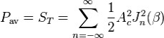
. (5)
1

Band width (BW)

Instantaneous frequency of FM signal is given by
fi = fc + kf m(t) (6)

According to Carson’s rule, bandwidth of a FM signal is given by
BW = 2 fm (β + 1) (7)

Frequency spectrum of the FM signal which correspond to a specific message signal can be changed by changing β value. As β =kf Am/fm, by changing Am, frequency spectrum of the FM signal is changed.

Sensitivity of the function generator

In this experiment, we use a function generator as a voltage controlled oscillator to generate a FM signal as shown in figure 1.

XFM
VCG input
Modulating Signal
DC Voltage
Function generator as VCO

Function generator

Figure 1: Modulator

Sensitivity of the function generator is a function generator specific parameter. Thus kf has to be calculated before doing meaningful FM work using the function generator.

kf can be calculated by feeding known DC signals as VCO inputs and then by analyzing the VCO output signal frequency.

2

V
f
f’

fc
0
Am
0

V

Figure 2: Variation frequency with DC voltage

The VCO output signal frequency can be written as,
fVCO = fc + kf VDC

Therefore, using the gradient of the plot (fVCO vs VDC), the sensitivity can be calculated.

PROCEDURE :

Part 1 : Identify the Sensitivity of the function generator

- Connect the circuit as shown in figure 1 with no modulation signal applied.
- Adjust the free running frequency of the VCO to be 1 MHz and its output amplitude to be 400mV while maintaining the VDC at 0 V.
- Change the VDC voltage level in steps of 0.5 V from -3V to +5V and observe the variation of carrier frequency.
- Check whether the sensitivity is changing linearly with respect to voltage.
- Find the sensitivity of the VCO using the observations.

Part 2 : Generate different frequency modulated signal which has different frequency spectrums for the same message signal

- Connect the circuit as shown in figure 1 with no DC voltage applied.
- Connect the output of the VCO to mixed domain oscilloscope time domain and frequency spectrum ports.
- Select frequency of the modulating signal (fm) to be about 10 kHz.
3

- Using the Bessel function, Identify the desired Am values that has to be set in order to get the following FM signal frequency spectrum cases
Calculate the desired frequency deviation
  - Carrier only.
  - Only the carrier and the 1st sideband pair are there.
  - Only the carrier, 1st sideband pair and the 2nd sideband pair are there.
  - Only the carrier, 1st sideband pair the 2nd sideband pair and 3rd sideband pair are there.
  - Suppressed carrier.
  - Suppressed 1st sideband pair.
- Then by observing the frequency spectrum of the FM signal using the spectrum analyzer, by trying to obtain the above cases by varying Am.
Obtain the above cases by varying frequency deviation.
- Record Am for each case to calculate modulation index (β).
frequency deviation value in each case to calculate the modulation index.
- Compare the previously calculated β value with the β value calculated using the observations.

Part 3 : Observe the effect of fm on the frequency spectrum

For the case of β=4, change fm and observe the frequency spectrum of the FM signals.

DISCUSSION :
- Explain why FM is better than AM in terms of resistance to noise.
- Describe two methods to estimate the occupied bandwidth of an FM signal.
- Describe the key features of spectrum allocation used for typical FM radio broadcasting.
- Compare the performance of FM and AM on the frequency spectrum.

4

Bessel table
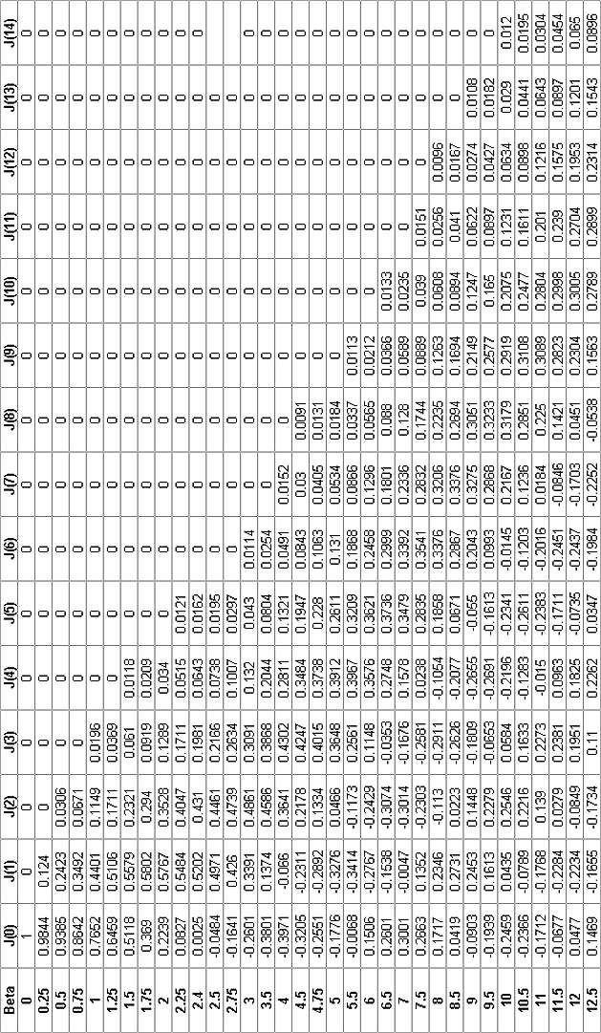

5

OBSERVATIONS

Part 1: Identify the Sensitivity of the function generator

Table 01: Frequency Vs V_{DC}

V_{DC} / V | Frequency / MHz
-3 | 0.9718
-2.5 | 0.9765
-2 | 0.9812
-1.5 | 0.9859
-1 | 0.9906
-0.5 | 0.9953
0 | 1.0000
0.5 | 1.0046
1 | 1.0097
1.5 | 1.0144
2 | 1.0191
2.5 | 1.0238
3 | 1.0285

Frequency / MHz

Figure 3 : Frequency Vs V_{DC}
2.4
2.2
2
1.8
1.6
1.4
1.2
1
0.8
0.6
0.4
0.2
0
-4
-3
-2
-1
0
1
2
3
4
5 6
VDC / V

Part 2: Generation of an FM signal
Observe the FM signal through the MDO in time and frequency domains.
- In frequency domain

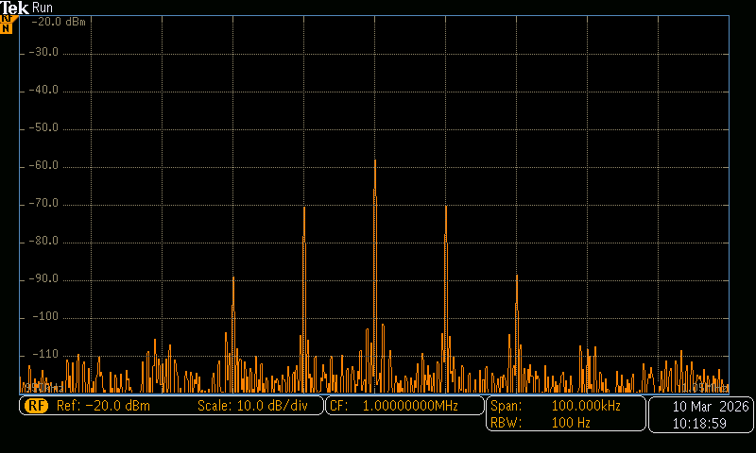
Figure 4: Frequency Spectrum of FM wave
- In time domain
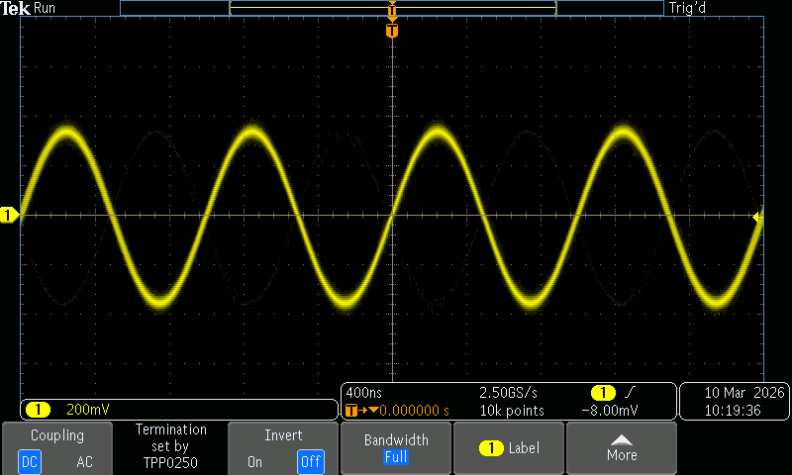
Figure 5: FM signal in time domain

Part 3: Generate different frequency modulated signal which has different frequency spectrums for the same message signal
2)
  - Carrier only
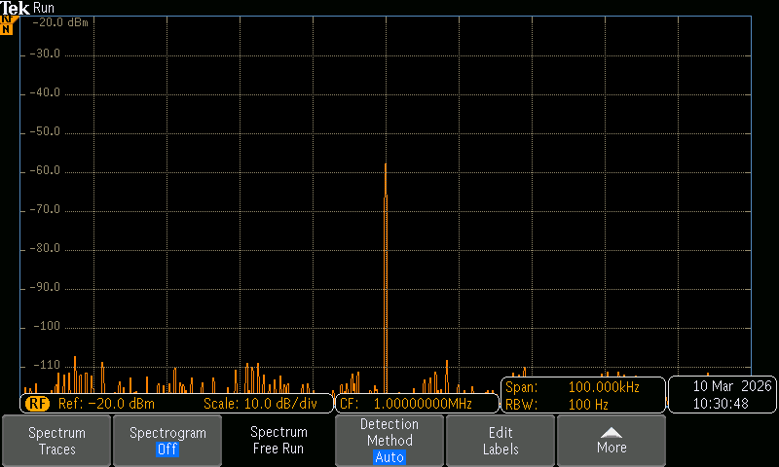
Figure 5: Frequency Spectrum when Modulation Index 𝛽 = 0
  - Only the carrier and the 1st sideband pair are there

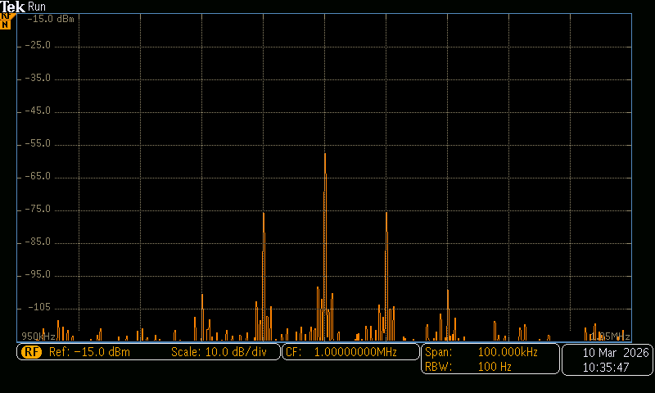

Figure 6: Frequency Spectrum when Modulation Index 𝛽 = 0.25

  - Only the carrier, 1st sideband pair and the 2nd sideband pair are there

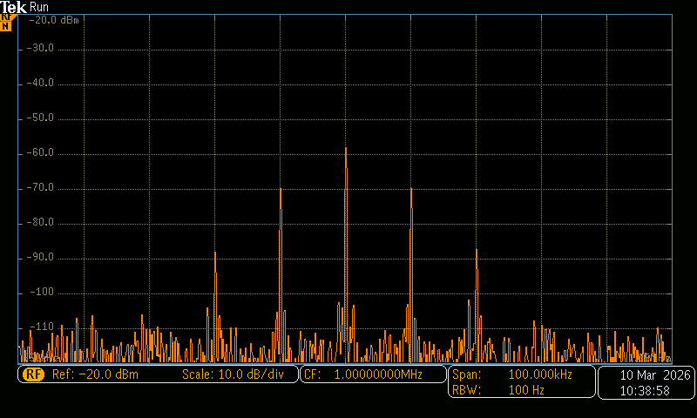
Figure 7: Frequency Spectrum when Modulation Index 𝛽 = 0.5

  - Only the carrier, 1st sideband pair, 2nd sideband pair and 3rd sideband pair are there

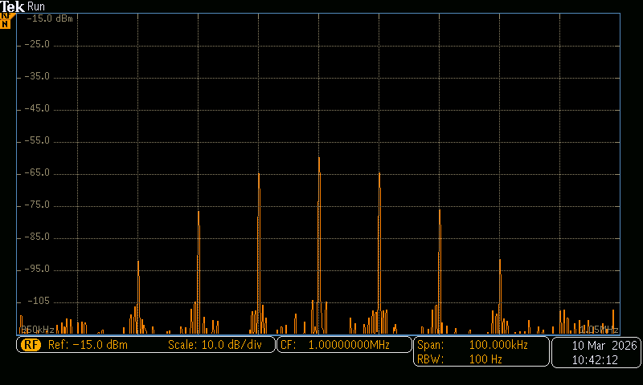
Figure 8: Frequency Spectrum when Modulation Index 𝛽 = 1

  - Suppressed carrier
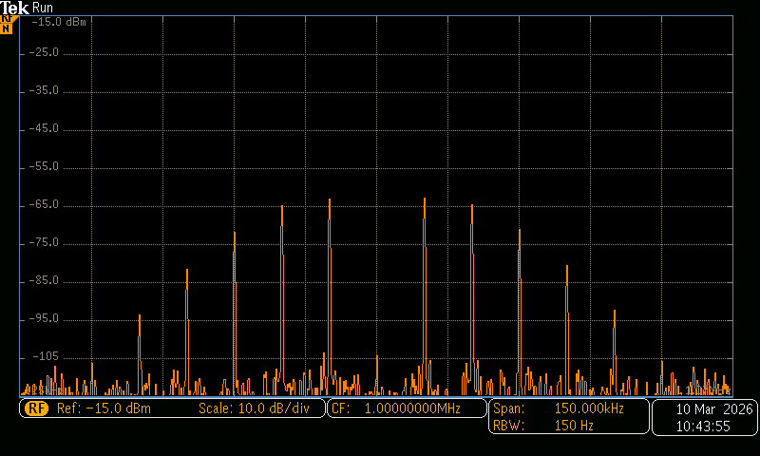
Figure 9: Frequency Spectrum when Modulation Index 𝛽 = 2.4048

  - Suppressed 1st sideband pair

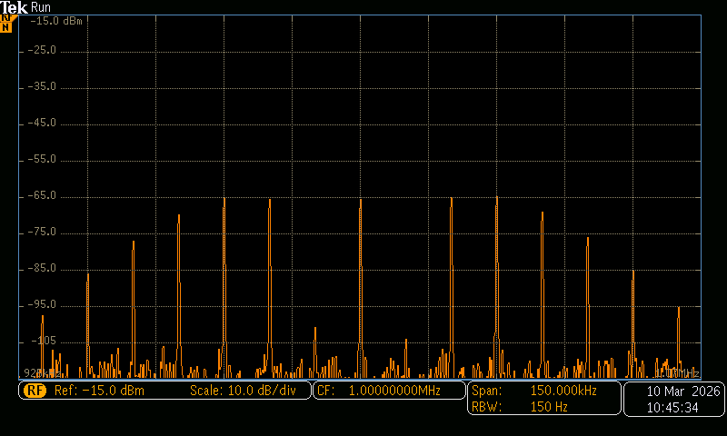

Figure 10: Frequency Spectrum when Modulation Index 𝛽 = 3.8317

  - Suppressed 2nd sideband pair

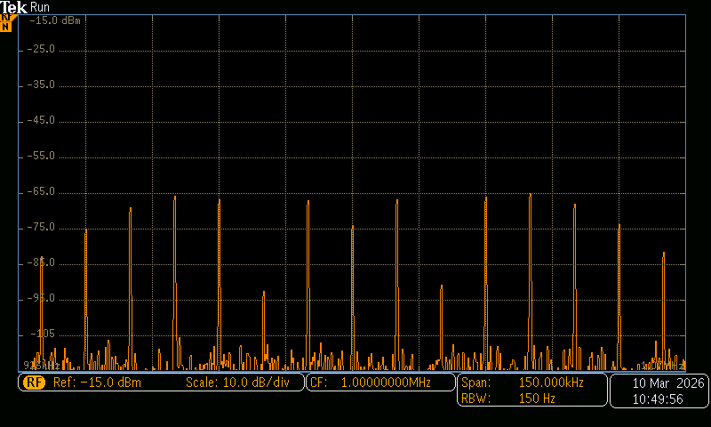
Figure 11: Frequency Spectrum when Modulation Index 𝛽 = 5.14

Record the practical values of 𝐴𝑚′ and calculate the modulation index 𝛽′ for each case.

beta | Am Vp | Am Vpp | Am' Vp | Am' Vpp
0 | 0 |  | 0 | 0
0.25 | 264.2706 | 528.5412 | 150 | 300
0.5 | 528.5412 | 1057.082 | 478.5 | 957
1 | 1057.082 | 2114.165 | 1057 | 2114
2.4 | 2536.998 | 5073.996 | 2543.5 | 5087
3.8 | 4016.913 | 8033.827 | 4016.5 | 8033
5.1 | 5391.121 | 10782.24 | 5384.5 | 10769

- Carrier only
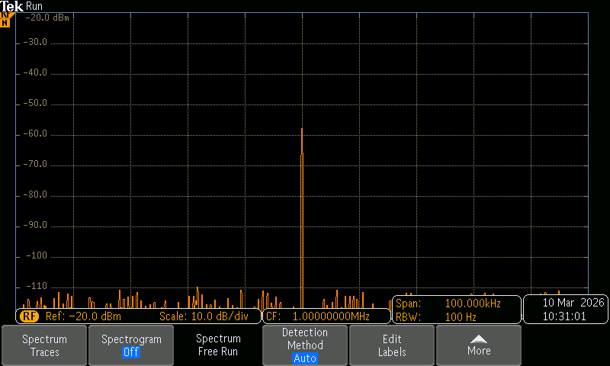
Figure 12: Frequency Spectrum with Carrier

- Only the carrier and the 1st sideband pair are there
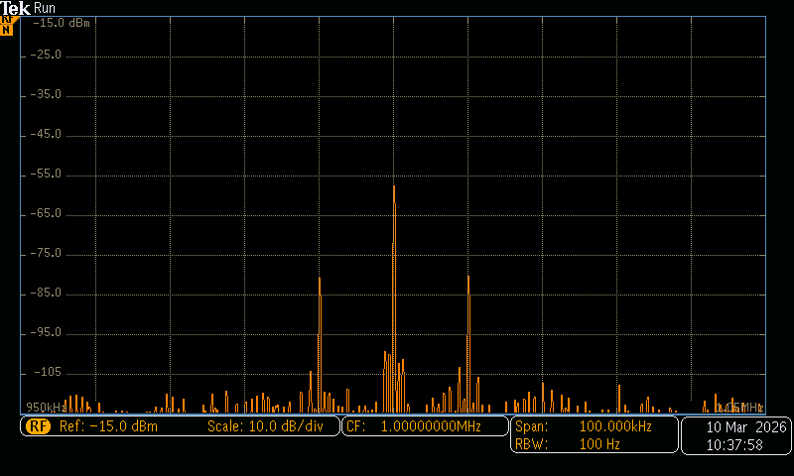
Figure 13: Frequency Spectrum with only the Carrier and First Sideband Pair

- Only the carrier, 1st sideband pair and the 2nd sideband pair are there

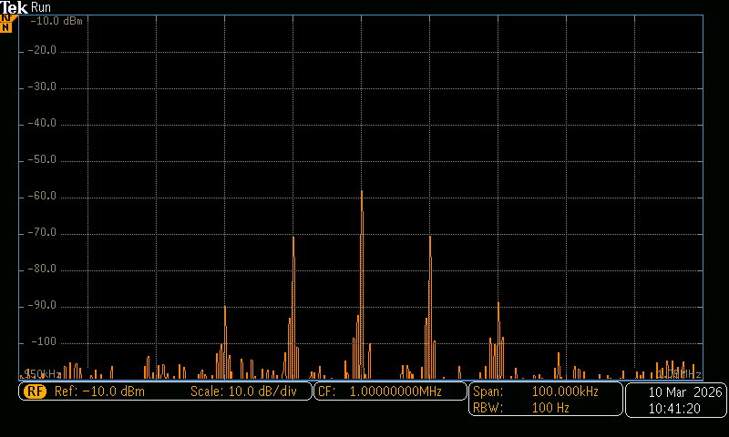

Figure 14: Frequency Spectrum with only the Carrier and First Sideband Pair

- Only the carrier, 1st sideband pair, 2nd sideband pair and 3rd sideband pair are there

Figure 15: Frequency Spectrum with only the Carrier and First Sideband Pair

- Suppressed carrier
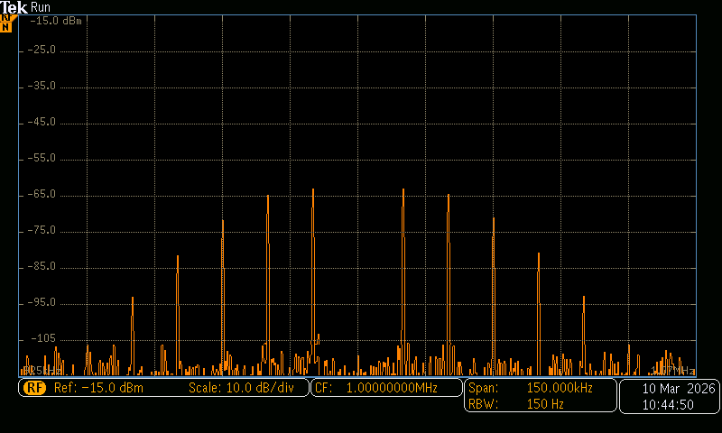
Figure 16: Frequency Spectrum suppressed carrier

- Suppressed 1st sideband pair

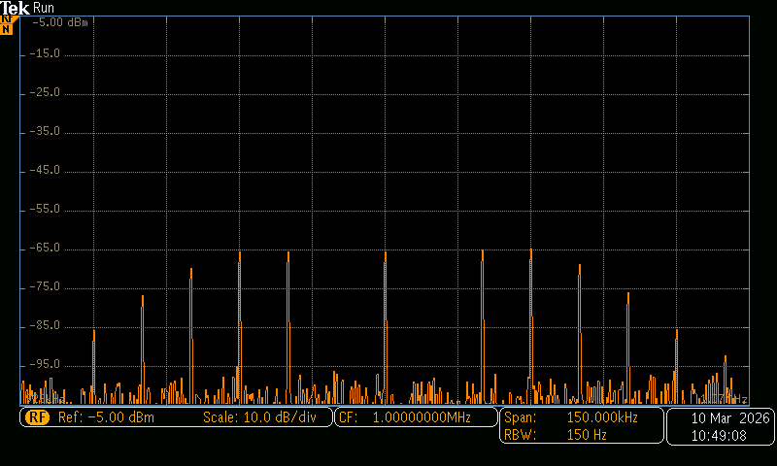

Figure 17: Frequency Spectrum of suppressed 1st sideband pair

- Suppressed 2nd sideband pair
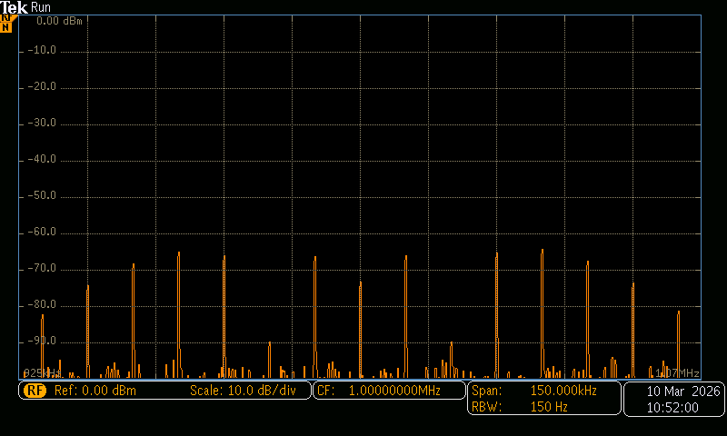
Figure 11: Frequency Spectrum when Modulation of suppressed 2nd side band pair
Part 4: Observe the effect of fm on the frequency spectrum
f_{m} = 10 kHz

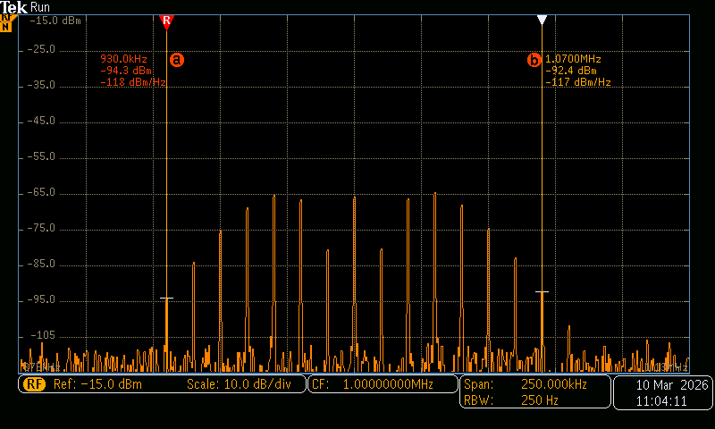

Figure 18: Frequency Spectrum with 𝛽 = 4 and 𝑓𝑚 = 10 𝑘𝐻𝑧
f_{m} = 15 kHz

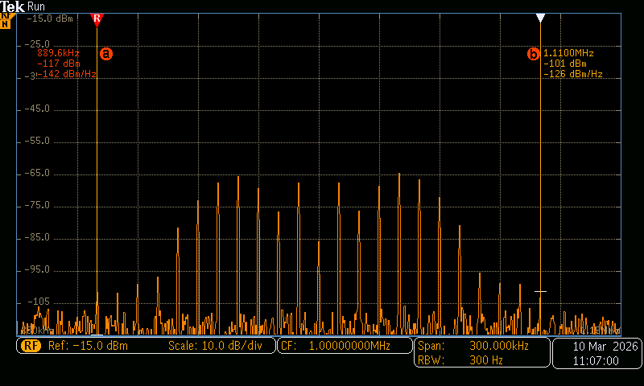

Figure 19: Frequency Spectrum with 𝛽 = 4 and 𝑓𝑚 = 15 𝑘𝐻𝑧

f_{m} = 20 kHz

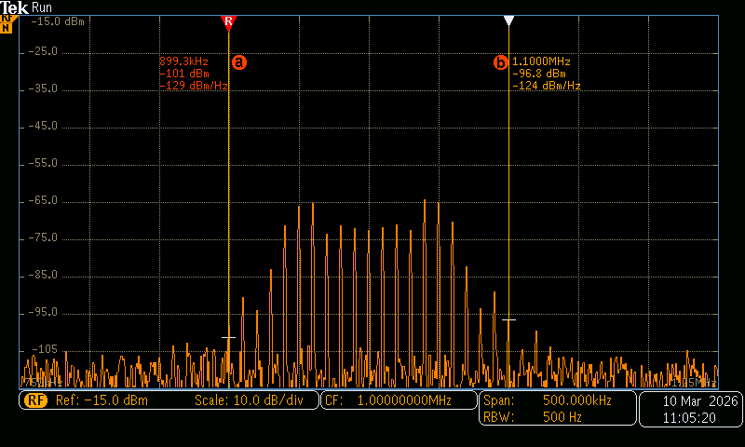

Figure 20: Frequency Spectrum with 𝛽 = 4 and 𝑓𝑚 = 20 𝑘𝐻𝑧

CALCUCLATIONS

Part 1: Identify the Sensitivity of the function generator
Gradient of the figure 3 gives the sensitivity

𝑆𝑒𝑛𝑠𝑖𝑡𝑖𝑣𝑖𝑡𝑦 =
1.0191 − 0.9718

2 − (−3)

𝑆𝑒𝑛𝑠𝑖𝑡𝑖𝑣𝑖𝑡𝑦 = 0.00946 𝑀𝐻𝑧𝑉⁻¹ = 9.46 𝑘𝐻𝑧𝑉⁻¹

Part 2: Generate different frequency-modulated signal which has different frequency spectrums for the same message signal
𝑓𝑚 = 10 𝑘𝐻𝑧
∆𝐹

- Carrier only
𝛽 =

𝑓𝑚

𝛽 =
0 𝑘𝐻𝑧
= 0
10 𝑘𝐻𝑧

- Only the carrier and the 1st sideband pair are there

𝛽 =
1.419 𝑘𝐻𝑧

10 𝑘𝐻𝑧
= 0.1419

- Only the carrier, 1st and 2nd sideband pairs are there

𝛽 = $\frac{4.527kHz}{10kHz}$ = 0.4527

- Only the carrier 1st, 2nd and 3rd sideband pairs are there

𝛽 = $\frac{9.999kHz}{10kHz}$ = 0.9999

- Suppressed carrier

𝛽 =
24.062 𝑘𝐻𝑧

10 𝑘𝐻𝑧
= 2.4062

- Suppressed 1st sideband pair
𝛽 = $\frac{37.996}{10kHz}$ = 3.7996

- Suppressed 1st sideband pair

𝛽 =
50.937 𝑘𝐻𝑧

10 𝑘𝐻𝑧
= 5.0937

Table 2: Comparison of 𝛽 values obtained using the Bessel Table and using the Observations of Frequency Spectrum

Frequency Spectrum Case | Calculated β using Observations | β values obtained using the Bessel Table
Carrier Only | 0 | 0
Only the carrier and the 1st sideband pair are there | 0.1419 | 0.25
Only the carrier, 1st and 2nd sideband pairs are there | 0.4527 | 0.5
Only the carrier, 1st, 2nd and 3rd sideband pairs are there | 0.9999 | 1.0
Suppressed Carrier | 2.4062 | 2.4048
Suppressed 1st sideband pair | 3.7996 | 3.8317
Suppressed 2nd sideband pair | 5.0937 | 5.14

According to Table 2, β values obtained using the Bessel Table are different from the calculated values except the suppressed carrier case and the suppressed 1st sideband pair case.

DISCUSSION
- Explain why FM is better than AM in terms of resistance to noise

FM (Frequency Modulation) is better than AM (Amplitude Modulation) in terms of resistance to noise because it encodes information in the frequency of the carrier wave rather than its amplitude. Noise primarily affects the amplitude of a signal, which directly impacts AM transmissions but has little effect on FM signals. Additionally, FM receivers benefit from the "capture effect," where the strongest signal is received while weaker signals and noise are suppressed. FM also offers a better signal-to-noise ratio (SNR) due to its wider bandwidth and uses limiter circuits to remove amplitude variations caused by noise before demodulation. Furthermore, FM operates in the VHF range, which is less susceptible to certain types of interference compared to the MF range used by AM. These factors make FM more resilient to noise and provide clearer reception.

- Describe two methods to estimate the occupied bandwidth of an FM signal

  - Carson's Rule: This is a widely used approximation method to estimate the bandwidth of an FM signal. According to Carson's Rule, the total bandwidth B_{T} can be approximated by the formula:

𝐵𝐵𝑇𝑇 = 2(Δ𝑓 + 𝑓𝑚)
where Δf is the peak frequency deviation of the carrier and 𝑓𝑚 is the maximum modulating frequency. Carson's Rule provides a quick and practical way to estimate the bandwidth, accounting for the significant sidebands that contain most of the signal's power.

  - Bessel Function Method: This more precise method involves analyzing the frequency spectrum of the FM signal using Bessel functions. The FM signal can be expressed as a sum of carrier and sideband frequencies. Each sideband's amplitude is given by Bessel functions of the first kind. By identifying the Bessel function values that fall below a certain threshold (often taken as 1% of the carrier amplitude), the significant sidebands can be determined. The bandwidth is then calculated by considering the range of frequencies from the lowest to the highest significant sideband frequency. This method provides an accurate bandwidth estimation but is more complex and typically requires computational tools or tables of Bessel functions.

- Describe the key features of spectrum allocation used for typical FM radio broadcasting

Spectrum allocation for typical FM radio broadcasting involves several key features to ensure efficient and interference-free transmission:
Frequency Range: FM radio broadcasting typically occupies the Very High Frequency (VHF) band, specifically from 88 to 108 MHz. This range is divided into smaller channels to accommodate multiple radio stations.
Channel Spacing: Each FM station is allocated a specific frequency channel with a standard spacing of 200 kHz between adjacent channels. This spacing helps prevent interference between neighbouring stations and allows for clear signal separation.
Bandwidth: Each FM channel is typically allocated a bandwidth of 200 kHz, which includes the carrier frequency and its associated sidebands. This bandwidth is sufficient to accommodate high-fidelity audio transmission, including stereo signals.

Frequency Deviation: The maximum permitted frequency deviation for FM broadcasting is usually ±75 kHz. This deviation allows for the encoding of audio signals with good fidelity and dynamic range.
Guard Bands: Guard bands are small frequency ranges left unassigned between channels to minimize interference and ensure that transmissions do not overlap. These guard bands help maintain clear signal boundaries.
Power Limits: FM transmitters are subject to power limits to prevent interference with other services and to ensure that the broadcast signal covers the intended geographic area without spilling over into neighbouring regions.

- Compare the performance of FM and AM on the frequency spectrum
When comparing FM (Frequency Modulation) and AM (Amplitude Modulation) on the frequency spectrum, there are some key differences

Bandwidth Utilization:
AM: Occupies a narrower bandwidth (~10 kHz), allowing more stations within a range but limiting audio quality.
FM: Uses a wider bandwidth (~200 kHz), enabling higher fidelity audio, including stereo and RDS services.

Audio Quality:
AM: Limited by narrower bandwidth, suitable for speech and talk radio.
FM: Higher fidelity due to wider bandwidth, ideal for music and high-quality broadcasts.

Frequency Bands:
AM: Operates in the Medium Frequency (MF) band (530-1700 kHz), with signals that travel long distances, especially at night.
FM: Operates in the Very High Frequency (VHF) band (88-108 MHz), offering better sound quality but a shorter, line-of-sight range.

Signal Propagation:
AM: Long-distance travel, especially at night, due to ionospheric reflection, suitable for wide coverage. FM: Limited to line-of-sight, providing more stable and higher quality reception but with restricted range.

REFERENCES
- GeeksforGeeks. (2024). Carson’s Rule for Bandwidth Calculation - Working Principle, Derivation. [online] Available at: https://www.geeksforgeeks.org/carsons-rule/. (Accessed : 29/07/2024)
- www.diffen.com. (n.d.). AM vs FM - Difference and Comparison | Diffen. [online] Available at: https://www.diffen.com/difference/AM_vs_FM#:~:text=FM%20radio%20ranges%20in%20a. (Accessed 29/07/2024)

