EE 352 - FEEDBACK CONTROL FUNDAMENTALS

PERERA J.D.T.
E/21/291
GROUP EE.21.E.15
SEMESTER 05 07/01/2026

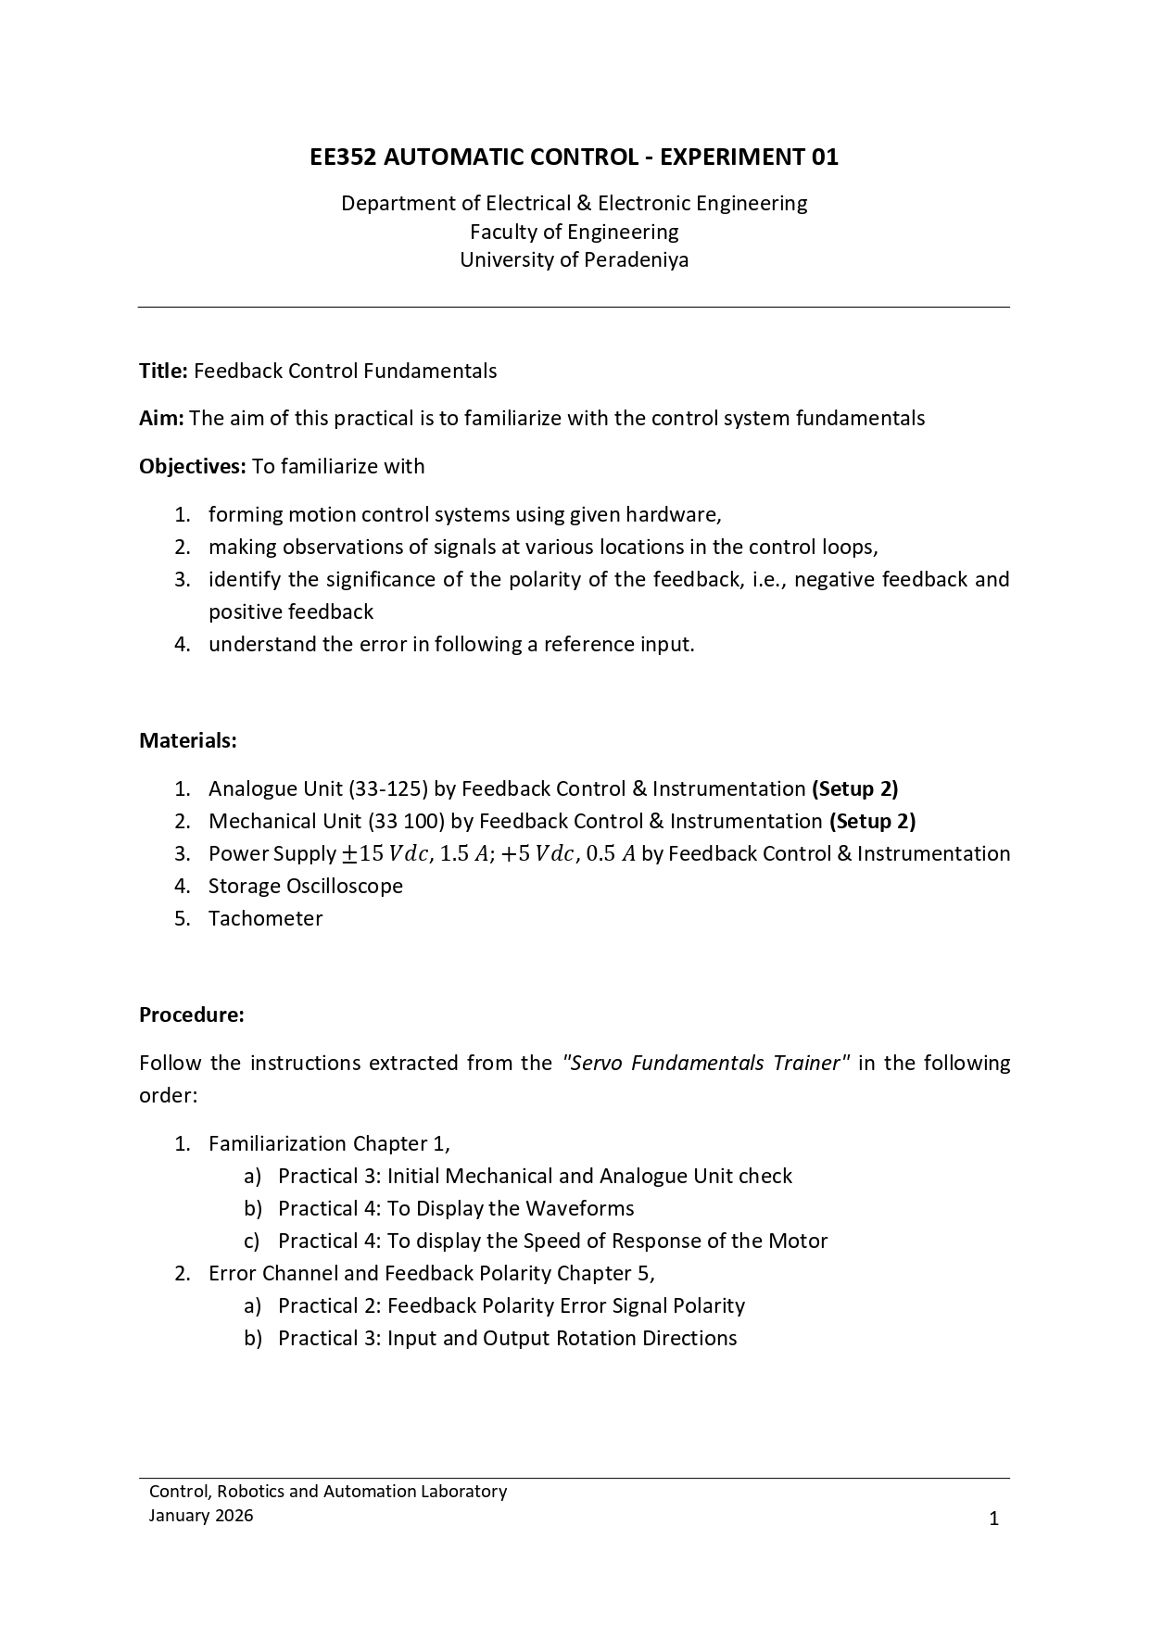

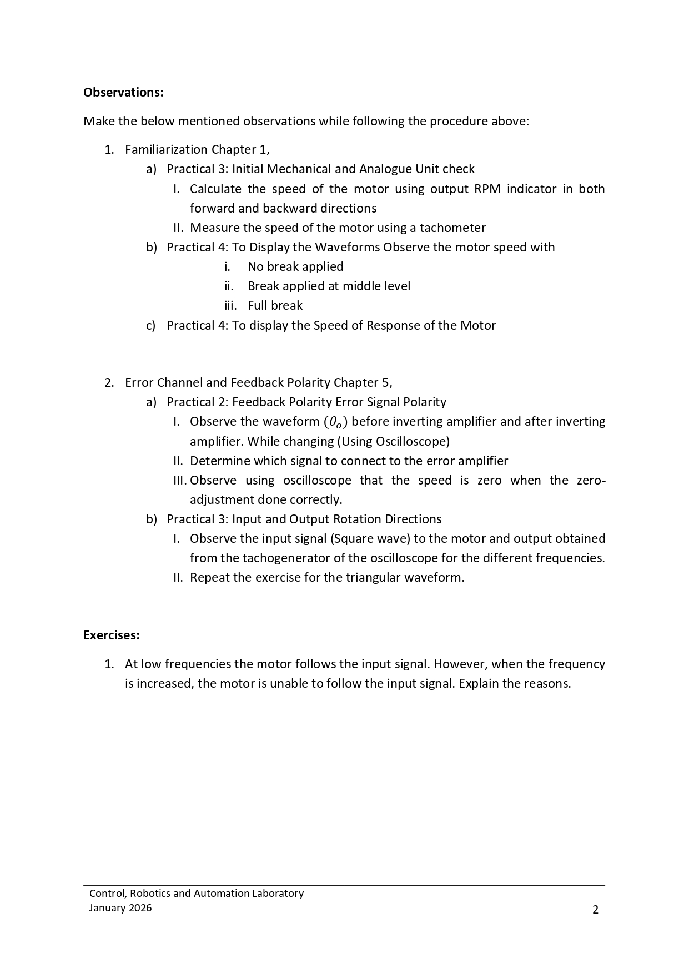

OBSERVATIONS

- Familiarization Chapter 1,
  - Practical 3: Initial Mechanical and Analogue Unit check

    - Calculate the speed of the motor using output RPM indicator in both forward and backward direction.

Forward direction,
RPM (N) = 11
Motor speed. = 2𝜋 N
60
= 2𝜋 × 11
60

=1.152𝑟𝑎𝑑𝑠⁻¹
Backward direction, RPM (N) = 11
Motor speed. = 2𝜋 𝑁
60
= 2𝜋 × 11
60

=1.152𝑟𝑎𝑑𝑠⁻¹
    - Measure speed of the motor using a tachometer

RPM (N) = 11
Motor speed. = 2𝜋 𝑁
60
= 2𝜋 × 11
60

=1.152𝑟𝑎𝑑𝑠⁻¹

  - Practical 4: To Display the Waveforms Observe the motor speed with
    - No break applied
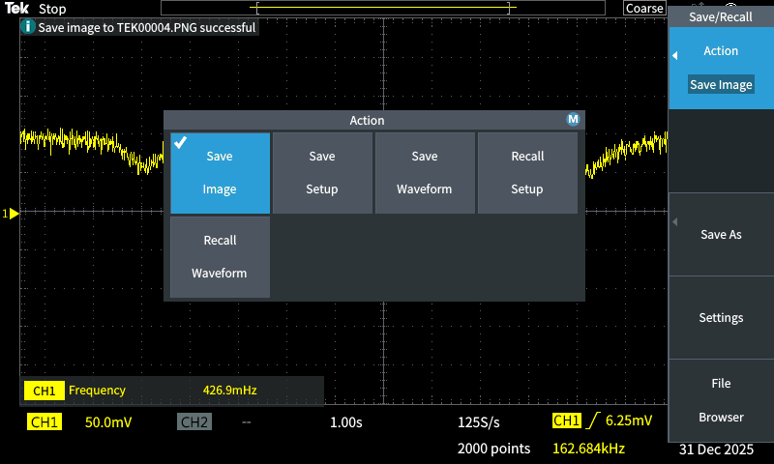
Figure 1 : Oscilloscope output when no break applied

    - Break applied at middle level

    - Full break

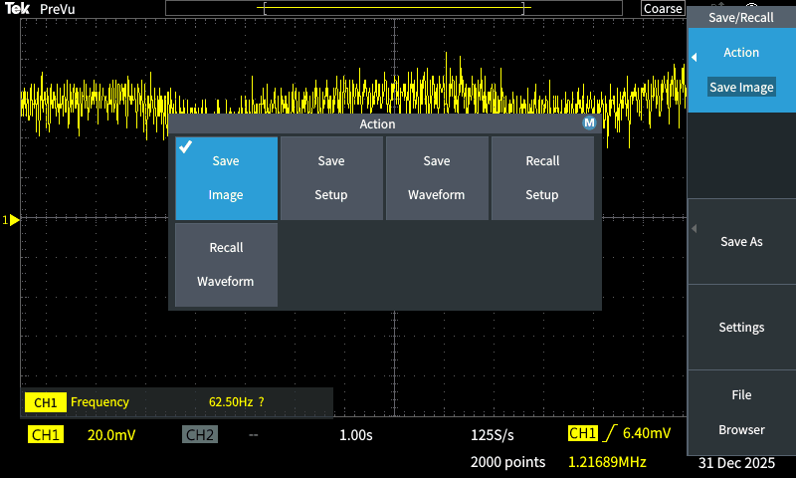
Figure 2 : Oscilloscope output when break applied at middle level

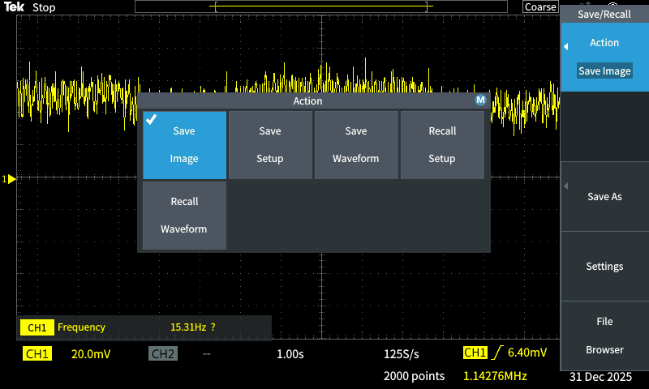
Figure 3 : Oscilloscope output when full break applied

  - Practical 4: To display the Speed of Response of the Motor

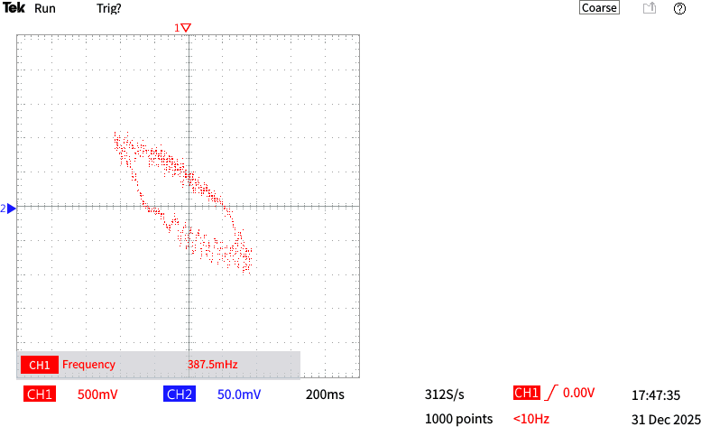

Figure 4: The speed response of the motor

- Error Channel and Feedback Polarity Chapter 5,

  - Practical 2: Feedback Polarity Error Signal Polarity

    - Observe the signal before the inverting amplifier and after the inverting amplifier. While
Changing (Using Oscilloscope)

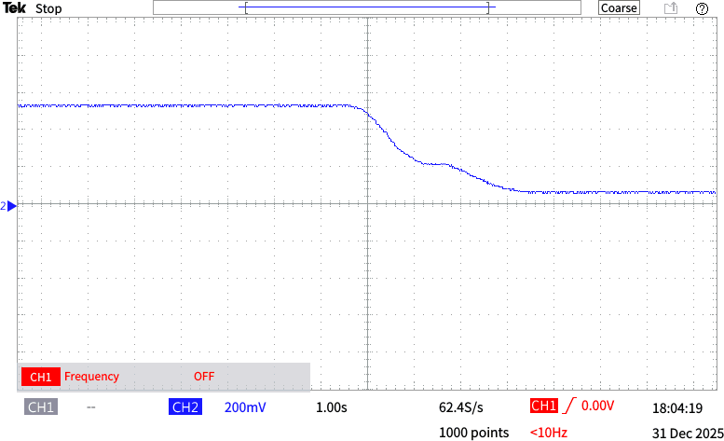

Figure 5 : The oscilloscope output before inverting amplifier

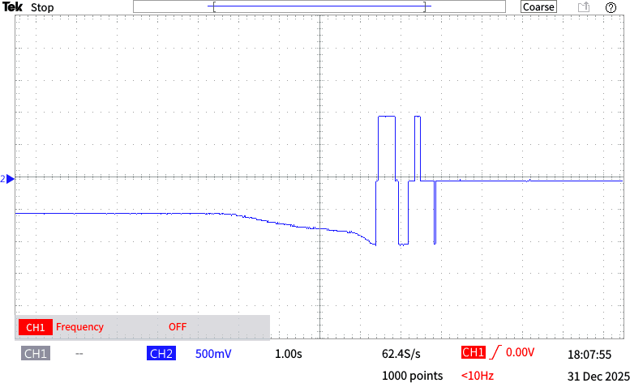
    - Determine which signal to connect to the error amplifier
Figure 6 : The oscilloscope output after inverting amplifier non inverting signal

  - Practical 3: Input and Output Rotation Directions
    - Observe the input signal (Square wave) to the motor and output obtained from the tachogenerator of the oscilloscope for the different frequencies.
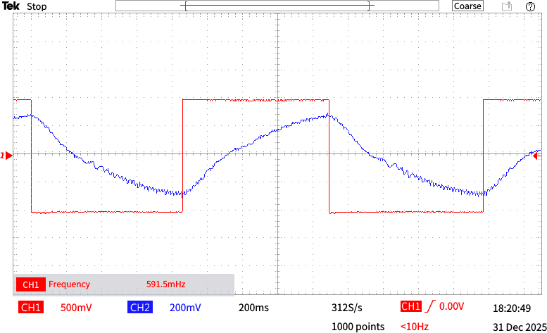

Figure 7 : Input square wave and tachogenerator output observed on the oscilloscope at an input frequency of 0.591 Hz.

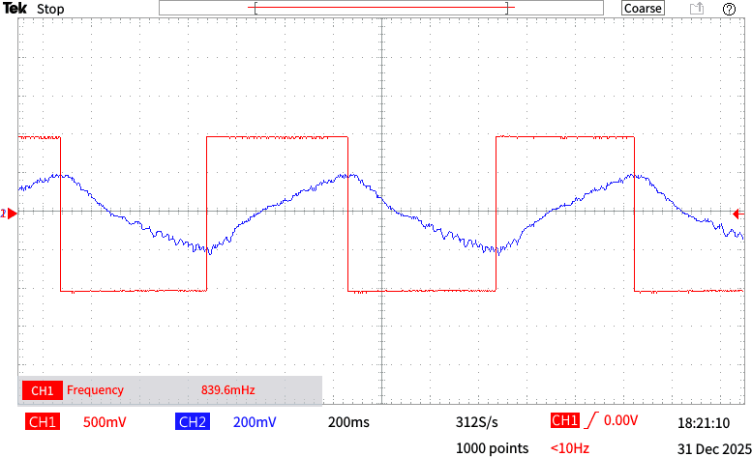
Figure 8: Input square wave and tachogenerator output observed on the oscilloscope at an input frequency of 0.839 Hz.

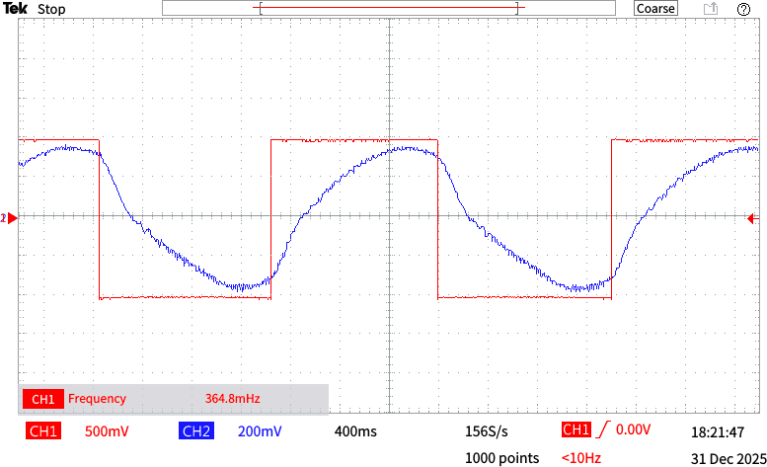

Figure 9: Input square wave and tachogenerator output observed on the oscilloscope at an input frequency of 0.364 Hz.

- Repeat the exercise for the triangular waveform.

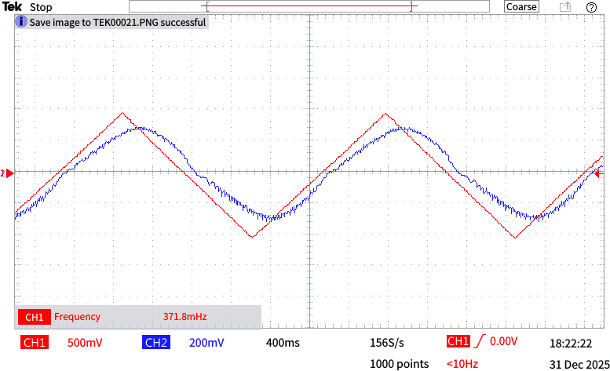
Figure 10: Input triangular wave and tachogenerator output observed on the oscilloscope at an input frequency of 0.371 Hz.

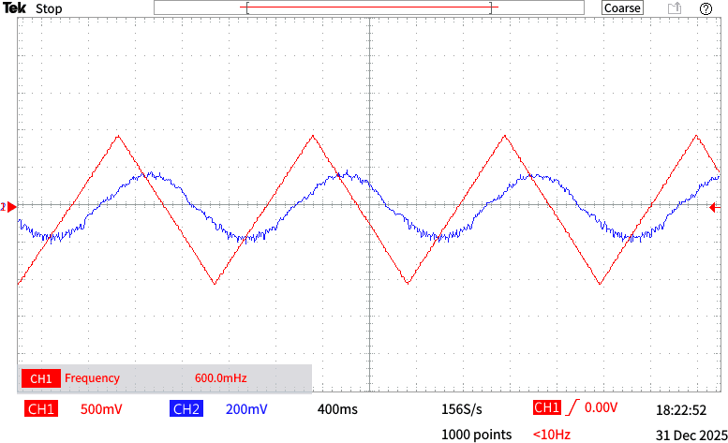

Figure 11: Input square wave and tachogenerator output observed on the oscilloscope at an input frequency of 0.600 Hz.

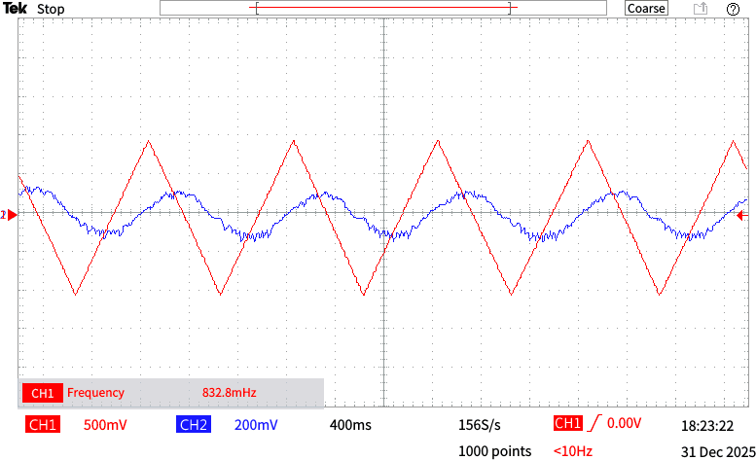
Figure 12: Input square wave and tachogenerator output observed on the oscilloscope at an input frequency of 0.832 Hz.

Exercise
At low frequencies the motor follows the input signal. However, when the frequency is increased, the motor is unable to follow the input signal. Explain the reasons.

At low frequencies, the input signal changes slowly, allowing the motor and the control system enough time to adjust the speed and direction. Therefore, the motor output is able to closely follow the input signal. However, as the input frequency increases, the motor is unable to track the input accurately due to several physical and electrical limitations.
First, the motor rotor and the attached mechanical components possess inertia. At higher frequencies, the input signal requires rapid acceleration and deceleration, which the motor cannot achieve instantaneously. As a result, the motor output lags behind the input.
Second, the motor windings have inherent resistance and inductance. At high frequencies, the inductive effect limits the rate of change of current, reducing the motor’s ability to respond to fast-varying inputs.
Finally, the motor and the feedback control system together behave as a low pass system. While low-frequency signals are accurately tracked, high-frequency components are attenuated, leading to reduced output amplitude and increased phase lag.

REFERENCES

- “Introduction to PID Control,” Control Tutorials for MATLAB and Simulink, University of Michigan, 2025. https://ctms.engin.umich.edu/CTMS/index.php?aux=Home_Overview. [Accessed: Jan 19, 2026]

- “DC Motor Velocity Control Using Feedback,” All About Circuits, 2024. https://www.allaboutcircuits.com/technical-articles/dc-motor-velocity-control-feedback-system/. [Accessed: Jan 19, 2026]

- “How to Control Motor Speed Using a PID Loop, Pulse Width Modulation and a High Speed Counter,” Maple Systems Tutorial, 2025. https://maplesystems.com/tutorial/how-to-control-motor-speed-using-pid-loop-pulse-width-modulation-and-high-speed-counter/ [Accessed: Jan 19, 2026 ]

