EE 352 - VELOCITY CONTROL SYSTEM

PERERA K.L.D.P. E/21/295
GROUP EE.21.E.15
SEMESTER 05 07/01/2026

EE352 AUTOMATIC CONTROL - EXPERIMENT 02
Department of Electrical & Electronic Engineering Faculty of Engineering
University of Peradeniya

Title: Velocity Control System
Aim: The aim of this practical is studying the characteristics of a closed loop system using an experimental velocity control system

Objectives:
- Understand the impact of the closed loop gain on the speed of operation and stability
- Understand the impact of velocity feedback on a closed loop position control system
- Understand the impact of the gain on the steady state and transient responses of a velocity feedback control system

Materials:
- Analogue Unit (33-110) by Feedback Control & Instrumentation (Setup 1)
- Mechanical Unit (33-100) by Feedback Control & Instrumentation (Setup 1)
- Power Supply ±15 𝑉𝑑𝑐, 1.5 𝐴; +5 𝑉𝑑𝑐, 0.5 𝐴 by Feedback Control & Instrumentation
- Storage Oscilloscope

Procedure:
Follow the instructions extracted from the "Servo Fundamentals Trainer" in the following order:
- Stability and the effect of loop gain: Assignment 5,
  - Practical 5.1: Measuring transient response
  - Practical 5.2: The effect of gain on stability
- Velocity Feedback: Assignment 6,
  - Practical 6.1: Simple Velocity Feedback
- Following Error: Assignment 7,
  - Practical 7.1: Following Error
  - Practical 7.2: Velocity Feedback
- Unstable System: Assignment 8,
  - Practical 8.1: Adding a Longer Time Constant
  - Practical 8.2: Instability at high gains

- Closed Loop Speed Controls: Assignment 9,
  - Practical 9.1: Closed loop Speed Control with Brake Loading

Observations:
Make the below mentioned observations while following the procedure above:
- Stability and the effect of loop gain: Assignment 5,
  - Practical 5.1: Step response
    - Observe the transient response using a closed loop control system for a step input.
    - Calculate rise time, settle time, steady state gain & percentage overshoot using your observations.
    - Observe the effect of gain by setting the amplifier feedback resistor to
100 𝑘Ω (gain=1).
    - Observe the effect of gain by setting the amplifier feedback resistor to
330 𝑘Ω (gain=3.3).
    - Observe the effect of gain by setting the amplifier feedback resistor to
1 𝑀Ω (gain=10).
    - Compare your results.

- Velocity Feedback: Assignment 6,
  - Practical 6.1: Simple Velocity Feedback
    - Compare the effect of the velocity feedback on transient response, when the gain is increased.
    - What happen when the polarity of the velocity feedback is reversed.

- Following Error: Assignment 7,
  - Practical 7.1: Following Error
    - Describe how to observe the following error in X-Y mode in the oscilloscope.
    - Compare the results when,
      - input & output resistance is 100 𝑘Ω .
      - input 2 × 100 𝑘Ω in parallel & output is 100 𝑘Ω.
      - input 100 𝑘Ω & output is 500 𝑘Ω.
  - Practical 7.2. Velocity Feedback
    - What are the effects of velocity feedback on following error, compare the results with previous step (practical 7.1).

- Unstable System: Assignment 8,
  - Practical 8.1: Additional Time Constant
    - Using the oscilloscope observe the time constant in X-Y mode as well as X-T, Y-T mode.
    - What happen to the time constant when 1 𝑀Ω resistor replaced by,
      - 330 𝑘Ω
      - 100 𝑘Ω
  - Practical 8.2: Unstable System
    - Using the oscilloscope observe the time constant in X-Y mode as well as X-T, Y-T mode.
    - Observe the system stability at different gain settings by replacing feedback resistor with,
      - 330 𝑘Ω
      - 1 𝑀Ω

- Closed Loop Speed Controls: Assignment 9,
  - Practical 9.1: Closed-loop Speed Control
    - Plot graphs for six brake settings with & without Velocity feedback for gain=1 and gain=10.

OBSERVATIONS

- Stability and the effect of loop gain: Assignment 6,
  - Practical 6.1: Step response
    - Observe the transient response using a closed loop control system for a step input.
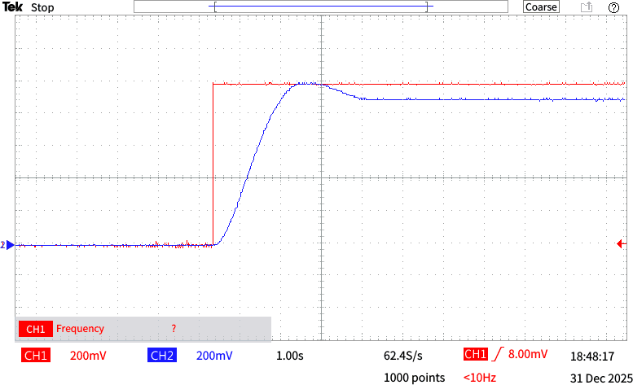

Figure 1 : Transient angular output response of a closed-loop control system for a step input.

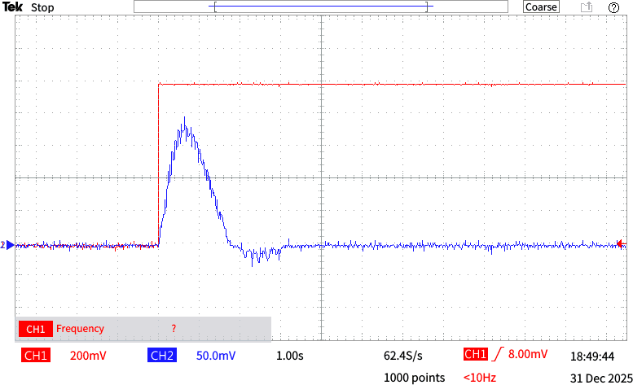

Figure 2 : Transient speed output response of a closed-loop control system for a step input.

    - Calculate rise time, settle time, steady state gain & percentage overshoot using your observations.
Rise time: 1.0 s Settle time: 3.0s
Steady state gain : 1.0
Percentage Overshoot: [ (1.0 -0.9)) × 100 %] / (1.0) =9 %

    - Observe the the effect of gain by setting the amplifier feedback resistor to 100 Ω (gain=1).
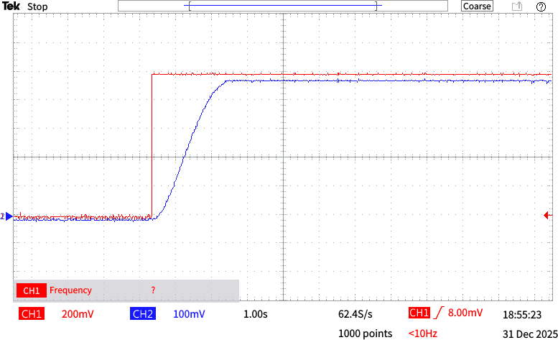

Figure 3 : Oscilloscope output showing the angular output response for an amplifier gain of 1 (feedback resistor = 100 kΩ)..

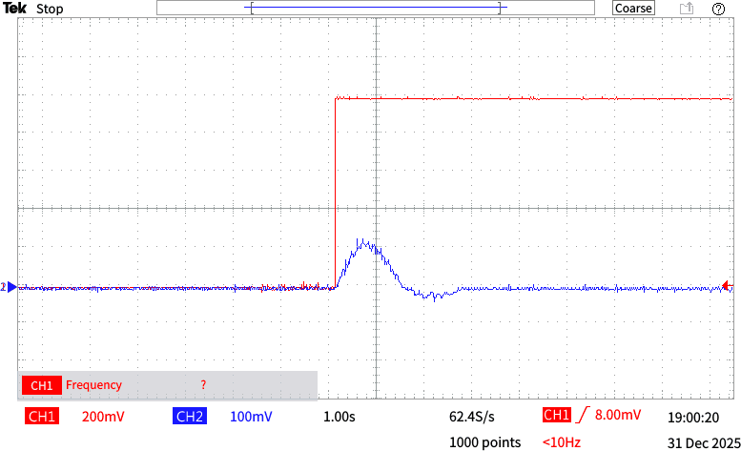

Figure 4 : Oscilloscope output showing the speed output response for an amplifier gain of 1 (feedback resistor = 100 kΩ)..

    - Observe the the effect of gain by setting the amplifier feedback resistor to 330 Ω (gain = 3.3).

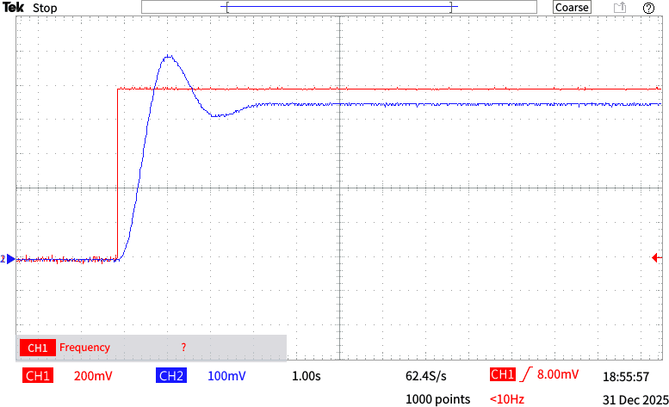

Figure 5: Oscilloscope output showing the angular output response for an amplifier
gain of 3.3 (feedback resistor = 330 kΩ).
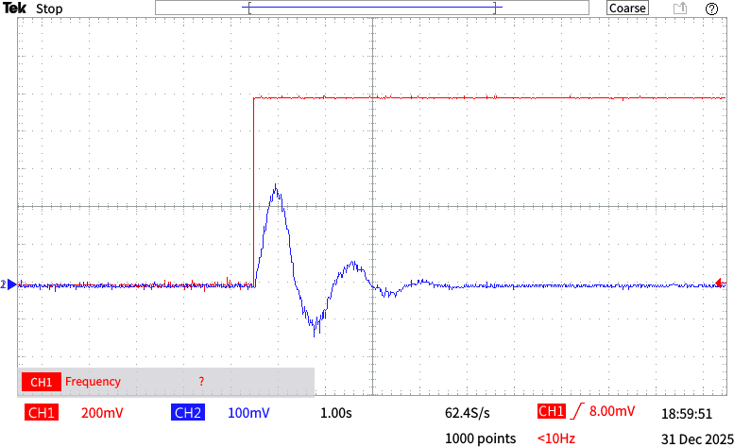

Figure 6 : Oscilloscope output showing the speed output response for an amplifier gain of 3.3 (feedback resistor = 330 kΩ).

    - Observe the the effect of gain by setting the amplifier feedback resistor to 1 MΩ (gain = 10).
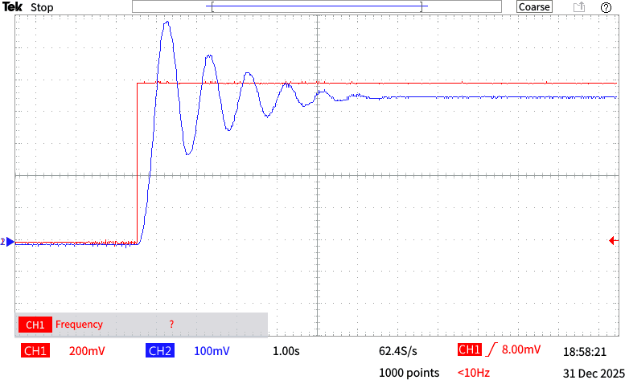

Figure 7 : Oscilloscope output showing the angular output response for an amplifier gain of 10 (feedback resistor = 1MΩ).
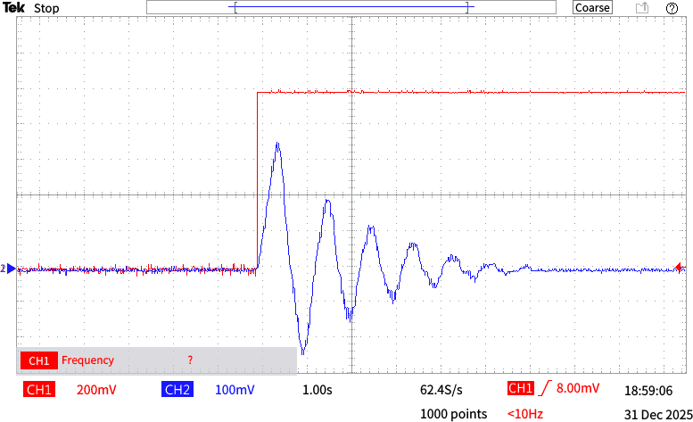

Figure 8 : Oscilloscope output showing the speed output response for an amplifier gain of 3.3 (feedback resistor = 330 kΩ).

    - Compare your results.
      - When the feedback amplification gain is set to 1, the system exhibits a highly damped response with no overshoot. However, the response is relatively slow.
      - At a gain of 3.3, the system becomes underdamped, which significantly reduces the rise time and results in a faster response. This introduces a moderate amount of oscillation and overshoot.
      - When the gain is increased to 10, the system becomes highly underdamped and approaches instability. Although the settling (alignment) time is further reduced, making the response faster, the oscillations increase significantly.

- Velocity Feedback:Assignment 7, a.Practical 7.1: Simple Velocity Feedback
- Observe Compare the effect of the velocity feedback on transient response, when the gain is increased.

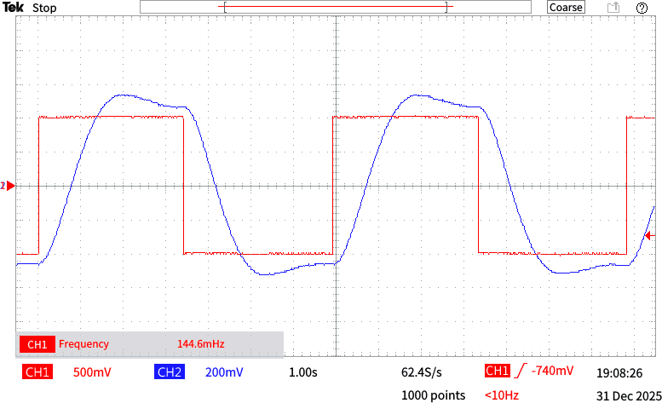

Figure 9 : Transient response of the system with velocity feedback gain set to 0.

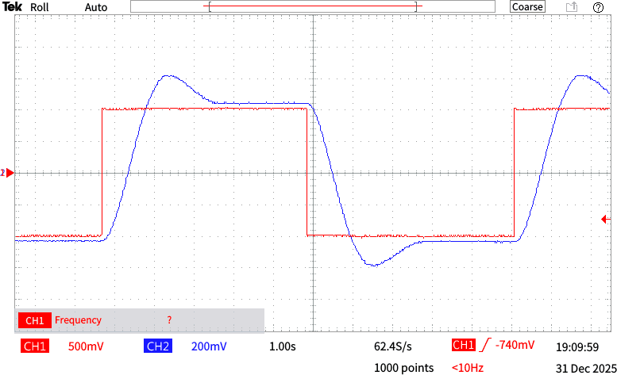

Figure 10 : Transient response of the system with velocity feedback gain set to 50.

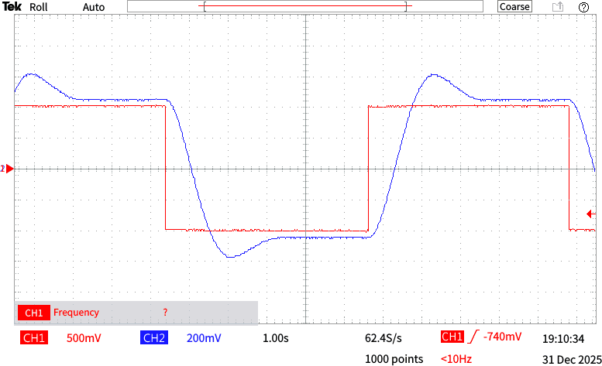

Figure 11 : Transient response of the system with velocity feedback gain set to 100.

In this case, positive velocity feedback is applied to the closed-loop control system. As the gain increases, system stability decreases significantly, making the system unsuitable. Even at moderate gain values, positive velocity feedback results in considerable overshoot.

- What happen when the polarity of the velocity feedback is reversed?
When the feedback polarity is reversed, the closed-loop control system receives negative velocity feedback. Compared to the previous case, the system becomes more stable, allowing higher gain to be used to reduce overshoot. Increased velocity feedback leads to an overdamped response. In addition, the gain reduces the rise and settling times, resulting in a faster response.

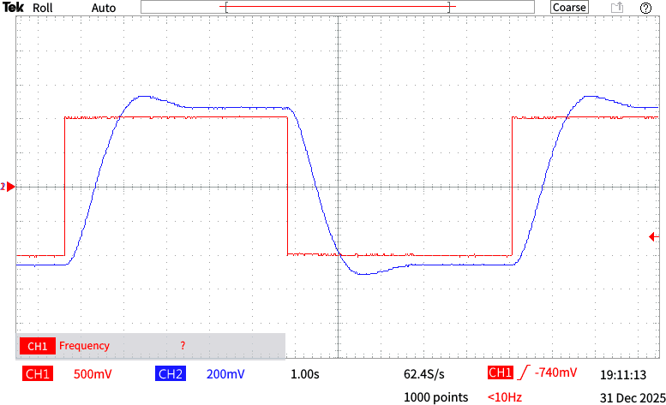

Figure 12 : Transient response of the system with reversed velocity feedback polarity at a gain of 100.

- Following Error: Assignment 8,
  - Practical 8.1: Following Error
- Describe how to observe the following error in X-Y mode in the oscilloscope.
The reference input is applied to the X (horizontal) channel and the system output to the Y (vertical) channel to observe the following error using the oscilloscope in X–Y mode. In this mode, the output is plotted directly against the input. A perfect 45° straight line indicates exact tracking, while any deviation from this line represents a following error.

- Compare the results when,
  - input & output resistance is 100 Ω .

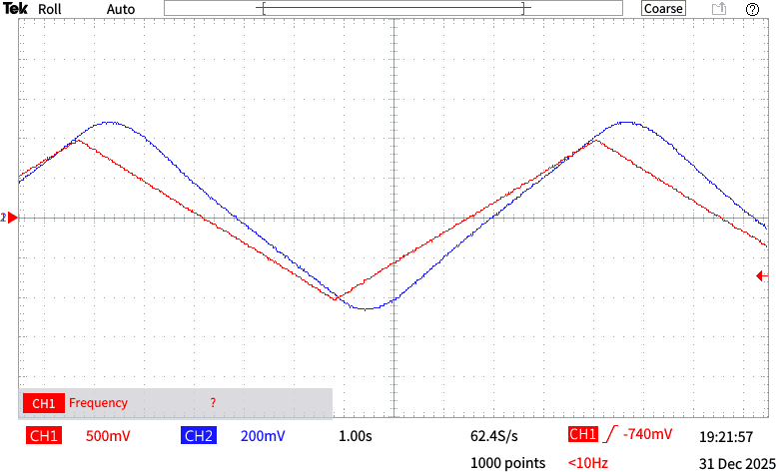

Figure 13 :Time-domain oscilloscope output showing the system response with
input and output resistances of 100 kΩ.
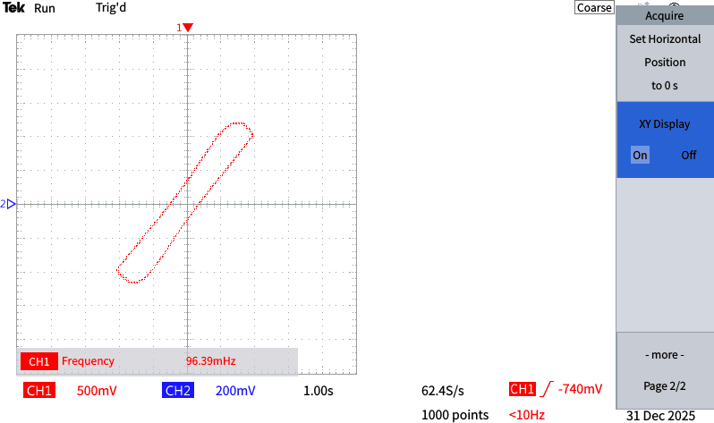

Figure 14 :Error observation in X–Y mode of the oscilloscope with input and output resistances set to 100 kΩ.

  - input 2 × 100 Ω in parallel & output is 100 𝑘Ω.

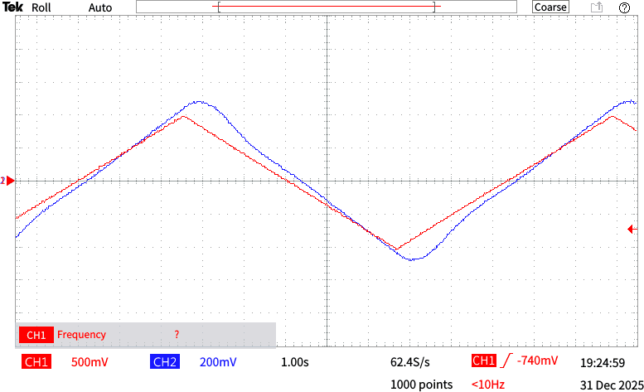

Figure 15 :Time-domain oscilloscope output showing the system response with input 2 × 100 Ω in parallel & output is 100 Ω.

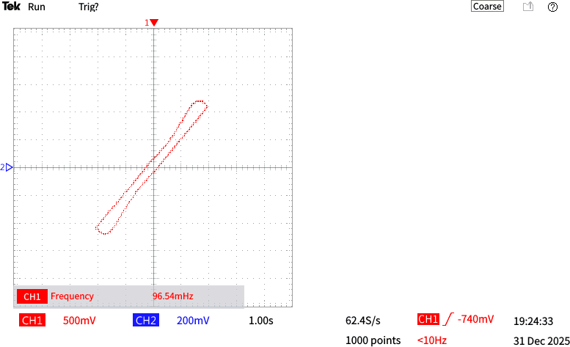

Figure 16 :Error observation in X–Y mode of the oscilloscope with input 2 × 100 Ω
in parallel & output is 100 Ω.

  - input 100 Ω & output is 500 Ω.
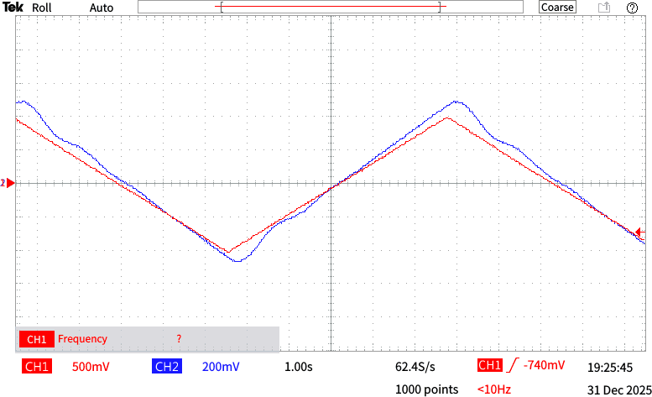
Figure 17 :Time-domain oscilloscope output showing the system response with input 100 Ω & output is 500 Ω.

The data indicate that the following error decreases as the feedback gain increases. This occurs because, for a given speed, the error is inversely proportional to the gain, so doubling the gain halves the error. However, higher gain makes the system response more oscillatory, indicating degradation of the transient response.
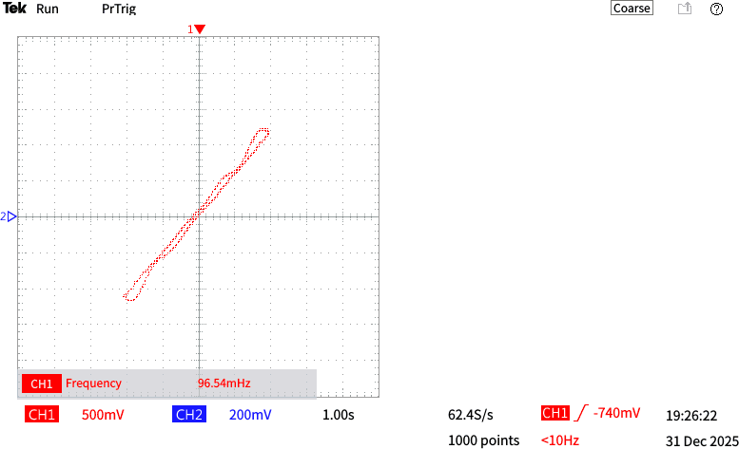

Figure 18 :Error observation in X–Y mode of the oscilloscope with input 100 Ω & output is 500 Ω.

  - Practical 8.2. Velocity Feedback
    - What are the effects of velocity feedback on following error compare the results with previous step (practical 7.1).

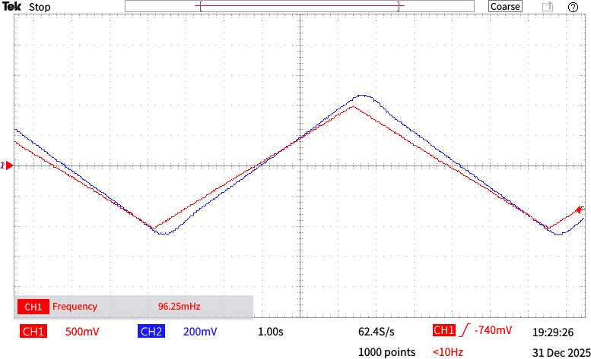

Figure 19 :Effect of velocity feedback on following error observed in time-domain using the oscilloscope
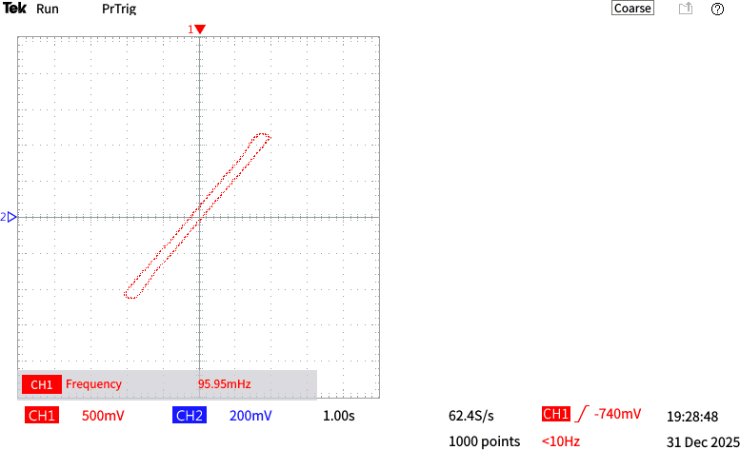

Figure 20 :Effect of velocity feedback on following error observed in X–Y mode of the oscilloscope

Increasing the amplifier gain reduces the following error. As observed earlier, high gain is beneficial for tracking an oscillating input signal. When velocity feedback increases the step- response transient, the transient component of the following error also increases, resulting in a higher following error.

- Unstable System: Assignment 9,
  - Practical 9.1: Additional Time Constant
- Using the oscilloscope observe the time constant in X-Y mode as well as X-T, Y-T mode.
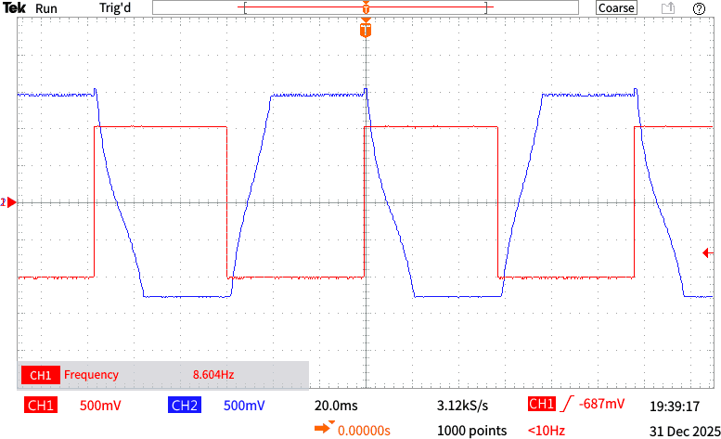

Figure 21 :Observation of the system time constant in X–T/Y–T mode using a 1 MΩ resistor.
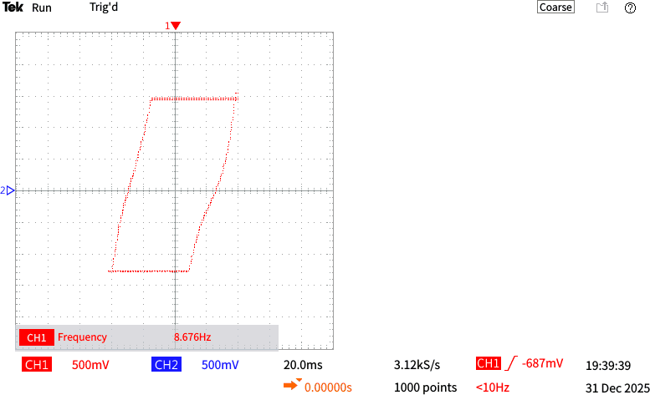

Figure 22 : Observation of the system time constant in X–Y mode using a 1 MΩ
resistor.

- What happen to the time constant when 1 Ω resistor replaced by,

0𝑘𝛺
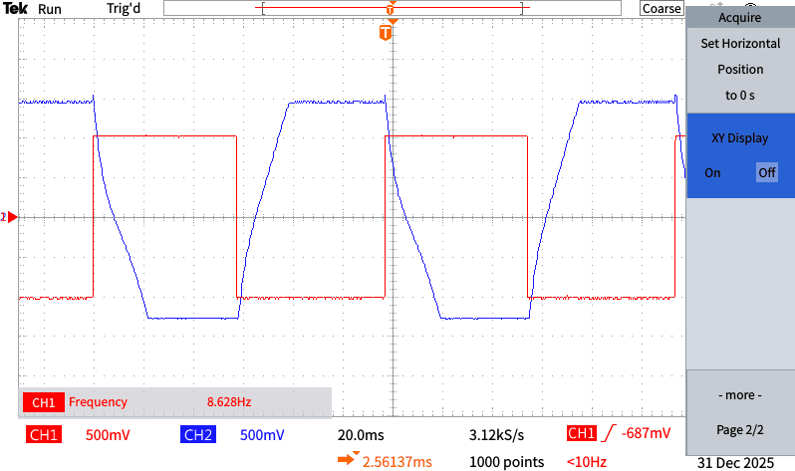

Figure 23 :Observation of the system time constant in X–T/Y–T mode using a
330kΩ resistor.

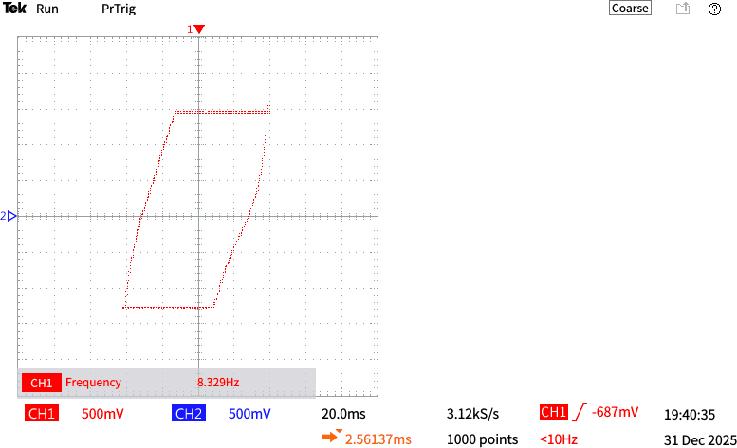

Figure 24 : Observation of the system time constant in X–Y mode using a 330kΩ
resistor.

  - 100𝑘𝛺
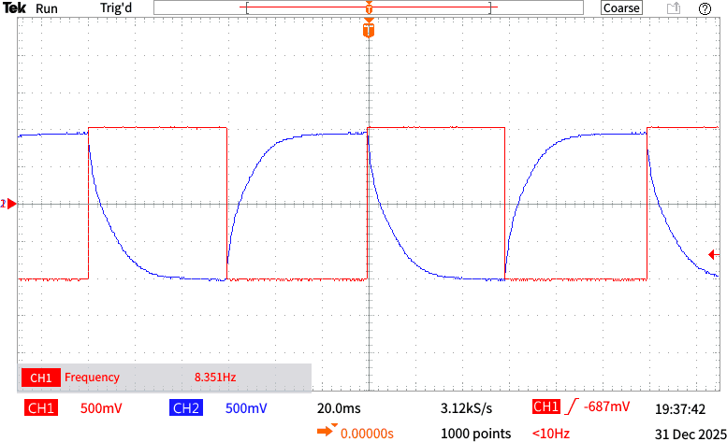

Figure 25 :Observation of the system time constant in X–T/Y–T mode using a
100kΩ resistor.
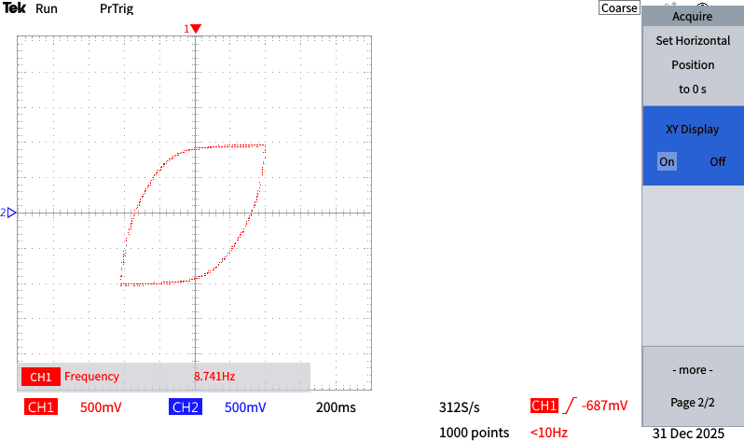

Figure 26 : Observation of the system time constant in X–Y mode using a 100kΩ
resistor.

As the gain is increased, the X–T and Y–T plots show a reduction in the transient response, indicating a decrease in the time constant. At a resistance of 100 kΩ, the time constant is minimum. Although a lower time constant should produce a faster response, this is not observed because the gain decreases as the resistance is reduced.

  - Practical 9.2: Unstable System
    - Using the oscilloscope observe the time constant in X-Y mode as well as X-T, Y-T mode.
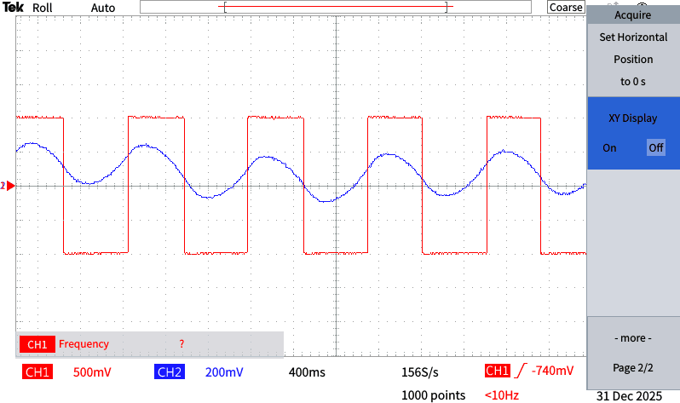

Figure 27 :Observation of the system time constant in X–T/Y–T mode using a
100kΩ resistor.

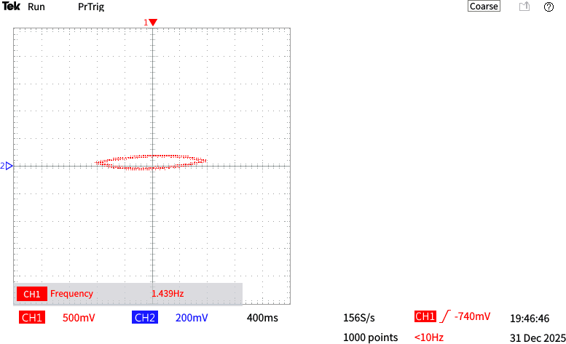

Figure 28 : Observation of the system time constant in X–Y mode using a 100kΩ
resistor.

    - Using the oscilloscope observe the time constant in X-Y mode as well as X-T, Y-T mode.

0𝑘𝛺
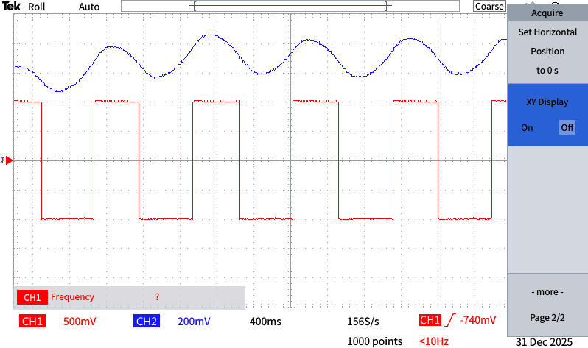

Figure 29 :Observation of the system time constant in X–T/Y–T mode using a
330kΩ resistor.

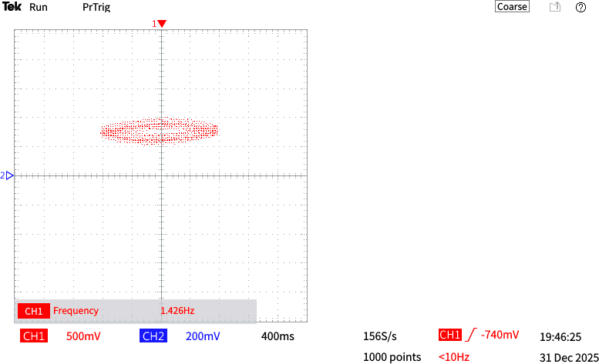

Figure 30 : Observation of the system time constant in X–Y mode using a 330kΩ
resistor.

1𝑀𝛺
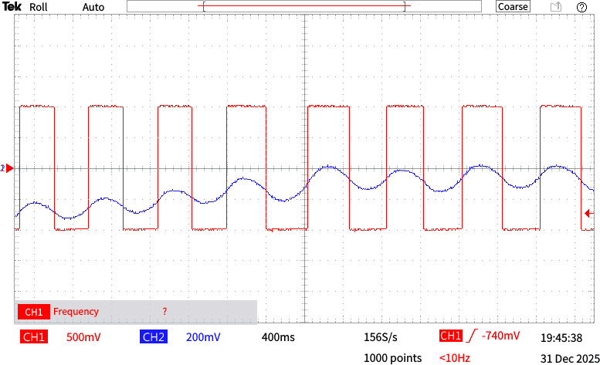

Figure 31 :Observation of the system time constant in X–T/Y–T mode using a 1 MΩ resistor.

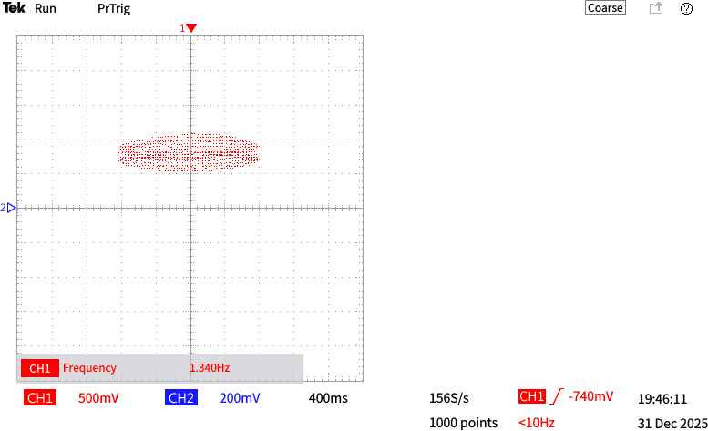

Figure 32 : Observation of the system time constant in X–Y mode using a 1 MΩ
resistor.

- Closed Loop Speed Controls: Assignment 10,
  - Practical 10.1: Closed-loop Speed Control
vi. Plot graphs for six brake settings with & without Velocity feedback for Gain=1 and Gain=10.

Table 1 : Motor speed response for six brake settings with and without velocity feedback at gains of 1 and 10.

Brake No | Motor speed / (rpm)
Brake No | With feedback |  | Without feedback
Brake No | For Gain = 1 | For Gain = 10 | For Gain = 1 | For Gain = 10
1 | 49.4 | 69.7 | 68.7 | 68.0
2 | 47.5 | 63.6 | 64.4 | 60.6
3 | 44.0 | 55.5 | 57.2 | 46.9
4 | 38.2 | 43.3 | 44.8 | 40.3
5 | 34.3 | 34.5 | 36.4 | 33.3
6 | 31.5 | 30.3 | 33.0 | 30.1
7 | 29.3 | 29.6 | 29.6 | 29.0

Table 2 : Variation of Speed against Brake Settings with & without Velocity Feedback for Gain = 1

Brake Setting | Speed / (rpm) Without Velocity Feedback | Speed / (rpm) With Velocity Feedback
1 | 49.4 | 68.7
2 | 47.5 | 64.4
3 | 44.0 | 57.2
4 | 38.2 | 44.8
5 | 34.3 | 36.4
6 | 31.5 | 33.0
7 | 29.3 | 29.6

Speed/ rpm

FIGURE 33 : SPEED VS BRAKE SETTINGS WITH & WITHOUT VELOCITY FEEDBACK FOR GAIN = 1
8
7
6
5
4
3
2
1
0
0
Brake setting
10
20
30
40
50
60
Speed / (rpm) Without Velocity Feedback
Speed / (rpm) With Velocity Feedback
70
80

Table 3: Variation of Speed against Brake Settings with & without Velocity Feedback for Gain = 10

Brake Setting | Speed / (rpm) Without Velocity Feedback | Speed / (rpm) With Velocity Feedback
1 | 69.7 | 68.0
2 | 63.6 | 60.6
3 | 55.5 | 46.9
4 | 43.3 | 40.3
5 | 34.5 | 33.3
6 | 30.3 | 30.1
7 | 29.6 | 29.0

80

Speed / (rpm) With Velocity Feedback
Speed / (rpm) Without Velocity Feedback
Speed / rpm

70

60

50

40

30

20

10

0
0 1 2 3 4 5 6 7 8
Brake setting

FIGURE 34 : SPEED VS BRAKE SETTINGS WITH & WITHOUT VELOCITY FEEDBACK FOR GAIN = 10

REFERENCES

[1]. K. Gowda, “Introduction to Control Systems 1.1,” CircuitBread, Aug. 19, 2020. https://www.circuitbread.com/tutorials/introduction-to-control-systems-1.1?utm_ [Accessed: Jan 12, 2026 at 5.15pm]

[2]. “Closed-Loop Control Systems | Electronics Tutorial,” Next.gr, 2025. https://www.next.gr/tutorials/control-systems/closed-loop-control-systems-tutorial?utm_ [Accessed: Jan 12, 2026 at 5.25pm]

[3]. “What is XY Mode in Oscilloscopes? - Keysight Oscilloscope Glossary - Keysight
Technologies,” Keysight.com, 2022. https://www.keysight.com/used/us/en/knowledge/glossary/oscilloscopes/xy-mode- oscilloscope [Accessed: Jan 12, 2026 at 6.00 pm]

