Sri Lanka Institute of Information Technology


IT1140 - Fundamentals of Computing
Year 1, Semester 1

Real-Time Smart Bus Tracking System

Progress Report
[Group ID]

IT Number | Name

- Introduction
This project aims to design and develop a real-time bus tracking system for a controlled arena environment. The system has three parts: an IoT device mounted on the bus that senses and reports its position and status, a cloud backend that stores this live data, and a web platform called Wayline that presents it to operators, drivers and passengers.
At present the full web platform, which is the central brain of the project, has been completed. It provides an operator console with a live fleet map, route editing, alerts, driver behaviour reports and account management, a driver view, and a passenger tracking view with estimated arrival times. All data flows through Firebase Realtime Database, so every client updates the moment the bus moves. The IoT hardware (microcontroller, positioning and sensor modules) has been purchased and is in the assembly stage.
Because of practical limitations of the originally planned sensors (see the Challenges section), the positioning approach for the hardware side is being revised around a camera-based method using the OpenCV library.

- System Architecture
The system is organised in three layers. On the arena side, a phone camera is mounted elevated above the map and its feed is sent to a PC. The four corners of the map are marked with four different colours so that OpenCV can work out the real dimensions of the map, and a red marker is fitted on top of the bus. The OpenCV program on the PC processes the video frames and outputs the bus's (x, y) position, which - together with the bus status reported by its microcontroller - is published to the cloud. The cloud layer is Firebase: the Realtime Database holds the buses, routes, users and events nodes, Authentication manages the three user roles (operator, driver, passenger), and security rules restrict who can write what. The application layer is the Wayline web platform built with Next.js and React. The operator console reads the live data and can issue commands such as force-stop back to the device; the driver view follows the assigned bus; the passenger view shows buses and estimated arrival times. The diagram below summarises these layers and the data flows between them.
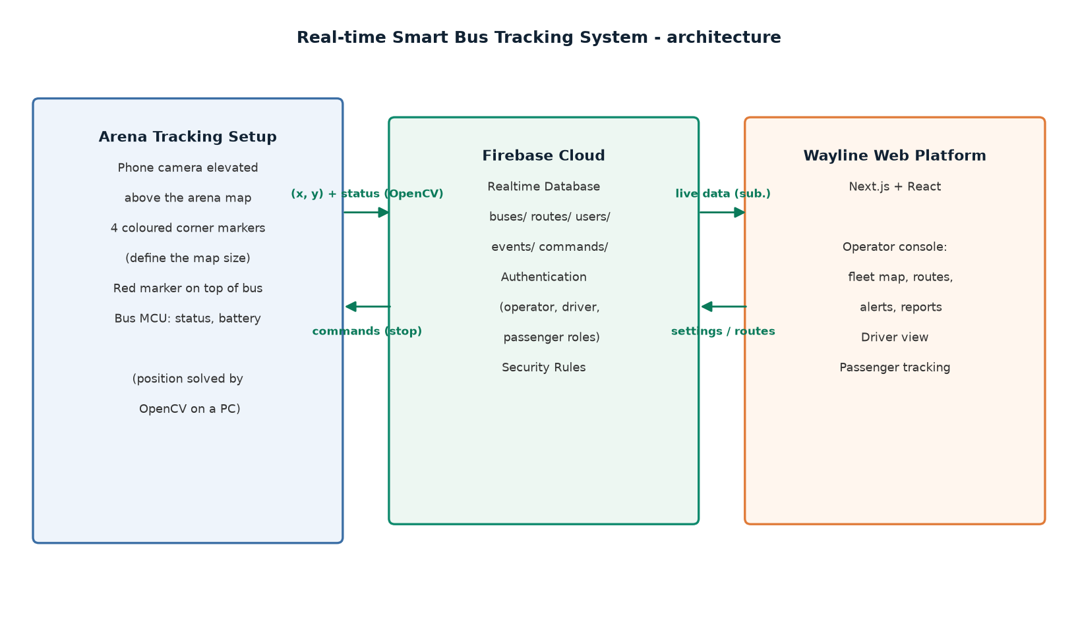

- Work Breakdown Structure
The group's work is split between two workstreams. The web platform workstream is complete: the full Wayline application (operator, driver and passenger sides, Firebase integration, security rules) has been built and tested against a telemetry simulator. The hardware workstream has completed component procurement and is currently in assembly; firmware integration and the camera-based tracking approach come next. The chart below shows how the activities are distributed among the members.

- Proof of Work
The main proof of work to date is the completed web platform: the operator console (live map, fleet cards, route editor, alerts, driver reports, team and bus management), the driver view and the passenger tracking view. Screenshots of these screens will be added below together with the hardware evidence.
[Insert screenshot of the operator dashboard here]
[Insert photograph of the purchased IoT hardware here]
[Insert circuit diagram of the bus tracker here]

- Challenges Encountered
GPS accuracy: standard GPS modules do not give reliable accuracy at the short distances involved in the arena, so a different way of achieving the tracking goal had to be found.
Sensor availability: BLE-based tracking sensors could not be sourced locally. Because of this, a camera-based approach is being developed: a phone camera is elevated above the map, the four corners of the map are marked with four different colours so that OpenCV can capture the map's dimensions, and a red marker is placed on top of the bus. The camera feed is sent from the phone to a PC, where the OpenCV library processes the frames and gives the (x, y) coordinates of the bus.
- Project Budget
Hardware components have been procured for the IoT side of the project. The cost breakdown is recorded in the table below (amounts to be completed).
Item | Qty | Unit Cost (LKR) | Total (LKR)
Microcontroller board | 1 | [TBD] | [TBD]
GPS module | 1 | [TBD] | [TBD]
Camera module (OpenCV tracking) | 1 | [TBD] | [TBD]
BLE sensor (tried, unavailable) | 4 | - | -
Accelerometer and other sensors | [TBD] | [TBD] | [TBD]
Power supply, cables, enclosure | [TBD] | [TBD] | [TBD]
Total |  |  | [TBD]

