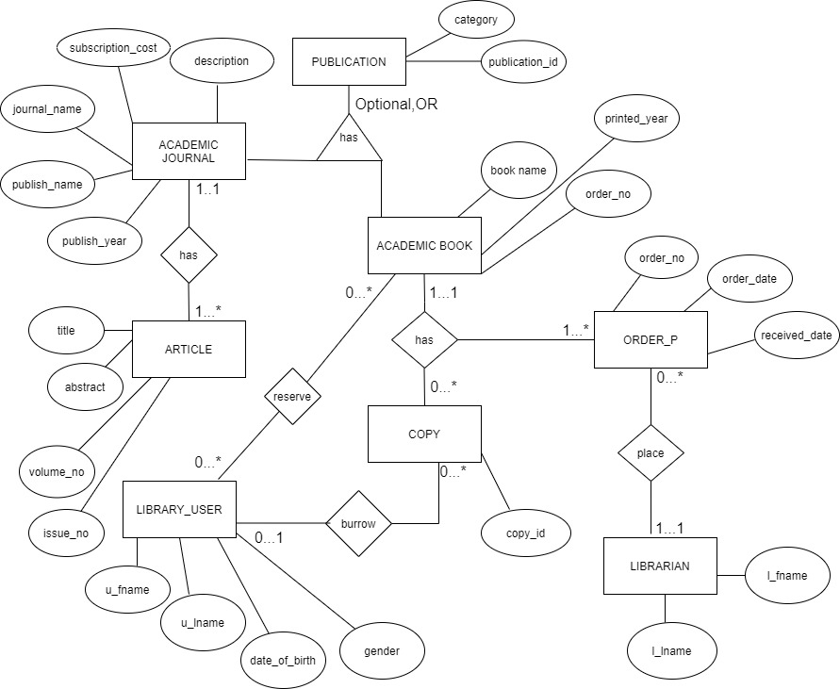

**(Q1)** (01) RELATIONSHIP BETWEEN USER AND ACADEMIC BOOK:

User can reserve many books but if the required book isn’t available no reservations.

A particular book may be reserved by many or not.

(02) RELATIONSHIP BETWEEN LIBRARYUSER AND COPY:

User may not burrow a copy or may burrow many copies.

At an instance a copy can, be burrowed by 1 or no user.

1. RELATIONSHIP BETWEEN ACADEMIC BOOK AND COPY:

An academic book can have many copies or copies may be finished.

A particular copy can be of one particular book.

1. RELATIONSHIP BETWEEN ACADEMIC JOURNAL AND ARTICLE:

An academic journal can have 1 or many articles.

A particular article can be of one particular academic journal.

1. RELATIONSHIP BETWEEN LIBRARIAN AND ORDER:

A librarian will not order books (if required number of copies available) or will order many books as required.

A particular order will be made by a particular librarian.

1. RELATIONSHIP BETWEEN ORDER, ACADEMIC BOOK, COPY:

This is a ternary relationship.

An order may contain 1 or many, academic book or copy.

1. GENERALIZATION CONCEPT used is Optional, OR – The library may contain publications except Academic Books and Academic Journals such as children’s books, novels

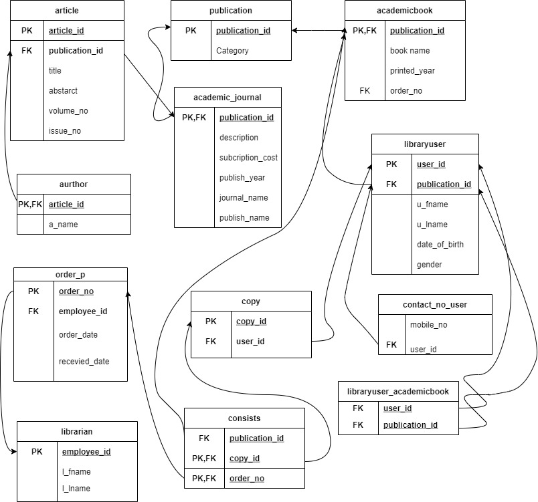

**(Q2)**

(1)library user and Academic book relationship is a many to many relationship therefore another relation named libraryuser_academicbook is created.Primary keys of libraryuser and Academic book are placed as foreign keys.

(2)A new relation is created named ‘consists’ because order,copy,academic_book is a ternary relationship.

(3) Contact no is a multivalued attribute therefore a new relation is created named ‘contact_no_user’ with foreign key user_id.

(4) Article relation is in unormalised form due to author name(a_name) being multivalued.Therefore a new relation is created named ‘Aurthor’ with article_id as foreign key.

(5) Since Optional, OR generalization concept is used Primary key of Publication relation is given to Academic Journal and Academic book relations as foreign keys.

(6) Librarian and Order_P are in one-to-many relationship therefore employee_id is placed in order_p as a foreign key.

(7) Academic Journal and Article are in one-to-many relationship therefore publication_id is placed in article as a foreign key.

(8) Library_user and Copy are in one-to-many relationship therefore user_id is placed in Copy as a foreign key.

**(Q3)** AND **(Q4)**

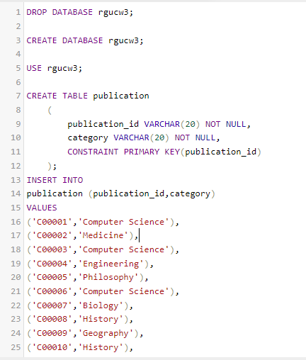

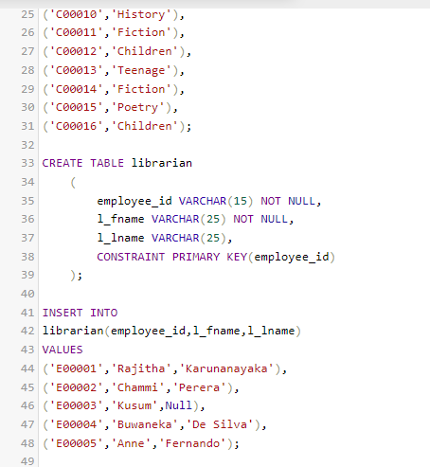

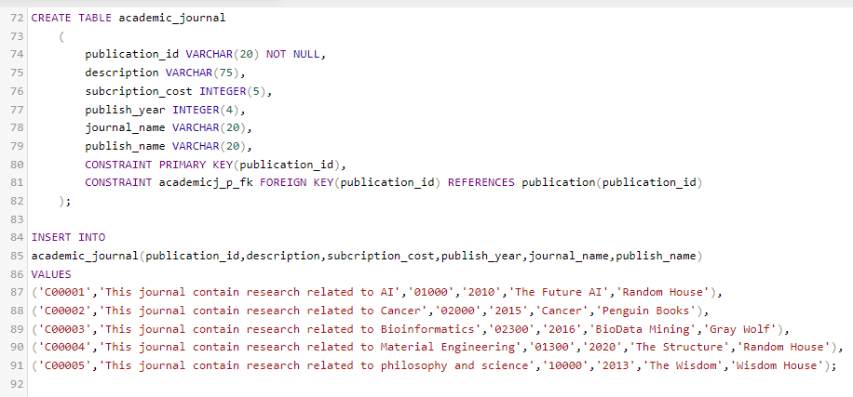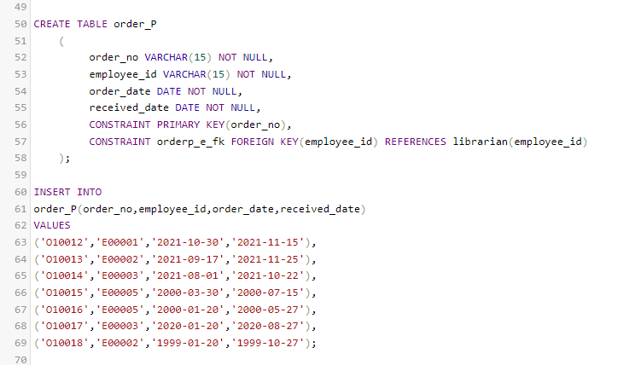

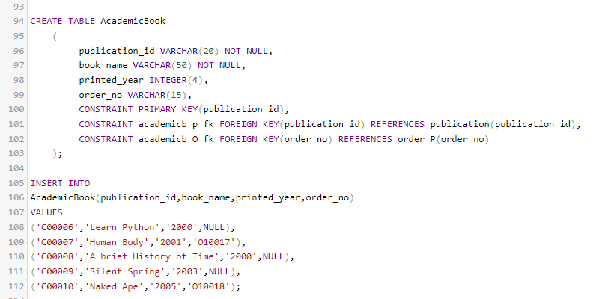

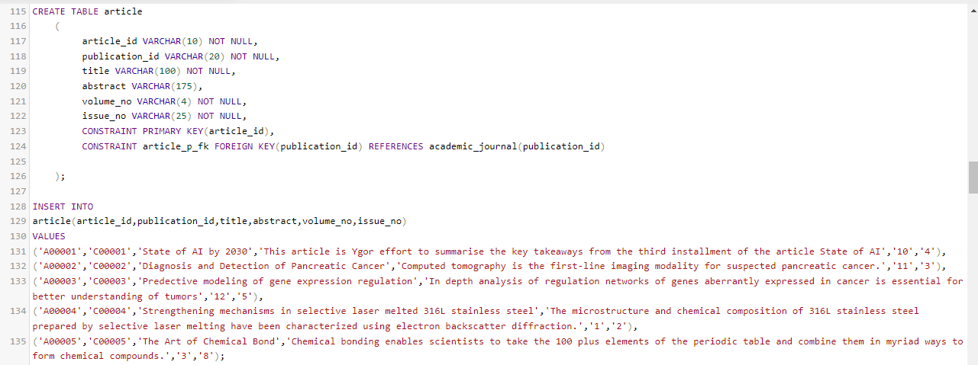

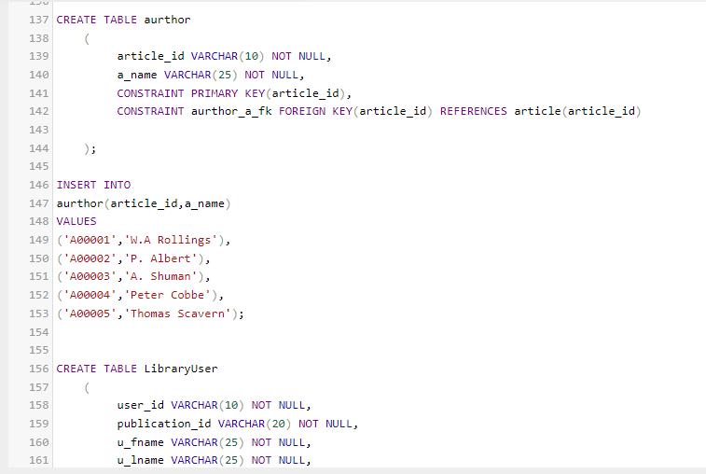

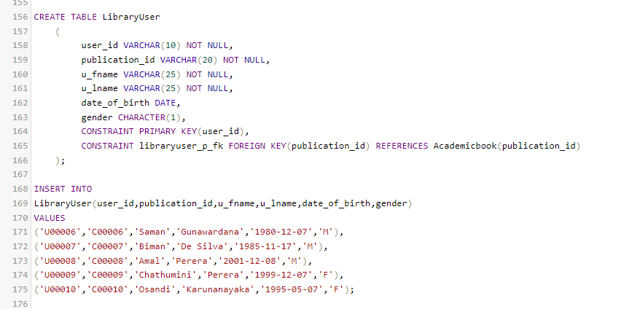

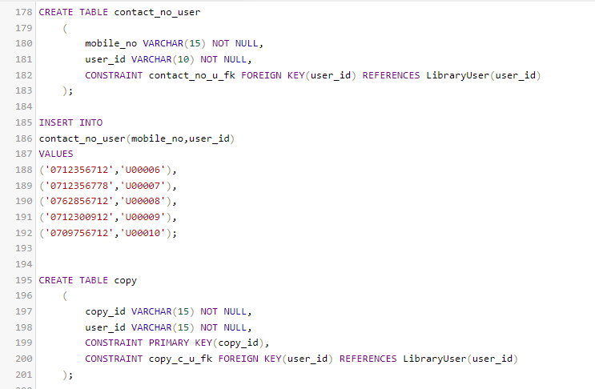

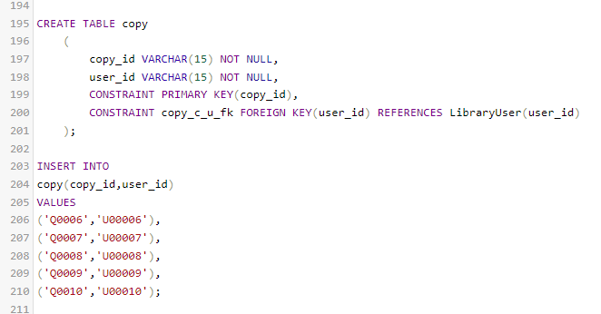

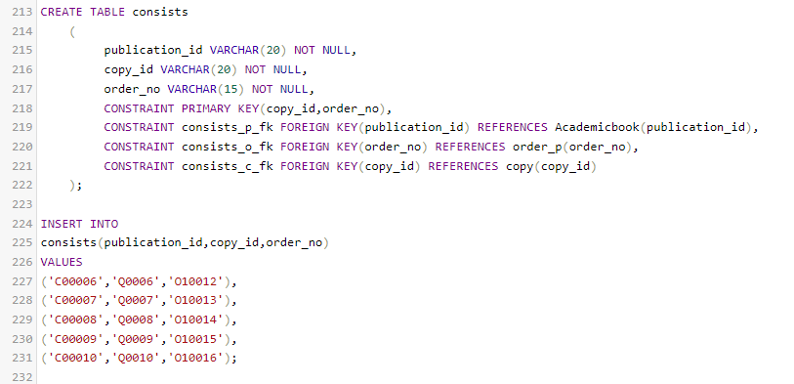

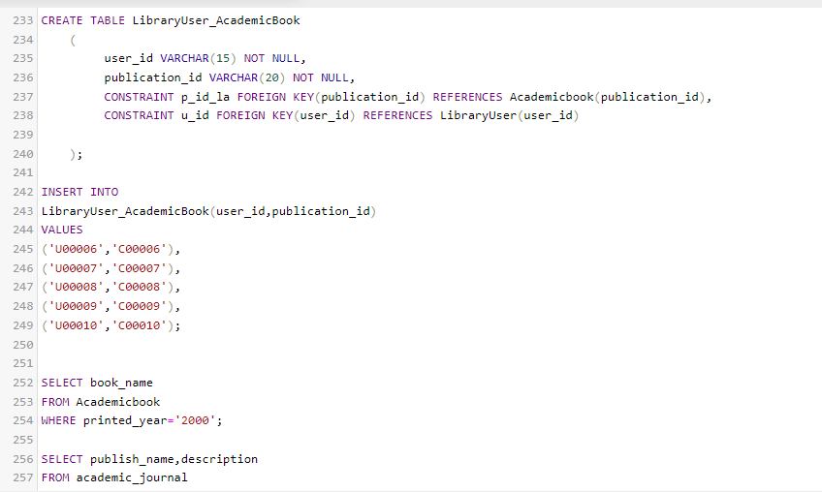

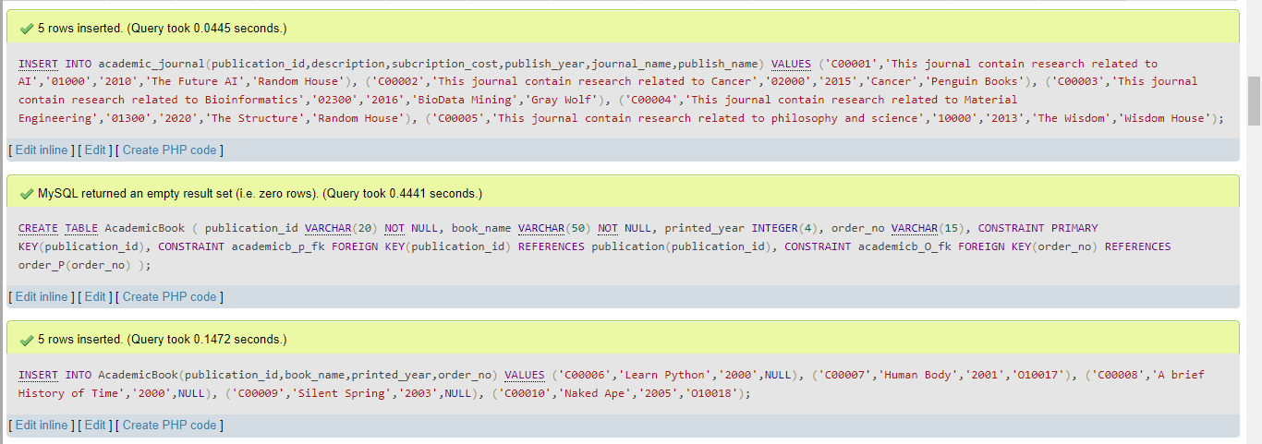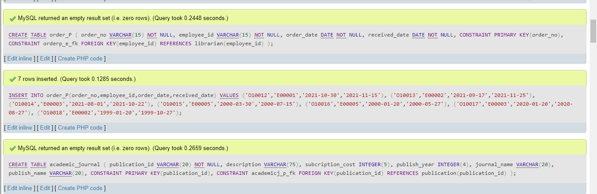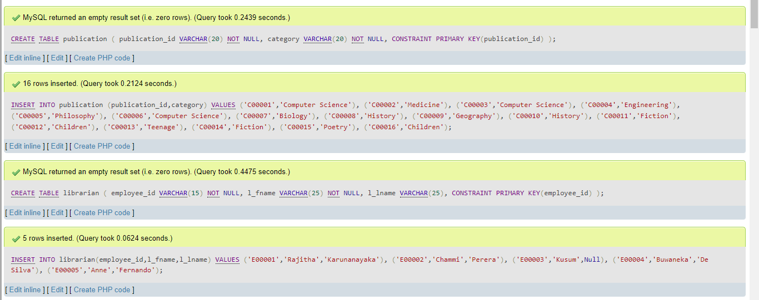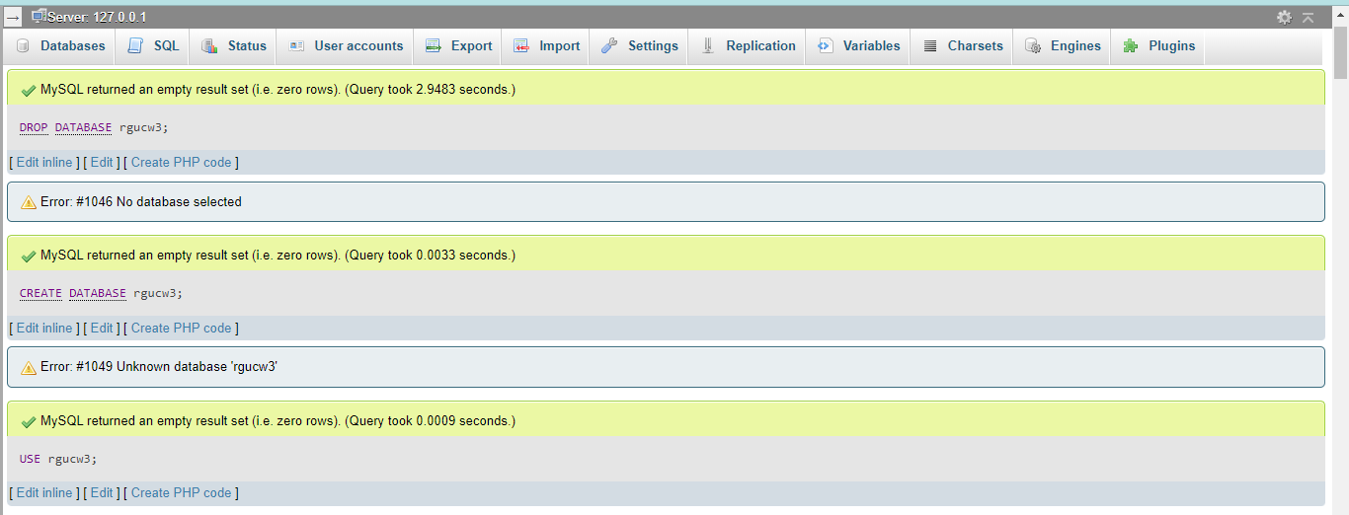

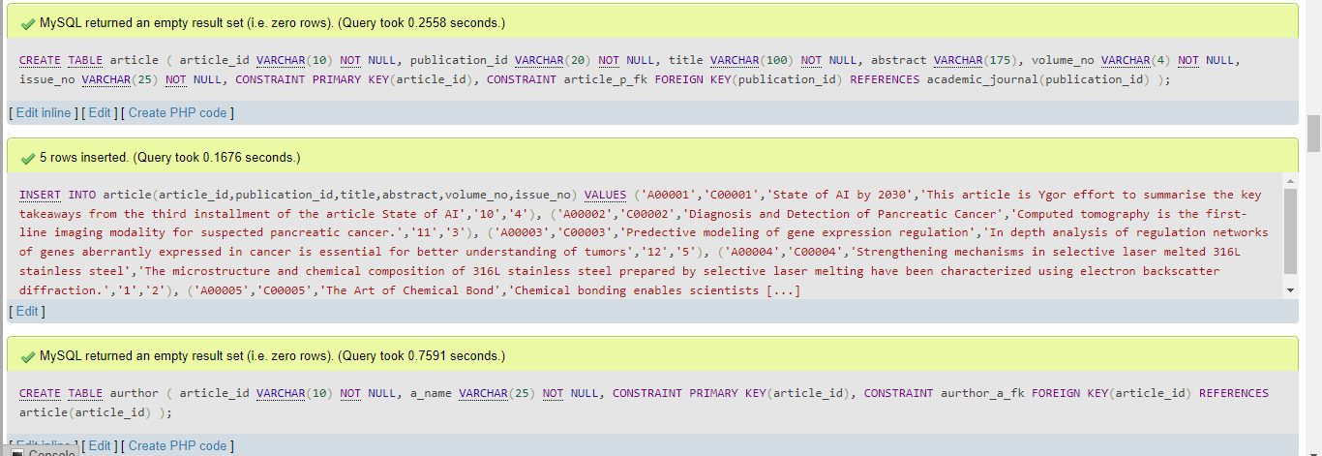

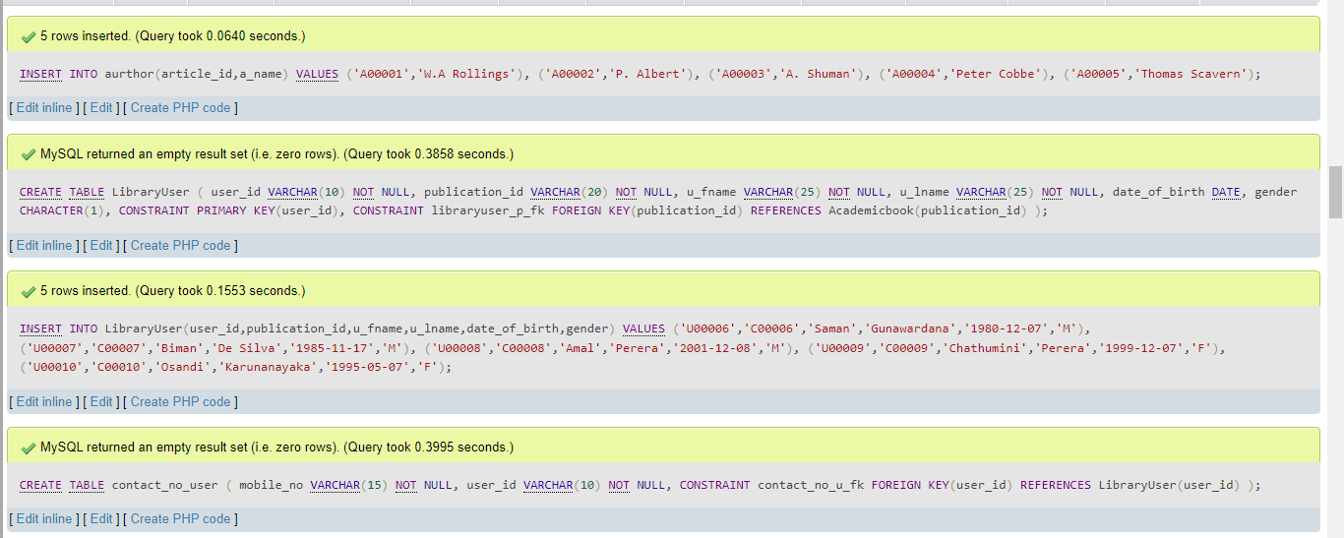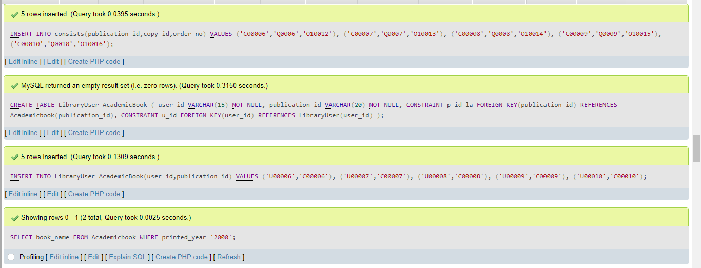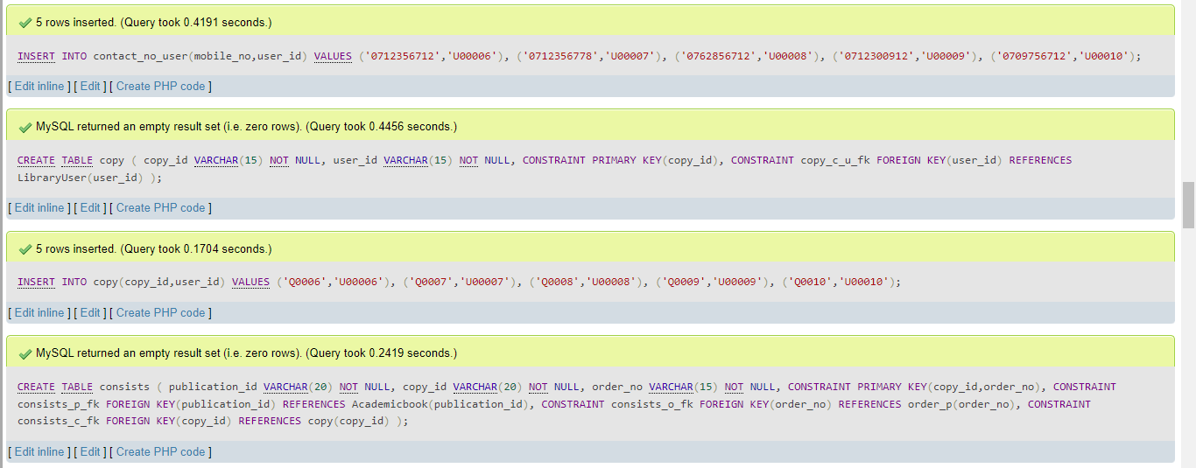

(Q5)

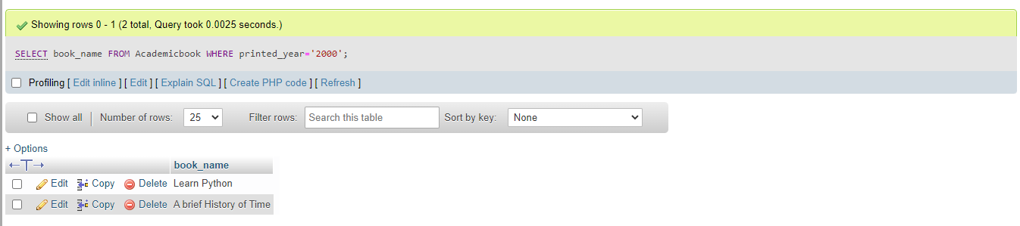

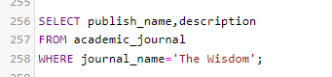

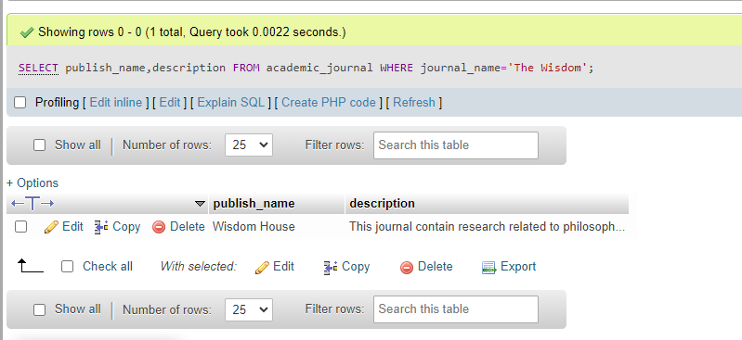

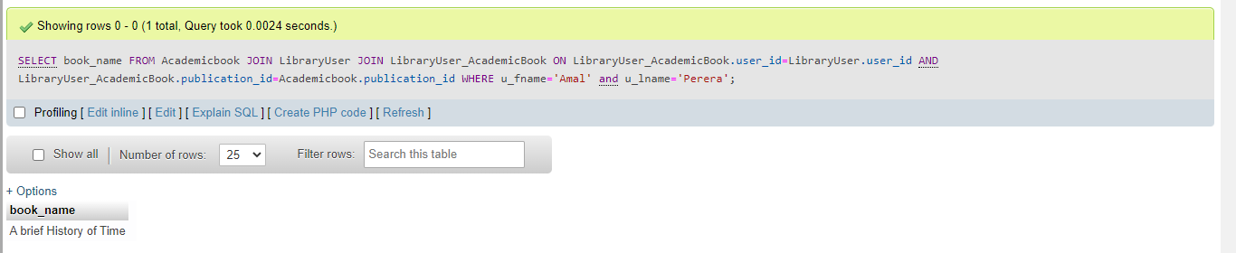

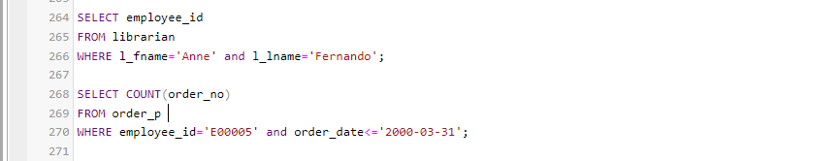

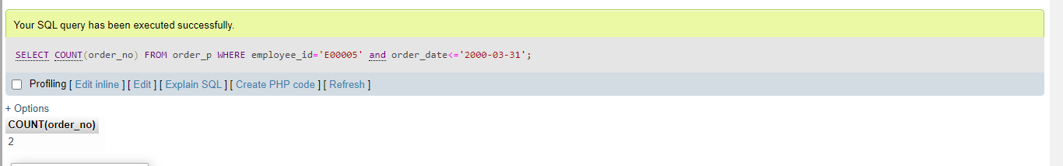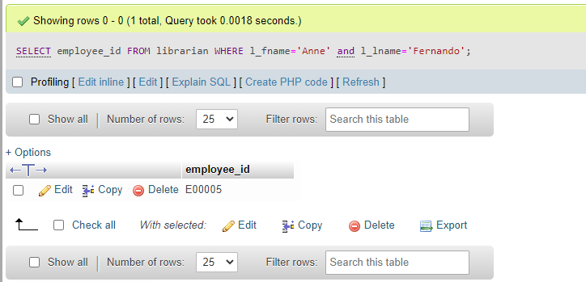

**DATABASE----------🡪**

