AI Tools for Different Professional and Academic Domains
Healthcare
Introduction
Healthcare is the combination of services and steps taken in order to diagnose a certain disease and to take the relevant steps to cure the disease in a more accurate and efficient manner as soon as possible, before the condition goes to a critical stage.
Healthcare is mainly focused on 3 parts:
- Prevention
- Diagnose
- Treatment.
How AI is used for the betterment of healthcare.
Use of AI tools in this sense means the use of software systems with advanced algorithms and machine learning systems for the development of healthcare by analyzing medical data and medical reports and providing an automated environment for hospital administration, diagnosis of diseases, and mainly developing solutions for those diseases.
Prevention
As always, prevention is better than cure; AI has been playing a major role in the prevention of the occurrence of diseases. There are many AI tools that are used nowadays, as below.
MILTON, Delphi 2M, and PathGen are some of the main AI tools that are currently used in the healthcare sector to prevent the occurrence of diseases. Here we mainly focus on the AI tool named Delphi 2M.
Delphi-2 M: This is a generative AI model that can estimate the risk of an individual being infected with 1,000+ diseases up to 20 years in advance by analyzing the health records and the lifestyle data of the particular individual.
This tool has been developed by the European Molecular Biology Laboratory in Germany and the German Cancer Research Center in Heidelberg.
Today, even though many AI models have been introduced for the identification of diseases, most of these tools can predict the possibility of only one or two particular diseases. The specialty of Delphi-2M is that it has been able to investigate all possible outcomes by considering a large set of data.
This particular AI model has been tested in real-world scenarios with the assistance of 1.9 million individual medical records obtained from the Danish National Patient Registry, which contained medical history up to five decades, proving the benefit of AI in the healthcare sector.
Reference to Delphi 2M –
Journal Nature - https://www.nature.com/articles/s41586-021-03819-2 /
Medscape - https://www.medscape.com/viewarticle/ai-delphi-2m-predicts-1000-disease-risks-benefits-risk-2025a1000qj7?form=fpf
Diagnosis
The next main stage in healthcare is the diagnosis of the disease, which has been already infected to the person. With the ongoing development in AI, it has become much easier to diagnose many diseases at an early stage. Some of the main AI tools are Lunit INSIGHT, Tempus, and LumineticsCore. Lunit INSIGHTS, which plays a major role in this section, is focused as follows.
Lunit INSIGHTS – This is an AI-powered model that assists radiologist to identify the diseases at an early stage. This tool has provided the ability for modern radiologists to detect diseases much more quickly within a short time period than a conventional radiologist. This is a medical imaging software developed by Lunit where X-rays, mammograms, and tomosynthesis are used in the detection of diseases.
Not only that, but one of the main concerns of today's world is identifying breast cancers at the early stages, which has been much more convenient to do using this AI model. Even with or without a specialized doctor or a radiologist, this AI model has been able to provide medical support with basic medications to the patient and even book a spot with a specialist if required.
Reference for Lunit INSIGHTS –
Valparaiso University research -https://www.valpo.edu/
Lunit official website. - https://www.lunit.io/en/ai-radiology-software/insight-mmg/
Treatment
The next main stage of the better healthcare sector is proper treatment of early-identified diseases. Nowadays, many supercomputers are working 24/7 with AI technology to find cures and medications for diseases that have been unresolved yet. These are a few of the main AI tools that are used. AlphaFold, DxGPT, and Genomic Integration. Here we would focus on AlphaFold, which has been used widely in the modern healthcare sector.
AlphaFold - This is an AI program developed by DeepMind that has been capable of predicting the protein structures required for various drug development with the help of advanced algorithms and deep learning abilities within itself.
Drug development highly depends on protein structures. Once all possible protein structures are developed by AlphaFold, it will be convenient for scientists to identify how these can be interlocked to produce the required drug and the required chemicals. The 50-year-old challenge faced by doctors and chemists in identifying protein structure from amino acid sequences has now been resolved with the assistance of AlphaFold.
Since we have already faced a pandemic period, we already have an idea of how many people suffered and lost their lives due to the COVID-19 virus. The help of such technologies is thereby definitely required for the development of relevant drugs and medicines.
References for AlphaFold-
AlphaFold official website- https://deepmind.google/science/alphafold/
Nature Journal - / https://www.nature.com/articles/s41586-021-03819-2
Not only on the above criteria, but AI tools have been able to support healthcare activities through healthcare administration and management. Such as hospital database management and medical report management of patients. With the help of these reports and analysis that could be taken down by the AI healthcare-related authorities have been able to generate important statistical reports regarding the individuals trying to provide a better life to them.
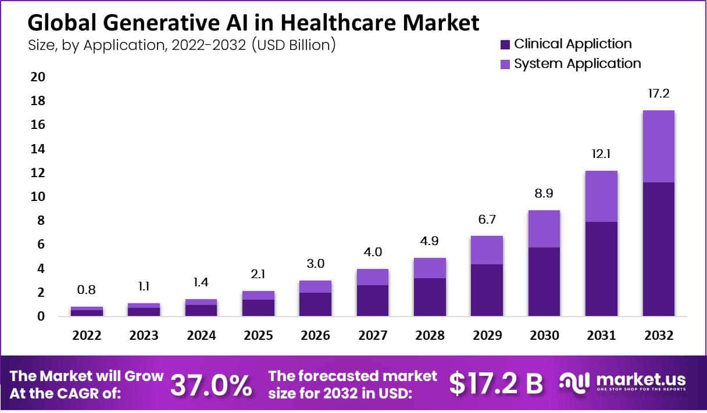
The bar chart here represents how the market related to AI in healthcare has been performing and how it will perform in the near future. As per the analysis, as at 2022 the net worth was $800 million; by 2026 the net worth is at $3,000 million and is expected to rise to $17.2 billion by 2032. The main reason for the above growth is the rapid use of AI for disease diagnosis and robotic surgeries, and the cost-cutting that has occurred due to large projects being able to perform well in the sector. As per the researchers, the idea of using AI in health sectors is heavily used in North American regions and is currently spreading to other regions too.
Reference –
Market.us - https://market.us/report/generative-ai-in-healthcare-market/
Advantages of AI influencing Healthcare
- Ability to prevent future diseases by identifying them in advance.
- Ability to diagnose diseases at an early stage to take required medications.
- Ability to develop medicines and drugs as soon as they are required.
- Providing the ability for patients to maintain proper health records and obtain medications online without physically being available in the hospital.
- Provides a convenient environment for healthcare administrations by assisting with administrative activities.
Disadvantages of AI influencing Healthcare
- Reduction in jobs in the market for positions like radiologists.
- Over-dependency on AI tools can cause a lack of skilled professionals
- Data breaches can be caused due to various intruder attacks on healthcare systems.
- High costs in AI tools and their development.
- Misdiagnosis of diseases and misdevelopment of drugs can be caused.
Responsible usage of AI tools in healthcare sectors.
With the development of AI, we as humans must be more intelligent and intellectual than AI and understand the use of AI in healthcare and be responsible while using it as a tool to improve patient care while protecting the safety and privacy of the individuals such that no negative impact is created on the patient. Not only that, we must not totally depend on AI tools while developing drugs and in the diagnosis of diseases, and have human involvement in each and every step to minimize any possible errors that could occur.

