2025年6月6日 SAGA-LS CTR実験log

- Samples
  - #13研削ありCVD 300℃ / TEOS-SiO₂
  - #14 研削なしCVD 300℃ / TEOS-SiO₂
  - #15 熱酸化膜
Si substrate 250μm thick, TEOS-SiO₂/熱酸化膜~200~235nm
- BL15: X-ray energy 8 keV, $λ=1.55 Å$, PILATUS 100K
HUBER diffractometer
(https://support.spring8.or.jp/BL/bl19b2/huber19/huber.html)
- Si wafer
  - Lattice parameter $a=b=c=5.43119$
  - Detecting the Si 400 diffraction peak ($θ=34.799, 2θ=69.599$, $θ/2θ$ scan)
- 9:45 #15 熱酸化膜 Stage set
  - Stage height (Sz) adj. / Sample rotation (Ry) adj , etc-> Optimization
  - Detecting the Si 400 diffraction peak ($θ=34.799, 2θ=69.599$, $θ/2θ$ scan) -> optimize
  - Si 400 diffraction peak ($θ/2θ$ scan) $θ=34.799±0.5$ scanning: -> saved : Test_02.dat
  - Si_thermo_01.dat:
    - $2θ$ = 68.592-70.5929, Step 1/100, 1point 10sec accumulation 80 mins -> we found asymmetric diffraction peak at 400
    - Prof. Hirosawa: In the thermos-oxidation, oxygen will insert horizontally, horizontal lattice constant will be expanded, thus the vertical lattice constant will become small 酸化膜だと酸素が水平方向に入って格子が水平面が伸びるので、z方向は縮む->そのような結果に見える。
  - Omega scan: Si_Thermo_01_omega.dat

Beam dump / stopped / 12:00 will be recovered.
  - 12:10 Positioning re-adjust / confirmation:
  - $ω$-scan under $θ$/$2θ$ fixed.

- 12:30 Sample change #14 研削なしCVD 300℃ / TEOS-SiO₂ ←#15 熱酸化膜
  - Stage height (Sz) adj. / Sample rotation (Ry) adj, etc-> Optimization
  - Detecting the Si 400 diffraction peak ($θ=34.799, 2θ=69.599$, $θ/2θ$ scan) -> optimize
  - Si 400 diffraction peak ($θ/2θ$ scan) $θ=34.799±0.5$ scanning: -> saved : TEOS_01.dat
  - Asymmetric feature is opposite to the sample #15. The lattice constant of z direction is considered to be expanded. On the other hand, in the case of #15, the lattice constant of z direction is considered to be compressed.
  - Omega scan: TEOS_01_omega.dat

- 14:20 Sample change #13研削ありCVD 300℃ / TEOS-SiO₂←#14 研削なしCVD 300℃ / TEOS-SiO₂
  - Stage height (Sz) adj. / Sample rotation (Ry) adj, etc-> Optimization
  - Detecting the Si 400 diffraction peak ($θ=34.799, 2θ=69.599$, $θ/2θ$ scan) -> saved: RoughTEOS_01.dat , RoughTEOS_02.dat
  - Omega scan: RoughTEOS_01_omega.dat
  - 筋はX線入射方向と垂直 / polished stripes are normal direction to incident direction of X-ray
- #13 Sample $ϕ$ 90度回転
  - 筋はX線入射方向と並行 / polished stripes are parallel to incident direction of X-ray
  - Stage height (Sz) adj. / Sample rotation (Ry) adj, etc-> Optimization
  - Detecting the Si 400 diffraction peak ($θ=34.799, 2θ=69.599$, $θ/2θ$ scan) -> saved: RoughTEOS_03.dat , RoughTEOS_04.dat
  - The asymmetric features are almost the same with $ϕ=0.$ This means that the deformation of the z-lattice is common and is independent of the polished stripes.
  - Omega scan: RoughTEOS_02_omega.dat
- 17:20 Sample Change #15 熱酸化膜←#13 Sample 研削ありCVD 300℃ / TEOS-SiO₂
  - Purpose: What is the reason for the asymmetric profile on omega-scan data.
  - Sample position is changed. The sample was rotated ~90 degree
  - Detecting the Si 400 diffraction peak ($θ=34.799, 2θ=69.599$, $θ/2θ$ scan)
    - During the scan, the beam intensity / alignment may be fluctuated. -> re-scan
    - It might be the sample moving? (by Prof. Hirosawa) -> sample attachment by manicure is better for holding the sample
    - Method of sample attachments should be considered.
Si_Thermo_02.dat~ Si_Thermo_05.dat
  - Omega scan:

- Sample attachments : M5 60mm□/ total height 36mm / Base plate size 80mm□ /
Center hole on the Base 20phi 20 mm depth
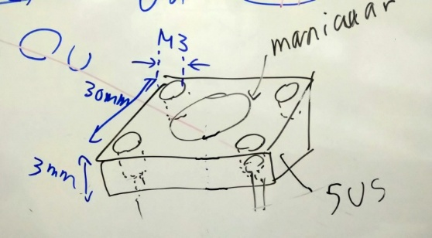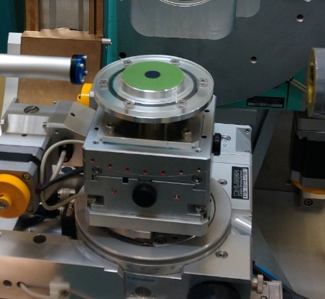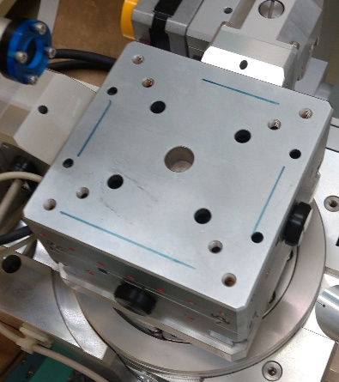
- 電気通信学会学術誌 http://globals.ieice.org/en_transactions/electronics
- PyMC Poisson
  - https://www.pymc.io/projects/docs/en/latest/api/distributions/generated/pymc.Poisson.html
  - https://zenn.dev/inaturam/articles/f2950608a2a2ed
  - https://www.pymc.io/projects/docs/en/stable/api/distributions/generated/pymc.ZeroInflatedPoisson.html

