4671340 Nan Ding

TELCOM 2310 Spring 2025
Project 01: Queuing Simulation

- Project Introduction:
This project focuses on simulation on queuing system of a router by implementing discrete events. According to the given instructions, the queuing simulation is divided into 2 different scenarios, constant input rate case and variable input rate case. Based on the simulation results, and the plots results, we can see how the parameters effect the performance of the system.

- Implementation of simulator
This project including 2 simulators, one is the simulator with the constant input rate(Table 1), another simulator with variable input rate(Table 2). These simulator uses discrete events to model the router(queuing) system with different arrive and depart rate of packets based on a given $λ$ (Arrival rate) and $μ$ (Departure rate).

λ(pkt/sec) | 30 | 80 | 120
μ (pkt/sec) | 50 | 100 | 120
n (packets) | 50 | 100 | 150
Table 1. Constant Input Case Simulation Parameters

Events (%) | 0-10 | 10-70 | 70-80 | 80-90 | 90-100
λ(pkt/sec) | 70 | 200 | 130 | 120 | 70
Table 2. Variable Input Case Simulation Parameters

Because the router has limited buffer space, when is full, incoming packets are dropped. So these 2 simulator can simulate the scenario of router’s queuing and packets arrive and depart and drop scenarios.
The parameters below are used in the simulator:

- $λ$ (Arrival rate): Average number of packets arriving in the queue per second
- $μ$ (Departure rate): Average number of packets leaving the queue per second
- $n$ (Queue buffer size) : Maximum number of packets the queue can hold.
- total events : Number of events to simulate

When using the python file to simulate the scenario, we can adjust these parameters to create different scenarios.

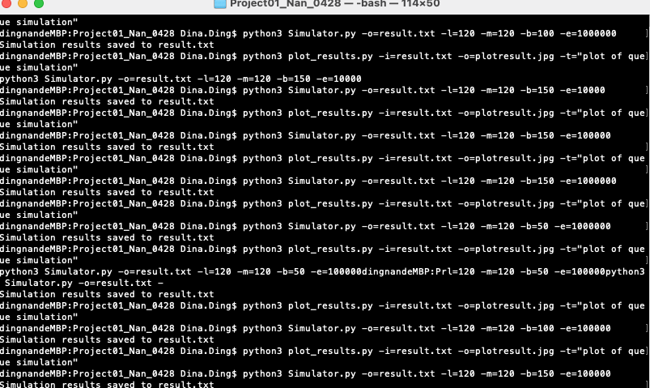

- Simulation results analysis
After running, simulator create 27 plots constant input rate simulation and 3 plots for variable input rate simulation.

  - Simulation with constant input rate
There are 27 plots for 27 different scenarios.

    - Scenario 1: $λ=30, μ=50, n=50$.
python3 Simulator.py -o=result.txt -l=30 -m=50 -b=50 -e=1000000
python3 plot_results.py -i=result.txt -o=plotresult.jpg -t="plot of queue simulation"

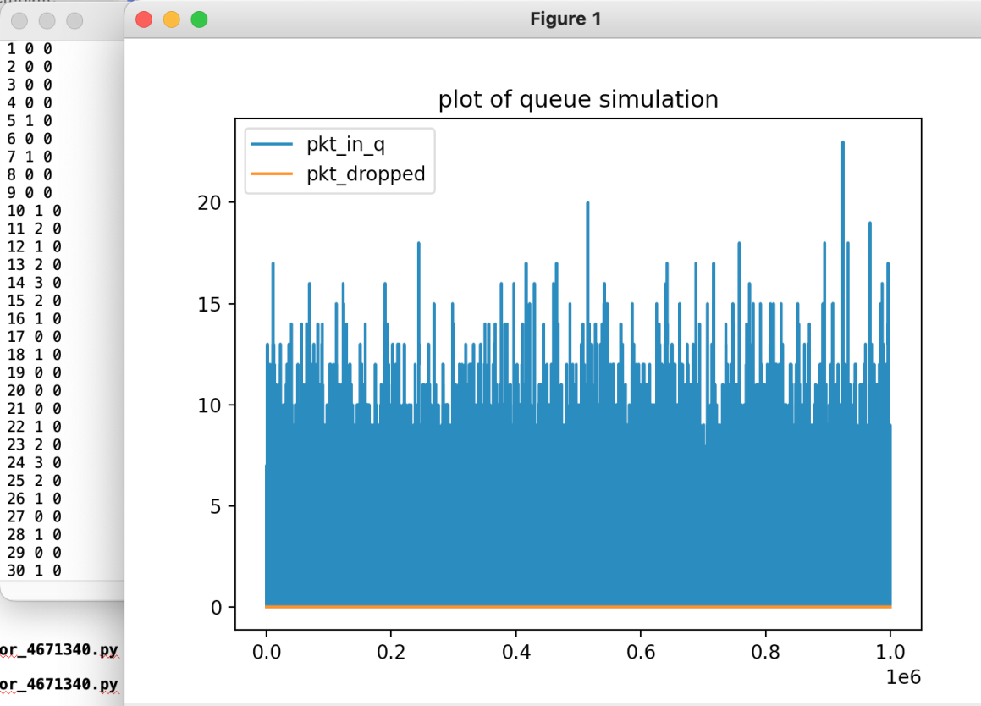

Analysis:
Throughout the entire 1 million events , we can see there are 0 dropped packets (orange line), and the packet in queue fluctuates around 10 and 15.
Due to the arrival rate is smaller than the departure rate, the router system can handle all the arriving packets, besides, system’s buffer size is large enough to hold the waiting packets within the queue. This is the reason why the packets in queue remain at value and not goes to infinite.
And because of this, the system does not need to drop packets.

    - Scenario 1: $λ=30, μ=50, n=100$.
python3 Simulator.py -o=result.txt -l=30 -m=50 -b=100 -e=1000000
python3 plot_results.py -i=result.txt -o=plotresult.jpg -t="plot of queue simulation"

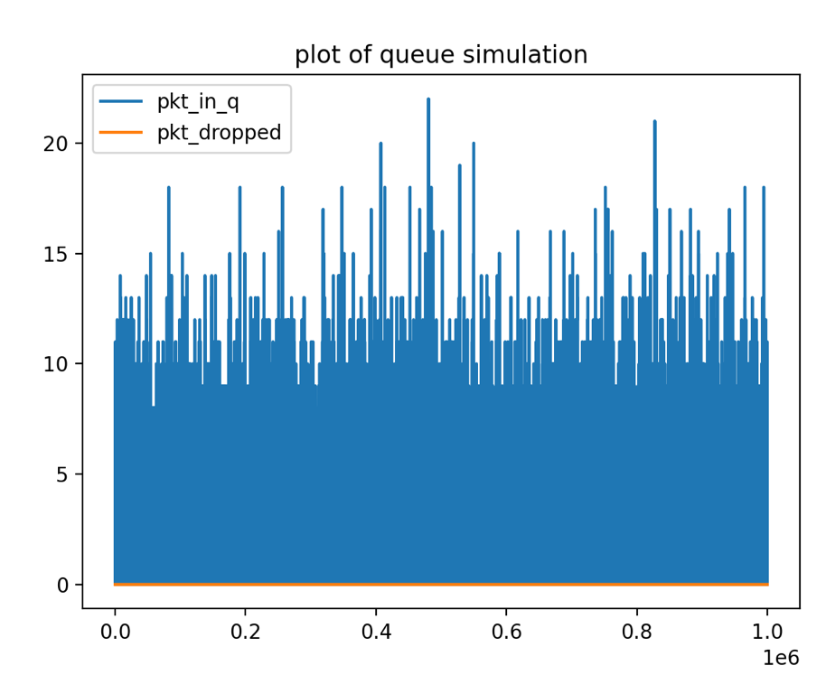
Analysis:
Compared to scenario 1, the only change is the buffer size changed from 5 to 100, since in scenario 1 , as we analyzed, all packets can arrive and leave normally without any drop, in the scenario 2, it is the same, the fluctuation of the packets in the queue does not change so much. And the drop packets number continue to remain 0.

    - Scenario 1: $λ=30, μ=50, n=150$.
python3 Simulator.py -o=result.txt -l=30 -m=50 -b=150 -e=1000000
python3 plot_results.py -i=result.txt -o=plotresult.jpg -t="plot of queue simulation"
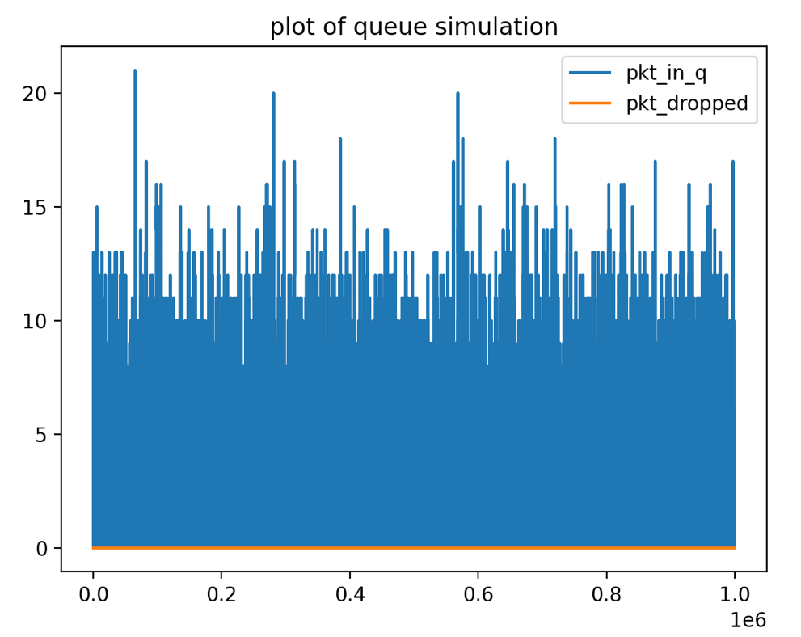

Analysis:
Like scenario 2, the change is buffer size change from 100 to 150, $λ=30, μ=50$ keep the same as scenario 1 and 2. And the drop packets continue to be 0.

    - Scenario 1: $λ=30, μ=100, n=50$.
python3 Simulator.py -o=result.txt -l=30 -m=100 -b=50 -e=1000000
python3 plot_results.py -i=result.txt -o=plotresult.jpg -t="plot of queue simulation"

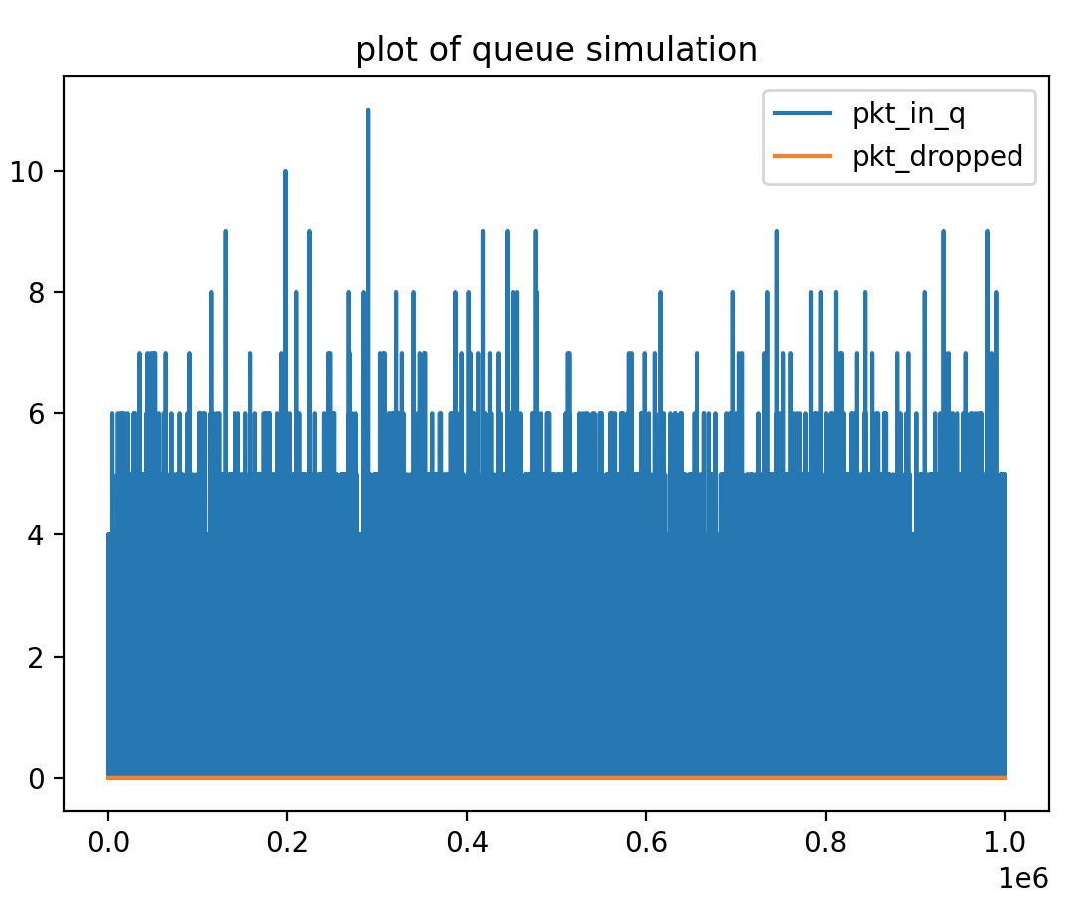
Analysis:
Compared to Scenario 1, 2, and 3, scenario 4 changes the departure rate to 100. Thus, for entire 1 million events, when the system is processing, the number of packets in queue, decreases to nearly only half of that in Scenario 1, 2, and 3 which is approximately 5. This is because the system can process more data in single unit time. And the range for the number of packets in queue is from 4 to 10.
As for the number of packets dropped, even the buffer size is merely 50, the departure rate(100) helps to reduce the pressure for holding packets in queue. Therefore, it keeps at 0.

    - Scenario 1: $λ=30, μ=100, n=100$.
python3 Simulator.py -o=result.txt -l=30 -m=100 -b=100 -e=1000000
python3 plot_results.py -i=result.txt -o=plotresult.jpg -t="plot of queue simulation"
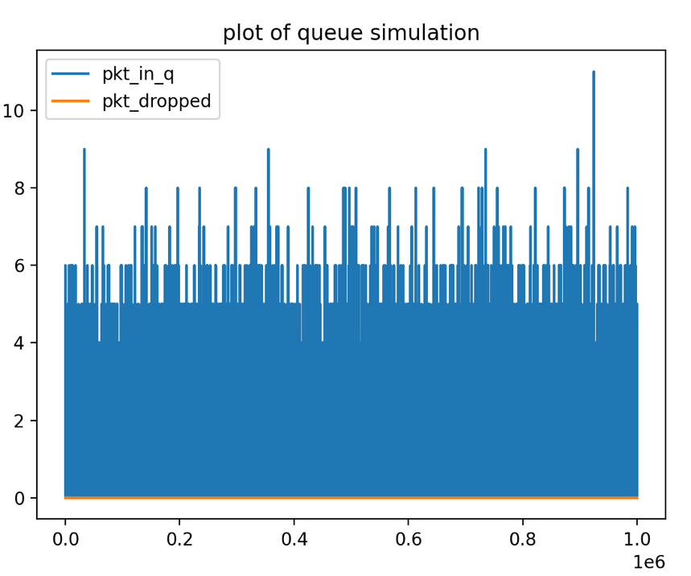

Analysis:
Compared to scenario 5, scenario 4 changes the buffer size from 50 to 100, but like scenario 5, since depart rate reduce the pressure for holding packets in queue, so the extended buffer size does not have an apparent performance improvement, since no dropped packets , so the orange line keep 0.

    - Scenario 1: $λ=30, μ=100, n=150$.
python3 Simulator.py -o=result.txt -l=30 -m=100 -b=150 -e=1000000
python3 plot_results.py -i=result.txt -o=plotresult.jpg -t="plot of queue simulation"
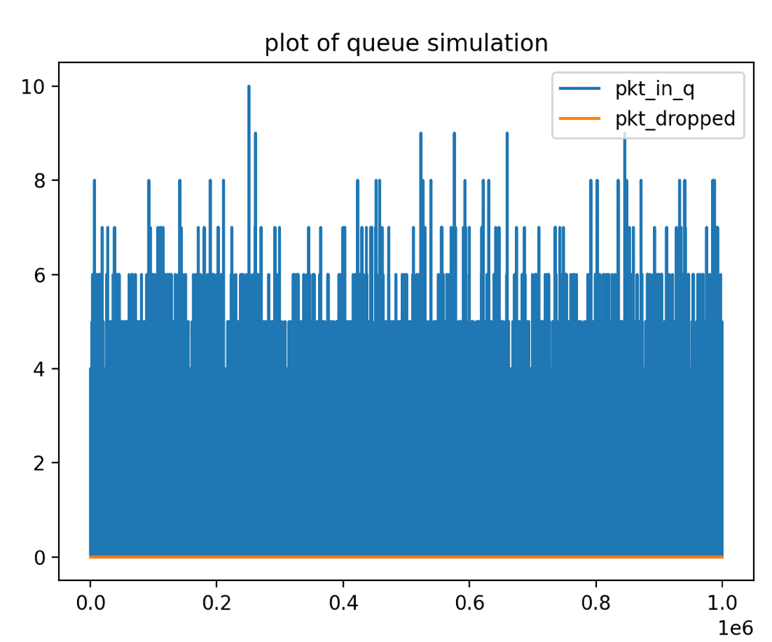
Analysis:
When analyzing Scenario 6, the conclusion for comparison among Scenario 4, 5, and 6 is like the conclusion for comparison among Scenario 1, 2, and 3.

    - Scenario 1: $λ=30, μ=120, n=50$.
python3 Simulator.py -o=result.txt -l=30 -m=120 -b=50 -e=1000000
python3 plot_results.py -i=result.txt -o=plotresult.jpg -t="plot of queue simulation"
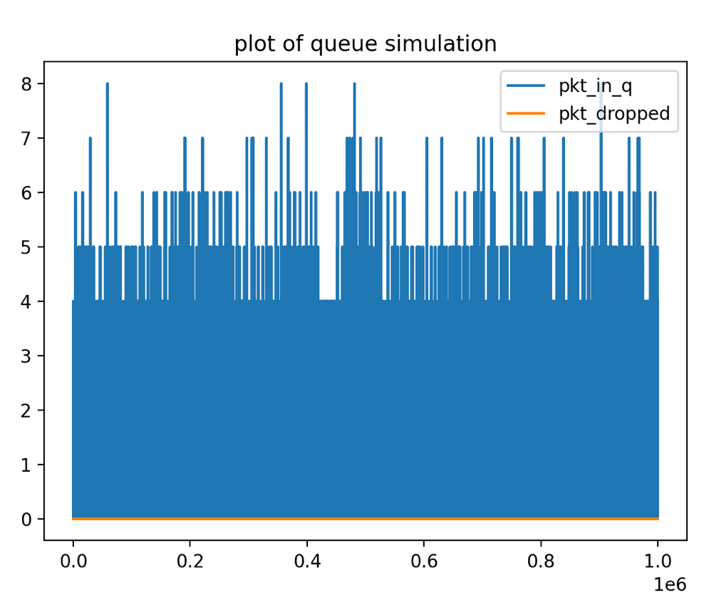
Analysis:
Compared to scenario 1 and 4, scenario 7 changes the departure rate to 120, which means the processing capability is enhanced, so this time, the packets in queue decreased to around 4. And the overall range for the packets in queue is from 4 to 8 which is less than scenario 1 and 4. Because the buffer size is still enough so the line of dropped packets is 0.

    - Scenario 1: $λ=30, μ=120, n=100$.
python3 Simulator.py -o=result.txt -l=30 -m=120 -b=100 -e=1000000
python3 plot_results.py -i=result.txt -o=plotresult.jpg -t="plot of queue simulation"
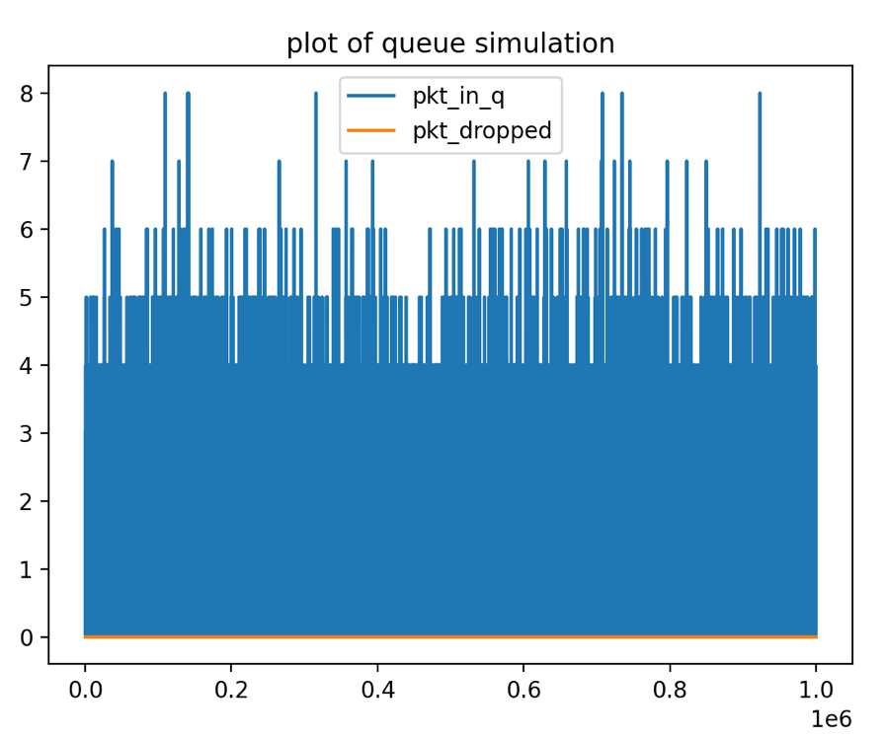
Analysis:
For Scenario 8, the only change compared to scenario 7 is the buffer size, change from 50 to 100, however, increase in buffer size does not influence much of the distribution or line trends. So, its performance like scenario 7.

    - Scenario 1: $λ=30, μ=120, n=150$.
python3 Simulator.py -o=result.txt -l=30 -m=120 -b=150 -e=1000000
python3 plot_results.py -i=result.txt -o=plotresult.jpg -t="plot of queue simulation"

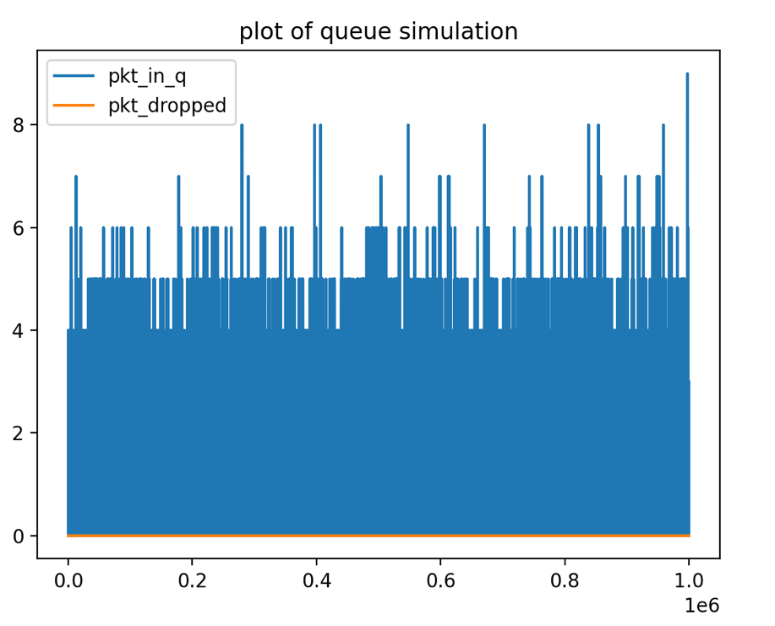

Analysis:
For Scenario 9, the only change compared to scenario 7 is the buffer size, change from 50 to 150, however, increase in buffer size does not influence much of the distribution or line trends. So, its performance like scenario 7.

    - Scenario 1: $λ=80, μ=100, n=50$.
python3 Simulator.py -o=result.txt -l=80 -m=100 -b=50 -e=1000000
python3 plot_results.py -i=result.txt -o=plotresult.jpg -t="plot of queue simulation"
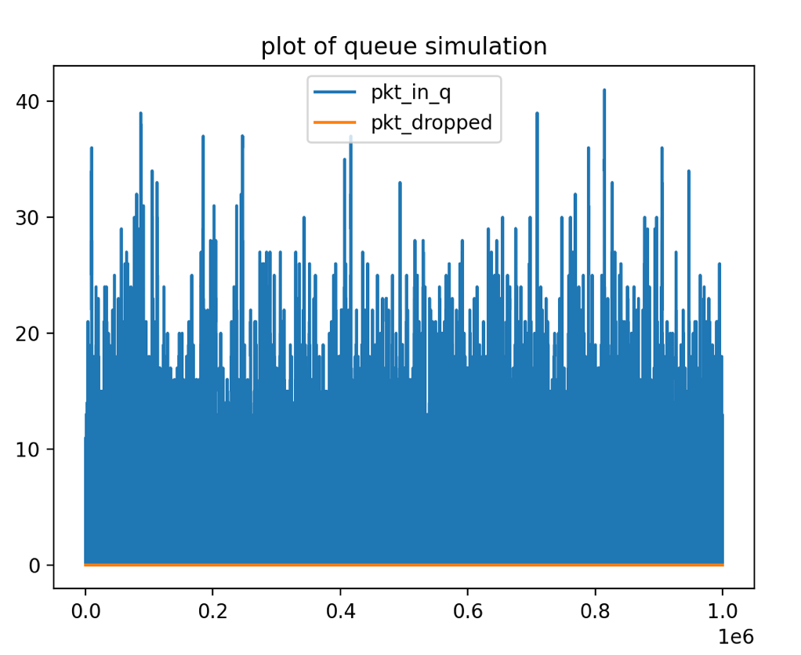
Analysis:
Throughout the entire 1 million events , for Scenario 10, the arrival rate has increased to 80 from 30 in Scenario 1 to 9. The departure rate has increased to 100 from 50 in Scenario 1 while the buffer size remains 50. Hence, the times for arrival rate to increase is larger than the times for departure rate to increase which may result in more packets the queue needs to hold. Therefore, it is obvious that the range for the number of packets in queue is from approximately 8 to approximately 40. And for the most portion, the number of packets in queue is close to 18. The plot has shown this growth. However, the buffer size is large enough to hold the packets in the queue while the departure rate is still bigger than the arrival rate, so the line for the number of packets dropped remain 0.

    - Scenario 1: $λ=80, μ=100, n=100$.
python3 Simulator.py -o=result.txt -l=80 -m=100 -b=100 -e=1000000
python3 plot_results.py -i=result.txt -o=plotresult.jpg -t="plot of queue simulation"

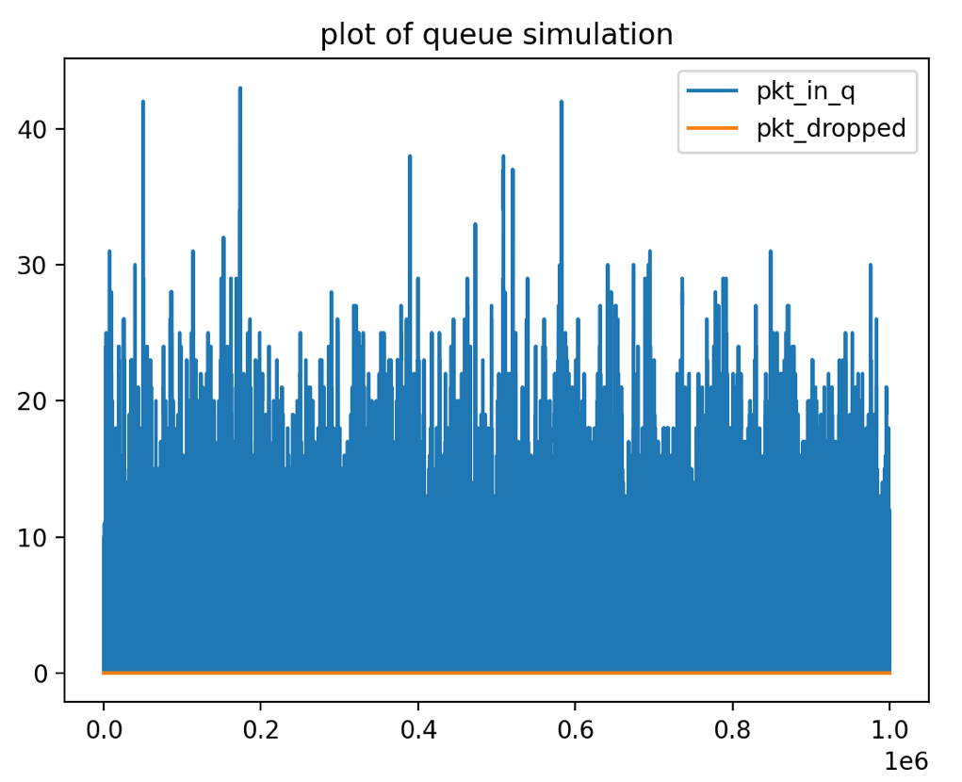

Analysis:
Like scenario 10, the packet dropped remains 0, since the change parameter of buffer size (from 50 to 100) does not contribute too much at performance.

    - Scenario 1: $λ=80, μ=100, n=150$.
python3 Simulator.py -o=result.txt -l=80 -m=100 -b=150 -e=1000000
python3 plot_results.py -i=result.txt -o=plotresult.jpg -t="plot of queue simulation"

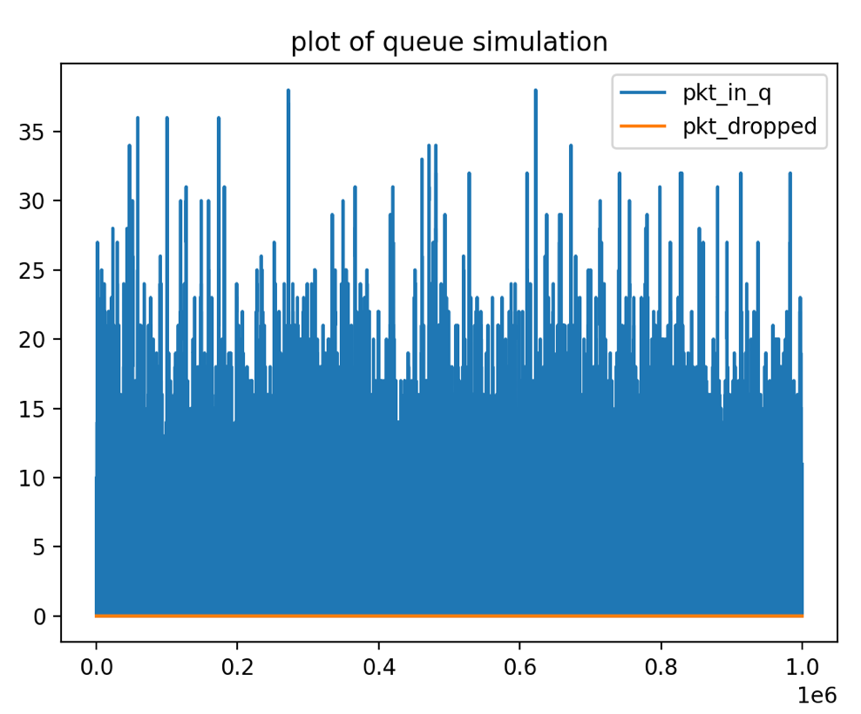
Analysis:
The conclusion for analysis on Scenario 12 is like the conclusion for analysis on Scenario 11.

    - Scenario 1: $λ=80, μ=120, n=50$.
python3 Simulator.py -o=result.txt -l=80 -m=120 -b=50 -e=1000000
python3 plot_results.py -i=result.txt -o=plotresult.jpg -t="plot of queue simulation"

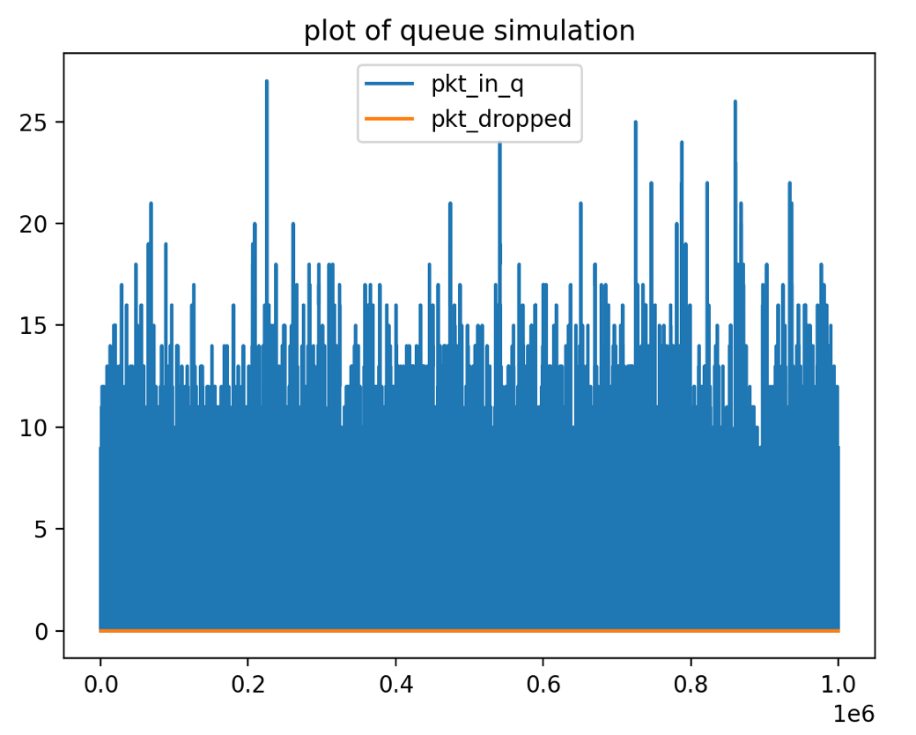
Analysis:
Scenario 13 changes the departure rate from 100 to 120, so we can see with the help of increased departure rate, the packet in queue decreases to around 12 from 18, and the range also changed to 10 to 26. Besides, since the departure rate is still larger than arrival rate, the dropped packets keep 0.

    - Scenario 1: $λ=80, μ=120, n=100$.
python3 Simulator.py -o=result.txt -l=80 -m=120 -b=100 -e=1000000
python3 plot_results.py -i=result.txt -o=plotresult.jpg -t="plot of queue simulation"
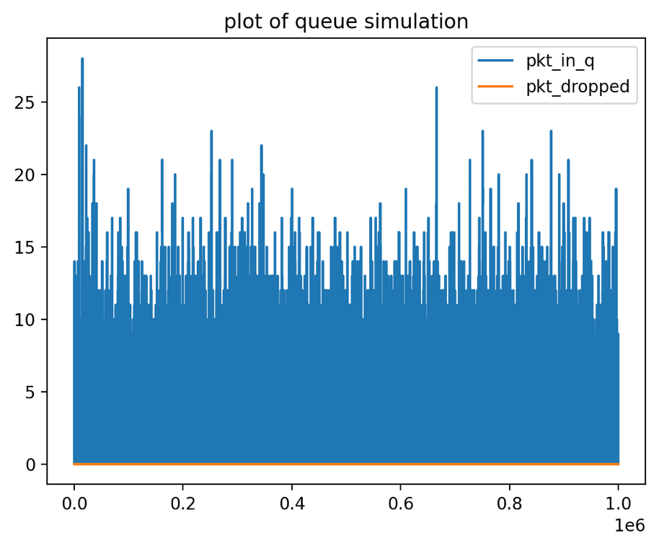

Analysis:
Like scenario 13, the packet dropped remains 0, since the change parameter of buffer size (from 50 to 100) does not contribute too much at performance.

    - Scenario 1: $λ=80, μ=120, n=150$.
python3 Simulator.py -o=result.txt -l=80 -m=120 -b=150 -e=1000000
python3 plot_results.py -i=result.txt -o=plotresult.jpg -t="plot of queue simulation"
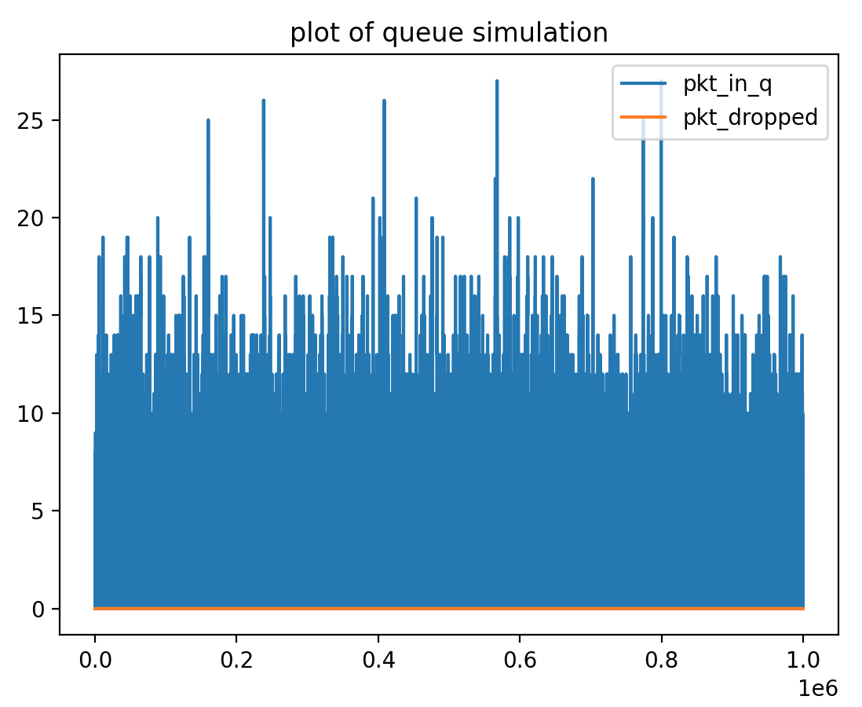

Analysis:
The conclusion for analysis on Scenario 15 is like the conclusion for analysis on Scenario 14.

    - Scenario 1: $λ=80, μ=50, n=50$.
python3 Simulator.py -o=result.txt -l=80 -m=50 -b=50 -e=1000000
python3 plot_results.py -i=result.txt -o=plotresult.jpg -t="plot of queue simulation"
python3 Simulator.py -o=result.txt -l=80 -m=50 -b=50 -e=2000
python3 plot_results.py -i=result.txt -o=plotresult.jpg -t="plot of queue simulation"

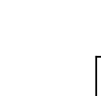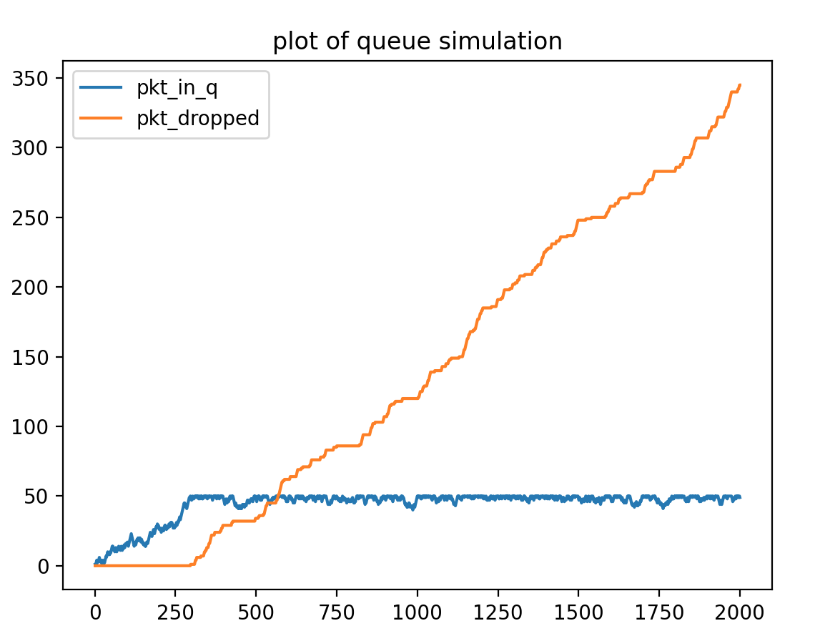

Analysis:
We use 2000 event plot instead of 1000000 event plots to show the detailed analysis.
For Scenario 16, it is the first time the arrival rate is larger than departure rate, so we can see, the packets dropped is not 0 anymore, it increases apparently with the packets arrives, although at the beginning, dropped packets still at around 0 , because at this time, packets in queue is not full (blue line), once the buffer size of queue arrives 50, the packet in queue (blue line) keeps the buffer size and the packet dropped (orange line) keeps increase.

    - Scenario 1: $λ=80, μ=50, n=100$.
python3 Simulator.py -o=result.txt -l=80 -m=50 -b=100 -e=2000
python3 plot_results.py -i=result.txt -o=plotresult.jpg -t="plot of queue simulation"
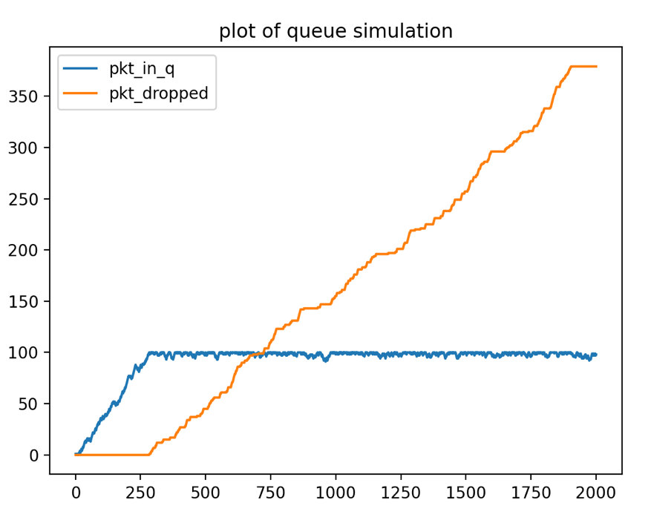

Analysis:
Compared to scenario 16, scenario 17 change the buffer size from 50 to 100, so we can see, until the packet in queue increase to 100, the dropped packets start to increase from 0 exponentially. It is because the departure rate is larger than the arrival rate, the system cannot handle all the incoming packets. The number of packets dropped will continue to grow after the buffer is full.

    - Scenario 1: $λ=80, μ=50, n=150$.
python3 Simulator.py -o=result.txt -l=80 -m=50 -b=150 -e=2000
python3 plot_results.py -i=result.txt -o=plotresult.jpg -t="plot of queue simulation"
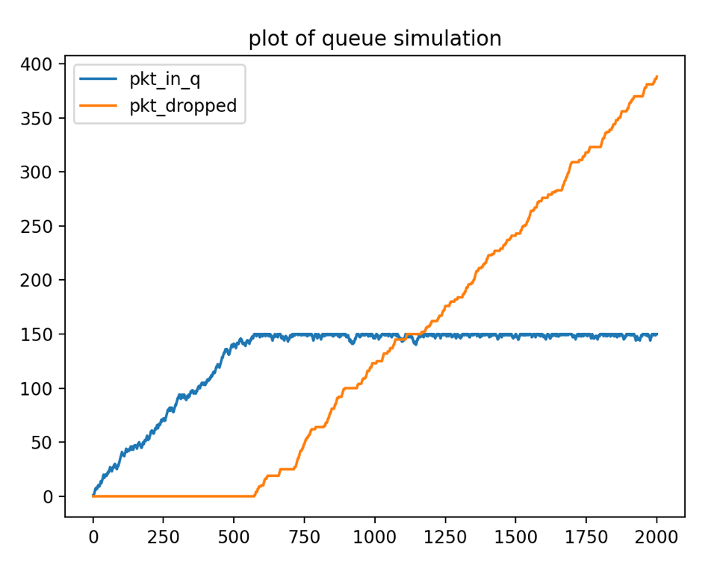
Analysis:
Like scenario 17, scenario 18 just change the buffer size from 100 to 150, so we can see the change for dropped packets, it starts to increase when packet in queue arrives 150.

    - Scenario 1: $λ=120, μ=50, n=50$.
python3 Simulator.py -o=result.txt -l=120 -m=50 -b=50 -e=2000
python3 plot_results.py -i=result.txt -o=plotresult.jpg -t="plot of queue simulation"
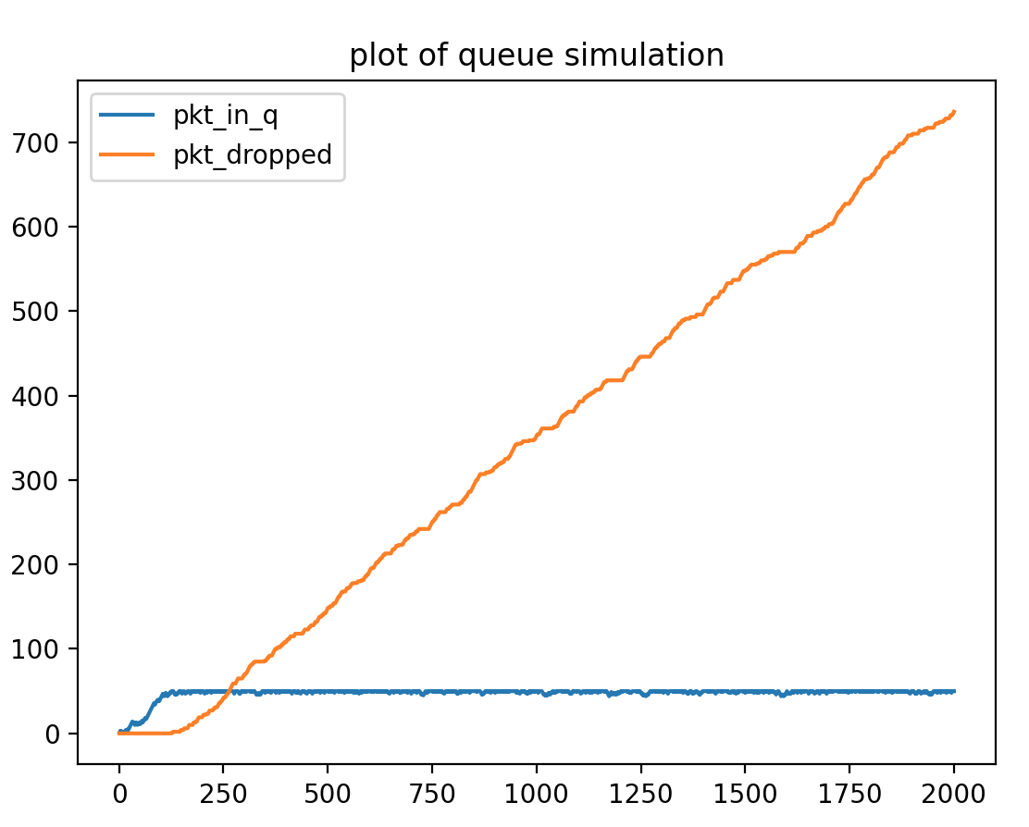

Analysis:
For Scenario 19, the arrival rate has increased to 120 while the departure rate and buffer size remain the same as Scenario 16. Thus, the growth for the number of packets in queue is faster than that in Scenario 16. It is approximately at event 125 that the buffer becomes full, and the number of packets dropped begins to grow.
And at the event 1000, the corresponding count for the number of packets dropped for Scenario 19 is approximately 350 while it is approximately 80 in Scenario 16. This reflects the growth rate in Scenario 19 is larger as the arrival rate in Scenario 19 is larger when compared to Scenario 16.
    - Scenario 1: $λ=120, μ=50, n=100$.
python3 Simulator.py -o=result.txt -l=120 -m=50 -b=100 -e=2000
python3 plot_results.py -i=result.txt -o=plotresult.jpg -t="plot of queue simulation"
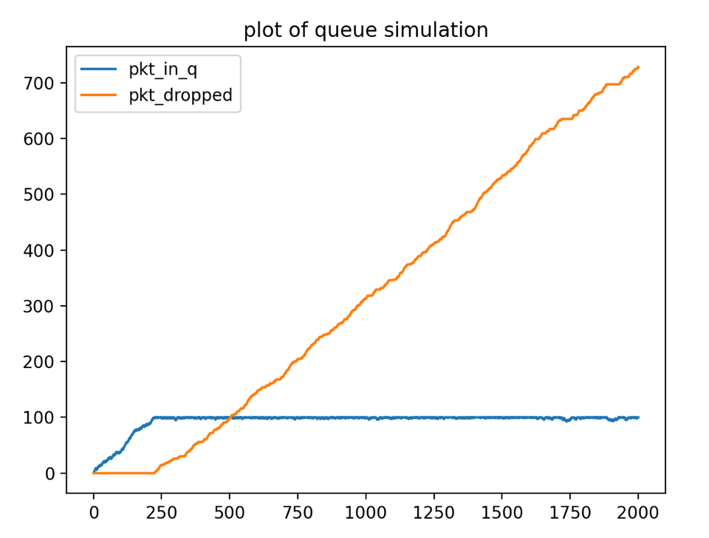
Analysis:
Scenario 20 changes the buffer size from 50 to 100, so we can see, the at around event 250, when the buffer is full , the dropped packets start to increase.

    - Scenario 1: $λ=120, μ=50, n=150$.
python3 Simulator.py -o=result.txt -l=120 -m=50 -b=150 -e=2000
python3 plot_results.py -i=result.txt -o=plotresult.jpg -t="plot of queue simulation"
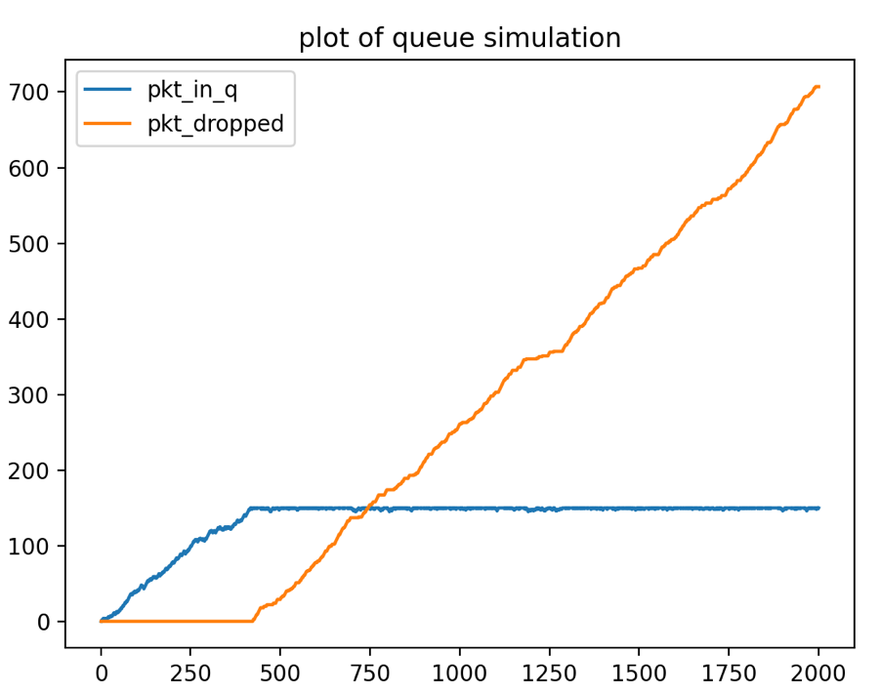
Analysis:
Like scenario 20, scenario 21 just change the buffer size from 100 to 150, so we can see the change for dropped packets, it starts to increase when packet in queue arrives 150.

    - Scenario 1: $λ=120, μ=100, n=50$.
python3 Simulator.py -o=result.txt -l=120 -m=100 -b=50 -e=2000
python3 plot_results.py -i=result.txt -o=plotresult.jpg -t="plot of queue simulation"
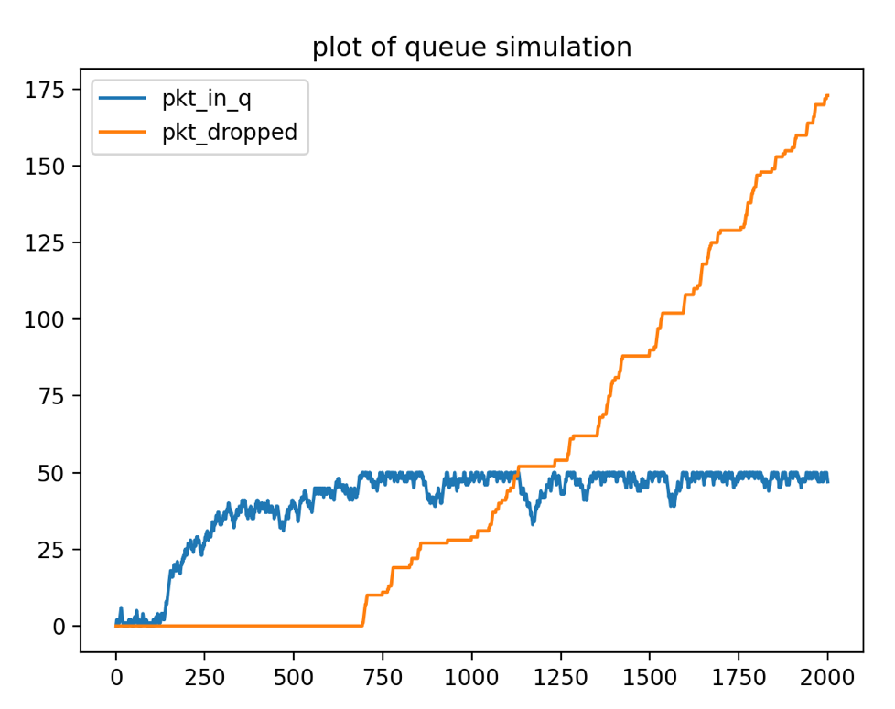

Analysis:
For Scenario 22, the arrival rate and buffer size remain the same while the departure rate increases to 100 from 50 when compared to Scenario 19. As we can see that the growth rate for the number of packets dropped in Scenario 22 is slower than that in Scenario 19 as the system can handle the arriving packets faster.

    - Scenario 1: $λ=120, μ=100, n=100$.
python3 Simulator.py -o=result.txt -l=120 -m=100 -b=100 -e=3000
python3 plot_results.py -i=result.txt -o=plotresult.jpg -t="plot of queue simulation"

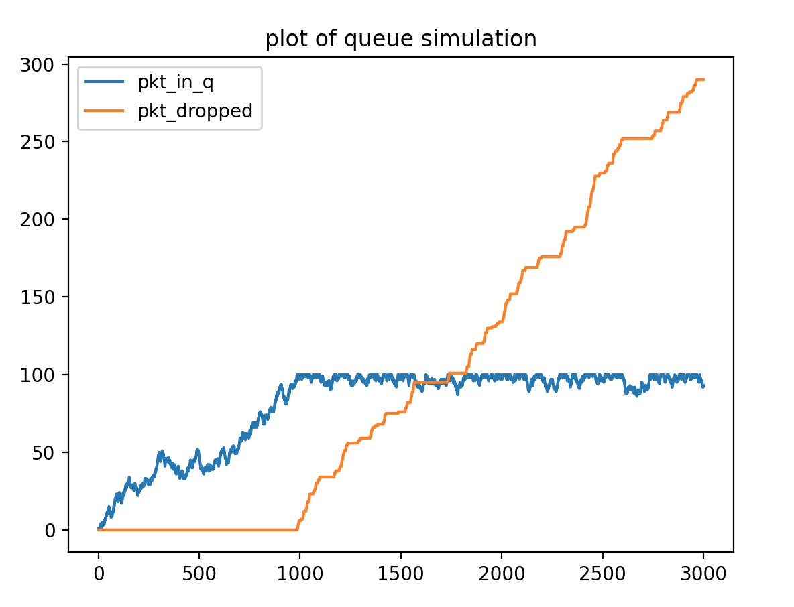
Analysis:
For Scenario 23, the buffer size changes to 100 while arrival rate and departure rate remain unchanged when compared to Scenario 22. Thus, the moment for the number of packets dropped comes a bit later than Scenario 22 as the buffer can hold more packets in the queue.

    - Scenario 1: $λ=120, μ=100, n=150$.
python3 Simulator.py -o=result.txt -l=120 -m=100 -b=150 -e=5000
python3 plot_results.py -i=result.txt -o=plotresult.jpg -t="plot of queue simulation"
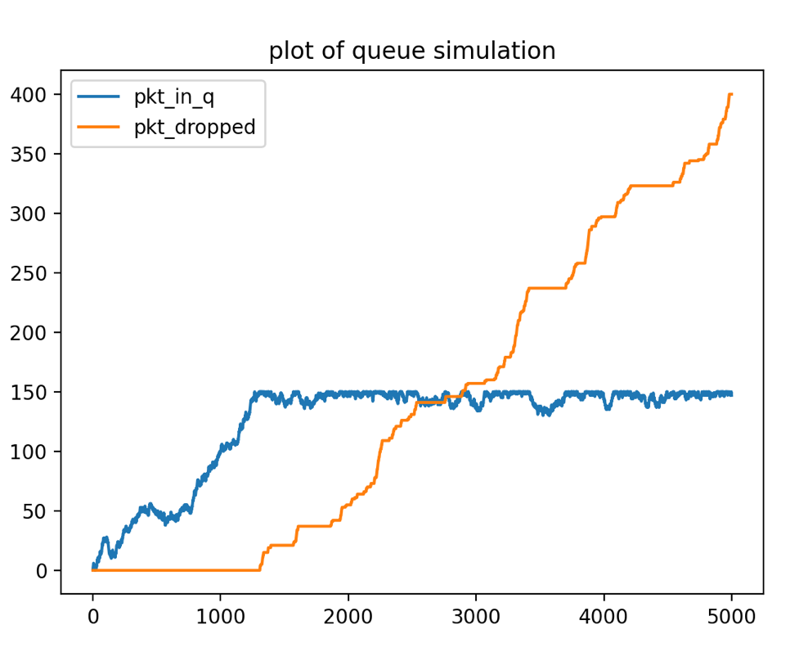

Analysis:
For Scenario 24, the buffer size changes to 150 while arrival rate and departure rate remain unchanged when compared to Scenario 22. Thus, the moment for the number of packets dropped comes a bit later than Scenario 22 as the buffer can hold more packets in the queue.

    - Scenario 1: $λ=120, μ=120, n=50$.
python3 Simulator.py -o=result.txt -l=120 -m=120 -b=50 -e=100000
python3 plot_results.py -i=result.txt -o=plotresult.jpg -t="plot of queue simulation"
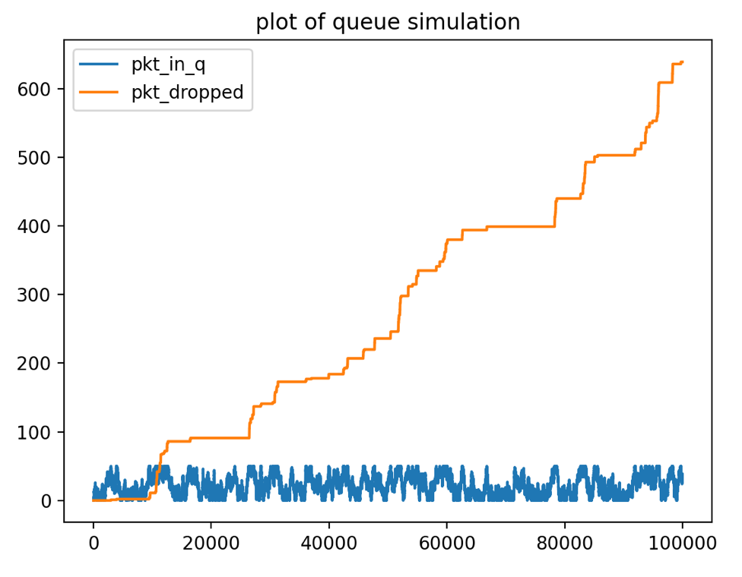
Analysis:
Scenario 25 to 27 are special as the arrival rate and departure rate are the same as 120, but their buffer size is different from 50,to 100 and 150. But due to the randomness of arrival and departure packets, so the number of packets in queue may continue to grow or decrease.
While the number of packets dropped may begin to grow when the arrival events continue to occur but once the event becomes departure event the growth will stop. In Scenario 25, 26, and 27, it is more likely to encounter the growth plateau for the curve of the number of packets dropped while the large oscillation for the curve of the number of packets in queue.

    - Scenario 1: $λ=120, μ=120, n=100$.
python3 Simulator.py -o=result.txt -l=120 -m=120 -b=100 -e=100000
python3 plot_results.py -i=result.txt -o=plotresult.jpg -t="plot of queue simulation"
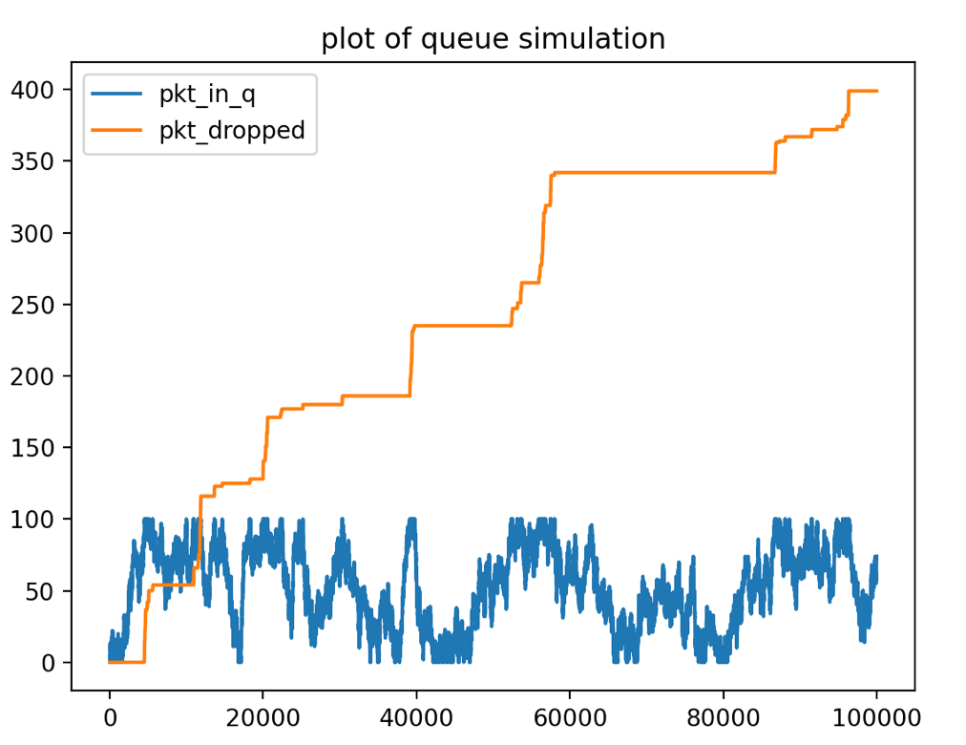

Analysis:
For scenario 26 , the buffer size changes to 100 , so the range of oscillation of the fluctuation of the curve of the number of packets in queue is larger than(change to 100 ) that in Scenario 25 which the number of packet in queue is below 50.

    - Scenario 1: $λ=120, μ=120, n=150$.
python3 Simulator.py -o=result.txt -l=120 -m=120 -b=150 -e=100000
python3 plot_results.py -i=result.txt -o=plotresult.jpg -t="plot of queue simulation"
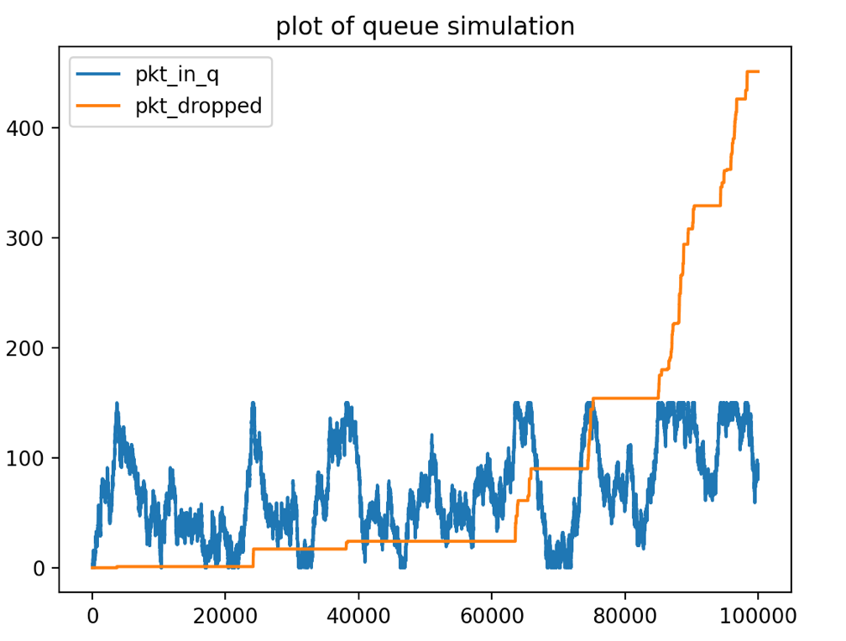

Analysis:
For scenario 27 , the buffer size changes to 150 , so the range of oscillation of the fluctuation of the curve of the number of packets in queue changes to 150.

  - Simulation with variable input rate
For 3.2 Variable input rate, the variable input rate will be fixed according to different event ,see table below:

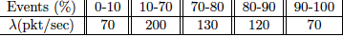

Fixed parameters:
total_events = 1000000 # fixed at 1,000,000 events
mu_rate = 120 # Departure rate: fixed as 120
buffer_size = 100 # Buffer size: fixed as 100

Commands:
python3 Simulator_variable.py -o=result_variable.txt
python3 plot_results.py -i=result_variable.txt -o=plotresult.jpg -t="plot of queue simulation with variable input rate"

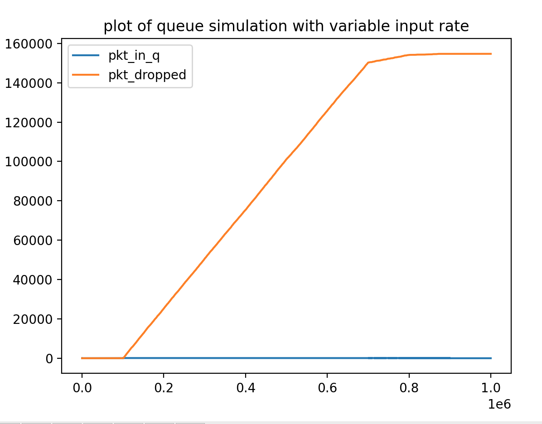
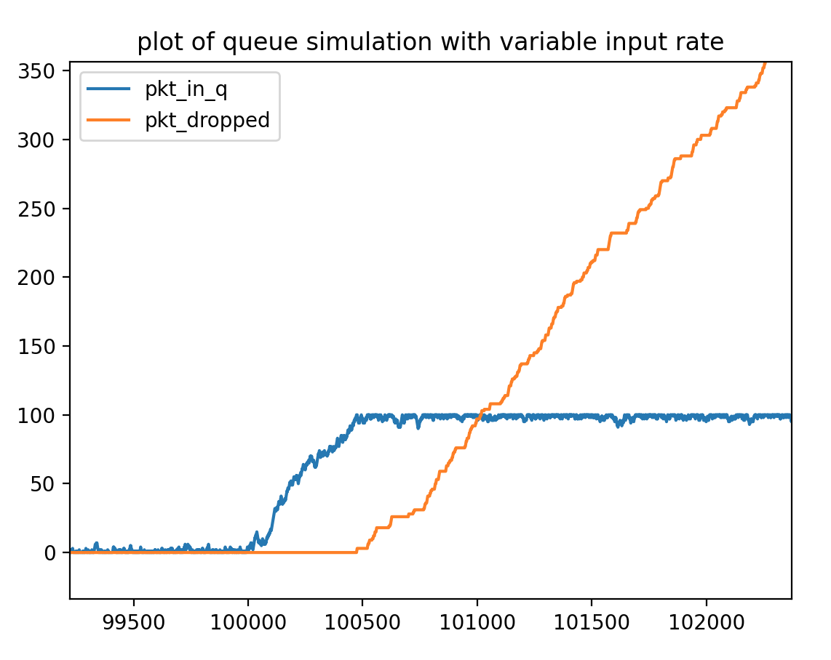

Analysis:
From the data and the figure, we can get:
when events go from 0 to 100,000 (10%), during this time, the arrive rate is 70, departure rate is 120, buffer size is 100, because the arrival rate is less than departure rate, so the dropped packets keep at around 0, and packets in queue does not increase a lot.
However, when events go beyond 100,000 (10%), the arrival rate changes to 200 (departure rate is still 120, buffer size is still 100), which is larger than departure rate, the packets in queue increase apparently, and once the packets in queue arrive its buffer size (100) , the number of dropped packets increases exponentially.
Then, when events go to 700,000, the dropped packets number starts to not increase, it is because the arrival rate change from 200 back to 130 which is just slightly larger than departure rate, then we can see the dropped packets really keep flat when events go to 800,000, because the arrival rate decrease again to 120 and then 70 when events go to 900,000. Because as the arrival rate decrease again and again, the router can send out the packets in queue, so it does not need to drop packets continually, so the number of dropped packets does not increase anymore.

